Fakebook – Startup Guide

• "Fakebook" is a free tool at www.classtools.net which allows teachers and students to create imaginary profile pages for study purposes.
• Use "Fakebook" to chart the plot of a book, the development of a character, a series of historical events, debates and relationships, and so on!
• You can save your work and edit it again later.

1. Enter the name of your character (or object, or concept, or whatever!)
An image will automatically appear. Click on this if you would rather change it to an image uploaded from your computer.

2. Add an appropriate cover image. Search Google Images (“Facebook cover images”)

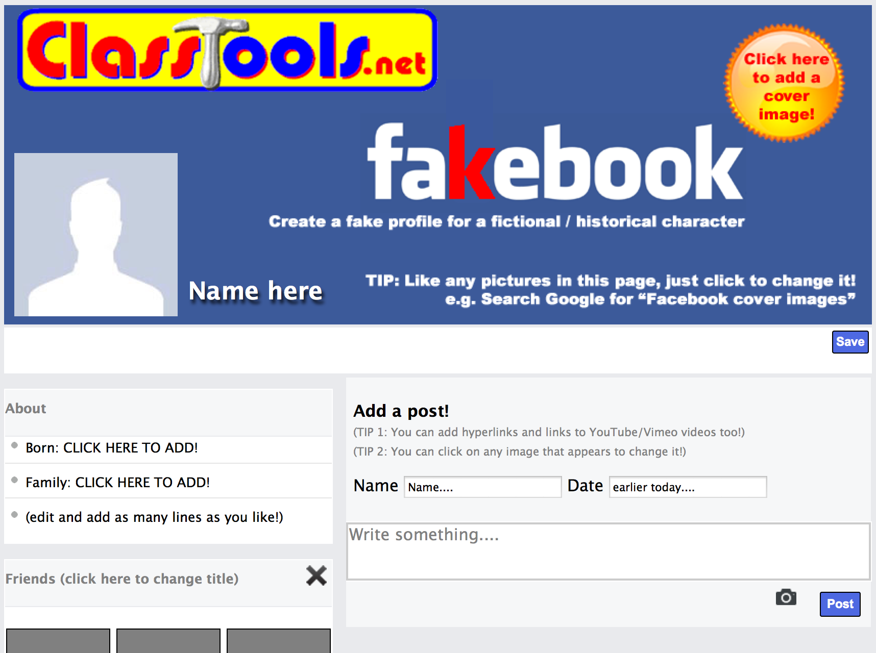

3. Add some key information
about in the ‘About’ box.

4. Start adding some “Friends” in the first block.
You can add as many of these blocks as you like – for example, add another for ‘hobbies’, ‘likes, ‘hates, ‘places visited, ‘favourite books’ and so on.
An image automatically loads. You can click any image to change it.

5. Add a post. Just provide a name, a date, and write something.
You can add hyperlinks and links to YouTube/Vimeo vidoes too.
An image automatically loads. You can click any image to change it.

6. Add a comment and / or a ‘liked by…’ after the post appears.
Like the posts, comments can be ‘dragged and dropped’ with your mouse.

