Group C
Wendy Bronson
Eric Sengvanhpheng
William Judd
Luis Cortez
Martha Guzman
July 30, 2026
Database Development and Use
Module 11.2 Milestone #5
Case Study: Bacchus Winery

Project Overview
For Milestone #5, Group C created three business reports using information stored in the Bacchus Winery database. Each report retrieves data from multiple tables and provides information that could help management make decisions about suppliers, wine sales, employee workloads, production, and inventory.

Report 1: Monthly Supplier Delivery Performance
This report summarizes supplier deliveries by month and calculates the average number of days between the expected and actual delivery dates. It helps Bacchus Winery evaluate supplier performance and identify delivery issues that could affect inventory and production planning.
The revised report also includes a delivery status for each shipment. Deliveries are classified as Early, On Time, Late, or Pending, making it easier for management to quickly understand supplier performance. A negative average day’s difference indicates an early delivery, zero indicates an on-time delivery, a positive value indicates a late delivery, and NULL indicates that an actual delivery date has not yet been recorded.

Figure 1. Monthly Supplier Delivery Performance Report
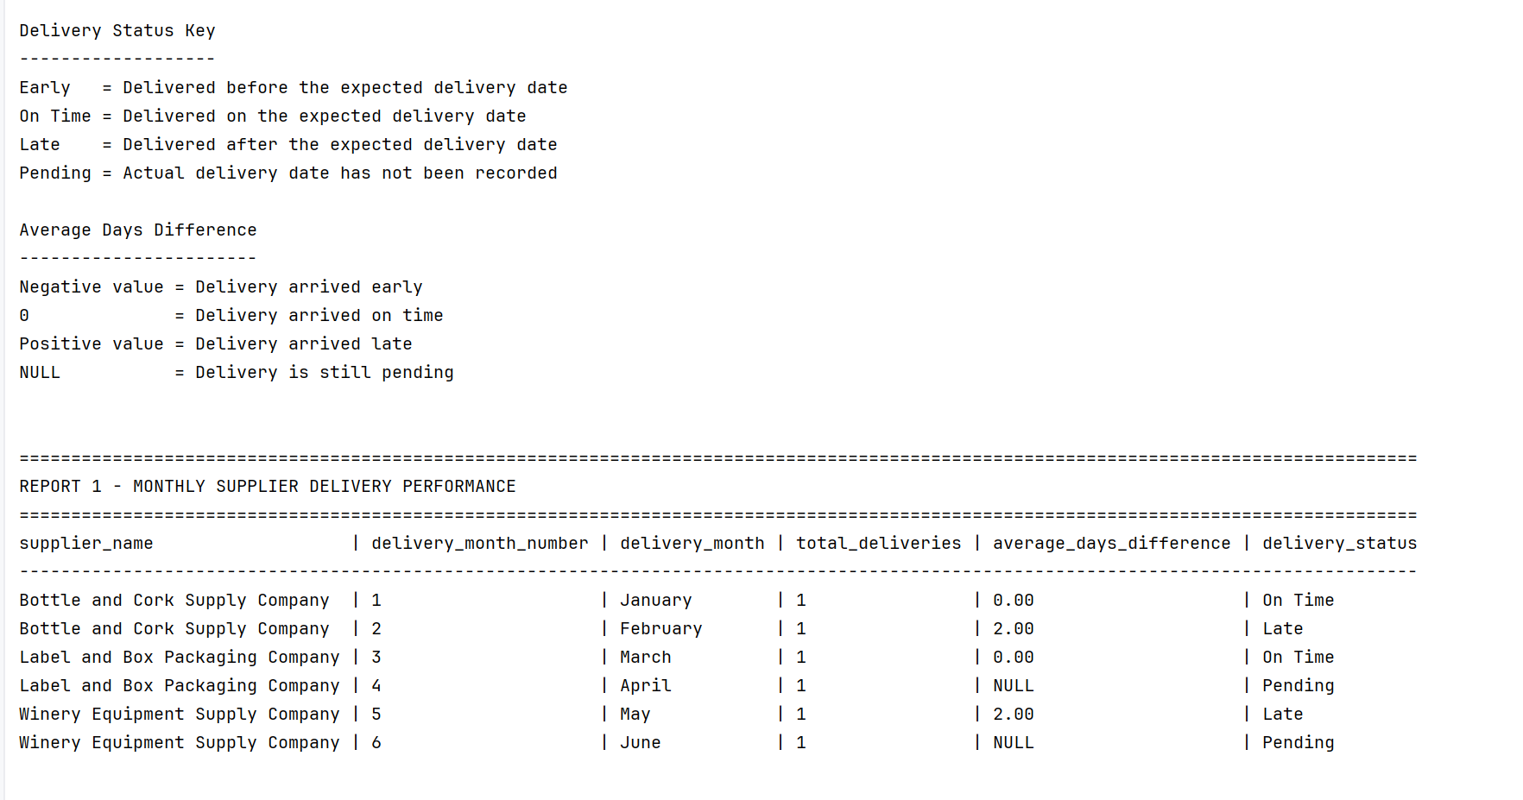

Report 2: Wine Sales by Distributor
This report displays the total number of bottles ordered and the total sales amount for each wine and distributor. It allows management to identify top-selling wines, evaluate distributor purchasing activity, and make informed production, inventory, and sales planning decisions.

Figure 2. Wine Sales by Distributor Report
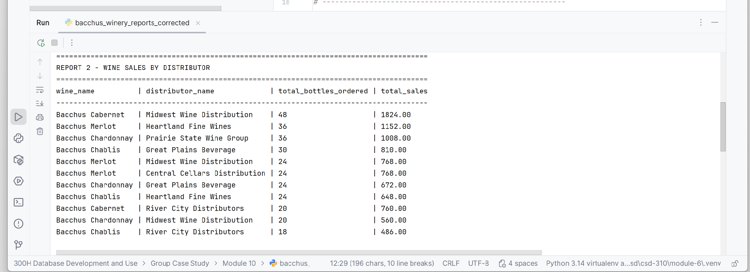

Report 3: Employee Hours for the Last Four Quarters
This report displays the total hours worked by each employee during the four most recent calendar quarters stored in the database. It allows management to compare employee workloads over time, identify staffing trends, and support scheduling decisions.
To address instructor feedback from the previous milestone, the employee time sample data was expanded to include more realistic daily work entries. This improvement allows the report to generate realistic quarterly totals while keeping the database structure and report logic unchanged.

Figure 3. Employee Hours for the Last Four Quarters
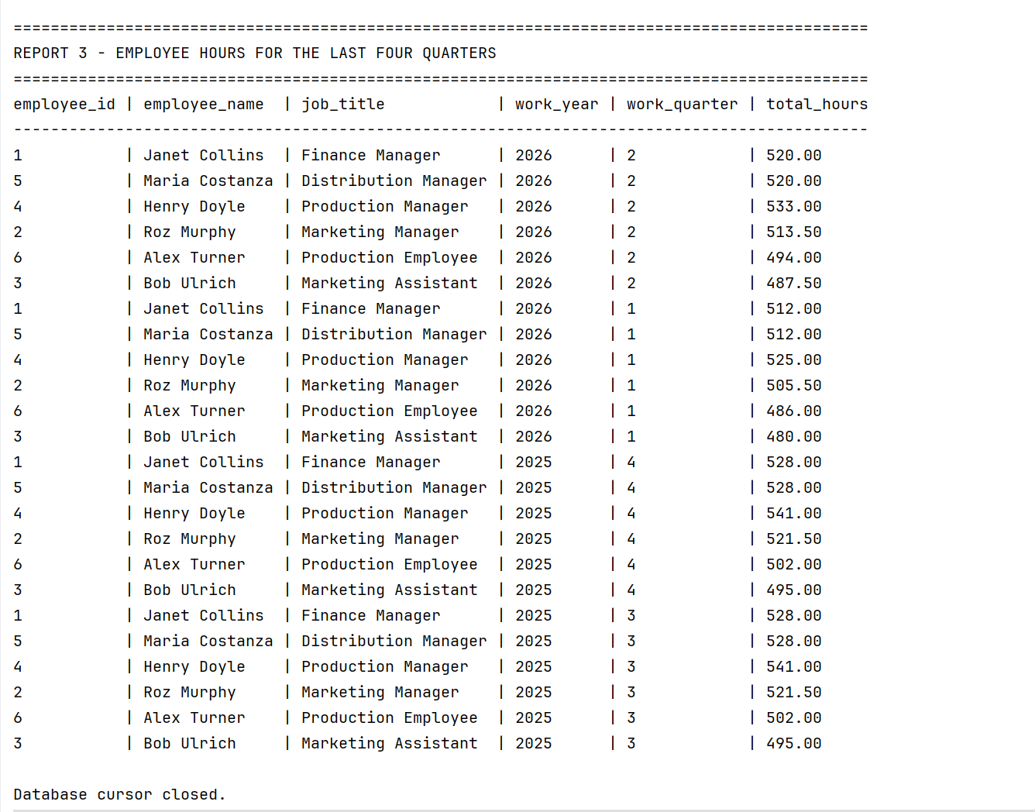

Revised Entity-Relationship Diagram
The final ERD reflects the complete structure of the Bacchus Winery database. It includes the tables, primary keys, foreign keys, and relationships that support the three business reports and demonstrates the normalized design developed throughout the project.
