Original flowchart based off of original python script
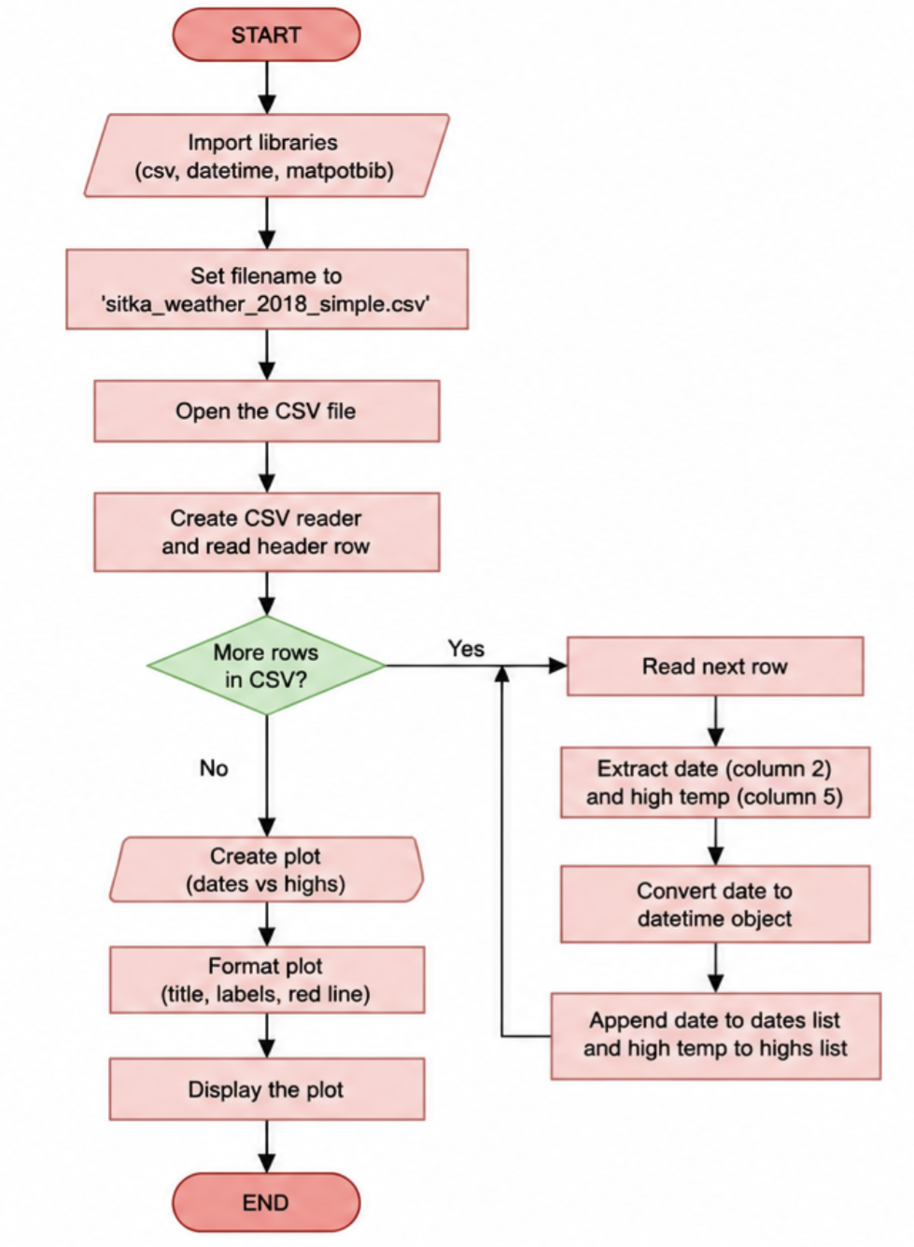

Revised flowchart based off of adjusted python script.
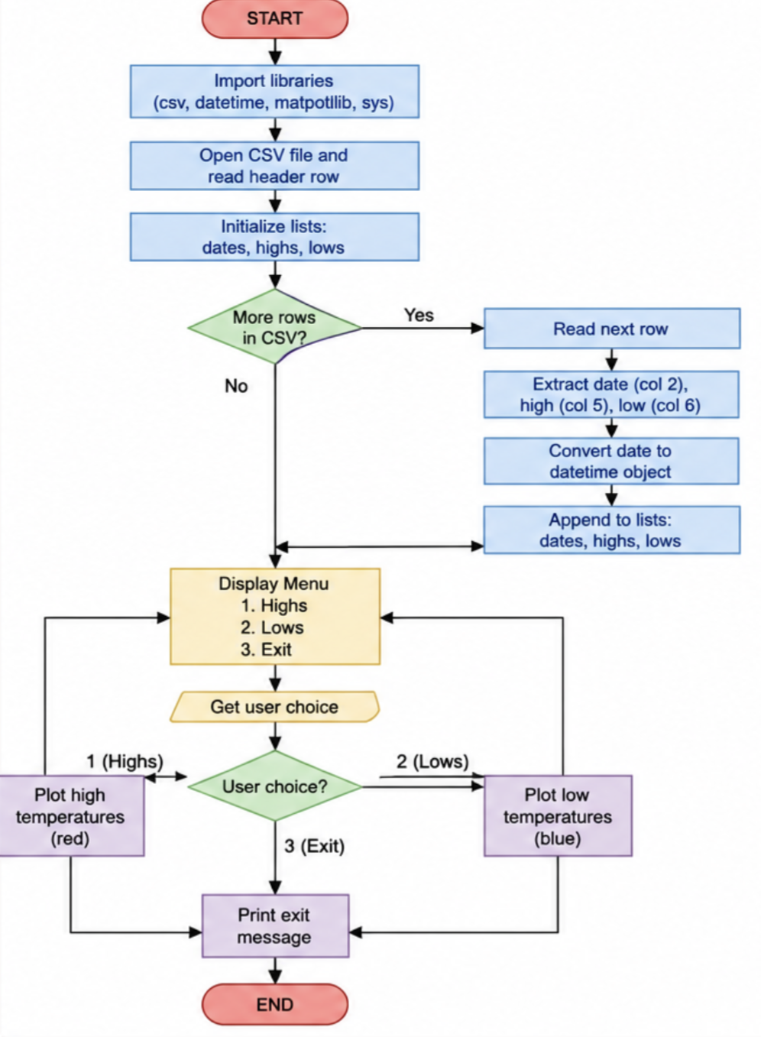

Revised Flowchart

The updated flowchart loads dates, highs, and lows, displays a menu, plots high temperatures in red, plots low temperatures in blue, loops until the user exits, and prints an exit message.

