https://github.com/WillJTools/csd-340/

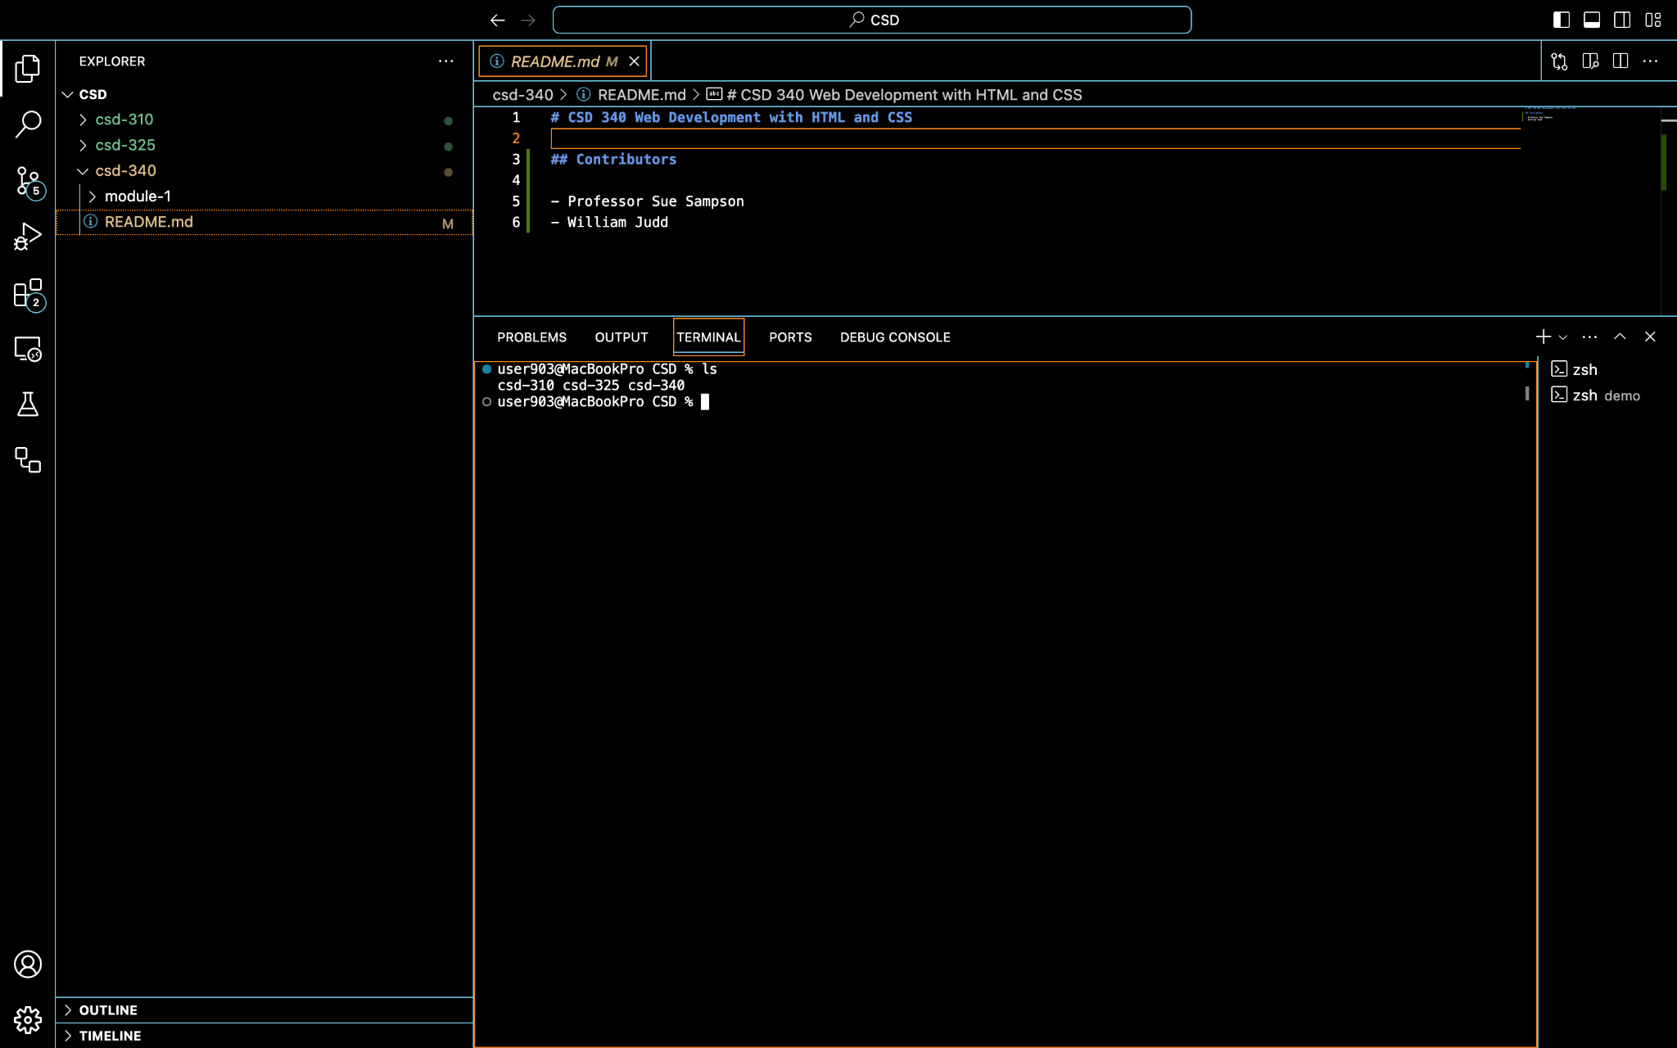
Screenshot 1 showing local directory structure

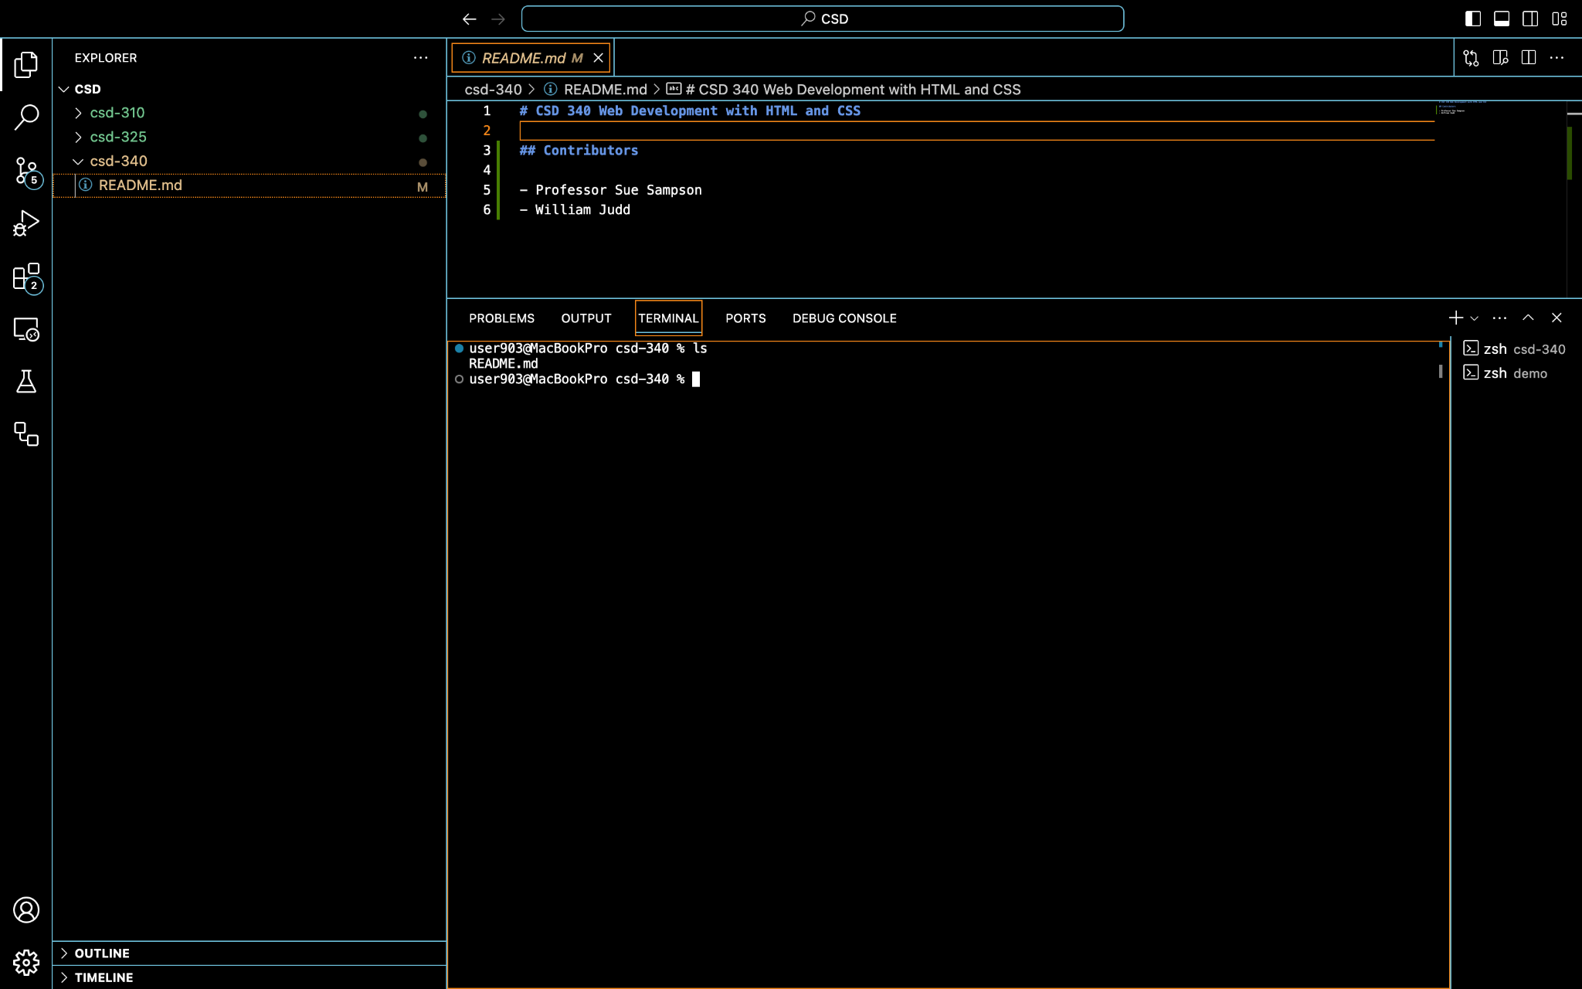
Screenshot 2 showing README.md

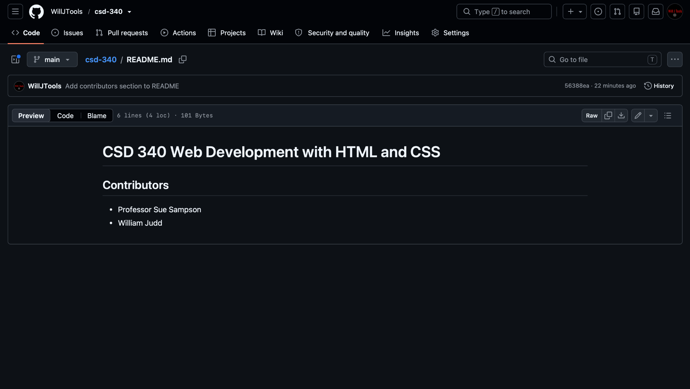
Screenshot 3 showing Github landing page

