William Judd
November 1, 2026
CSD420 – Advanced Java Programming
Module 2.2 Programming Assignment
GitHub repository: https://github.com/WillJTools/csd-420

Java File Input and Output
I wrote one program to save five random integers and five random doubles to a .dat file, and another to read the numbers back. Running the writer again adds another set without deleting the first.

1. Creating and reading the file
The first run saved five integers and five doubles. The reader returned the same numbers.
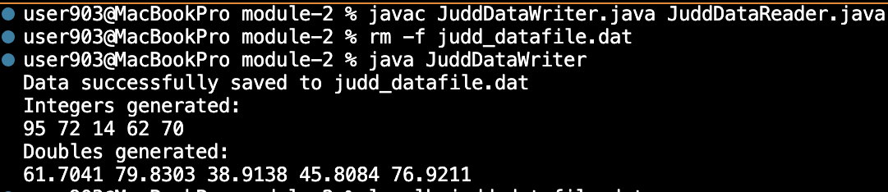
2. Appending another set
I ran the writer a second time. The file increased from 60 to 120 bytes, and the reader showed both sets of numbers.
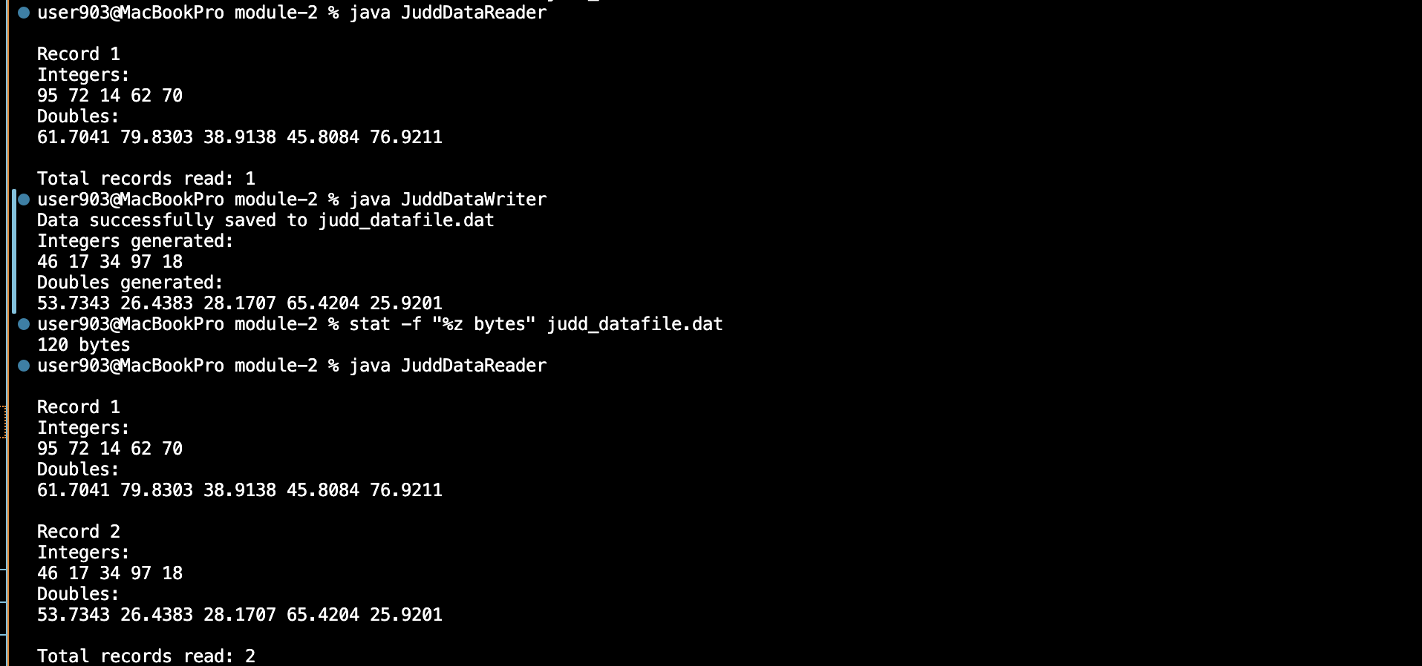

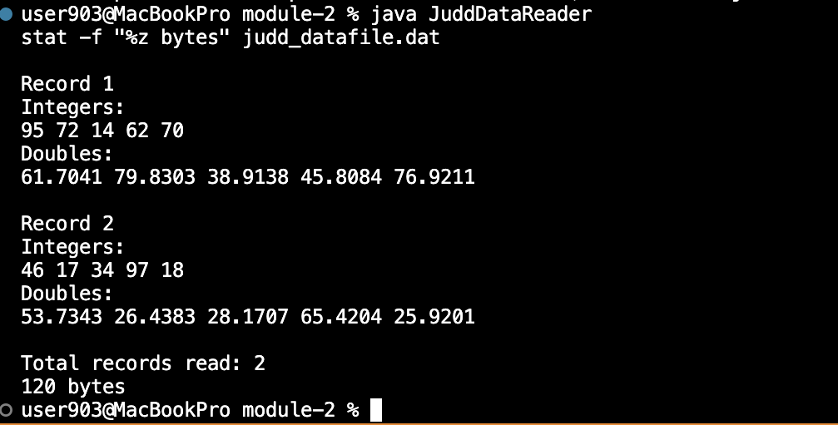
I ran the reader once more and checked the file size. Both records were still there, and the file was 120 bytes.
3. Checking the saved file
4. Missing file test
I renamed the data file and ran the reader. It displayed an error message instead of crashing. I then restored the file.
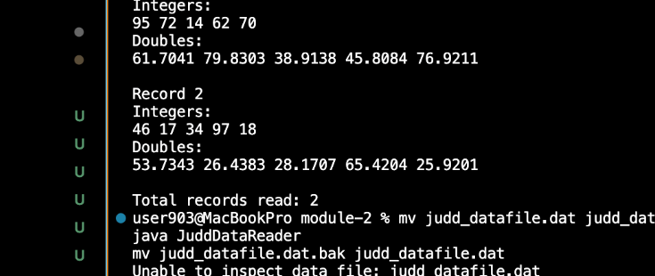
Environment: macOS; OpenJDK 25.0.4. JavaFX was used in Module 1.3; these programs use standard Java.

