**Billions of dollars of new developments are springing up in NYC flood zones**

[Home](https://willjarrettdata.com/) > [Articles](https://willjarrettdata.com/articles/) > Billions of dollars of new developments are spinging up in NYC flood zones | 19/04/2021

On the bank of the creek in downtown Flushing, there is a triangle of old industrial land that lies barren and unused. Where some might see nothing but 29 acres of waste ground, a consortium of real estate developers sees a golden opportunity.

In December 2020, the consortium’s plan for a multi-billion dollar development got the green light from New York City Council. They promise to bring housing, office space, shops, and access to the waterfront for thousands of people. But the scheme has met stubborn opposition from some locals – in part because the new development sits squarely within the flood zone and may be at risk of inundation if another storm like Hurricane Sandy hits the city.

This pattern has been repeated across New York City over the past eight years. In areas that were not long ago inundated by Sandy, developers have been building massive housing estates and offices. While these developments must incorporate flood resiliency measures by law, some experts claim that they are doing the bare minimum and putting homes at risk. The risk is only set to increase as climate change causes sea levels to rise and the city’s floodplains grow.

“This development is a colossal missed opportunity,” said Thomas Devaney, Senior Director of Land Use and Planning at the Municipal Art Society (MAS), a New York City advocacy group for community-focused urban design. MAS has opposed the project for a number of reasons, including its lackluster flood resilience plans. In a [statement](https://www.mas.org/news/comments-flushing-waterfront-plan/), they noted that “while the project meets the basic resiliency requirements for shoreline stabilization, building design, stormwater infrastructure, and environmental clean-up, it lacks an innovative vision.”

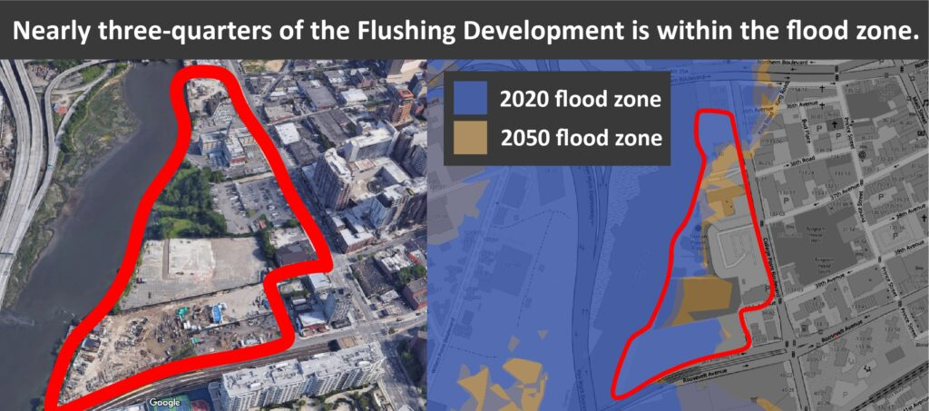Most of the development is already within 2020's hundred-year-flood zone. Even more will be exposed by 2050.

The Waterfront Alliance, a group that promotes strong flood resilience measures, approached the consortium with [recommendations](http://wedg.waterfrontalliance.org/) for improving the development’s flood defenses – for instance, by reintroducing wetlands as a natural flood barrier or including more open space in the designs. None of their ideas were accepted. Instead, a promenade will be built along the waterline.

“It’s not like they’re doing anything illegal,” said Devaney. “They’re just doing the minimum. And the bare minimum isn’t enough.”

[Studies](https://www.nature.com/articles/s41558-020-0798-9) have shown that soft defenses like wetlands may be more effective than traditional hard defenses for mitigating flooding, especially as climate rise causes sea levels to rise. Reliance on hard defenses and a lack of open space may also have worrying implications for nearby neighborhoods – urbanization around rivers typically leads to [more extensive flooding](https://pubs.usgs.gov/fs/fs07603/), as water cannot be absorbed into tarmacked and concreted ground. This is a potentially serious problem for Flushing, as [data](https://waterfrontalliance.org/what-we-do/harbor-scorecard/#your-scorecard) suggests that 37% of its inhabitants are already economically and socially vulnerable to floods.

Elsewhere in the city, luxury waterfront apartments are already facing problems. In Brooklyn, areas just outside  
apartment complex “The Greenpoint” have struggled with regular flooding for years.

“This situation drives me crazy,” reads one comment on the [Greenpointers Instagram page](https://www.instagram.com/greenpointers/). “The price you pay for waterside property,” reads another.

Despite the issues, building in flood zones is not slowing down. A [report](https://comptroller.nyc.gov/reports/safeguarding-our-shores-protecting-new-york-citys-coastal-communities-from-climate-change/) from the Comptroller’s Office found that, over the last ten years, the value of property within the city’s flood zone skyrocketed 76% to over $101 billion. Queens saw the biggest increase, with a staggering 128% increase in exposed property value. These rises are in large part down to new developments.

At the same time, the city is dragging its feet in spending money on resilience measures. Seven years after Sandy, only a little over half of the money set aside for resilience measures had been spent, and it is unclear if progress is improving.

“The city continues to consider many of the recommendations made in the report,” said a spokesperson for the Comptroller’s Office. But key recommendations like returning at-risk areas to wetlands and adding a surcharge to flood insurance to pay for resiliency have yet to be instituted.

Even properties that the city bought out after Sandy due to their extreme flood risk can be redeveloped by private parties under current rules, encouraging more development in areas previously devastated by floods. “By promoting re-development on these properties, the City potentially stands to lose out on substantial resiliency benefits that could be realized by returning bought-out plots to wetlands or other forms of green infrastructure,” the report notes.

Analysis of buildings within the flood zones reveals another looming issue; although buildings within the current flood zone are required to include flood resilience measures, the flood zones are set to increase significantly over the coming years due to rising sea levels. Data from the [Mayor’s Office for Sustainability](https://data.cityofnewyork.us/Environment/Sea-Level-Rise-Maps-2020s-100-year-Floodplain-/ezfn-5dsb) and the [Department of Information Technology & Telecommunications](https://data.cityofnewyork.us/Housing-Development/Building-Footprints/nqwf-w8eh) shows that around 80 thousand buildings now sit within the flood zone, and more than 125 thousand will be exposed by the 2050s. That will mean nearly one in ten of the city’s residents living in jeopardy. And the buildings further inland are likely to be less well prepared for floods.

For instance, luxury apartments that once sat comfortably outside of danger are quickly becoming exposed. Riverwalk Crossing, a block of expensive apartments on Roosevelt Island, is not yet in the flood zone – but by the 2050s, it will be, according to predictions from FEMA.

“Our property is currently in the area of minimal flood hazard and we were not affected during hurricane Sandy,” said Lisa Asari, a realtor for Riverwalk Crossing. She added that she was unaware of any flood resilience measures incorporated into the building.

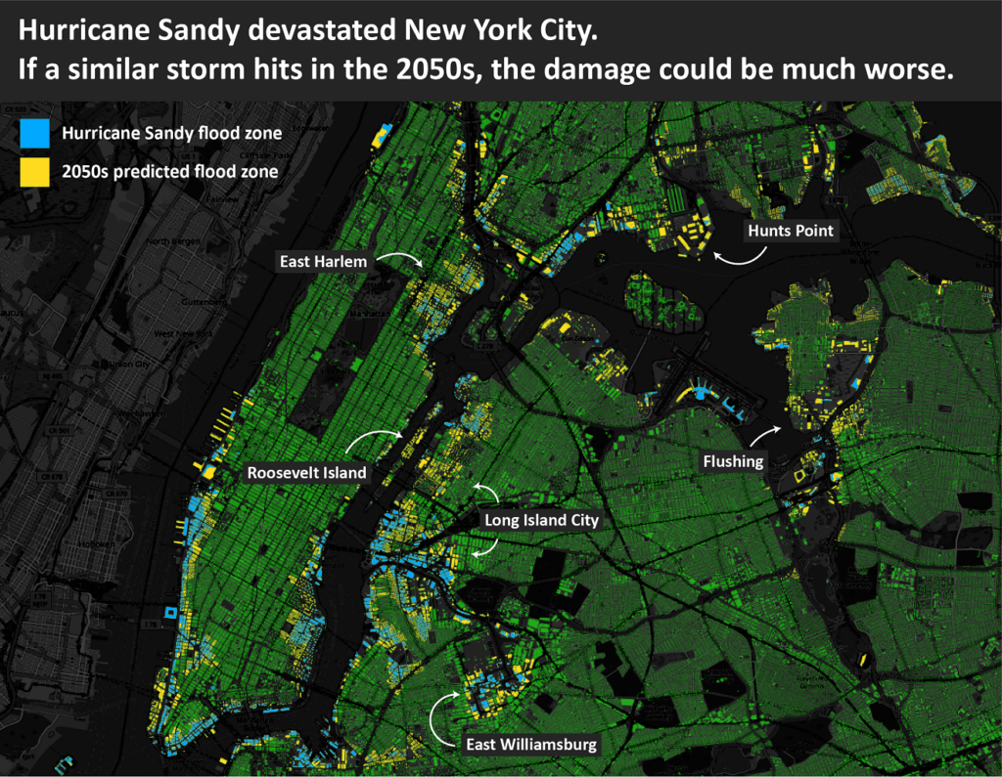A hundred-year-storm hitting in the 2050s would lead to considerably more flood damage than the same storm today.

The city has recently attempted to combat the rising threat from flooding through [policy](https://www1.nyc.gov/assets/planning/download/pdf/plans-studies/flood-resiliency-update/project-description.pdf). In March 2021, they widened the zone in which buildings can be retrofitted to be resilient to floods (for example, by putting electrical equipment on the roof or installing waterproof panels on the first floor). But the measures are optional, and it remains to be seen how widely they are taken up.

In the meantime, the city has resolved that regardless of the increasing risk, curtailing development or giving up land is not an option for New York City. “With such a vast and populous area subject to varied risks of flooding,” reads the recent zoning legislation, “it is evident that the city cannot simply retreat from the entire coastline.”

Devaney agrees that building is sure to continue. “Waterfront development is more popular than ever,” he said. “It’s not going to stop any time soon.”

—

Photo credit [Noah Negishi](https://unsplash.com/photos/inbHwAgYDI0)