|  |  |  |
| --- | --- | --- |
|  | **Rochester Institute of Technology**  **Golisano College of Computing and Information Sciences**  **School of Interactive Games and Media**  **2145 Golisano Hall – (585) 475-7680** |  |

**Data Structures & Algorithms for Games & Simulation II**

**IGME 309**

**First exam – Practical (version f)**

I’ve included a solution under the _Binary folder. Please take a look at that before continuing reading this document.

Right out of the box you will begin with this:

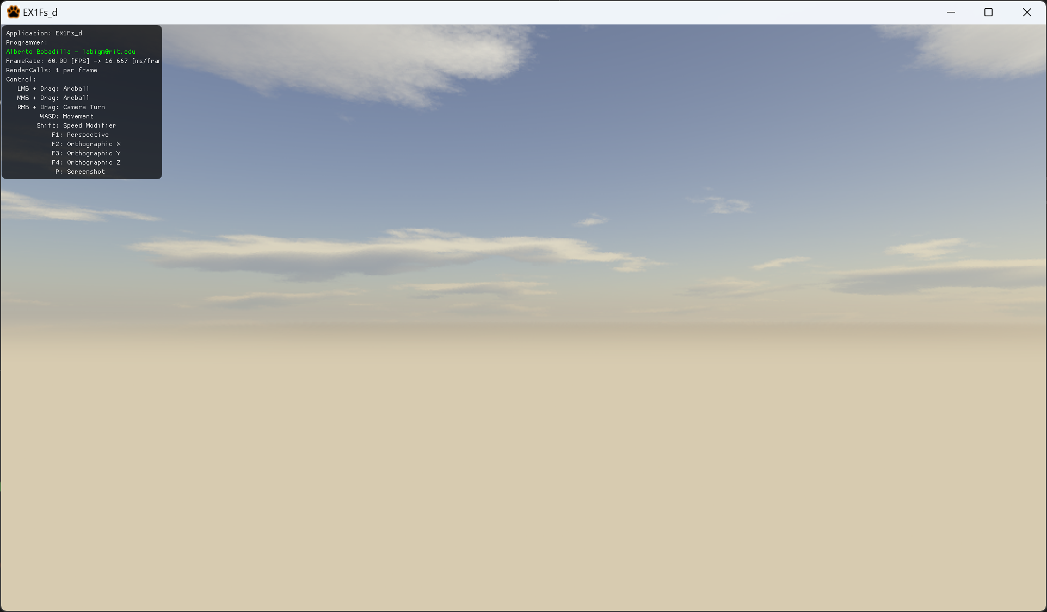

You are working on an app that will display a cylinder model that can be dynamically generated and automatically increases its subdivision by one every second.

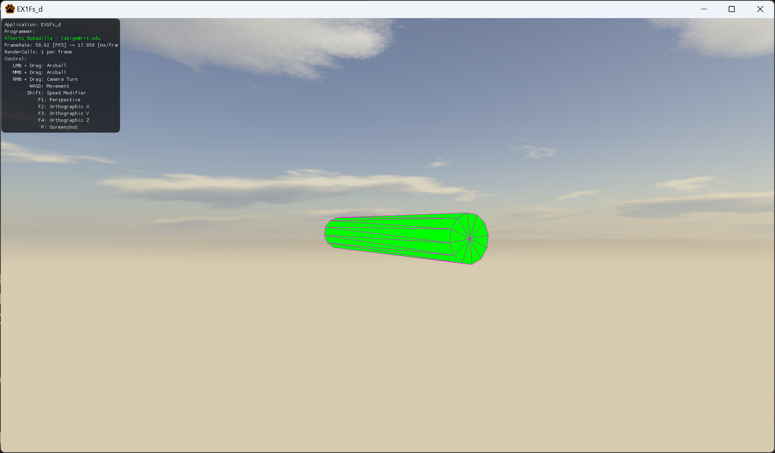

Incrementing its subdivisions each second happens in the start code, so there is no need to figure out how.

From the starter code there are some things you need to do:

Modify the GenerateWave method under MyMesh.cpp to generate the required shape, its arguments are as follow:

void GenerateWave(float a_fCircleRadius, int a_nSubdivisionsCircle, float a_fLenght, int a_nSubdivisionsLenght, vector3 a_v3Color);

float a_fCircleRadius Radius of the circle that makes the caps

int a_nSubdivisionsCircle Subdivision of the circle that makes the caps

float a_fLenght Lenght of the shape

int a_nSubdivisionsLenght Subdivisions of the length of the shape

vector3 a_v3Color Color of the shape

The reason this method is called GenerateWave instead of GenerateCylinder is because there is chance for extra credit. This will be explained below.

When you submit, the only file I need, UNZIPPED is the MyMesh.cpp file. Do not push this code to your repository either.

Tips

1. Your files need to compile, if the code does not compile it gets an automatic 0, its better for you to comment the faulty lines and receive partial credit than no credit at all.
2. You are allowed to add more variables and methods as needed. But you will **only submit MyMesh.cpp** if you are adding more variables make sure you are giving me all the files I need to grade. (i.e. if you make a helper method I need the MyMesh.h file or wherever you created new code)
3. Memory is handled for you unless you allocate something on the heap.
4. As usual middle or left clicking will let you rotate the object.
5. The only method you *need* to modify is:

MyMesh.cpp

* + - GenerateWave(…)

You will be graded as follows (all of them assume you are generating the shape dynamically, meaning the subdivision level will change):

25% (up to) if you can generate a circle facing front (not back).

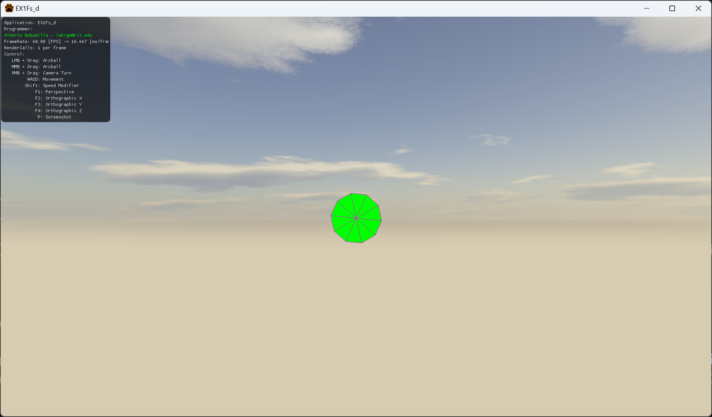

50% (up to) if you can generate a circle facing either left or right.

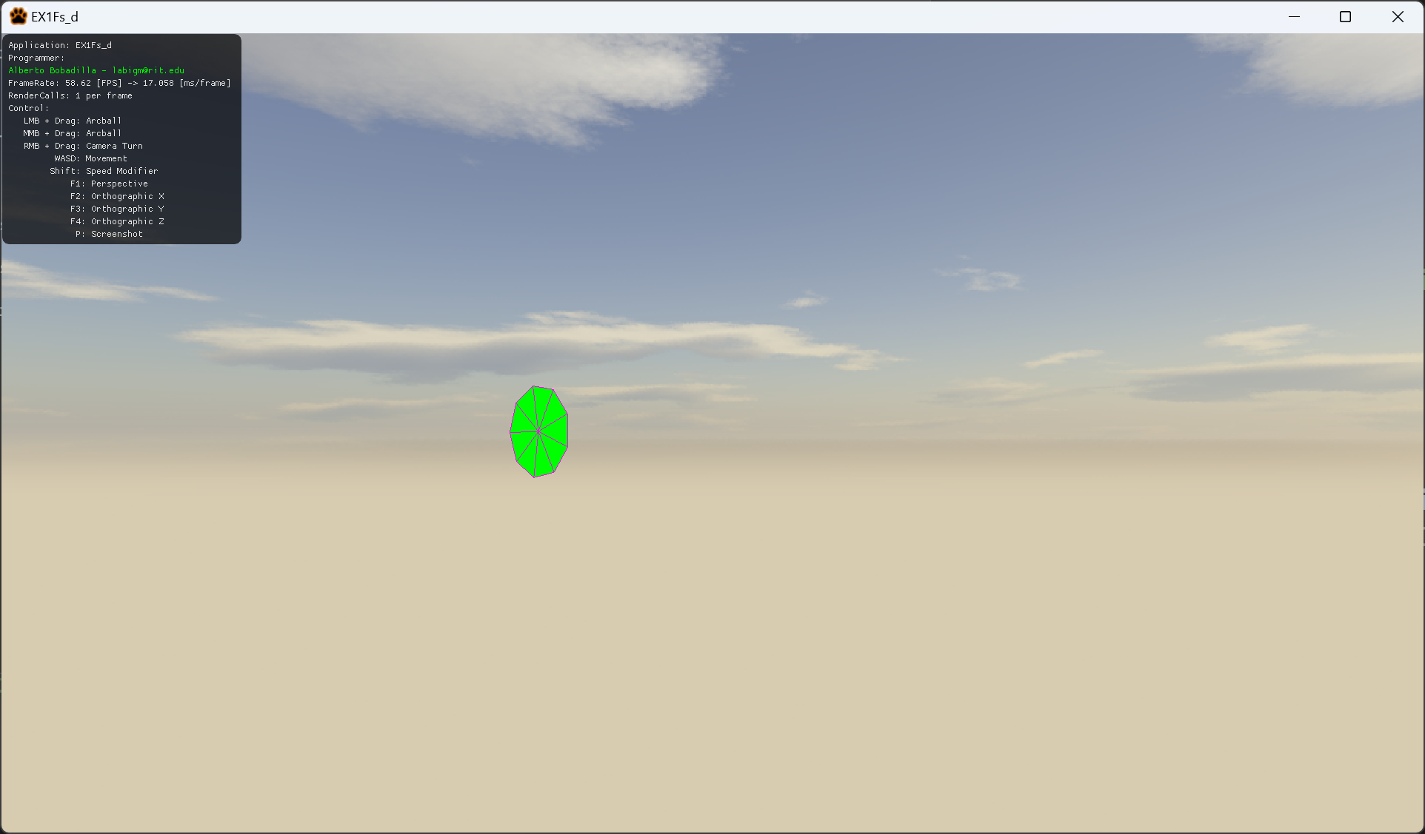

75% (up to) draw one circle facing left and one facing right center at the origin with length space in between them

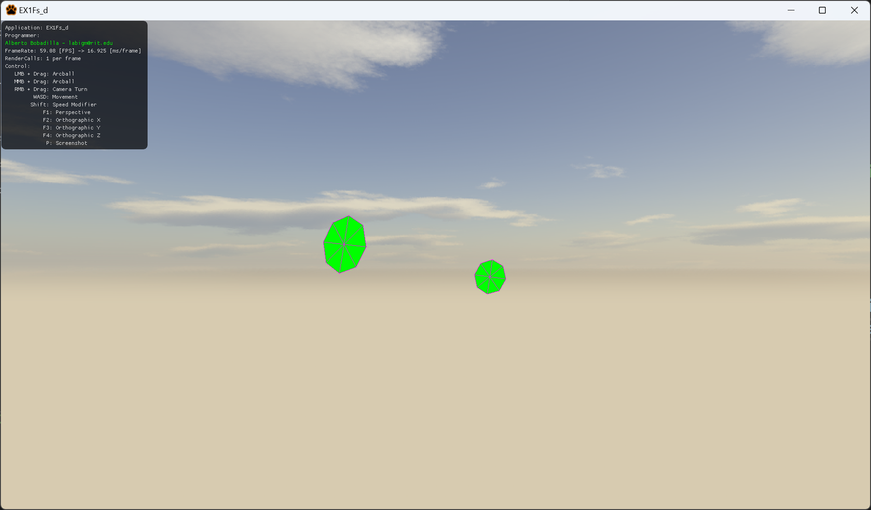

(note, as you may be aware, if one of them is facing the opposite direction I cannot have them both on the same screenshot, thus I reversed it for demonstration purposes, they have to be facing in opposite directions, if they are facing the same way as in the screen shot it is 60%)

**100%** (up to) draw one circle facing left and one facing right center at the origin and have them be connected by side faces

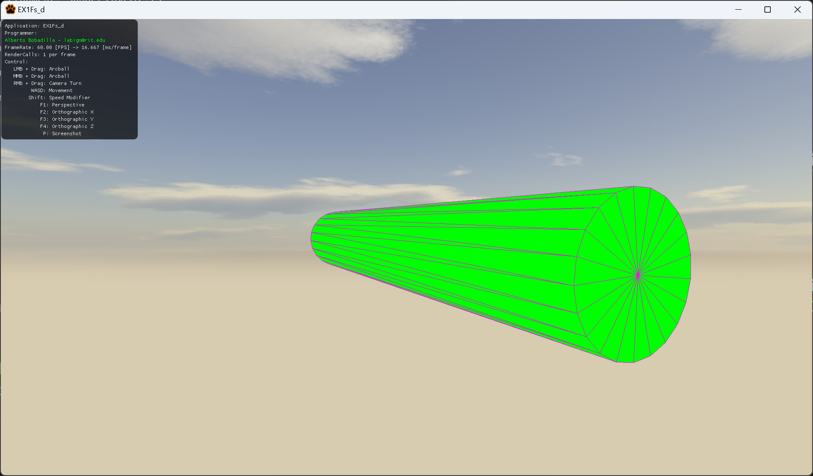

Deductions will happen as follows (no more than 100% deductions can happen):

-100% your code does not compile

-100% (up to) your code does not generate the shape

-20% for each argument that is hardcoded to make your shape work

-20% you submit more than the single unzipped MyMesh.cpp file (unless you really needed to include more files for a reason)

***Submit to the dropbox labeled Exam 1 –Practical***

The required submission asks only for MyMesh.cpp NOT ZIPPED, **not the whole solution** or project, it should be no larger than 50kb, if you are using extra files for creating variables and such, please include those files as well, not zipped.

After you submit your file it is your responsibility to download your submission and make it is what you worked on and not the starter code, **it has happened to other students before, do not let it happen to you.**

**EXTRA CREDIT**

50pts (up to) draw n cones (with no caps, inverted faces are ok) whose centers are the origin and all are a_nSubdivisionLenght separated from each other.

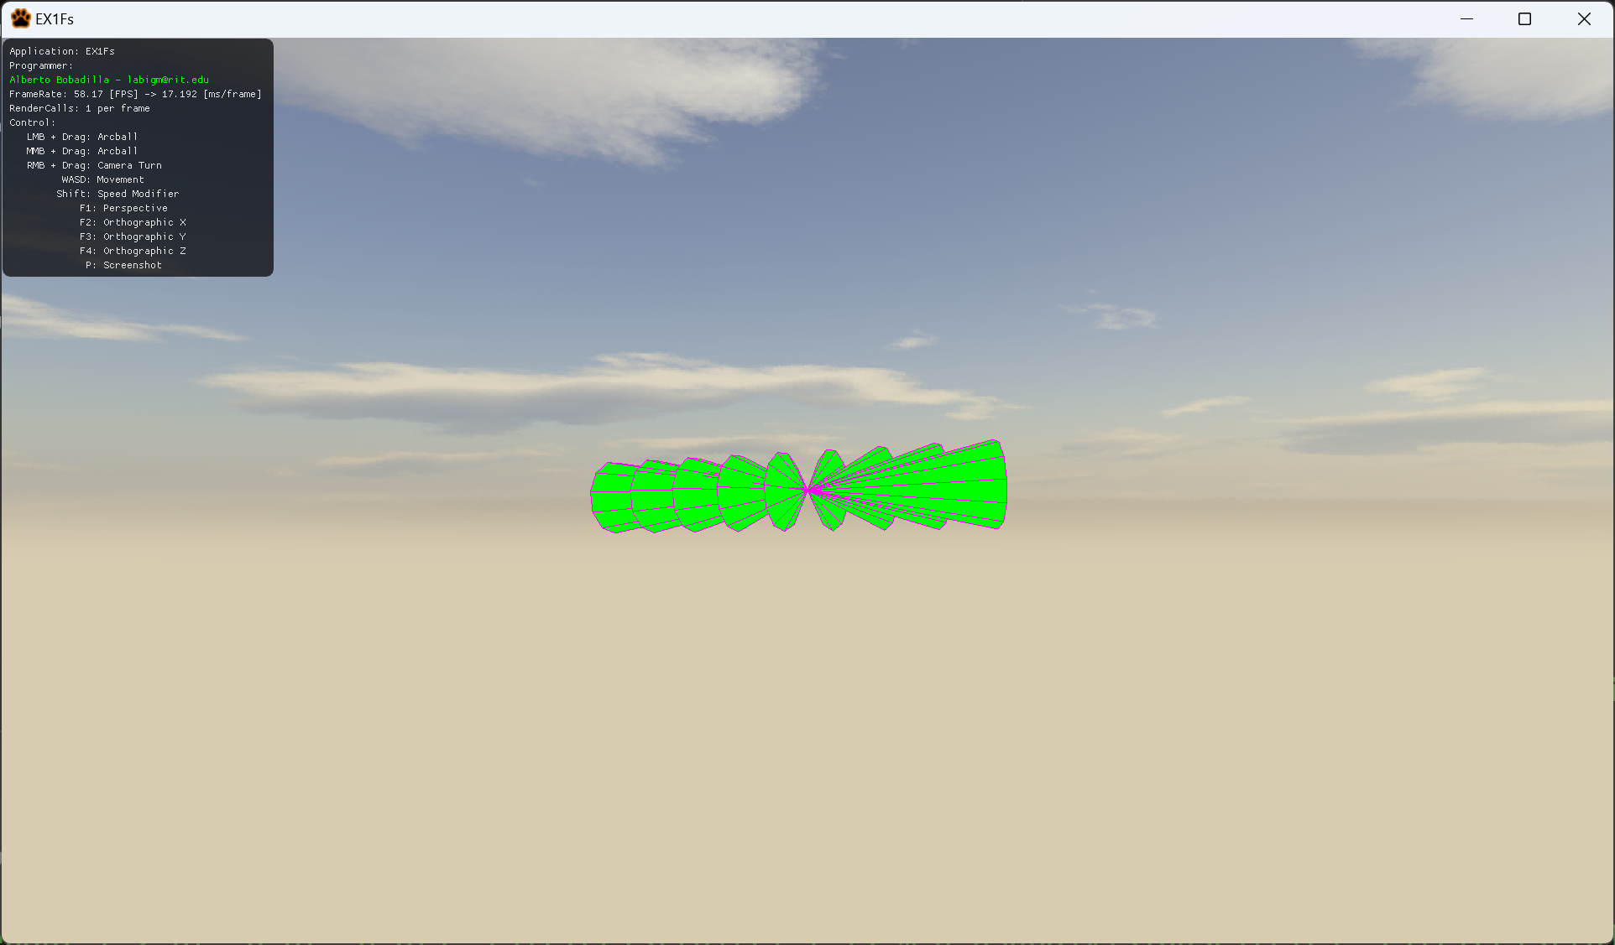

100pts (up to) draw a cylinder with multiple subdivision levels on the height as in the example

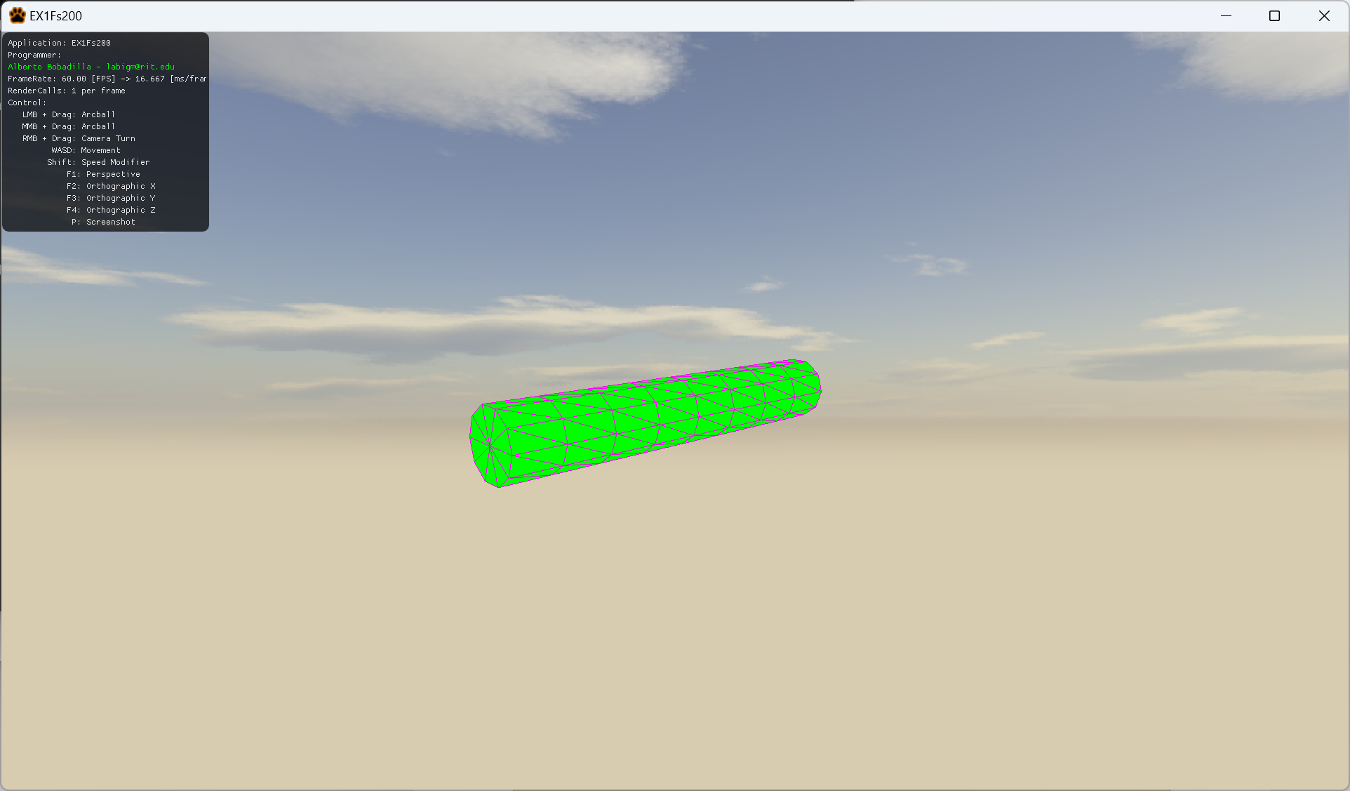

120pts (up to) draw a cylinder with multiple subdivision levels on the height as in the example, displayed as a sine wave, each subdivision will make it look closer to the wave.

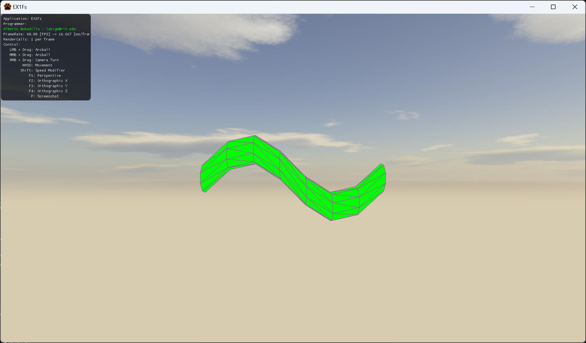

150 (up to) make all the circles oriented in such a way that the angle does not make it lose volume as if it was a spline tube, no image or binary example provided.