SmartSim - Database Design
FIT4002 • System Database Design
This document describes the implemented SmartSim database design, including its PostgreSQL schema, entity relationships, JSONB storage model, student simulation persistence, access patterns, security, and key design trade-offs. It is based on the repository analysis supplied for the project.

1. Database Overview
SmartSim uses a managed PostgreSQL database hosted by Supabase. The design is hybrid: stable identity, membership and project structures are relational, while variable spreadsheet, canvas and student-state data is stored as JSONB. Database access is backend-only through the Express API and the Supabase JavaScript client.
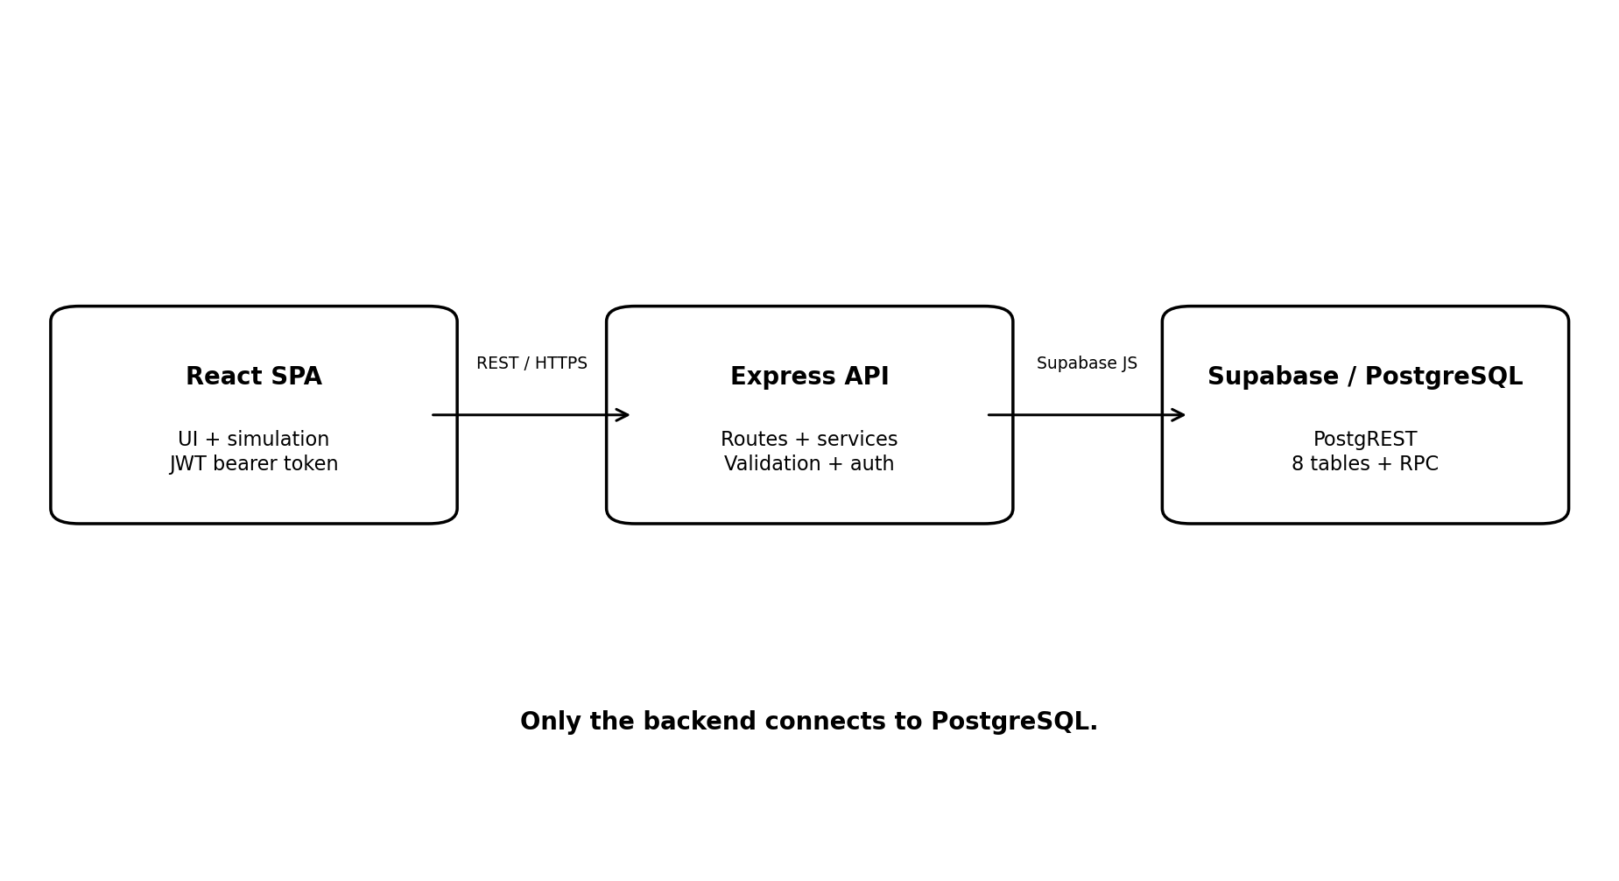
Aspect | Implemented design
Database | PostgreSQL on Supabase
Access | Backend-only via @supabase/supabase-js / PostgREST
ORM | None; Supabase query builder + one PostgreSQL RPC
Model | Relational core + JSONB payloads
Authentication | Custom JWT + bcrypt, not Supabase Auth
Database objects | 8 tables + 1 RPC function

2. Core Database Schema
The schema contains eight tables. The main entities and their responsibilities are:
Table | Purpose | Key data
organisations | Tenancy root | id, unique name, created_at
users | Application accounts | username, email, bcrypt password_hash, role, organisation_id
projects | Teacher-authored simulations | created_by, organisation_id, visibility, excel_data JSONB
project_participants | Project enrolment junction | project_id, user_id, role, max_attempts, attempts_used
project_pages | Teacher-designed canvas pages | project_id, sort_order, elements JSONB
student_simulation_state | Current per-student, per-attempt state | project_id, user_id, attempt_number, input_values JSONB, current_page_id
project_results | Completed/saved submissions | project_id, user_id, final_state JSONB, completed_at
simulation_progress | Legacy saved state | project_id, user_id, state JSONB

3. Entity Relationship Design
Organisations contain users and projects. Projects are authored by a user, contain pages, and have project participants. Users can participate in many projects through the project_participants junction table. Student simulation state is associated with a project, user and optionally the current project page.
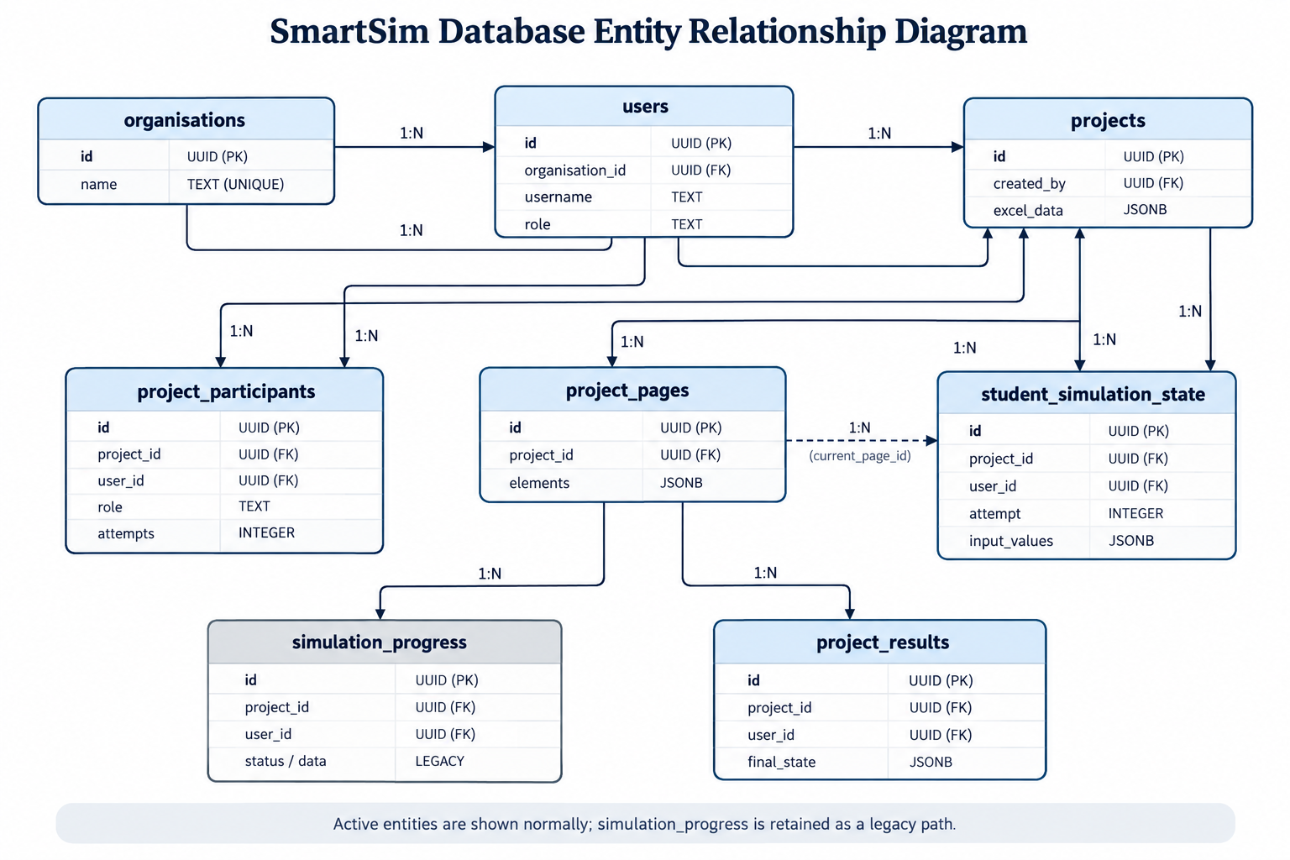

4. Relationships and Integrity
Relationship | Cardinality | Implementation
Organisation → Users | 1 : many | users.organisation_id
Organisation → Projects | 1 : many | projects.organisation_id
User → Projects | 1 : many | projects.created_by
Projects ↔ Users | many : many | project_participants
Project → Project Pages | 1 : many | project_pages.project_id
Project/User → Student State | 1 : many per attempt | unique project_id + user_id + attempt_number
Project Page → Student State | 1 : many | current_page_id, nullable
Project/User → Results | 1 : many | project_results
PostgreSQL constraints provide primary-key, foreign-key, unique, CHECK and NOT NULL integrity. Cascading deletes are used for project/user dependent records such as participants, pages, student state, progress and results. Some relationships, including current_page_id and users.organisation_id, do not cascade.

5. JSONB and Hybrid Data Model
JSONB is used where the data structure is inherently variable. This avoids creating a database row for every Excel cell or every visual canvas property while retaining relational integrity for core entities.
JSONB field | Contents | Reason
projects.excel_data | cells, sheets, multiSheet, inputCells, outputCells and dependencies | Workbook structure varies by uploaded spreadsheet
project_pages.elements | Canvas elements and type-specific properties | Designer layouts are variable
student_simulation_state.input_values | Per-page cell-value overrides | Student state is variable and user-specific
simulation_progress.state | Legacy arbitrary saved state | Legacy persistence model
project_results.final_state | Submission snapshot | Stores completed simulation state

6. Excel Workbook Storage
An uploaded workbook is processed by the backend before it reaches the database. SheetJS reads the workbook, while worksheet XML parsing recovers formulas that may not have cached values. Cells are normalised into a single-sheet or qualified multi-sheet representation and classified into input/output structures. The resulting object is stored as projects.excel_data; individual cells are not stored in separate relational rows.
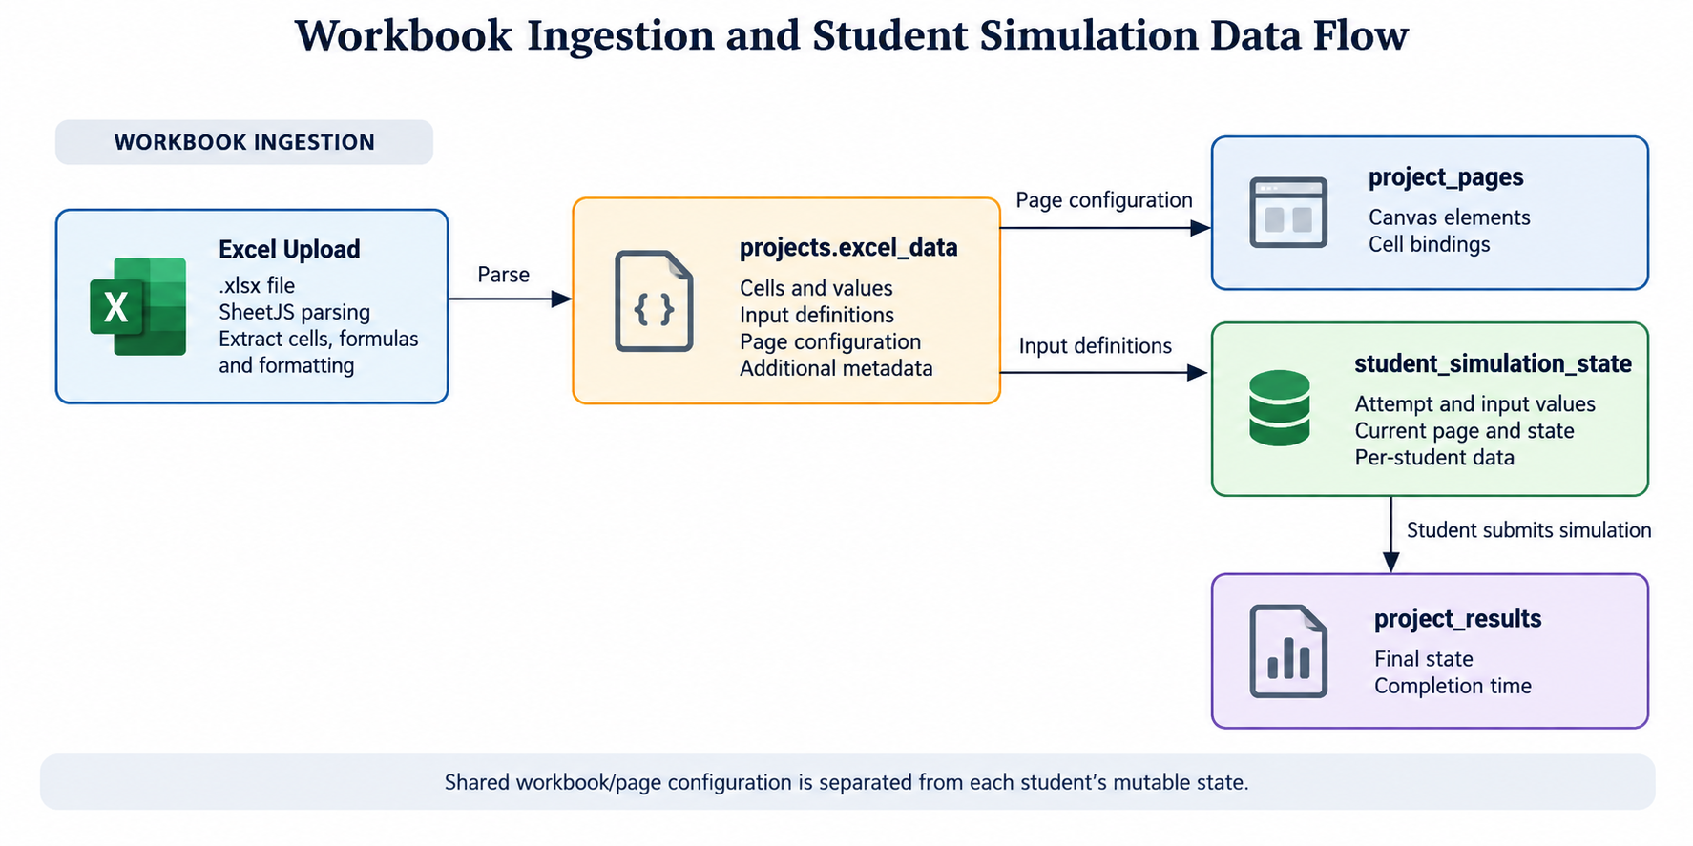
The Excel sheets themselves do not automatically become project pages. Workbook sheets are stored as workbook data, while project_pages are teacher-created visual canvases that bind UI elements to workbook cells.

7. Student Simulation State
The current persistence model separates shared simulation configuration from individual student state. The project and its Excel/page configuration are shared, while each student's input values, current page, completion status and attempt number are stored separately.
Shared project data | Per-student data
projects.excel_data | student_simulation_state.input_values
project_pages.elements | student_simulation_state.current_page_id
Workbook formulas/dependencies | student_simulation_state.attempt_number
Canvas layout | student_simulation_state.is_completed
 | project_results.final_state
Student input updates are persisted through the student-state API, with the frontend debouncing writes. On completion, the state is marked completed, the participant attempt count is incremented, and a result record is inserted.

8. Authentication and User Data
SmartSim implements custom authentication in the Express backend. User passwords are stored as bcrypt hashes. JWTs contain the user ID and are verified by backend middleware. Project access is then determined using project ownership and project-participant membership rather than direct database access from the frontend.
Database roles are organisation, admin, teacher and student. Project participants separately use teacher/student membership roles. The organisation relationship is nullable for users but required when creating projects. Removing a student from a project deletes both their membership row and their users row, so the username is released and can be reused.

9. Database Access Patterns
Application queries are performed through the Supabase query builder. Common patterns include UUID point lookups, foreign-key filtering, project/page retrieval, participant membership queries, student-state retrieval and updates, and result insertion. There are no application-level raw SQL queries apart from the attempt-increment RPC.
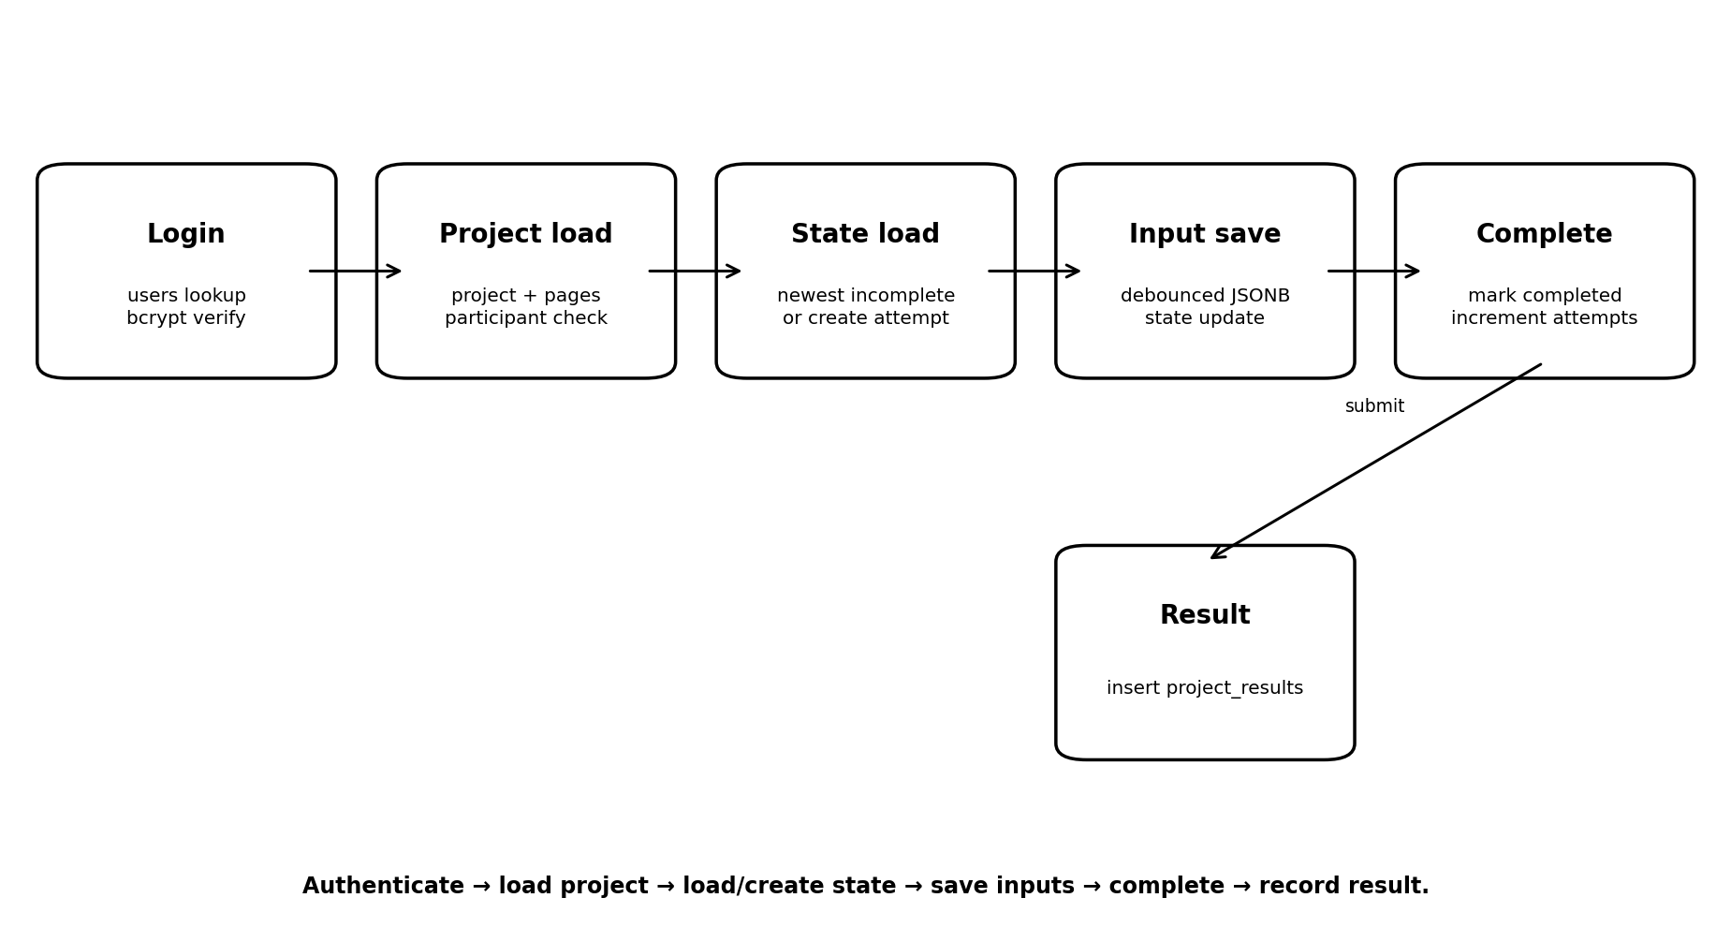

10. Indexing and Performance
The migrations define indexes for organisation, project ownership, participant lookups, progress, results, pages and student state. Unique constraints also provide useful composite indexes. No GIN indexes exist for JSONB, which is consistent with the current access pattern because JSONB is retrieved as a whole rather than queried internally.
The main scalability consideration is workbook size: excel_data is stored inline on the project row and the full workbook cell graph is retrieved for student simulations. Formula calculation is performed client-side, reducing database computation and allowing many students to calculate independently.

11. Security and Data Integrity
Implemented protections include bcrypt password hashing, JWT middleware, backend-only database access, foreign keys, unique constraints, CHECK constraints and creator-based project authorisation.
The repository analysis also identifies important limitations: Row Level Security is not configured; the database client uses a Supabase service-role key; student-state mutation endpoints do not verify that a supplied stateId belongs to the authenticated user; signup is unauthenticated and accepts organisation/role values; CORS is unrestricted; and JWT_SECRET has an insecure fallback if the environment variable is missing.

12. Legacy Structures
simulation_progress and the /simulations API remain in the backend but are no longer referenced by the frontend. They represent the earlier persistence approach and should be consolidated once it is confirmed that no external clients depend on them. project_results is still active but is written by both legacy and newer completion paths, producing different final_state shapes. This should also be unified.

13. Key Database Design Decisions
Decision | Benefit | Trade-off
PostgreSQL + Supabase | Managed relational database with simple JS access | Vendor coupling and powerful service-role credential
Custom JWT + bcrypt | Control over application auth and roles | No Supabase Auth/RLS integration; secret management is manual
Relational core | Strong FK/unique integrity for identity and membership | More relational service code
JSONB for variable data | Handles arbitrary workbooks and layouts efficiently | Less schema validation and large inline payloads
Separate student state | Isolates concurrent student changes from shared configuration | Requires coordinated project/page/state retrieval
Legacy compatibility | Allows migration without immediately breaking older paths | Creates parallel data and result flows

14. Recommended Improvements
- Consolidate the legacy simulation_progress and /simulations path after checking for external consumers.
- Unify project_results completion and final_state formats.
- Verify student-state ownership on every state mutation using both stateId and authenticated user ID.
- Move signup/organisation assignment behind appropriate administrative authorisation.
- Remove the JWT secret fallback and require a configured production secret.
- Restrict CORS to known frontend origins.
- Consider stronger database policies/least-privilege access if the authentication model is revised.
- Consider external/object storage for very large workbook payloads if workbook size becomes a scalability issue.
- Add JSONB indexes only if future query requirements begin filtering inside JSONB.

15. Summary
SmartSim's database is a practical hybrid PostgreSQL design. Relational tables manage organisations, users, projects, membership, pages and results, while JSONB stores the variable structures created by Excel workbooks, the visual designer and student input state. The backend acts as the single database boundary, keeping business rules and authorisation in the Express application. The strongest design feature is the separation of shared project configuration from per-student state, while the main areas for improvement are security hardening, legacy consolidation and managing large workbook payloads.

