SmartSim - Security & Privacy
FIT4002 | Security and Privacy Design Document

1. Security Overview
SmartSim uses a React frontend, an Express API, and Supabase-hosted PostgreSQL. The frontend does not connect directly to the database; database access is performed by the backend through a Supabase service-role client. Authentication is based on bcrypt password verification and signed JWTs, while most authorisation is implemented in individual API handlers.
The current implementation provides a reasonable baseline for a university MVP, particularly for password hashing, JWT verification, backend-only database access, and creator checks on many write operations. However, several object-level authorisation gaps and exposed endpoints create significant security and privacy risks.
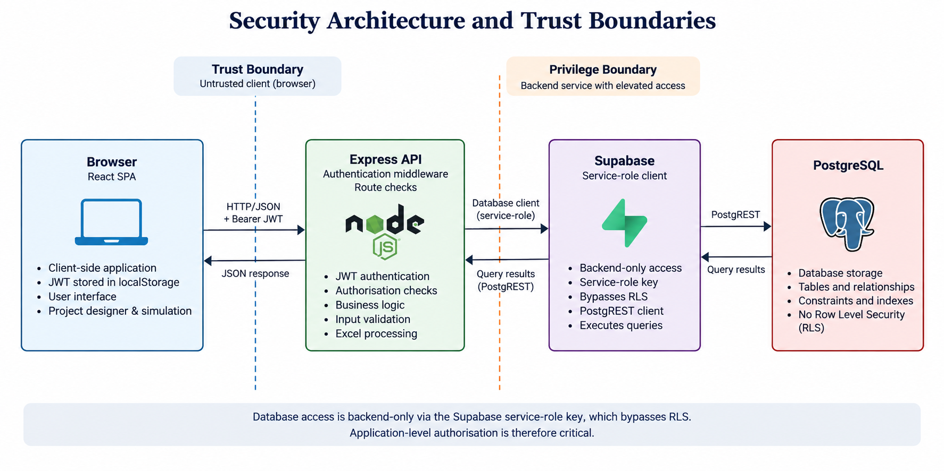

2. Authentication
- Passwords are stored as bcrypt hashes using 10 salt rounds; plaintext passwords are not persisted.
- POST /auth/login verifies the username and password, then issues a signed JWT containing the userId with a 7-day expiry.
- The authentication middleware validates the Bearer token and sets req.userId for protected routes.
- The frontend stores the JWT and returned user object in localStorage. This makes the token accessible to JavaScript running in the origin.
- Logout only removes localStorage values; issued JWTs remain valid until expiry because there is no server-side revocation.
- Signup endpoints are unauthenticated. Users can create organisations or register teacher/student accounts for a supplied organisation ID.
- JWT_SECRET is mandatory. The server refuses to start without it and rejects placeholder values.

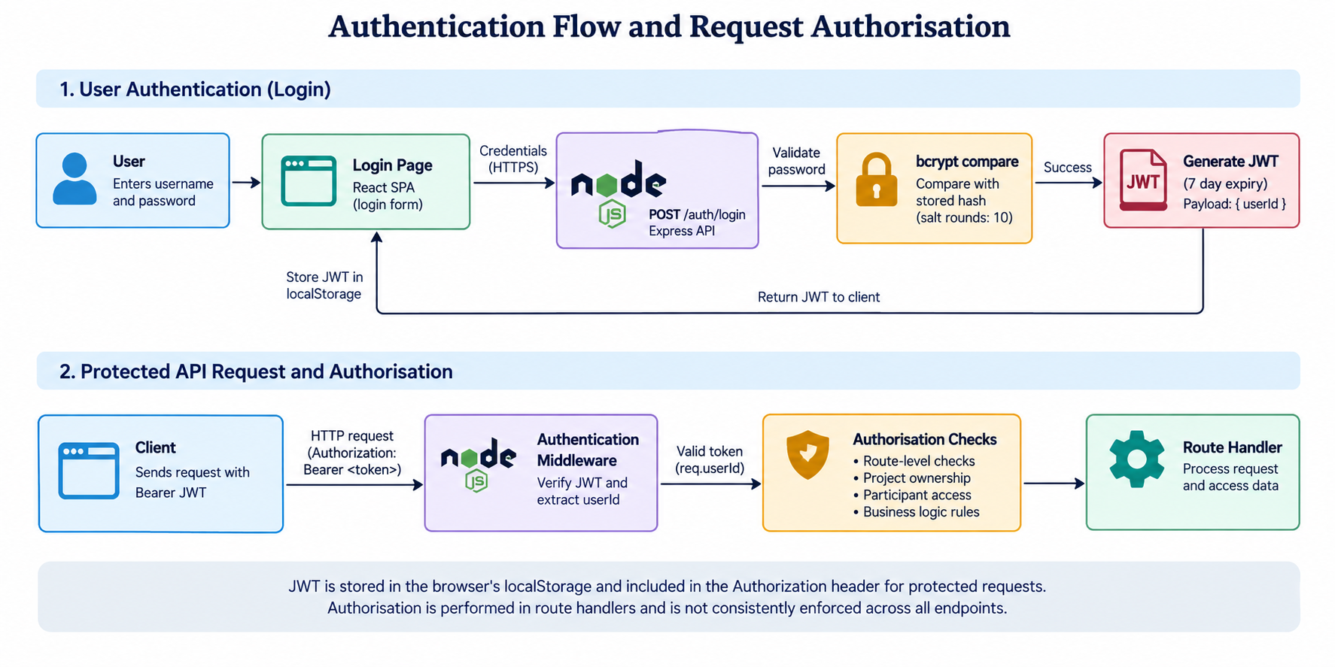

3. Authorisation & Access Control
SmartSim has roles including admin, teacher and student, but these roles are primarily used for frontend routing. Backend business routes do not consistently enforce role-based permissions.

Controls currently present
- Creator checks protect project update/delete and participant management.
- Creator checks protect project page creation, update, deletion and reordering.
- Teacher result views include creator checks, while students' own results are scoped to their user ID.
- Student state creation verifies project participation.

Important gaps
- Project, page and participant read endpoints can be accessed by an authenticated user without verifying project ownership or participation, creating an IDOR/BOLA risk.
- Student-state mutation endpoints accept a client-supplied stateId without verifying that the state belongs to the authenticated user, allowing tampering with another student's attempt.
- Some simulation write endpoints do not verify project participation before accepting submissions.
- Project/page updates spread raw request bodies into database updates, creating a mass-assignment risk.
- Frontend role checks are not a security boundary because they can be bypassed with direct API requests.
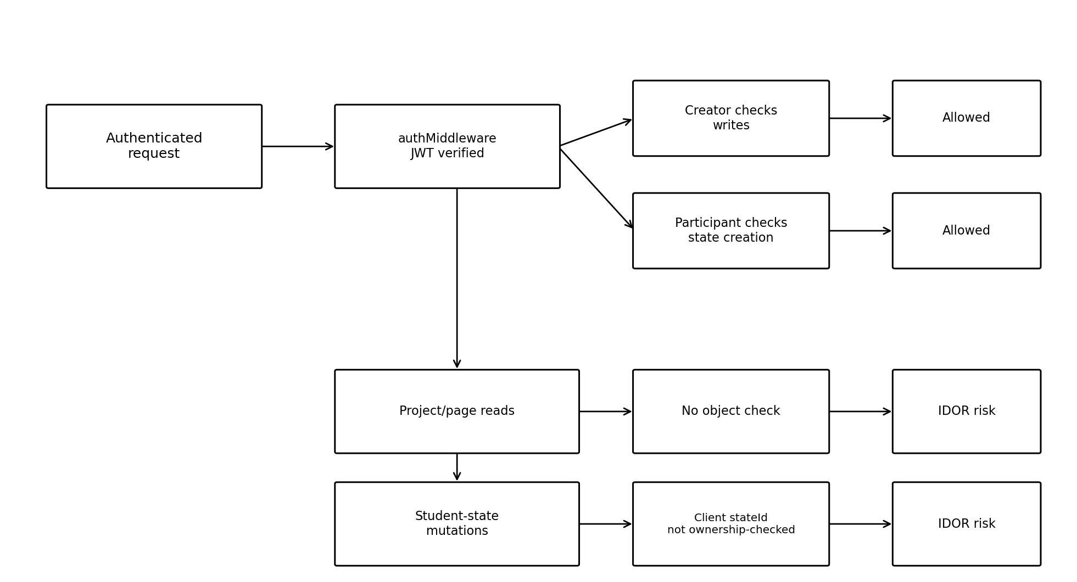

4. Database Security
- Supabase PostgreSQL is accessed exclusively through the backend.
- The backend uses a SUPABASE_SERVICE_ROLE_KEY, which has high database privileges and bypasses Row Level Security.
- No RLS policies or database GRANT-based access controls are present in the migrations reviewed.
- Database integrity is strengthened by primary keys, foreign keys, NOT NULL constraints, CHECK constraints, unique constraints and cascading deletes.
- Current Supabase query-builder access is parameterised; no evidence of string-built SQL injection was found.
Because database-level access control is absent, application-level authorisation is the primary security boundary. A flaw in a route or service can therefore expose or modify rows that the backend credential itself can access.

5. Sensitive Data & Privacy
Data | Storage | Protection | Key concern
Password hashes | PostgreSQL users.password_hash | bcrypt | Not returned by API
JWT | Browser localStorage | Signed token; not encrypted at rest | Accessible to JavaScript; no revocation
User information | PostgreSQL + authUser localStorage | No field encryption | Some information is returned by APIs
Student state/results | PostgreSQL JSONB | No field encryption | State IDOR can enable tampering
Workbook data | projects.excel_data JSONB | No field encryption | Project read IDOR can expose content
Project metadata | PostgreSQL + limited localStorage | No field encryption | Read access is not consistently authorised
The repository shows no field-level encryption, explicit retention policy, account deletion endpoint, audit trail, consent mechanism, privacy policy implementation, or data-export/DSAR mechanism. Supabase is the only external service identified in the codebase.

6. API Security
- All routes except login, signup and the student join endpoint require authentication, including /excel/upload. Authentication runs before the file is parsed.
- Input validation is minimal and generally checks presence rather than schema or range constraints.
- CORS is configured with cors() and therefore allows all origins.
- Rate limiting covers login (per account and per IP, failed attempts only), signup and student join. Helmet security headers are enabled.
- Some route handlers return error.message directly, potentially exposing internal details; authentication responses also distinguish user-not-found from invalid-password cases.
- The Express JSON parser uses its default body-size limit.
- The most significant API weaknesses are object-level authorisation gaps, rate-limited but open signup, open CORS and limited validation.

7. Excel Upload Security
Excel workbooks are untrusted input. SmartSim processes uploads in memory, extracts workbook and formula information, stores the resulting structure in JSONB, and later evaluates formulas in the browser.
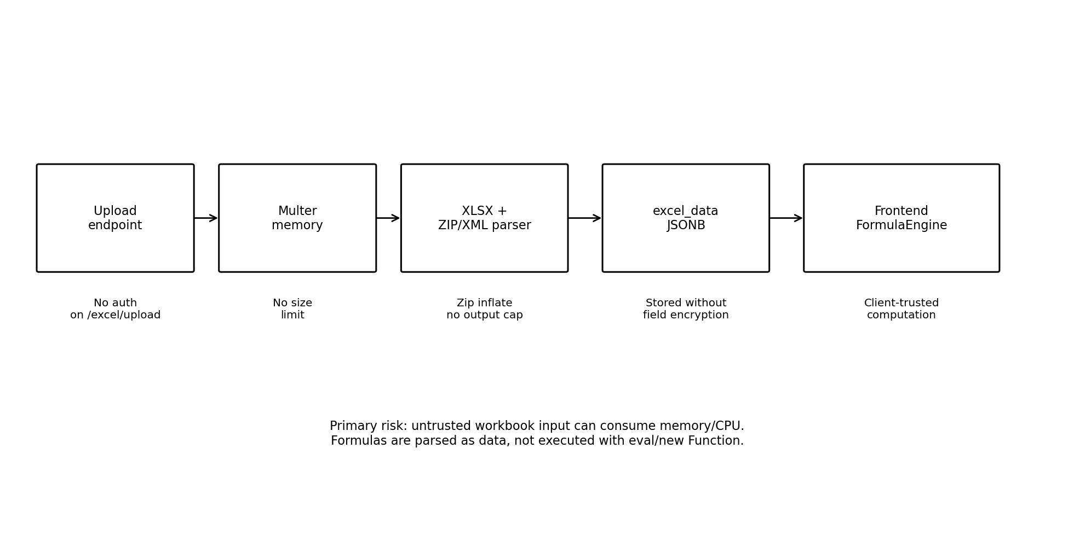
- Uploads require authentication and are capped at 10 MB (configurable). The ZIP extraction still has no decompression cap, and there is no file-type filter.
- The custom ZIP/XML extraction uses inflateRawSync without a decompression output cap, creating a potential memory-exhaustion/zip-bomb risk.
- Uploaded content is not persisted as an original file; the parsed workbook structure is stored in projects.excel_data.
- Formulas are handled as strings and evaluated by the custom client-side FormulaEngine rather than eval or new Function, reducing server-side code-execution risk.
- No macro execution was identified.

8. Frontend Security
- JWT and user information are stored in localStorage, which is accessible to JavaScript and therefore increases the impact of an XSS compromise.
- React renders interpolated workbook/user content as normal JSX; no dangerouslySetInnerHTML usage was identified.
- Client-side role and route gating is useful for user experience but cannot enforce security.
- Students can modify browser state and send direct API requests, so the backend must remain the authoritative security boundary.
- The FormulaEngine performs calculations client-side using a custom parser rather than JavaScript eval/new Function.

9. Key Security Risks
Priority | Risk | Impact | Primary mitigation
High | Project/page/participant read IDOR | Unauthorised users can read project content and participant information | Require creator or participant checks before reads
High | Student-state IDOR | Users can alter or complete another student's attempt | Verify state.user_id and project ownership before mutation
High | Insecure JWT fallback (Updated: Fixed) | Tokens could be forged if JWT_SECRET is missing | Fail startup when secret is absent
High | Unrestricted signup/default password | Unauthorised accounts and weak credentials | Restrict signup and remove default passwords
Medium | Unauthenticated/unbounded Excel upload (Updated: Partly fixed with authenticated upload and size-capped (10 MB). Decompression cap and file-type filter still outstanding. | Memory/CPU exhaustion and zip-bomb risk | Authenticate, limit size/type and cap decompression
Medium | No RLS + service-role DB access | Handler flaws can reach arbitrary rows | Use RLS/least privilege where practical
Medium | Open CORS | Any origin can interact with API using an obtained token | Allow only trusted frontend origins
Medium | Mass assignment | Creators can alter protected fields | Whitelist updateable fields
Low | localStorage JWT/no revocation | Token theft has longer-lived impact | Shorter-lived tokens and safer session storage

10. Implemented Security Controls
- bcrypt password hashing with 10 salt rounds.
- JWT authentication with signature verification and expiry.
- Authentication middleware returning 401 for missing or invalid tokens.
- Password hashes are removed from returned user objects.
- Creator/ownership checks on several project, participant, page and result operations.
- Participant validation before creating student simulation state.
- Parameterised database access through the Supabase query builder.
- Relational integrity through foreign keys, unique constraints, CHECK constraints and cascading deletes.
- Database credentials are kept in environment variables and .env files are ignored/not committed.
- Uploaded files use memory storage rather than being written to disk.

10.1. Remaining risks
- Several read routes (project, pages, student state) require login but may not check project membership (see 11.1).
- Any logged-in user, including a student, can call /excel/upload.
- No Row Level Security (the backend uses the service-role key), and CORS allows all origins.
- The default student password password123 still exists.
- xlsx has a high-severity advisory with no upstream fix; it is mitigated by authentication and the 10 MB cap.
- No privacy policy, retention policy or account-deletion endpoint.

11. Recommended Improvements

11.1. Immediate
- Fix object-level authorisation on project/page/participant reads and student-state mutations.
- Remove the JWT fallback secret and fail fast when JWT_SECRET is missing. (Done, PR #23)
- Restrict signup and remove the password123 default for automatically created students.
- Authenticate /excel/upload and add file-size, type and decompression limits. (Partly done, PR #23: authentication and a 10 MB size limit are in. Type and decompression limits are not.)
- Whitelist fields accepted by project/page update endpoints.

11.2. Medium-term
- Enable RLS and/or adopt least-privilege database access where practical.
- Restrict CORS to the deployed frontend origin.
- Add Helmet/security headers and rate limiting for authentication and upload endpoints. (Done, PR #23: Helmet, login/signup/join rate limits. Uploads are covered by the authentication requirement only.)
- Introduce request-schema validation and generic authentication error responses.
- Consider shorter-lived tokens and a revocation/session mechanism.

11.3. Future / hardening
- Introduce password policy and forced reset for automatically created accounts.
- Add security audit logging, account deletion and data-retention controls.
- Harden the custom Excel parser and cap ZIP decompression output.
- Consider stronger XSS/CSP hardening and moving away from localStorage token storage if the architecture permits.

12. Security Data Flows

12.1. Login
User → LoginPage → POST /auth/login → bcrypt password comparison → JWT signing → frontend localStorage.

12.2. Protected API request
Frontend + Bearer JWT → Express → authMiddleware → route-level authorisation → service → Supabase service-role client → PostgreSQL.

12.3. Student simulation
Student → participant check during state creation → project/pages → input updates → autosave → completion → project results. The current input/page/complete state mutations do not consistently verify ownership of the supplied state ID.

Excel upload
Teacher → authenticated project creation/upload path → Multer → XLSX/XML parsing → projects.excel_data. Uploads require authentication and are capped at 10 MB (configurable). Files are processed in memory and not written to disk.

13. Privacy & Security Assessment
SmartSim has a workable security foundation for an educational MVP, but it is not yet appropriate to treat the current implementation as production-ready. The strongest controls are password hashing, JWT verification, backend-only database access, parameterised queries and ownership checks on many write operations.
The insecure JWT fallback, unauthenticated Excel upload, missing rate limiting and missing security headers have been addressed. JWT_SECRET is now mandatory, uploads require authentication and are size-capped, login, signup and student join are rate limited, and Helmet headers are enabled. The highest-priority remaining work is object-level authorisation, because IDOR/BOLA gaps on read operations can still expose project content and student state. The next priorities are removing the default student password, adding database-level policies (Row Level Security), and restricting CORS to the deployed frontend origin. After these, stronger request validation, a decompression cap and file-type filter on uploads, and privacy lifecycle controls (retention, account deletion) should be added.

14. Evidence Scope
This document is based on the provided SmartSim security analysis, which states that its evidence base covers backend/src/**, frontend/src/**, backend/migrations/*.sql and configuration files. Claims about implemented controls and missing controls are limited to what that analysis reports as evidenced in the repository.

