SmartSim
System Architecture Document

FIT4002 - Educational Excel Simulation Platform

Architecture of the implemented system

1. Introduction

1.1 Purpose
This document describes the system architecture of SmartSim, an educational web platform that transforms Excel workbooks into interactive simulations for students. It provides a structured view of the system's components, responsibilities, communication paths, data model, security mechanisms, deployment characteristics and key architectural trade-offs.

1.2 System Overview
SmartSim allows teachers to upload Excel workbooks and transform them into interactive educational simulations. The workbook provides the underlying data and formulas for the simulation. Teachers can configure projects, organise content into multiple pages, define interactive elements and publish projects to students.
Students access published simulations, modify designated input values and observe recalculated results. A key architectural feature is that formula calculations are performed in the student's browser, providing immediate feedback without requiring a backend request for every interaction.

1.3 Scope
This document covers the implemented frontend, backend, simulation engine, Excel processing pipeline, database, authentication, authorisation, API architecture, data flows, deployment characteristics, testing and future architectural considerations. Prototype-only and unimplemented functionality is not treated as production architecture.

1.4 System Goals
- Transform static Excel workbooks into interactive educational simulations.
- Support a teacher-to-student project publishing workflow.
- Provide immediate feedback during simulation interaction.
- Persist student progress and final results.
- Separate teacher and student capabilities through role-based access.
- Maintain a simple architecture consisting primarily of one frontend, one API and one managed database.

2. Architectural Overview

2.1 Architectural Style
SmartSim uses a client-server, layered architecture. The React frontend provides the presentation and interactive simulation experience, while an Express REST API provides authentication, business operations, Excel processing and persistence. Supabase provides the hosted PostgreSQL database.
The architecture is intentionally simple rather than being decomposed into multiple microservices. This is appropriate for the current educational use case and reduces deployment and operational complexity.
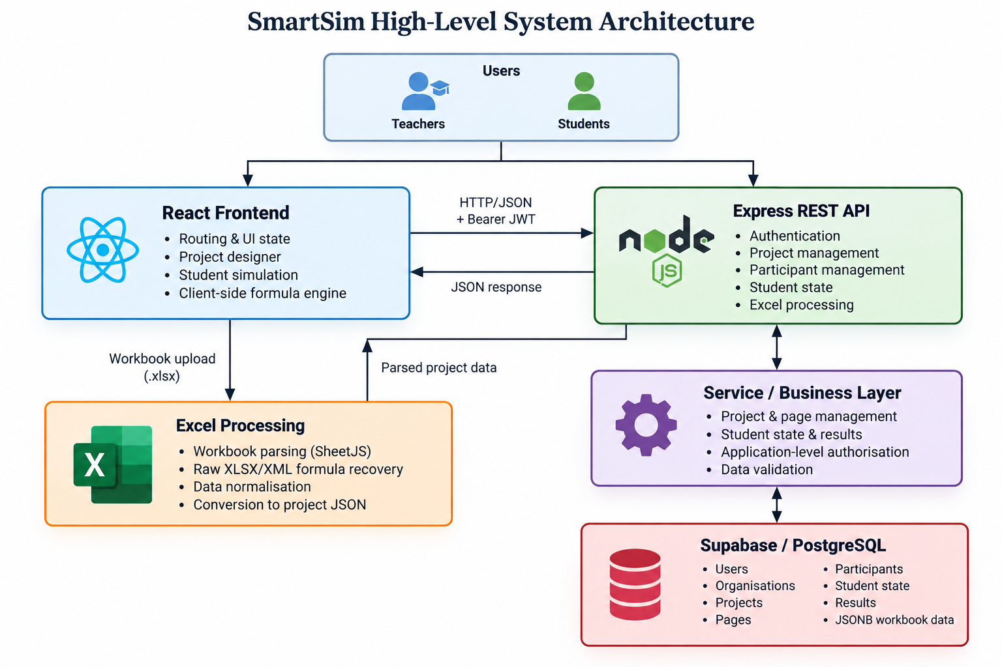

2.2 Architectural Principles
- Separation of concerns between presentation, API handling, business logic and persistence.
- Client-server separation using HTTP-based API communication.
- Centralised persistence for projects, users and student state.
- Client-side simulation calculation for responsive interaction.
- Role-based separation of teacher and student capabilities.
- Flexible JSONB storage for variable spreadsheet and canvas data.

3. Technology Stack
Layer | Technology | Purpose
Frontend | React 19 + TypeScript | Single-page user interface and simulation experience
Frontend tooling | Create React App | Application build and development tooling
Routing | react-router-dom | Client-side navigation and route protection
Backend | Node.js + Express 5 + TypeScript | REST API and application services
Authentication | bcrypt + JSON Web Tokens | Password hashing and authenticated API access
File processing | Multer + SheetJS | Workbook upload and Excel parsing
Database | Supabase / PostgreSQL | Persistent relational and JSONB data
Configuration | dotenv | Environment-specific configuration

4. System Components
Component | Primary Responsibility
React Frontend | User interface, routing, authentication state, project design and student simulation.
Express REST API | HTTP endpoints, request handling, authentication middleware and application operations.
Service Layer | Business logic, project management, student state and database operations.
Excel Processing | Workbook parsing, formula recovery and normalisation.
Formula Engine | Browser-side recalculation of supported Excel formulas.
Supabase / PostgreSQL | Persistent storage for users, projects, pages, participants and simulation state.
Authentication | Credential verification, JWT creation and role-based access.

5. Frontend Architecture

5.1 React Single-Page Application
The frontend is a React and TypeScript single-page application. Client-side routing separates login, project management, project design and student simulation experiences. Authentication state is maintained centrally and the authenticated token is used when making protected API requests.

5.2 Teacher Experience
- Upload Excel workbooks.
- Create and manage simulation projects.
- Organise projects into multiple pages.
- Configure canvas elements and interactive inputs.
- Manage project participants.
- Publish projects to students.

5.3 Student Experience
- Open projects to which the student has access.
- Navigate through project pages.
- Change simulation inputs.
- Observe recalculated results.
- Persist progress and completion state.
- View final results.

5.4 Client-Side State
The frontend maintains short-lived interaction state in React components while durable project and student state is retrieved from the backend. Authentication state is persisted in local storage so a page refresh can retain the current session.

6. Simulation Architecture

6.1 Simulation Lifecycle
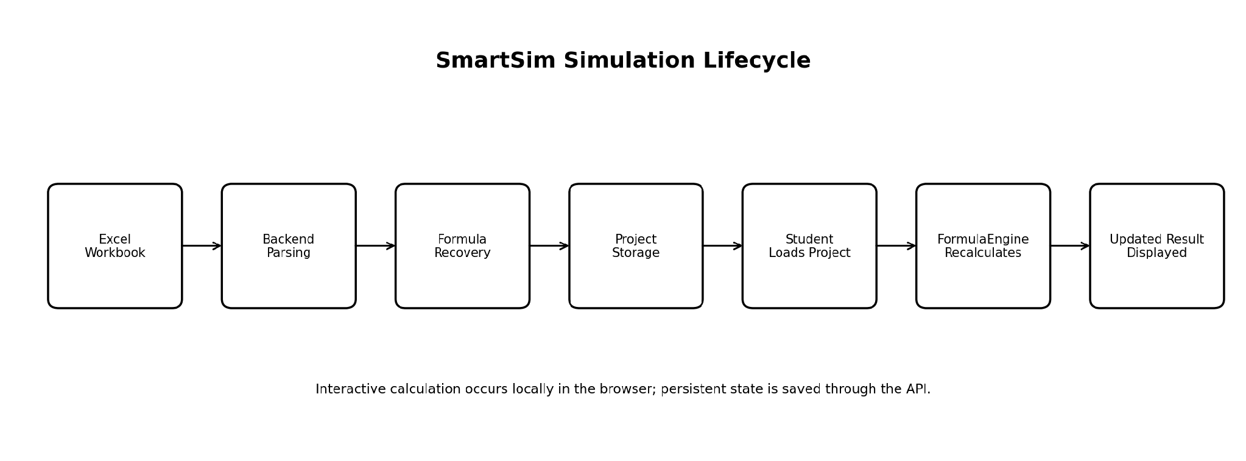
The simulation lifecycle begins with an Excel workbook and ends with an interactive browser-based model. The backend is responsible for ingesting and storing the workbook representation, while the FormulaEngine is responsible for interactive recalculation during student use.

6.2 Formula Engine
The FormulaEngine is a central architectural component. It parses supported formulas, resolves cell and cross-sheet references, evaluates functions and recalculates dependent cells in dependency-aware order.
- Arithmetic operators.
- SUM, AVERAGE, MIN, MAX, COUNT and PRODUCT.
- IF expressions.
- Cross-sheet references.
- Student input overrides.
- Dependency-aware recalculation.

6.3 Architectural Trade-off
Running calculations locally provides immediate feedback and reduces server-side computation. The trade-off is that calculation capability is constrained by the functionality implemented by the FormulaEngine and large or complex workbooks may increase browser CPU and memory requirements.

7. Excel Processing Architecture

7.1 Ingestion Pipeline
Excel workbooks are uploaded to the backend and processed through a multi-stage pipeline.
- The workbook is received through the API.
- SheetJS parses the workbook structure and cell information.
- The underlying XLSX/XML representation is inspected to recover formulas that may not be completely returned by the primary parser.
- The extracted workbook information is normalised into SmartSim's internal representation.
- The resulting workbook data is stored with the project using JSONB.
The hybrid parsing strategy is important because preserving formulas is necessary for SmartSim to reproduce the behaviour of the source spreadsheet during student simulations.

8. Backend Architecture

8.1 Layered Structure
The backend is an Express 5 application written in TypeScript. Routes provide the API boundary, middleware performs authentication checks, services contain application logic and the Supabase client provides access to PostgreSQL.
Layer | Responsibility
API / Routes | Expose HTTP endpoints and convert requests into application operations.
Authentication Middleware | Verify JWTs and attach authenticated user information to requests.
Service Layer | Perform business operations and persistence tasks.
Excel Layer | Parse, recover and normalise workbook data.
Supabase Client | Communicate with PostgreSQL.
Database | Persist application and simulation data.

8.2 Error Handling
A terminal backend error-handling middleware catches unhandled errors, logs them and returns a generic internal-server-error response. This prevents internal stack traces from being exposed to API clients.

9. API Architecture

9.1 API Areas
API Area | Purpose
Authentication | Organisation registration, user registration, login and organisation lookup.
Projects | Project creation, retrieval, editing, deletion and publication-related operations.
Pages | Create, update, delete and reorder project pages.
Participants | Add, list and remove students from projects.
Student State | Retrieve and persist student inputs, page position, completion and results.
Excel | Parse uploaded workbooks.
Legacy Simulation API | Earlier progress and results workflow retained in the codebase.

9.2 Request Flow
A typical authenticated request follows the path below:
React Frontend → HTTP/JSON request → Express Route → JWT Middleware → Service Layer → Supabase Client → PostgreSQL → JSON Response
The current student workflow uses the student-state API. A legacy simulations API remains in the repository and should eventually be consolidated to reduce duplication.

10. Data Architecture

10.1 Core Entities
Entity | Purpose
Organisations | Institutional accounts that own users and projects.
Users | Teacher and student accounts, differentiated by role.
Projects | Uploaded workbook-based simulations and project metadata.
Project Pages | Ordered pages containing simulation layout elements.
Participants | Associates students with projects.
Student Simulation State | Per-student current page, input overrides and completion state.
Project Results | Final state and results captured for a student.
Simulation Progress | Legacy progress representation from the earlier simulation workflow.

10.2 Data Model
SmartSim uses a hybrid relational and JSONB model. Relational structures are used for stable entities and relationships, while JSONB is used for variable structures whose shape depends on the uploaded workbook or project design.
- projects.excel_data stores parsed workbook data.
- project_pages.elements stores page layout data.
- student_simulation_state.input_values stores student input overrides.
- project_results.final_state stores final simulation state.
This approach avoids requiring a new relational schema for every possible Excel workbook structure while retaining relational integrity for users, projects and participants.

10.3 Entity Relationships
The main logical relationships are:
Organisation 1-to-many Users; User/Teacher 1-to-many Projects; Project 1-to-many Project Pages; Project 1-to-many Participants; Project 1-to-many Student Simulation State records; Project 1-to-many Project Results.

11. Key Data Flows
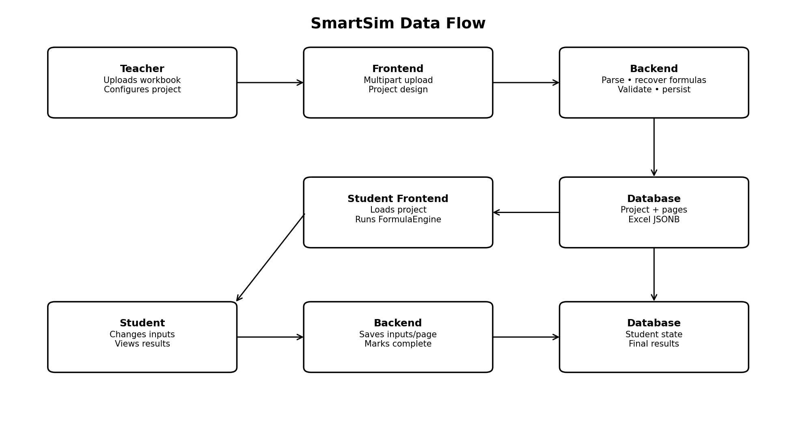

11.1 Teacher Upload Flow
- Teacher selects an Excel workbook in the frontend.
- The frontend sends the workbook to the backend.
- The backend parses the workbook.
- Formula recovery extracts formulas from the XLSX structure.
- Workbook information is normalised.
- The project and workbook representation are persisted.

11.2 Student Simulation Flow
- Student opens a published project.
- The frontend retrieves the student's saved state.
- The workbook and project configuration are loaded.
- The FormulaEngine initialises the simulation.
- The student changes an input.
- The FormulaEngine recalculates dependent values locally.
- The updated result is displayed immediately.
- Student state is persisted through the API.

11.3 Authentication Flow
- The user submits credentials.
- The backend verifies the password using bcrypt.
- A signed JWT containing user identity and role is returned.
- The frontend stores the token.
- Protected requests send the token using the Bearer authentication scheme.
- The backend middleware verifies the token before protected operations continue.

12. Authentication and Security

12.1 Authentication
Passwords are hashed using bcrypt. Successful authentication results in a signed JWT containing the user's identity and role. Tokens expire after a defined period and are supplied to protected API requests using the Bearer scheme.

12.2 Authorisation
The backend uses authenticated user information and the TEACHER/STUDENT role distinction to restrict operations. Teacher-only operations include project creation, page management and participant management. Student access is scoped to projects in which the student participates.

12.3 Current Security Limitations
- The backend uses the Supabase service-role key, with application-level access control rather than database Row Level Security policies in the current migrations.
- CORS is broadly configured rather than restricted to an explicit production origin.
- Uploads are authenticated and capped at 10 MB. Login, signup and student join are rate limited, and Helmet headers are enabled.
- There is no documented JWT secret rotation process.
- Google sign-in controls are present visually but no OAuth implementation is currently active.

13. Deployment Architecture

13.1 Current Development Environment
The current repository supports local execution of the React frontend and Express backend, with the backend connecting to a hosted Supabase PostgreSQL database. Environment variables provide database and secret configuration.

13.2 Production Deployment
The frontend can be built for production and the backend can be compiled into a distributable Node.js application. However, the repository currently contains no Docker configuration, CI/CD pipeline, deployment scripts or cloud hosting configuration.
A production deployment would therefore require a host for the frontend, a host for the API and a configured Supabase project. These deployment details are outside the currently implemented repository architecture.

14. Architectural Decisions and Trade-offs
Decision | Rationale | Trade-off
React SPA | Provides a responsive and interactive teacher/student interface. | Requires client-side application and routing management.
Express REST API | Simple and well-suited to the application's CRUD and authentication requirements. | API contracts must be maintained as the system evolves.
Supabase PostgreSQL | Provides managed relational persistence without operating the database directly. | Creates a dependency on Supabase.
Client-side FormulaEngine | Provides immediate feedback and reduces repeated API calls. | Browser performs computation and only supported Excel functionality can be evaluated.
JSONB workbook storage | Handles arbitrary workbook structures without dynamic relational schemas. | Less structured and less directly queryable than normalised relational data.
JWT authentication | Provides straightforward stateless API authentication. | Token storage and secret management require careful security practices.
Layered backend | Separates routing, business logic and persistence responsibilities. | Introduces more structure than a single-layer API.

15. Scalability and Performance

15.1 Client-Side Computation
Client-side simulation reduces the amount of calculation performed by the backend as the number of students increases. This provides a useful scalability characteristic for interactive simulations.

15.2 Excel Processing
Workbook processing is currently performed by the API and uploads are handled in memory. Large workbooks or many simultaneous uploads could therefore increase API memory consumption.

15.3 Database
PostgreSQL provides a suitable foundation for increasing numbers of users, projects and student state records. As usage grows, query performance, JSONB storage size and indexing strategy would become increasingly important.

15.4 API
The backend is currently structured as one Express application. If demand increases, the stateless API could potentially be deployed across multiple instances behind a load balancer.

16. Reliability and Error Handling
- Centralised backend error middleware prevents internal stack traces from being returned to users.
- Authentication middleware prevents unauthenticated access to protected operations.
- Student state is persisted separately from temporary browser interaction state.
- Excel processing is isolated into dedicated parsing and transformation logic.
- The backend has 181 automated tests and the frontend 199, run on every pull request in CI. End-to-end flows are verified manually.

17. Testing Architecture

17.1 Current State
Testing coverage is currently minimal. The backend test command is a stub and the frontend contains a basic smoke test that renders the application. TypeScript provides compile-time type checking.

17.2 Recommended Testing
- Unit tests for the FormulaEngine and formula functions.
- Fixture-based tests for Excel parsing and formula recovery.
- Integration tests for authentication and project APIs.
- Student-state persistence tests.
- End-to-end tests covering the teacher-to-student simulation lifecycle.

18. Architectural Strengths
- Clear separation between frontend, API, services, Excel processing and persistence.
- Client-side simulation provides a responsive student experience.
- Hybrid relational/JSONB storage accommodates arbitrary spreadsheet structures.
- Role-based access supports distinct teacher and student workflows.
- The overall architecture avoids unnecessary microservice complexity.
- The architecture can evolve incrementally without requiring a fundamental redesign.

19. Architectural Limitations
- Minimal automated testing creates regression risk in the FormulaEngine and Excel pipeline.
- Legacy and current simulation APIs coexist, increasing maintenance complexity.
- Application-level database authorisation provides less defence-in-depth than database Row Level Security.
- Deployment infrastructure is not automated within the repository.
- In-memory workbook processing may become a limitation for large files or concurrent uploads.

20. Future Architectural Improvements
Priority | Improvement | Expected Benefit
High | Expand automated unit, integration and end-to-end testing. | Reduce regression risk and improve confidence in core simulation workflows.
High | Consolidate the legacy simulation API into the student-state workflow. | Reduce duplicate logic and simplify maintenance.
High | Strengthen database and API security with Row Level Security (RLS), restricted CORS, project-level read-access checks and stronger secret management. | Improve defence-in-depth and production readiness.
Medium | Introduce automated deployment through containers and CI/CD. | Make deployment repeatable and reduce manual configuration.
Medium | Move large workbook processing to background jobs or streaming workflows. | Reduce API memory pressure and improve resilience.
Future | Evaluate server-side or background simulation for exceptionally large models. | Support more computationally demanding simulations while retaining client-side calculation where appropriate.

21. Conclusion
SmartSim is implemented as a client-server educational platform using a layered architecture consisting of a React frontend, Express REST API, service layer and Supabase PostgreSQL database.
The most significant architectural decision is the client-side FormulaEngine. This design allows students to interact with simulations and receive immediate calculation feedback while the backend remains responsible for persistent state, project management and Excel processing.
The hybrid relational and JSONB database model complements this approach by providing structured relationships for core application entities while accommodating the highly variable structure of uploaded Excel workbooks.
The architecture is appropriately simple for the current project scope. Its primary future challenges are operational and quality-related rather than requiring a fundamental architectural redesign. Expanded testing, security hardening, legacy API consolidation and deployment automation would provide the greatest improvements to the system's maintainability and production readiness.

