SmartSim User Guide
FIT4002 | User Guide
A tutorial and walkthrough of the software for users looking to use SmartSim.
Abstract 3
1. Quick Start 3
If you're a teacher 3
If you're a student 3
2. Creating Your Account & Signing In 4
Signing Up 4
Logging In 4
Signing Out 4
3. The Dashboard 5
Starring & Recent Simulations 5
Searching 5
The "⋮" Menu 5
Opening a Simulation 5
4. Creating a New Simulation 6
Step 1: Simulation Details & Excel File 6
Step 2: Adding Students 7
5. Editing an Existing Simulation 7
6. The Simulation Designer 8
Managing Pages 8
Adding Elements to the Canvas 8
Text 8
Input Fields 9
Output Fields 10
Images 11
Linking Elements to Spreadsheet Cells 11
Moving, Resizing & Deleting Elements 11
Previewing Your Spreadsheet Data 11
Saving Your Work 12
Previewing as a Student 12
7. Sharing a Simulation with Students 13
The Join Link 13
Using the Join Link on a Local Network 13
Logging In Directly 13
8. Taking a Simulation (Student Guide) 14
Starting a Simulation 14
Understanding Pages 14
Entering Input Values 15
Reading Output Values & Charts 15
Submitting Your Work 15
Attempts & Trying Again 15
9. Managing Your Organisation 16
10. Troubleshooting & Common Messages 16
11. Glossary 17

Abstract
SmartSim turns an Excel spreadsheet into an interactive simulation that students can play with in their browser. As a teacher, you upload a workbook, then use a drag-and-drop canvas to build one or more pages where students can change input values and instantly see outputs, charts, and tables update. As a student, you open a simulation, adjust the values you're asked for, and submit your results.This guide covers everything you need to use SmartSim, whether you're building a simulation or taking one.

1. Quick Start

1.1. If you're a teacher
- Sign up to create your organisation and admin account.
- On the Dashboard, click Create New Simulation.
- Give it a title and upload your Excel workbook, then add your students.
- Open the simulation and use the Designer (Section 6) to place input fields, output fields, charts, and text onto one or more pages, linking each one to a cell in your spreadsheet.
- Click Save, then share the join link with your students.

1.2. If you're a student
- Open the join link your teacher gave you (it looks like .../join/your-simulation-id).
- Sign in with the username and password your teacher gave you.
- Work through the pages, adjusting the input values. Your answers save automatically. When you reach the last page, click Submit.

2. Creating Your Account & Signing In

2.1. Signing Up
Go to the SmartSim homepage and click Get Started (or Sign Up). This takes you to the Create Admin Account page.
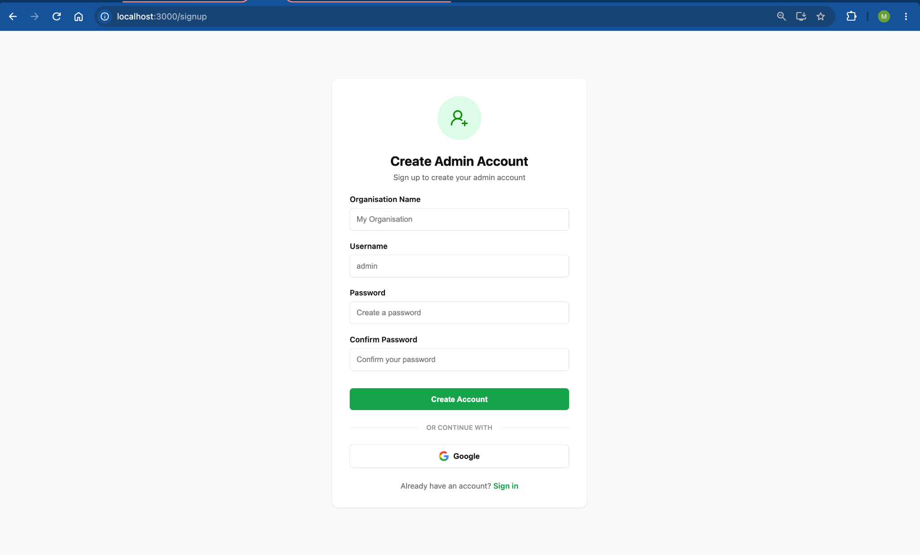
Click Create Account. This creates a brand-new organisation with you as its administrator, and immediately signs you in.
Note: Every sign-up creates a new organisation. If your school or team already has an organisation set up in SmartSim, ask the person who created it to add you as a user instead of signing up again, otherwise you'll end up with a separate, empty organisation.

2.2. Logging In
If you already have an account, go to Sign In and enter your Username and Password.

2.3. Signing Out
Click Logout at the bottom of the left-hand sidebar at any time.

3. The Dashboard
After logging in, you'll land on the Dashboard, the home screen listing every simulation you've created (or, for students, every simulation you've been added to).
Each simulation is shown as a card with:
- A colored badge and the simulation's name and description.
- How many students are currently added to it.
- A star button to mark it as a favorite.

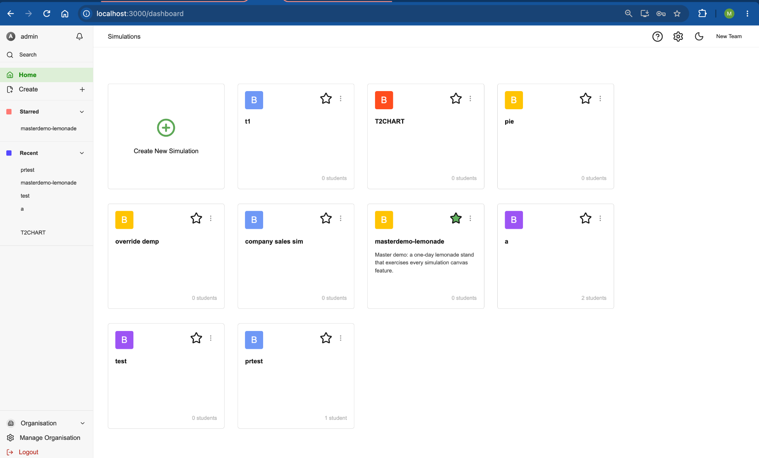

3.1. Starring & Recent Simulations
Click the star icon on any card to pin it under Starred in the left sidebar for quick access. Simulations you've opened recently also appear automatically under Recent in the sidebar.

3.2. Searching
Use the search icon in the sidebar to filter your simulations by name.

3.3. The "⋮" Menu
On each simulation card, click the ⋮ (three-dot) menu to:
- Edit - open the simulation's title, student list, and attempt settings for editing.
- Copy join link - copy the shareable link students use to access this simulation (see Section 7, Sharing a Simulation with Students).
- Delete - permanently remove the simulation. You'll be asked to confirm, since this cannot be undone.

3.4. Opening a Simulation
Click anywhere on a card to open it. Teachers land in the Designer (Section 6); students land directly in the running simulation.

4. Creating a New Simulation
From the Dashboard, click Create New Simulation. This is a two-step process.

Step 1: Simulation Details & Excel File
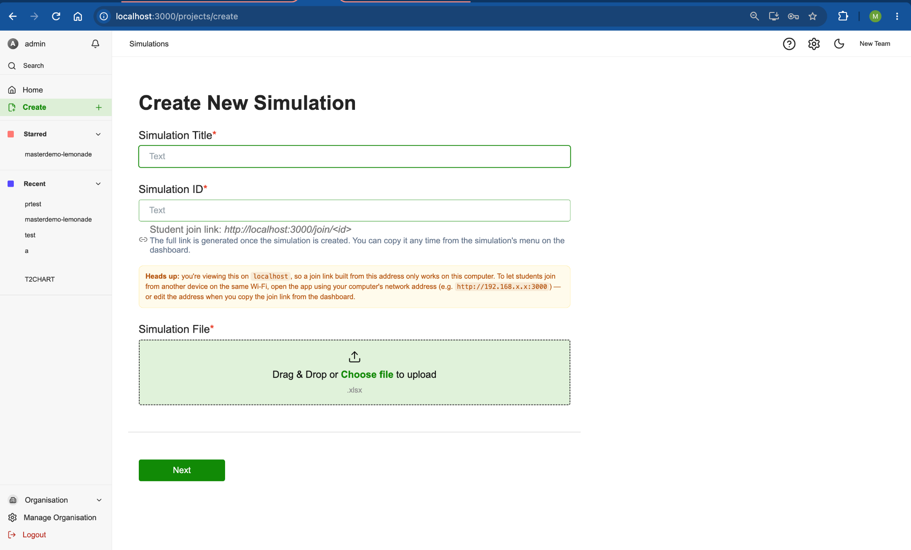
Field | Notes
Simulation Title | Required. The name students and you will see.
Simulation ID | Required. This becomes part of the link you'll share with students (.../join/your-id), so pick something short and memorable, without spaces, for example biology-101.
Simulation File | Required. Drag and drop your Excel file (.xlsx or .xls) onto the upload area, or click Choose file to browse for it.

Once you've filled these in, click Next.
Tip: The input and output cells in your spreadsheet don't need to be laid out specially, you'll choose exactly which cells to expose to students in the next step, inside the Designer (Section 6).

Step 2: Adding Students
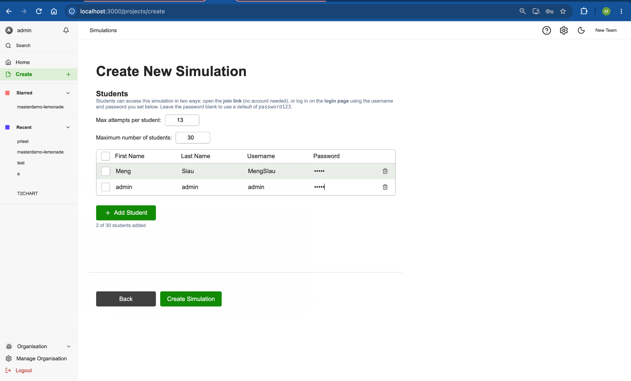

Here you set up how students will access the simulation and how many tries they get.
- Max attempts per student - how many times each student can submit an attempt before they run out.
- Maximum number of students - a cap on how many student rows you can add below.
For each student, add a row with:
- First Name and Last Name
- Username - must be unique within this simulation and must not contain spaces.
- Password - if you leave this blank, it defaults to password123.
Students will sign in with this username and password using the join link (a dedicated sign-in page just for this simulation), rather than the main SmartSim login page. You can always add more students later by editing the simulation.
Click Add Student to add another row, or the trash icon to remove one.

Tip: Make sure every username is unique and nobody's row has a password without a username, SmartSim will stop you with an on-screen message if either happens.
When you're ready, click Create Simulation. You'll be taken straight into the Designer (Section 6) to start building your pages.

5. Editing an Existing Simulation
Open the ⋮ menu on a simulation's Dashboard card and choose Edit to change its title, maximum attempts, or student list.
- The Simulation ID cannot be changed once created, since it's part of the join link you've already shared.
- Existing students can't be edited or have their passwords changed from this screen, you can only add new students or remove existing ones. Removing a student deletes their account. If you add the same username again later, it is a new account with a fresh attempt count.
- To change the canvas layout (pages, text, inputs, outputs, images), use the Designer (Section 6) instead, click into the simulation from the Dashboard.

6. The Simulation Designer
The Designer is where you build what students actually see and interact with. It opens automatically after creating a simulation, or whenever a teacher clicks a simulation card on the Dashboard.

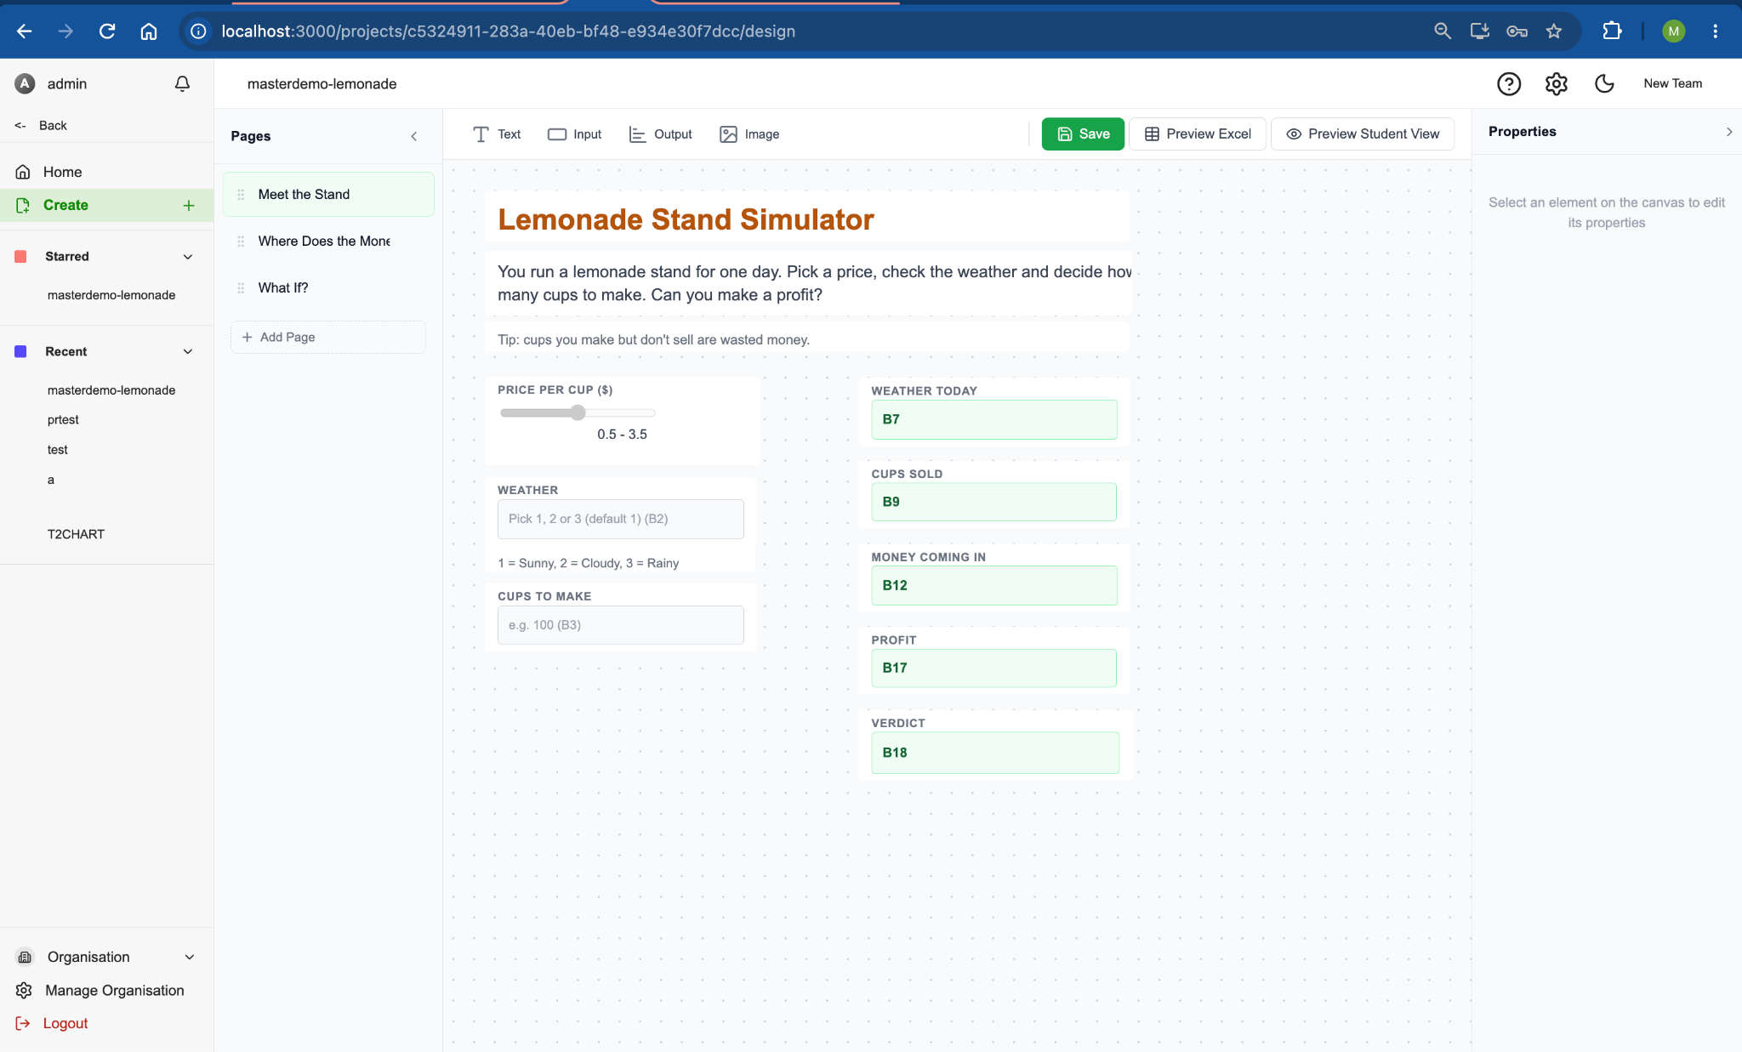
The screen has three parts:
- Pages (left) - the list of pages in your simulation.
- Canvas (center) - where you place and arrange elements, with a toolbar across the top for adding new ones.
- Properties (right) - appears when you select an element, letting you configure it.

6.1. Managing Pages
Simulations can have one or more pages, which students navigate through in order (like slides). Each page has its own independent set of values, if the same spreadsheet cell is used as an input on two different pages, changing it on one page won't affect the other.
- Click Add Page at the bottom of the Pages panel to create a new page.
- Click a page's name to rename it inline.
- Click the trash icon next to a page to delete it. You must always have at least one page.
- Click a page in the list to switch to editing it.

6.2. Adding Elements to the Canvas
Use the toolbar above the canvas to add any of four element types. Click a toolbar button to drop a new element onto the current page, then drag it into place.

Text
Use text elements for headings, instructions, or labels. Select a text element to edit its:
- Content
- Font size
- Bold
- Color

Input Fields
Input fields are how students enter values. After adding one, select it and set:
Property | Notes
Label | The field's title, shown above it.
Cell ref | Which spreadsheet cell this field controls, chosen from a dropdown of the input cells found in your uploaded workbook.
Placeholder | Grey hint text shown inside an empty field.
Format | How the field is displayed to students, see below.

Three input formats are available:
Format | What students see | Extra settings
Number | A plain number box. | -
Slider | A drag-to-adjust slider. | Step Size, Min, Max
Dropdown | A list of preset choices. | Options, type the choices separated by commas, e.g. Low, Medium, High

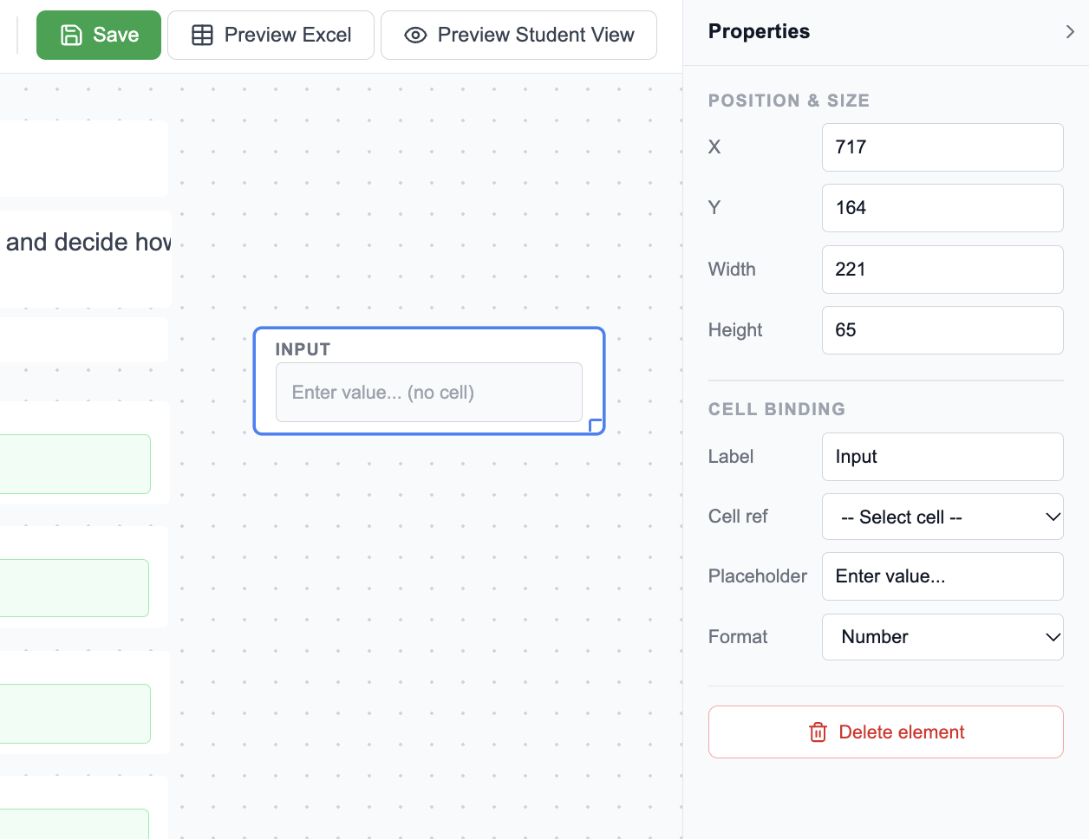

Output Fields
Output fields display results computed from your spreadsheet's formulas. Select one and set its Label, then choose a Format:
Format | Displays | Extra settings
Number | A plain number, rounded sensibly. | Pick a single Cell ref.
Text | The cell's raw text result. | Pick a single Cell ref.
Currency | Formatted as $1,234.56. | Pick a single Cell ref.
Percentage | Formatted as 12.3%. | Pick a single Cell ref.
Bar Chart | A bar for each cell in a range. | Cell range (e.g. B4:B8), Chart title, X-axis title, Y-axis title.
Pie Chart | A pie slice for each cell in a range. | Cell range, Chart title.
Table | A row-and-column table built from multiple ranges. | A list of row labels, and a list of columns, each with its own heading and cell range.
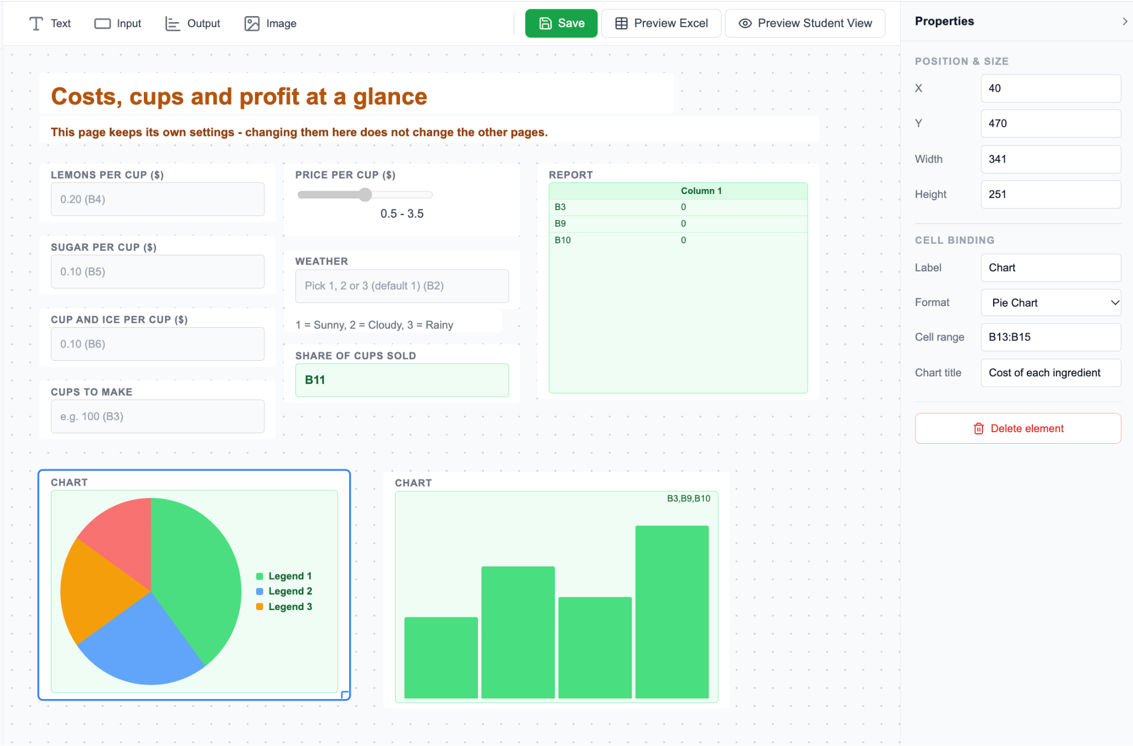For Cell range fields, you can combine multiple ranges with a comma, e.g. B1:B3,B5:B7.
For Table outputs: give your row-label column a heading (e.g. "Month"), then add one row label per row and one column per column you want shown, each pointing at its own cell range. SmartSim fills in each cell of the table by matching row position to the values in each column's range.

Images
Add an image element and either:
- Paste an Image URL, or
- Click Choose Image to upload a picture from your device. Large images are automatically resized and compressed so your simulation stays fast to load.
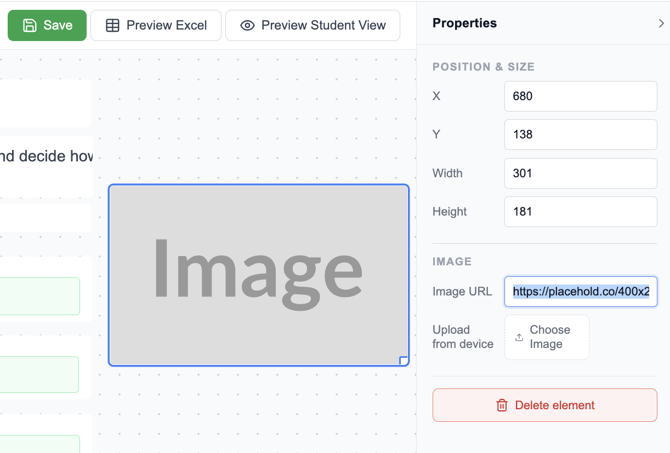

6.3. Linking Elements to Spreadsheet Cells
Input and output fields are always connected to a specific cell (or range of cells) in the workbook you uploaded. Rather than typing a cell reference by hand, use the Cell ref dropdown in the Properties panel; it lists every available cell from your spreadsheet along with its title and current value, so you can find the right one without reopening Excel.
- Input fields only show input cells (plain values, not formulas).
- Output fields only show output cells (cells containing a formula), except Bar Chart, Pie Chart, and Table outputs, which use a typed Cell range instead.

6.4. Moving, Resizing & Deleting Elements
- Move an element by clicking and dragging it anywhere on the canvas.
- Resize by dragging the small handle in its bottom-right corner.
- You can also set exact X, Y, Width, and Height values in the Properties panel.
- Delete a selected element by pressing Delete/Backspace, or by clicking Delete element at the bottom of the Properties panel.

6.5. Previewing Your Spreadsheet Data
Click Preview Excel in the toolbar to open a read-only table of every cell SmartSim currently tracks from your workbook, its reference, title, whether it's an input or output, and its value or formula. This is handy for finding the right cell reference while you're laying out your page. If your workbook has multiple sheets, cell references are shown as Sheet!Cell (e.g. Sales!B3).
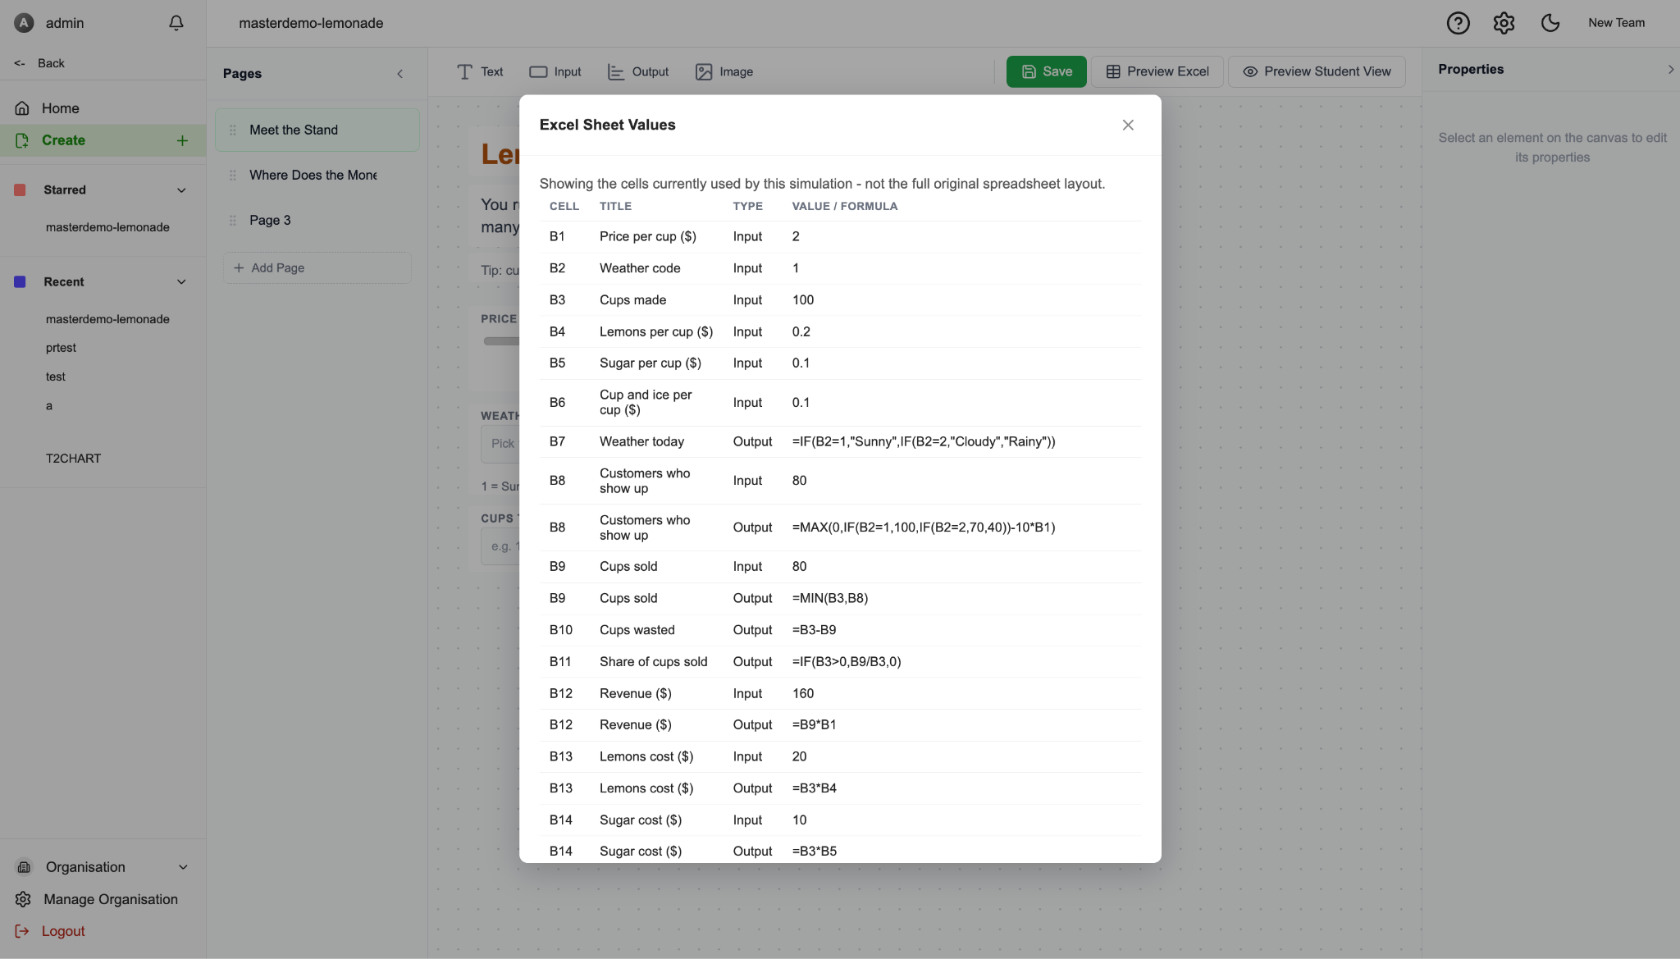

6.6. Saving Your Work
Click Save in the toolbar whenever you want to store your changes.
Important: The Designer does not save automatically. If you navigate away without clicking Save, your changes to the canvas will be lost.

6.7. Previewing as a Student
Click Preview Student View to see (and interact with) your simulation exactly as a student would, including entering values and navigating between pages. This automatically saves your current work first. While previewing, a Back to Editing button returns you to the Designer.


7. Sharing a Simulation with Students

7.1. The Join Link
The easiest way to get students into a simulation is the join link, a direct link students open in their browser, with no SmartSim account for your organisation required.
To get it, open the ⋮ menu on a simulation's Dashboard card and choose Copy join link. This opens a window where you can:
- See and copy the full link (.../join/your-simulation-id).
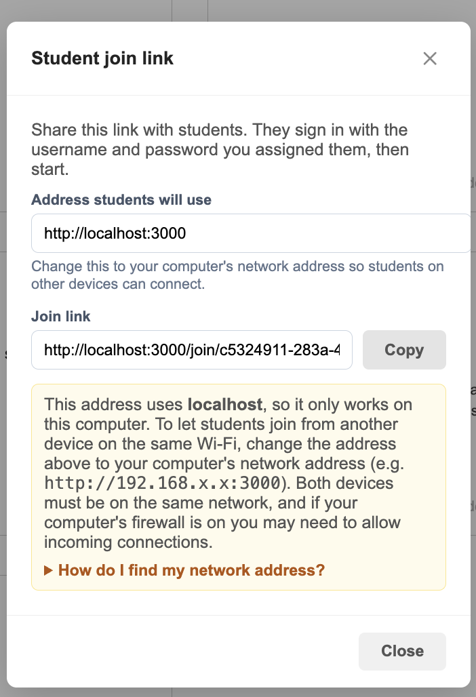
- Edit the "address students will use" if needed (useful if you're hosting SmartSim somewhere other than its default address).

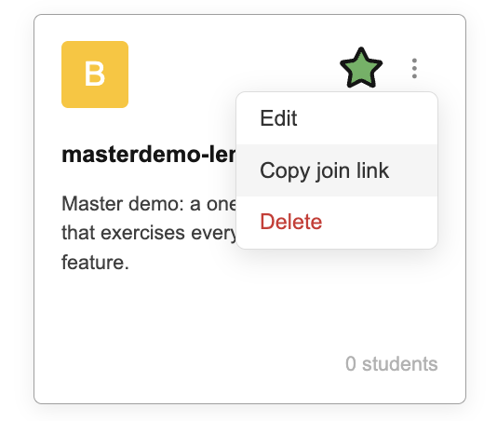

Share this link with your students by any means you like, email, a learning management system, a QR code, or simply writing it on the board. When students open it, they'll be asked to sign in with the username and password you set for them in Step 2 of creating the simulation (Section 4), not their own separate SmartSim account.

7.2. Using the Join Link on a Local Network
If you're running SmartSim on your own computer (rather than a hosted server), a link starting with localhost will only work on that same computer, students on other devices won't be able to reach it. SmartSim will warn you about this and show instructions for finding your computer's network address (e.g. 192.168.1.42) so you can share a link that works across your local network instead.

7.3. Logging In Directly
If you'd rather students sign in through the main SmartSim login page instead of a join link, they can do so with the same username and password, this is also how a student can get back into a simulation they were previously added to, by selecting it from their own Dashboard.

8. Taking a Simulation (Student Guide)

8.1. Starting a Simulation
Open the join link your teacher gave you, or log in and select the simulation from your Dashboard. Sign in with the username and password your teacher provided.
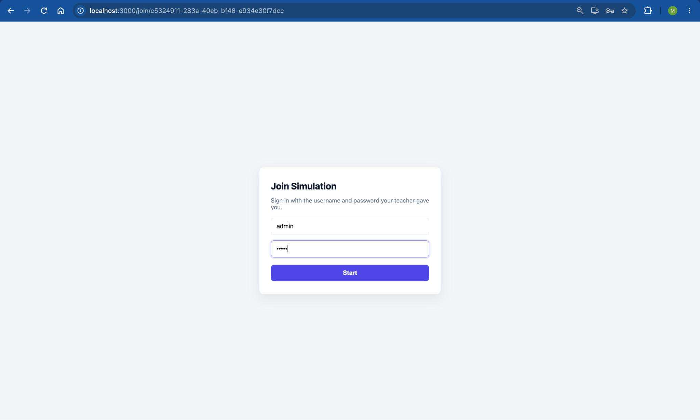
Each time you start, SmartSim tracks it as one of your attempts, shown as a small "Attempt N" badge while you work.

8.2. Understanding Pages
A simulation may have several pages, shown as dots at the top of the screen. Use Previous and Next at the bottom to move between them, or click a dot to jump directly to that page.
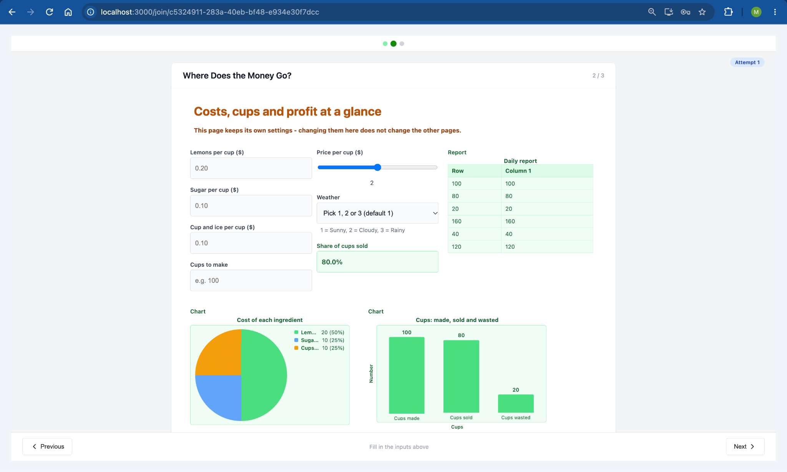
Note: Each page keeps its own set of answers. If the same question appears to involve the "same" value on two different pages, changing it on one page will not change it on the other, treat each page as a self-contained scenario.

8.3. Entering Input Values
Depending on how your teacher set each field up, you'll see:
- A number box, type a value directly.
- A slider, drag to adjust, with the current value shown next to it.
- A dropdown, pick from a preset list of options.
Your answers are saved automatically as you type, there's no need to click a save button while working through a page.

8.4. Reading Output Values & Charts
As you change your inputs, output values recalculate instantly. These may appear as plain numbers, currency, percentages, bar charts, pie charts, or tables, depending on how your teacher designed the page.

8.5. Submitting Your Work
On the last page, a Submit button appears in place of Next. Click it to finish your attempt. You'll see a confirmation screen once it's been submitted successfully.

8.6. Attempts & Trying Again
If your teacher allows more than one attempt and you have attempts remaining, the confirmation screen offers a Do another attempt button, which starts you over from page one with a clean slate. If you've used up all your attempts, you'll see a message letting you know instead.

9. Managing Your Organisation
From the sidebar, click Organisation or Manage Organisation to open the Organisation Management screen. Here you can view and switch between organisations you have access to.
Note: Full organisation management, adding additional admins or users, is still being developed and isn't available yet in this screen.

10. Troubleshooting & Common Messages
You see… | What it means
"All fields are required" / "Please fill in all required fields" | Go back and make sure every required field on the form has something in it.
"Passwords do not match" | Your password and confirm-password fields don't match, retype them.
"Please upload a simulation file" | You need to attach an .xlsx/.xls file before continuing.
"Username 'X' cannot contain spaces" | Remove any spaces from that student's username.
"Duplicate username 'X'" | Two students in your list share a username, make each one unique.
"This simulation allows at most N students, but M are listed" | You have more student rows than your "Maximum number of students" setting allows, either remove some rows or raise the maximum.
"No projects match '...'" | Your Dashboard search didn't find any simulations with that name.
"This simulation has no pages yet" (student view) | The teacher hasn't added any pages in the Designer yet, check back later or contact them.
"Incorrect username or password" (join link) | Double-check the username and password your teacher gave you. If it still fails, ask your teacher to confirm your details or reset your password.
"Unable to start this simulation" / an attempts-related error | You may have used up all your allowed attempts, or aren't added as a participant on this simulation yet, contact your teacher.
"You've used all your attempts for this simulation" | You've reached the attempt limit your teacher set. Contact them if you need another attempt.
A join link only works on your own computer | The link is pointing at localhost, which only works on the machine SmartSim is running on. Ask whoever set it up for a link using their network address instead (see Using the Join Link on a Local Network, Section 7).
Too many attempts, try again later | After 10 failed sign-ins for one account in 15 minutes, sign-in for that account pauses. Wait about 15 minutes and try again, or ask your teacher to check your username and password.

11. Glossary
Term | Meaning
Simulation | A SmartSim project built from one Excel workbook, the thing students open and interact with.
Designer | The drag-and-drop screen where teachers build a simulation's pages.
Page | One screen of a simulation, containing its own set of elements and its own independent values.
Element | Anything placed on the canvas: a text box, input field, output field, or image.
Input cell / Input field | A spreadsheet cell containing a plain value (not a formula); on the canvas, a field students can type or choose a value into.
Output cell / Output field | A spreadsheet cell containing a formula; on the canvas, a field that displays a calculated result.
Cell reference | The spreadsheet address of a cell, e.g. B4, or Sales!B4 in a multi-sheet workbook.
Cell range | A span of cells, e.g. B4:B8, used by charts and tables to pull in several values at once.
Manual override | When a student types their own value into a field that would normally be calculated, temporarily replacing its formula result.
Attempt | One complete run-through of a simulation, from start to submission.
Join link | A shareable link that lets a student sign in directly to a specific simulation.

