Project Management

FIT4002 | Product Management

1. Brief
To manage ourselves throughout this project, we use two main tools: Jira and a project timeline in the form of a Gantt chart. Jira is used to delegate tasks among group members and to maintain a clear, shared list of the work that needs to be completed. The Gantt chart gives group members a rough idea of how the project should progress. It was deliberately kept broad in scope and in draft form, so that new tasks can be added, and existing tasks broken down further, as the need arises.

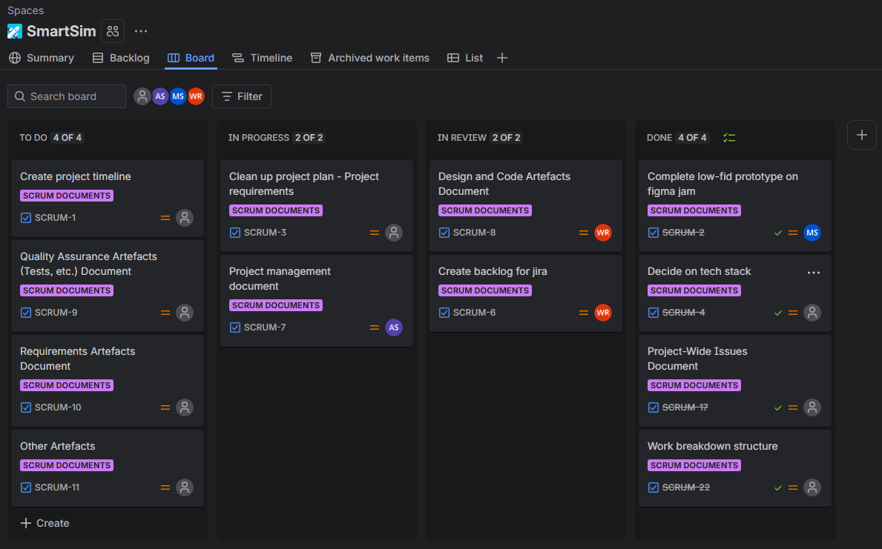

Figure 1: Jira board for the project.
Link - https://fit4002smartsim.atlassian.net/jira/software/projects/SCRUM/boards/1

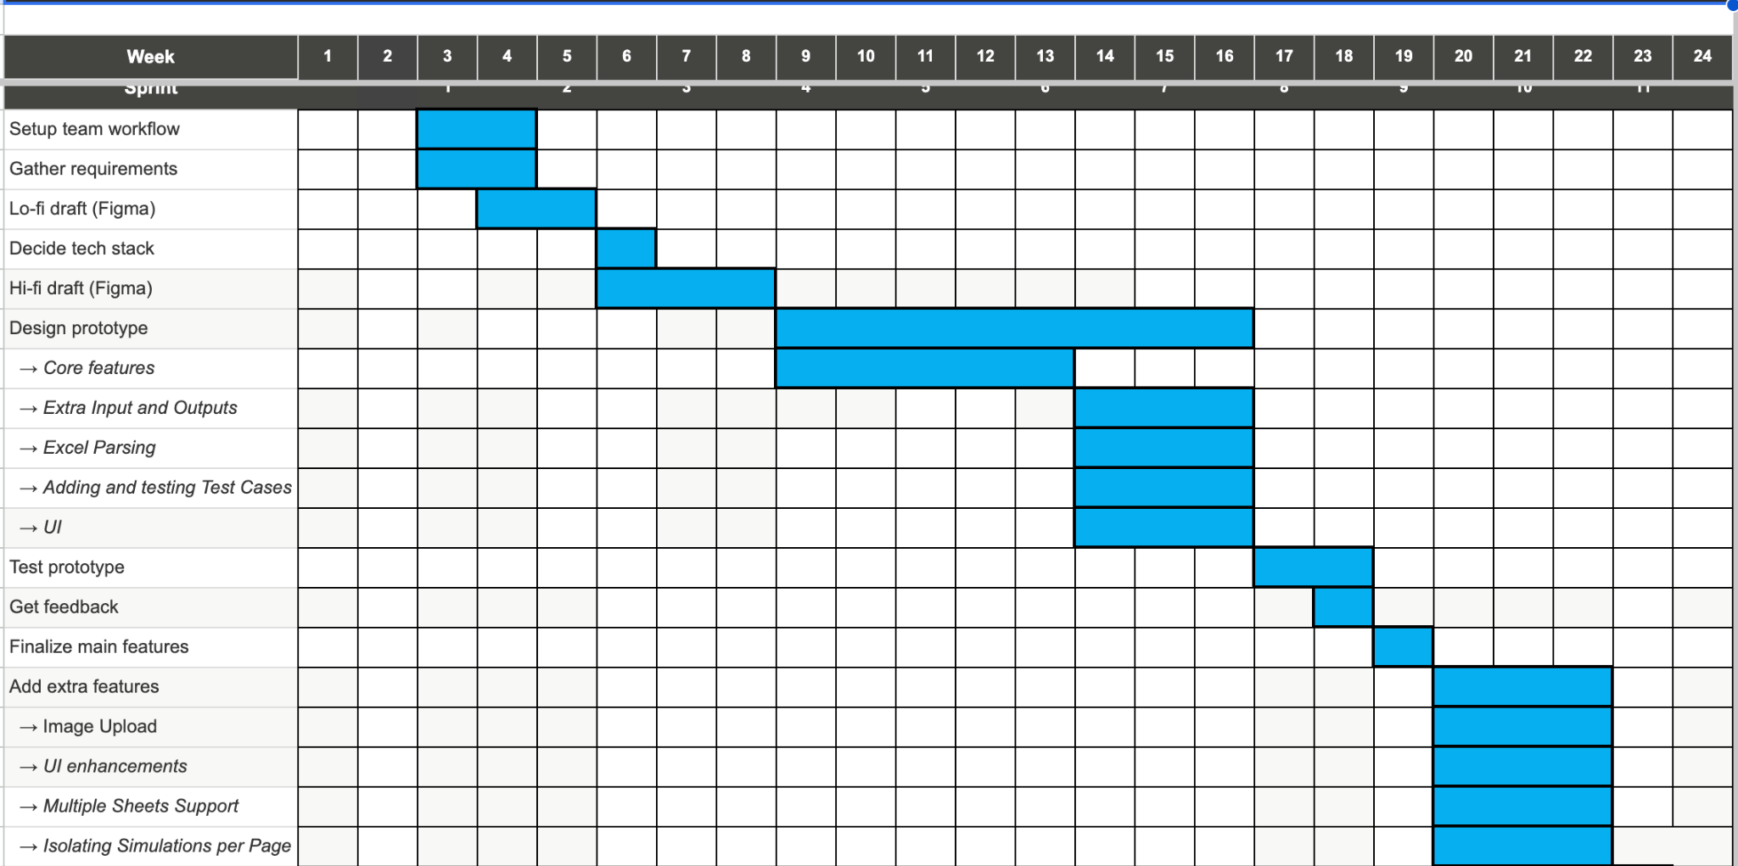

Figure 2: Rough project timeline - gantt chart
Link - SmartSim_Project Timeline.xlsx

2. Project Roles

2.1. Project Manager
Name: Meng Siau
Email: hsia0003@student.monash.edu
Responsibility: Maintaining the product backlog and for allocating tasks across the team. During sprint planning, Meng adds and updates backlog items so that the backlog accurately
reflects the current state of product development. He then assigns tasks to team members, taking into account each person's role, skills and current workload. Throughout the sprint, he tracks the progress of all work against its deadlines so that any difficulty in completing a task can be spotted early and raised with the team in a timely manner, before it affects the sprint goal. He also keeps the Jira board and Gantt chart up to date, so that every member has an accurate view of the project's overall progress.

2.2. Lead Backend Developer
Name: Agamjot Singh
Email: asin0114@student.monash.edu
Responsibility: Designing and implementing the program's backend logic, including the excel parsing module that supports smart cell referencing. Agamjot leads the implementation of backend features and makes sure the code is readable, maintainable and consistent with the agreed tech stack. He works closely with the Lead Frontend Developer to define and maintain the interfaces between the backend and the user interface. He also reviews backend contributions from other members, tests and debugs backend functionality before it is shown in a sprint review, and helps teammates who are blocked on backend tasks.

2.3. Lead Frontend Developer
Name:Jackson Tong
Email: jton0021@student.monash.edu
Responsibility: Leading the design and implementation of the UI/UX. Jackson designs the user interface so that the product is clear, usable and consistent, and builds the frontend components that let users interact with the simulation and spreadsheet features. He works with the Lead Backend Developer to connect the interface to backend functionality. He also takes the feedback gathered from the client in sprint reviews and turns it into interface improvements, and reviews frontend contributions to check that the interface behaves correctly and is easy to use.

2.4. Software Architect
Name: William Richter
Email: Wric0006@student.monash.edu
Responsibility: setting up the repository and the tech stack. William establishes the code repository, including the branching strategy and contribution conventions the team follows, and selects and configures the technologies used in the project, documenting the reasoning behind these choices. He defines the overall structure of the system and how its components fit together, so that the team builds on a consistent foundation. He also advises the team on design decisions, helps resolve technical disagreements, and keeps the project setup and documentation up to date so that new members can get started quickly.

2.5. Scrum Master
Name: Huu Nguyen
Email: hngu0187@student.monash.edu
Responsibility: facilitating group meetings and supporting collaboration within the team. Huu runs the team's meetings, including stand-ups, sprint planning, sprint reviews and retrospectives, and keeps them focused and on time. He encourages open communication and makes sure that every member has the opportunity to contribute. He helps the team follow Scrum practices, records the outcomes of retrospectives and follows them up in later sprints, and makes sure that notes from client and team meetings are recorded and shared. When the team encounters an obstacle it cannot resolve itself, he escalates it to the Project Manager or the Project Supervisor.

2.6. Stakeholders

Project Supervisor
Name: Md Shamsujjoha
Email: md.shamsujjoha@monash.edu
Responsibility: The project supervisor is who we ask any assessment related questions alongside any concerns about the development of the project.

2.7. Project Client
Name: Alphan Culha
Email: alphan.culha@monash.edu.
Responsibility: The client is responsible for clarifying any details about the implementation details.

3. Process Framework
To maintain high productivity and efficiency, the team has adopted an Agile framework using Scrum practices. Agile encourages active collaboration and communication between team members and the client. Through regular feedback, reviews and evaluations at the end of each iteration, the team can continuously improve its workflow while delivering incremental progress towards the final product. This approach suits our project well, because regular client feedback is essential for refining the excel parsing module for smart cell referencing in the spreadsheet, and it can also improve the overall user experience.

The Smart Simulation project is managed by a small, cross-functional team of five members. Each member is assigned specific responsibilities based on their skills and expertise, while remaining flexible enough to collaborate with and support other areas of development when required. The team works from a shared Product Backlog containing the project's requirements and features. These requirements are broken down into smaller, manageable user stories and prioritised by their importance to the overall project.

Development is iterative, with work organised into two-week cycles called sprints. At the beginning of each sprint, the team holds sprint planning to decide which tasks and features to complete. Throughout the sprint, regular communication and progress updates help identify potential issues early and keep development on track. At the end of each sprint, the team conducts a sprint review to evaluate the completed work and gather feedback, followed by a retrospective to identify improvements to the team's workflow and collaboration.

This lightweight Agile framework keeps the project flexible, organised and responsive to change. With a small team, consistent communication and regular feedback built into every development cycle, the team can manage its workload efficiently while ensuring continuous improvement and the quality of the final product.

4. Client Meetings Structure
Client meetings are held weekly or fortnightly, depending on the stage of the project. In the first couple of weeks, weekly meetings are used to gather as much information as possible from the client. From this, the team forms a list of technical and non-technical requirements and breaks it down into smaller backlog items so that progress can be tracked during development. Once team members are comfortable with the product details, meetings move to every two weeks to demonstrate the increment from the last sprint. Alternatively, and according to the client's preference, the team may contact the client by email.

During development, the team holds a sprint review after hearing the client's feedback and takes notes for further discussion at the internal team meeting. When a client meeting and a team meeting fall in the same week, the client meeting is always scheduled for the day before the team meeting.

5. Team Meeting Structure
Team meetings are held weekly and in person. When a meeting falls in the middle of a sprint, its purpose is to track each member's progress on their allocated tasks. Any roadblocks are raised so that the team can decide whether to address them before the sprint ends or defer them to a future sprint.

When a meeting is held at the start of a sprint, the team begins with a retrospective on the previous sprint, discussing which processes went well and which did not, and noting improvements for the next sprint. The team then plans the upcoming sprint. This is an extended internal discussion that follows on from the client meeting, and it involves updating the backlog status, adding new feature or bug-fix items, and revising any items that are out of date.

Team meetings also double as work sessions. After the stand-up, members begin working through the project backlog alongside other team members.

6. Team Communication Method
Outside of in-person meetings, team members have agreed to use Discord as their primary communication channel. When team members have any queries or roadblocks, Discord’s general chat is used. When there are any serious or complex issues, Discord’s voice chat will be used to help verbally communicate these issues.

7. Work Breakdown structure
Our team has decided to use a work breakdown structure to help keep track of who has done what. An actionable item, along with a description, date, and time it took to complete is taken note of. The work breakdown structure also briefly records any challenges members faced, and their solution or approach to solve the problem.

Link: Work Breakdown

