Implement Estimator

The first thing this project had us do was determine the standard deviation of the mesaurement noise of both the GPS X data and the Accelerometer X data. This was accomplished with a Python script which read the log files and used numpy to determine standard deviation. This script is located at ~/Student/std_dev.py. Out of laziness and convenience (I’m afraid I’ll forget to put the code back in place) the figures from each of these sections is taken with the control model from the previous project included in the code (thus some of the results look less than ideal).
The next thing we had to do was to implement the function UpdateFromIMU(). This was accomplished using the math from the Estimation for Quadrotors paper. Figure 1 shows the results from the Scenario 7 using the final model for the project (including the model from the Controls project).
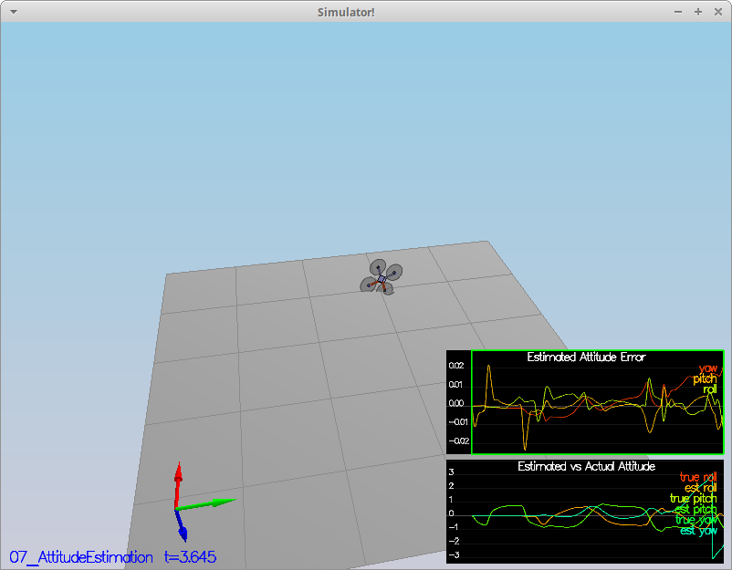Figure 1: Results from Scenario 7

Next the project required us to implement all of the elements of the prediction step for the estimator (PredictState()). This, again, was accomplished using the math from the paper. Figure 2 shows the simulation results from Scenario 8, and Figure 3 shows the simulation results from Scenario 9. Both of these results were using the controls module from the previous project (so not ideal results).

Figure 2: Scenario 8 results

Figure 3: Scenario 9 results

The fourth thing that the project had us do was to implement the magnetometer update (UpdateFromMag()). The math from this section was pulled from the paper. Figure 4 shows the passing results with the controls module from the previous project.
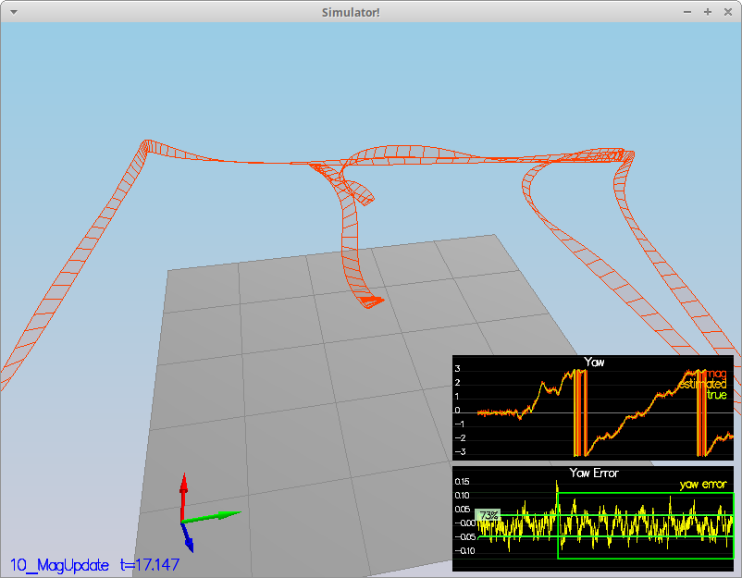Figure 4: Passing results from Scenario 10

The final step of the project was to implement GPS update. My first run of this step was not particularly good, and I had to tune most of the parameters again. Figure 5 shows the final run of this step.
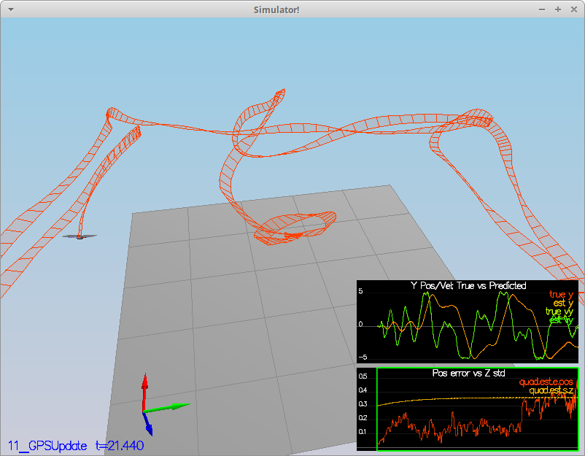Figure 5: Passing results from GPS update

