Final Project Design Phase
Computer Science - Week 11
Oct 3, 2026 - Version 0.0.4

For complete instructions and project ideas, refer to the assignment in Canvas. Specifically, review the final project requirements before you continue below. If you have not reviewed the project requirements in Canvas (you might have to go to the modules view and check the current or past week's content), you will not be able to properly complete the parts below. In addition, it may be helpful to review the information on this Drafter documentation page.

0) Project Planning and Preparation
Successful programmers spend time planning before they begin coding. After reviewing the project requirements, answer the following questions to help guide your design and development process.
- What concepts from class or previous assignments might help you complete this project? Which programming concepts (loops, conditionals, lists, classes, etc.) do you expect to use? What programming skills do you want to improve while completing this project?
This program will use loops, lists, and classes. This program will help me improve my organizational skills and my ability to choose the right design for a specific goal.

- Which parts of the project do you expect to be the easiest for you? The hardest? Why?
The easiest will be the flow through user input
The hardest part will be getting exercises for the needs of the user

- Even though you have not yet designed the final project, estimate which tasks will likely require the most time and effort? Which features or components should be implemented first?
Implementing the flow to get the users' needs will need to be implemented before I can generate a workout.

- What distractions might interfere with your work and how will you minimize them? What resources will you need available while working? What questions, if any, do you still have about the assignment requirements?
To create this app, I will need to find a dataset of exercises that fits my needs and stays within the project's scope.

1) Site Diagram
Create a mock-up of your planned website. We suggest you make the mockup on paper, although you can also use software like PowerPoint or Slides to make a mockup. There is other design software that could also be used, but we strongly encourage you to keep it simple. Do not spend more than 15-30 minutes detailing the mock-up. Your goal should be to make a very quick and dirty diagram, to show that you have some kind of idea.

We recommend drawing each page as a rectangle, and laying out the text, buttons, and other components inside. Then, use arrows to indicate links between pages. Label each page the way you will name each function, and then put labels on the arrows to indicate what the button links. Also write down any parameters that should come into the pages.

In addition to the pages and routes, write down what fields your `State` will have, both their names and types. Think clearly about what data will need to be persistent across the entire website.

Add photo(s) or screenshot(s) of your website mock-up and labeled diagram on the next page.
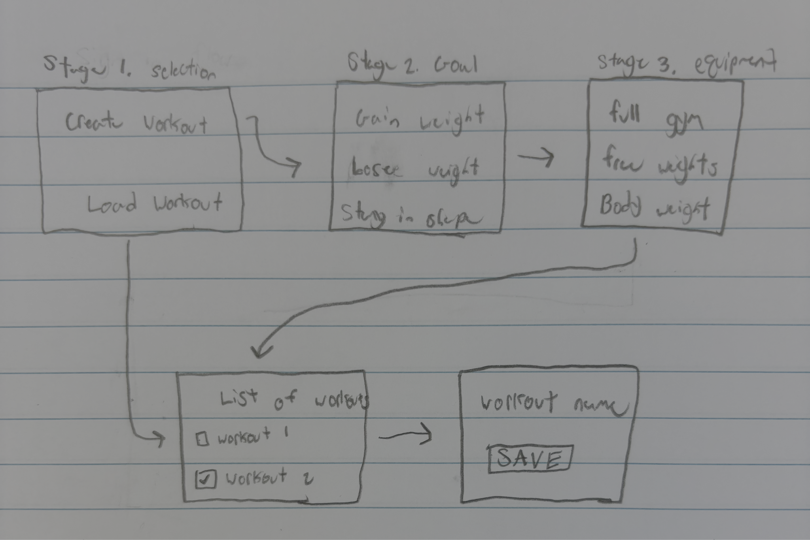

2) Implementing Requirements
This table should serve as a draft for how you will implement the requirements into your final project. You may change your ideas later on, but your final site must fulfill all the requirements.

Requirement | Implementation
Purpose/Functionality  A 1-2 sentence description of the purpose or functionality of your site | The site will help users create a workout plan based on their goals and needs and allow the user to track progress.
State Dataclass Attributes  Minimum of 4 attributes, one of which must be a list/dict of instances of your second dataclass.  Briefly describe each attribute, its type, and how it will be meaningfully modified throughout the site. | class State:  goal: str (goal the user wants to achieve)  equipment: str (equipment the user has access to)  workout: list (the workout generated)
Second Dataclass  Your second dataclass, including its attributes, their types, and how they will be meaningfully modified (if they are modified) | class Workout:  name: str  equipment: str  category: str  primaryMuscles: str
Routes (minimum 7)  The names of your route functions | Selection_page  Goal_page  Equipment_page  Workout_page  Save_page  Set_goal  Set_equipment  Create_workout
Pages (minimum 5)  A brief description of the pages in your site | Selection,  Goal,  Equipment,  Workout,  Save
User Input (minimum 3)  Description of user input components (TextBox, TextArea, CheckBox, or SelectBox) and their purposes  For more information on these input types, see Drafter Documentation. | Buttons on Selection page  Select box on Goals and equipment pages  Checkboxes to complete your workout
If Statements (minimum 3)  Brief description of what will be evaluated in your if statements and how they will meaningfully change the logic of the site | On the selection page, the flow of the page will be determined by the user's input.  List workouts based on equipment and goals
Loop (minimum 1)  This loop must iterate over the list/dict of dataclass instances in your State attribute.  Description of this loop and why it is meaningful to the site | Iterate over the workout list

LLM Conversation
If you used an LLM in any part of this work, copy and paste every part of that conversation below. Otherwise, you may be given a zero for the assignment. Obviously, these words will not all be yours, and this is the exception to the requirement at the top of this assignment that all responses be in your own words. If you did not use an LLM to assist you in this assignment, simply say so below.
Replace this text with your answer.

Final Submission
When you are finished, download this file as a Word Document (docx) and upload the file to the appropriate assignment on Canvas.

