Road map 2 : trajGRU training and testing

1, first, check the bams/ium_data/config.py. Change the nc_data_path and info_path. nc_data_path is the dataset that you have clipped (600*600).

2, go to ium_data/benchmark_stat, delete the .json file. Then go to the ium_info/info, delete the sequence_len_35(I would assume you guys use 5 frames as input and 30 frames as output). Then run the ium_data/data_process/get_date_list.py to get all the date list that will be splited. After that, run ium_data/data_process/split_dataset.py, see if the directory sequence_len_35 is generated or not.

3, go to bams/experiments/, run sh train_trajgru.sh ../train_35 “../train_35” is the directory that store the trained model. I would recommend you set the valid_and_save_checkpoint_iterations as 1 to see if the program can save the model correctly. Once it saved the model successfully, you can stop and change the parameter to like 2000, 3000, 4000 or 5000.

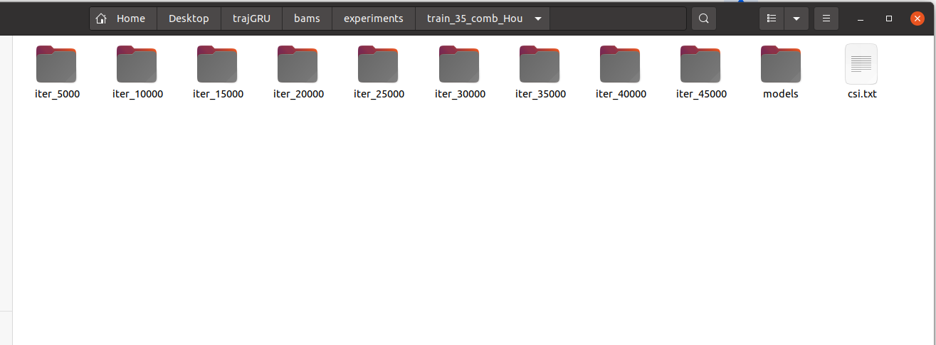
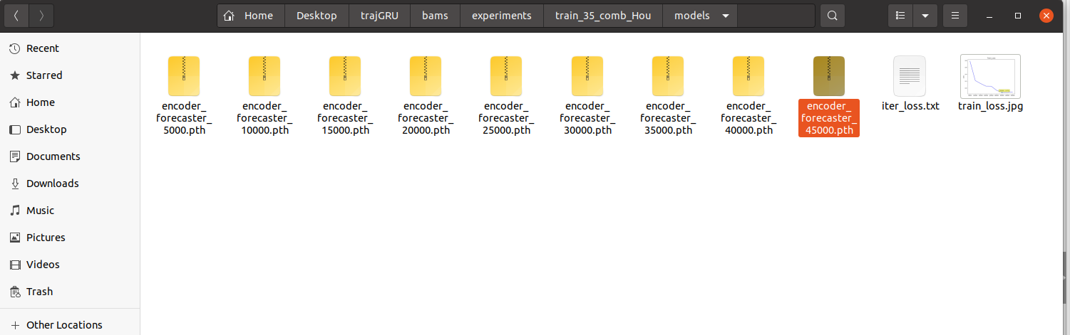
4, After may be few days training, you may get the saved model like this. Go to the models and copy encoder_forecaster_****.pth to a new directory that will store the test results. For me, it will be like
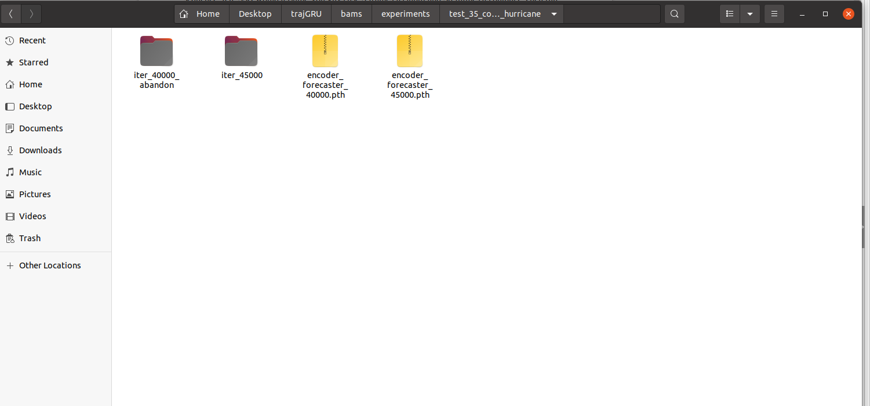
note that this iter_45000 will be generated later. Just copy .pth.

5, then run sh test_35.sh

tips: if you want to change some configuration about trajGRU, check the /bams/nowcasting/config.py.

