# Analysis of working memory experiment using state-trace

## 18 SUBJECTS with DESIGN LEVELS

## $T  
## [1] "Trace"  
##   
## $D  
## [1] "Lag1" "Lag2" "Lag3" "Lag4" "Lag6" "Lag8"  
##   
## $S  
## [1] "Accuracy" "Visibility"

## AVERAGE   
## ACCURACY

## , , S = Accuracy  
##   
## D  
## T Lag1 Lag2 Lag3 Lag4 Lag6 Lag8  
## Trace 0.68 0.61 0.6 0.61 0.75 0.72  
##   
## , , S = Visibility  
##   
## D  
## T Lag1 Lag2 Lag3 Lag4 Lag6 Lag8  
## Trace 0.26 0.31 0.32 0.39 0.55 0.53

## Loading required package: OpenMx

## Loading required package: digest

## Loading required package: MASS

## Loading required package: Matrix

## Warning: package 'Matrix' was built under R version 3.3.3

## Loading required package: Rcpp

## Loading required package: parallel

## OpenMx is not compiled to take advantage of computers with multiple cores.

##   
## Attaching package: 'OpenMx'

## The following objects are masked from 'package:Matrix':  
##   
## %&%, expm

## Loading required package: gtools

## CALCULATING BAYES FACTORS

## Warning in matrix(D.orderX, nrow = Dx.c, ncol = Dx.r): data length [14] is  
## not a sub-multiple or multiple of the number of columns [5]

## $BF0  
## $BF0$m.nm  
## 1001 1002 1003 1004 1005 1006   
## 2.39511341 0.08751937 4.17445071 3.66573085 1.31405478 0.33409053   
## 1007 1008 1009 10010 10011 10012   
## 27.14350468 1.08415386 0.47335621 1.11096873 12.76850796 2.79264719   
## 10013 10014 10015 10016 10017 10018   
## 0.55178472 3.17101101 2.21528285 3.61970110 11.63594627 2.39314076   
##   
##   
## $BF1  
## $BF1$m.nm  
## 1001 1002 1003 1004 1005 1006   
## 2.39511341 0.08751937 4.17445071 3.66573085 1.31405478 0.33409053   
## 1007 1008 1009 10010 10011 10012   
## 27.14350468 1.08415386 0.47335621 1.11096873 12.76850796 2.79264719   
## 10013 10014 10015 10016 10017 10018   
## 0.55178472 3.17101101 2.21528285 3.61970110 11.63594627 2.39314076   
##   
##   
## $BF2  
## $BF2$d.nd  
## 1001 1002 1003 1004 1005   
## 2.88508516 18.37361402 10.67880867 0.10868271 5.75433223   
## 1006 1007 1008 1009 10010   
## 1.61365781 2.14821665 32.59296137 5.42193273 0.16642311   
## 10011 10012 10013 10014 10015   
## 73.71542709 43.49795480 10.23480203 594.06685713 0.08288503   
## 10016 10017 10018   
## 27.60061491 6.91375065 0.96359565   
##   
## $BF2$m.nm  
## 1001 1002 1003 1004 1005   
## 0.5016733476 0.0353049185 0.6361942713 0.0381929915 0.4033104964   
## 1006 1007 1008 1009 10010   
## 0.0061634779 0.0260421808 0.0646873759 0.1105554641 0.0060864181   
## 10011 10012 10013 10014 10015   
## 0.8992366629 0.5060784166 0.2928649543 0.8820491411 0.2045009193   
## 10016 10017 10018   
## 0.2582826151 2.7708997101 0.0005600187   
##   
##   
## $BF3  
## $BF3$m  
## [1] 1.168422e-17  
##   
##   
## $BF4  
## $BF4$m  
## [1] 1.072403e+13  
##   
##   
## attr(,"type")  
## [1] "BF"

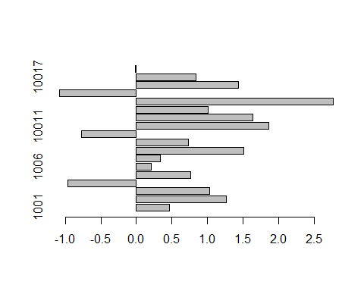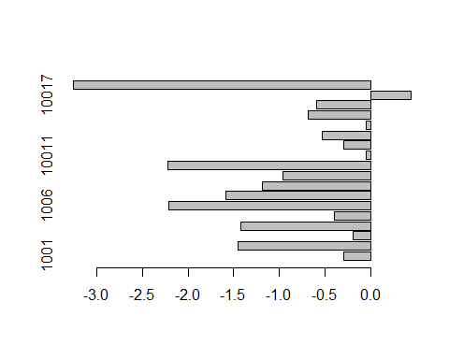

## Warning: package 'gdtools' was built under R version 3.3.3

