Scrolling:

The $2000 Register sets the name table to be displayed.

The $2005 Register sets the scroll. The first write sets the left/right value and the second write sets the up/down value.

Example:
LDA SOFT_2000 ; Get $2000 Settings
AND #%11111100 ; Remove Name Table
ORA NAME_TABLE ; Add Name Table
STA $2000 ; Store $2000 Settings
LDA XSCROLL ; Set Left / Right Scroll
STA $2005
LDA YSCROLL ; Set Up / Down Scroll
STA $2005

Mirroring has a great effect on our scrolling. When we want to scroll left and right like Super Mario Bros., we should use vertical mirroring so we can use name table 0 and name table 1. When we want to scroll up and down like Ice Climber, we should use horizontal mirroring so we can use name table 0 and name table 2.

The process for scrolling left/right or up/down is the same but on a different axis. The following will be based for a left/right scroll.

Reset:

In the Reset Routine, we need to load the initial screen and set the initial screen location (in 16-bits).

load_name_table:
LDA #$21 ; Set Number of Columns to Draw
STA DRAW_WIDTH
@column:
LDX XSCROLL+0 ; X Lo
LDY XSCROLL+1 ; X Hi
JSR get_column ; Get Name Table and Source Addresses
LDA #$1E ; Number of Rows in Column
STA DRAW_HEIGHT
JSR draw_column ; Draw Column to VRAM
LDX XSCROLL+0 ; X Lo
LDY XSCROLL+1 ; X Hi
JSR get_attribute ; Get Attribute Table and Source Addresses
JSR draw_attribute ; Draw Attribute to VRAM
LDA XSCROLL+0 ; Next Column
CLC
ADC #<$0008
STA XSCROLL+0
LDA XSCROLL+1
ADC #>$0008
STA XSCROLL+1
DEC DRAW_WIDTH ; Last Column?
BNE @column
LDA XSCROLL+0 ; Set to Original Location
SEC
SBC #<$0108
STA XSCROLL+0
LDA XSCROLL+1
SBC #>$0108
STA XSCROLL+1
RTS

get_column:
; Get Name Table Address
TXA ; X Lo / 8 = Name Table Address Lo
LSR
LSR
LSR
STA VRAM_ADDRESS+0
TYA ; X Hi
AND #%00000001 ; Even X Hi = Name Table 0, Odd X Hi = Name Table 1
ASL ; Name Table * 4 + $20 = Name Table Address Hi
ASL
ADC #>$2000
STA VRAM_ADDRESS+1
; Get Source Index
LDA XSCROLL+0 ; X / 8 = Column
STA SOURCE+0
LDA XSCROLL+1
STA SOURCE+1
LSR SOURCE+1
ROR SOURCE+0
LSR SOURCE+1
ROR SOURCE+0
LSR SOURCE+1
ROR SOURCE+0
ASL SOURCE+0 ; (Column * 32) - (Column * 2) = Source Index
ROL SOURCE+1
LDA SOURCE+0
STA TEMP+0
LDA SOURCE+1
STA TEMP+1
ASL SOURCE+0
ROL SOURCE+1
ASL SOURCE+0
ROL SOURCE+1
ASL SOURCE+0
ROL SOURCE+1
ASL SOURCE+0
ROL SOURCE+1
LDA SOURCE+0
SEC
SBC TEMP+0
STA SOURCE+0
LDA SOURCE+1
SBC TEMP+1
STA SOURCE+1
; Get Source Address
LDA SOURCE+0 ; Source Index + Source = Source Address
CLC
ADC #<title_name_table
STA SOURCE+0
LDA SOURCE+1
ADC #>title_name_table
STA SOURCE+1
RTS

draw_column:
LDA SOFT_2000 ; Get $2000 Settings
ORA #%00000100 ; Set VRAM Increment Down
STA $2000 ; Store VRAM Increment
LDA VRAM_ADDRESS+1 ; Store VRAM Address
STA $2006
LDA VRAM_ADDRESS+0
STA $2006
LDX DRAW_HEIGHT ; Set Rows to Draw
LDY #$00
: LDA (SOURCE),Y ; Store Tile in VRAM
STA $2007
INY ; Next Tile
DEX ; Last Row?
BNE :-
RTS

get_attribute:
; Get Attribute Table Address
TXA ; X Lo / 32 + $C0 = Attribute Table Address Lo
LSR
LSR
LSR
LSR
LSR
CLC
ADC #<$23C0
STA VRAM_ADDRESS+0
TYA ; X Hi
AND #%00000001 ; Even X Hi = Name Table 0, Odd X Hi = Name Table 1
ASL ; Name Table * 4 + $23 = Attribute Table Address Hi
ASL
ADC #>$23C0
STA VRAM_ADDRESS+1
; Get Source Index
LDA XSCROLL+0 ; X / 32 = Column
STA SOURCE+0
LDA XSCROLL+1
STA SOURCE+1
LSR SOURCE+1
ROR SOURCE+0
LSR SOURCE+1
ROR SOURCE+0
LSR SOURCE+1
ROR SOURCE+0
LSR SOURCE+1
ROR SOURCE+0
LSR SOURCE+1
ROR SOURCE+0
ASL SOURCE+0 ; Column * 8 = Source Index
ROL SOURCE+1
ASL SOURCE+0
ROL SOURCE+1
ASL SOURCE+0
ROL SOURCE+1
; Get Source Address
LDA SOURCE+0 ; Source Index + Source = Source Address
CLC
ADC #<title_attribute_table
STA SOURCE+0
LDA SOURCE+1
ADC #>title_attribute_table
STA SOURCE+1
RTS

draw_attribute:
LDY #$00 ; Set to First Attribute
@loop:
LDA VRAM_ADDRESS+1 ; Store VRAM Address
STA $2006
LDA VRAM_ADDRESS+0
STA $2006
LDA (SOURCE),Y ; Store Attribute in VRAM
STA $2007
INY ; Next Attribute
CPY #$08 ; Last Attribute?
BEQ @exit
LDA VRAM_ADDRESS+0 ; Next VRAM Address
CLC
ADC #$08
STA VRAM_ADDRESS+0
JMP @loop
@exit:
RTS

title_name_table:
.incbin "SMBlevel1.bin" ; Name Table

title_attribute_table:
.incbin "SMBattrib.bin" ; Attribute Table

NMI:

In the NMI, we need to update the scroll.

update_scroll:
LDA SOFT_2000 ; Get $2000 Settings
AND #%11111100 ; Remove Name Table
STA SOFT_2000
LDA XSCROLL+1 ; Get Name Table
AND #%00000001
ORA SOFT_2000 ; Add $2000 Settings
STA SOFT_2000 ; Store $2000 Settings
STA $2000
LDA XSCROLL+0 ; Set Vertical Scroll Offset
STA $2005
LDA YSCROLL ; Set Horizontal Scroll Offset
STA $2005
RTS

Now we have loaded the initial name table (the red box) and one column in the next name table.

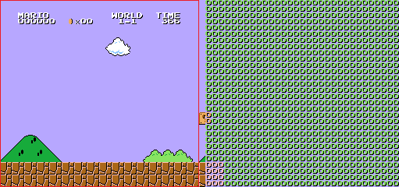
Game Loop:

In the Game Loop, we need to calculate the scrolling and buffer new columns and attributes.

scroll_check:
LDA #$00 ; Clear Direction
STA X_DIRECTION
JSR move ; Check Movement
JSR column_check ; New Column?
JSR attribute_check ; New Attribute?
RTS

move:
@left:
LDA JOYRAW1 ; Left Button?
AND #LEFT_BUTTON
BEQ @right
LDA XSCROLL+0 ; Move Left?
CMP #<$0001 ; Max Scroll Left Lo
LDA XSCROLL+1
SBC #>$0001 ; Max Scroll Left Hi
BCC @exit
@moveleft:
LDA DRAW_FLAG ; Wait for Previous Draw
BNE @moveleft
LDA #$FF ; Speed Left
STA X_DIRECTION
CLC ; Change Scroll by Speed
ADC XSCROLL+0
STA XSCROLL+0
LDA XSCROLL+1
SBC #$00
STA XSCROLL+1
JMP @exit
@right:
LDA JOYRAW1 ; Right Button?
AND #RIGHT_BUTTON
BEQ @exit
LDA XSCROLL+0 ; Move Right?
CMP #<$0300 ; Max Scroll Right Lo
LDA XSCROLL+1
SBC #>$0300 ; Max Scroll Right Hi
BCS @exit
@moveright:
LDA DRAW_FLAG ; Wait for Previous Draw
BNE @moveright
LDA #$01 ; Speed Right
STA X_DIRECTION
CLC ; Change Scroll by Speed
ADC XSCROLL+0
STA XSCROLL+0
LDA XSCROLL+1
ADC #$00
STA XSCROLL+1
@exit:
RTS

After we have moved 8 pixels, we need to draw a new column.

column_check:
LDA XSCROLL+0 ; Moved 8 pixels?
AND #%0000111
BNE @exit
LDA X_DIRECTION ; No Movement?
BEQ @exit
BPL @right ; Moved Left or Right?
@left:
LDA XSCROLL+0 ; Set to New Column
SEC
SBC #<$0010
STA XSCROLL+0
TAX
LDA XSCROLL+1
SBC #>$0010
STA XSCROLL+1
TAY
JSR get_column ; Get Name Table and Source Addresses
JSR buffer_column ; Buffer Column
LDA XSCROLL+0 ; Set to Current Column
CLC
ADC #<$0010
STA XSCROLL+0
LDA XSCROLL+1
ADC #>$0010
STA XSCROLL+1
JMP @exit
@right:
LDA XSCROLL+0 ; Set to New Column
CLC
ADC #<$0100
STA XSCROLL+0
TAX
LDA XSCROLL+1
ADC #>$0100
STA XSCROLL+1
TAY
JSR get_column ; Get Name Table and Source Addresses
JSR buffer_column ; Buffer Column
LDA XSCROLL+0 ; Set to Current Column
SEC
SBC #<$0100
STA XSCROLL+0
LDA XSCROLL+1
SBC #>$0100
STA XSCROLL+1
@exit:
RTS

buffer_column:
LDX VRAM_ADDRESS+0 ; Set VRAM Address Lo
LDA VRAM_ADDRESS+1 ; Set VRAM Address Hi
CLC
ADC #%10000000 ; Add VRAM Increment Down
TAY
LDA #$1E ; Set Number of Rows in Column
JSR buffer_vram
RTS

Now the scroll has moved 8 pixels right in the name table (the red box) and the next column is ready to move right. We also see that the previous column is still available to move left.

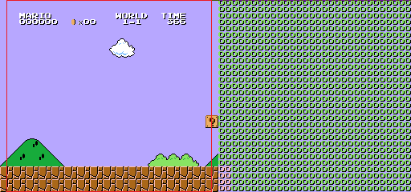

After we have moved 32 pixels, we need to draw a new attribute.

attribute_check:
LDA XSCROLL+0 ; Moved 32 pixels?
AND #%00011111
BNE @exit
LDA X_DIRECTION ; No Movement?
BEQ @exit
BPL @right ; Left or Right?
@left:
LDA XSCROLL+0 ; Set to New Column
SEC
SBC #<$0010
STA XSCROLL+0
TAX
LDA XSCROLL+1
SBC #>$0010
STA XSCROLL+1
TAY
JSR get_attribute ; Get Attribute Table and Source Addresses
JSR buffer_attribute ; Buffer Attribute
LDA XSCROLL+0 ; Set to Current Column
CLC
ADC #<$0010
STA XSCROLL+0
LDA XSCROLL+1
ADC #>$0010
STA XSCROLL+1
JMP @exit
@right:
LDA XSCROLL+0 ; Set to New Column
CLC
ADC #<$0100
STA XSCROLL+0
TAX
LDA XSCROLL+1
ADC #>$0100
STA XSCROLL+1
TAY
JSR get_attribute ; Get Attribute Table and Source Addresses
JSR buffer_attribute ; Buffer Attribute
LDA XSCROLL+0 ; Set to Current Column
SEC
SBC #<$0100
STA XSCROLL+0
LDA XSCROLL+1
SBC #>$0100
STA XSCROLL+1
@exit:
RTS

buffer_attribute:
LDY #$00 ; Set Attribute Row Index
@loop:
TYA ; Store Attribute Row Index
PHA
LDX VRAM_ADDRESS+0 ; Set VRAM Address Lo
LDY VRAM_ADDRESS+1 ; Set VRAM Address Hi
LDA #$01 ; Set Number of Attributes
JSR buffer_vram
PLA ; Get Attribute Row Index
TAY
INY ; Next Attribute Row
CPY #$08 ; Last Attribute Row?
BEQ @exit
LDA VRAM_ADDRESS+0 ; Next Attribute Row Address
CLC
ADC #$08
STA VRAM_ADDRESS+0
INC SOURCE+0 ; Next Source Address
BNE @loop
INC SOURCE+1
JMP @loop
@exit:
RTS

Now the scroll has moved 32 pixels right in the name table (the red box) and the next column is ready to move right.

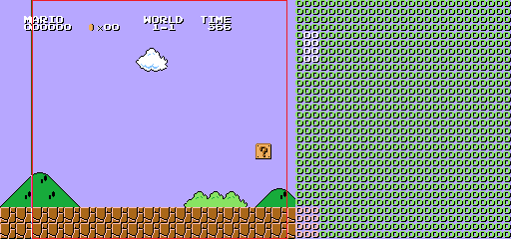

When we scroll 256 pixels right (below XSCROLL = #$0100), it is important to make sure to change the name table to be displayed (the red box) else you’ll incorrectly wrap back to the first column. The new columns being drawn will occur on the old name table as we see with the first column.

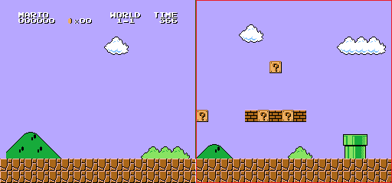
Scroll Both Up/Down and Left/Right:

The process for doing both is harder but works in a similar manner. We need to update either all the up/down scrolling or all the left/right scrolling then the other in the game loop.

However, unless we are using a mapper with 4-way scrolling then mirroring gets in the way as we have no free columns in vertical mirroring and no free rows in horizontal mirroring. To work around this, we can use the $2001 Register to clip the left column of the screen allowing one free column with horizontal mirroring.

We can see the clipping being used in the screenshot of Super Mario Bros. 3
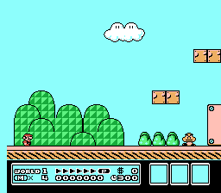

Because we only have one column to handle both left and right movement, we will see “screen artifacts”. “Screen artifacts” are previous column or attribute values on the edge of the screen. In the following snapshot, we see the previous attribute value making part of the pink box green.

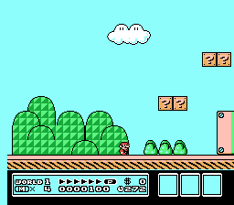

We also have to adjust the left/right update sizes to smaller increments. At the forth pixel move right, we need to update the column. At the eighth pixel move right, we need to update the first half of the attribute. At the twenty-fourth pixel move right, we need to update the second half of the attribute. Note: there are advanced techniques to create smaller “screen artifacts” than the original Super Mario Bros. 3 or even none.

