## Homework3:

**#Problem1:**

**a.**

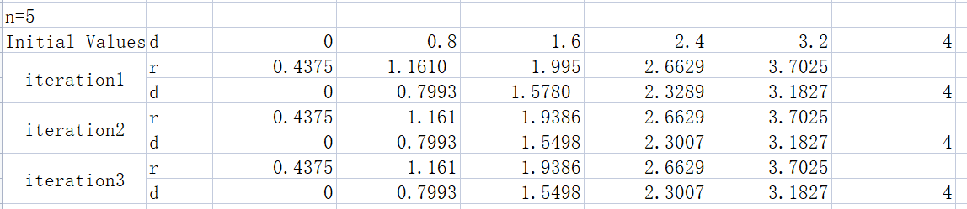

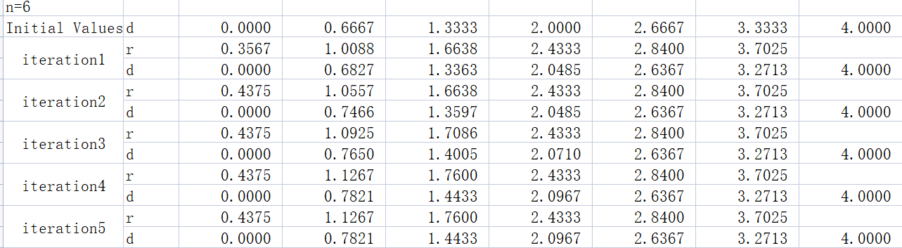

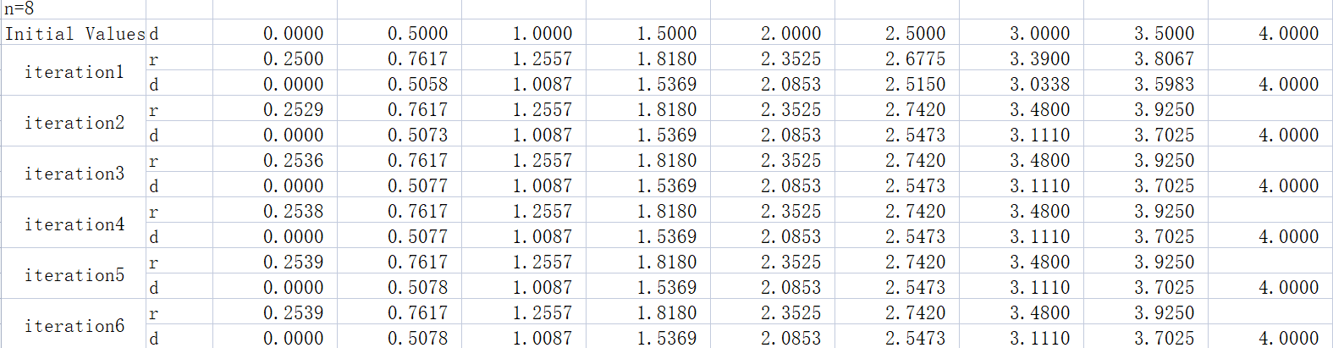

**b.**

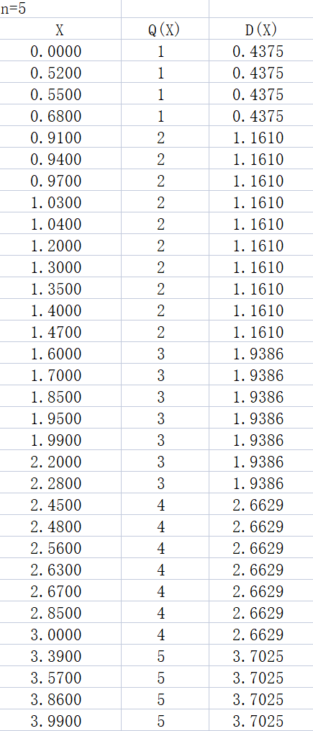 MSE5 = 0.0465 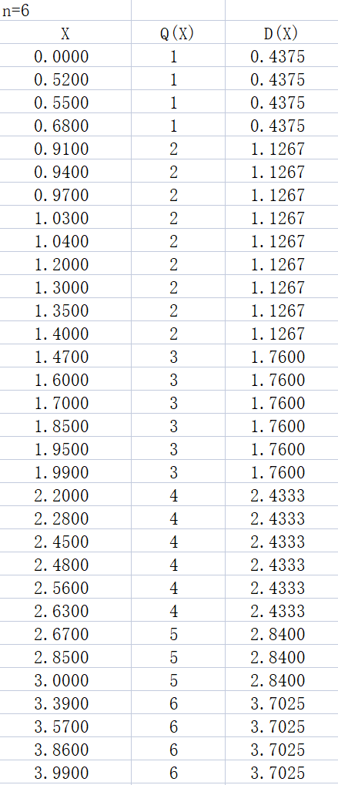 MSE6 = 0.0367

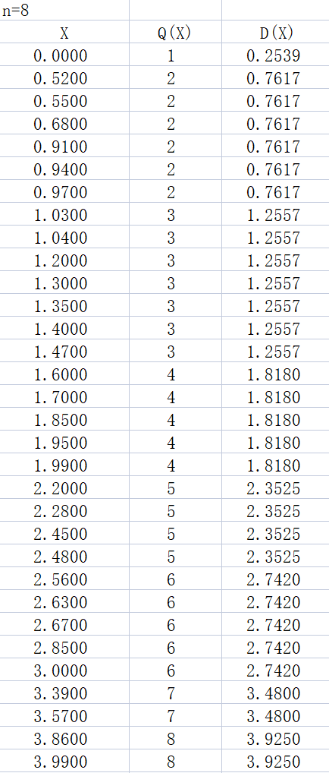 MSE8 = 0.0240

**c.**

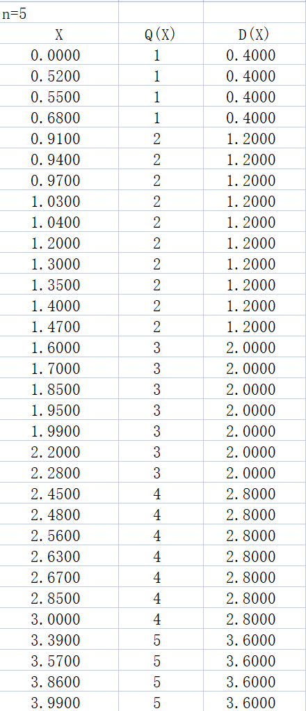 MSE5=0.0543 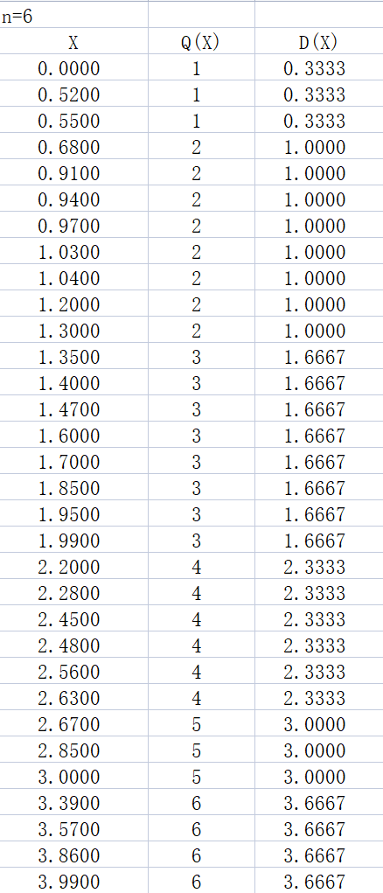MSE6=0.044

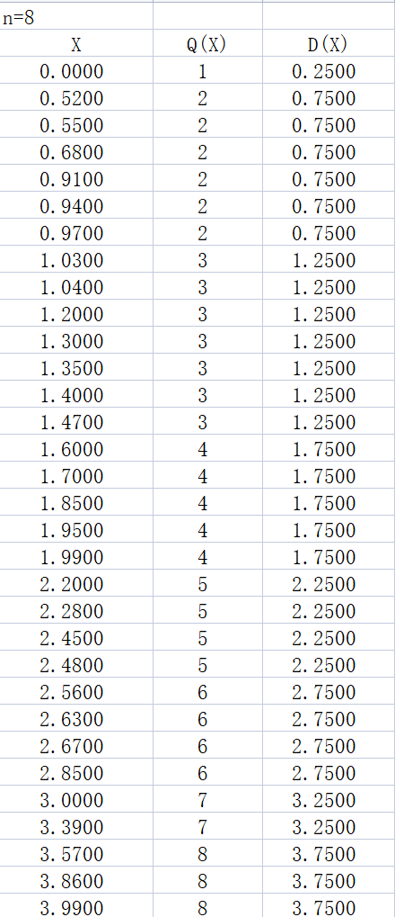MSE8=0.0290

**d.**

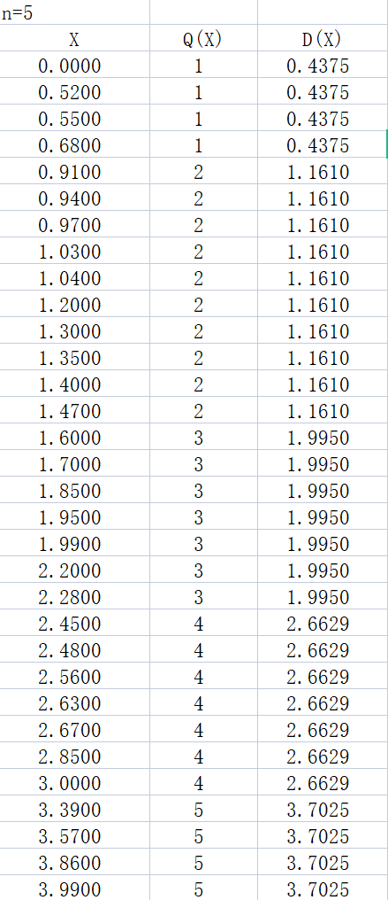MSE5=0.0472 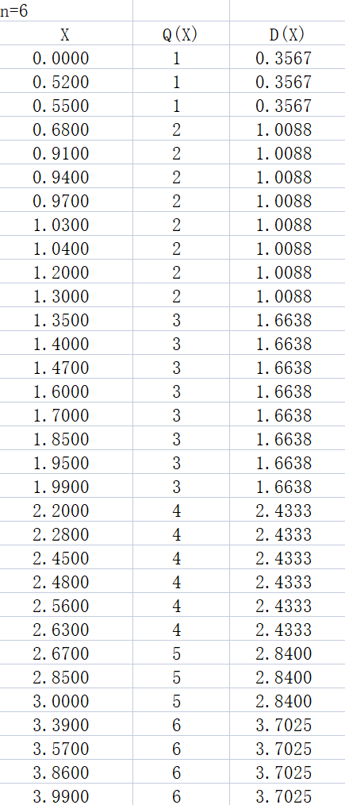MSE6=0.0401

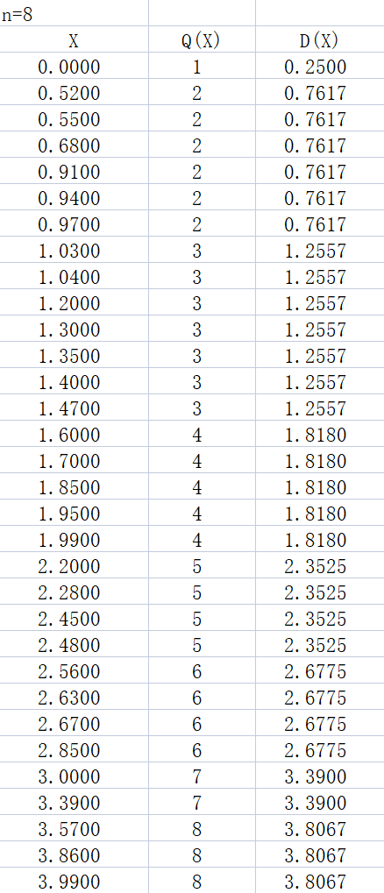MSE8=0.0282

**E.**

|  |  |  |  |
| --- | --- | --- | --- |
|  | **MLn** | **UQn** | **SUQn** |
| **N=5** | 0.0465 | 0.0543 | 0.0472 |
| **N=6** | 0.0367 | 0.0447 | 0.0401 |
| **N=8** | 0.0240 | 0.0290 | 0.0282 |

**#Problem2**

**a.**

*[I,map]=imread('river.gif');*

*G=ind2gray(I,map);*

*H = entropy(G);*

The entropy is 6.5977.

**b.**



The entropy of 

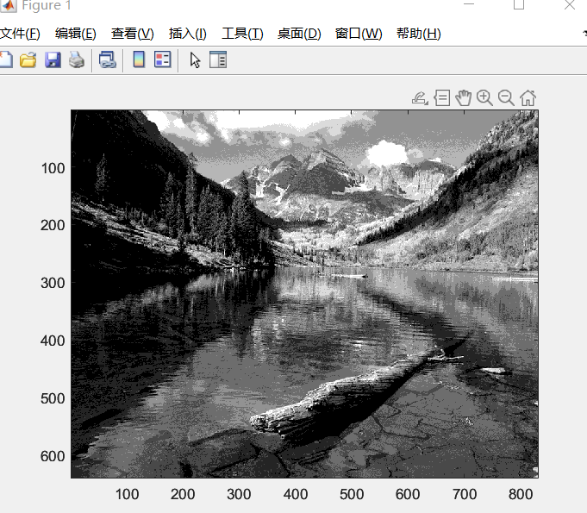



**C.**



The entropy of 

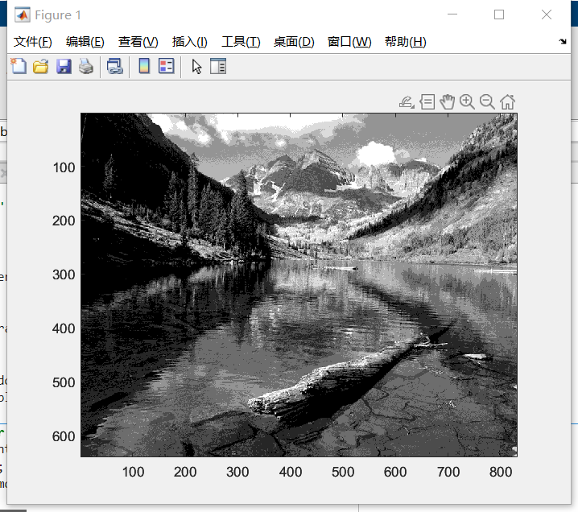

**D.**



The entropy of 

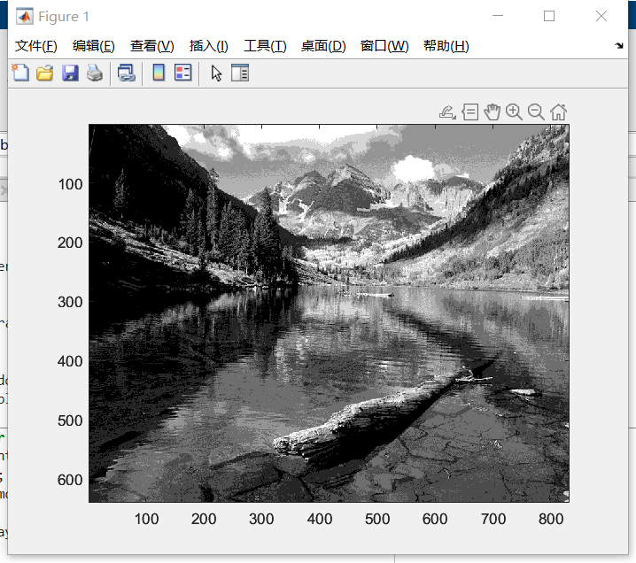

**#Problem3**

**a.**

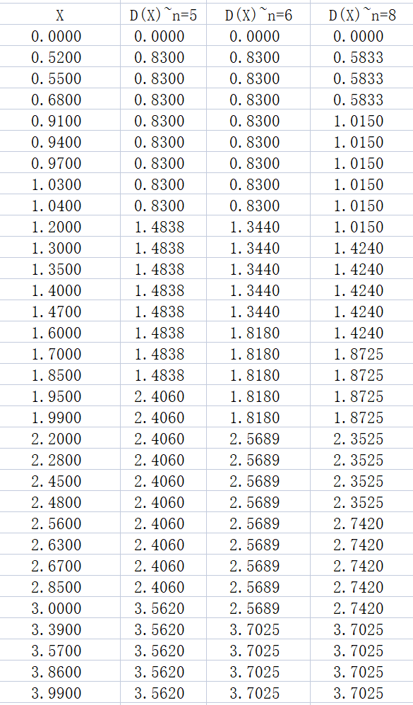

**B.**



**C.**

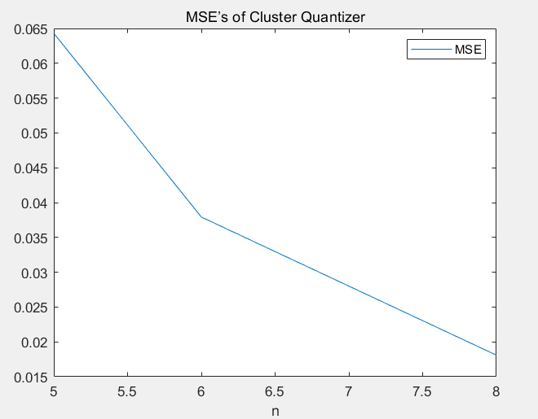 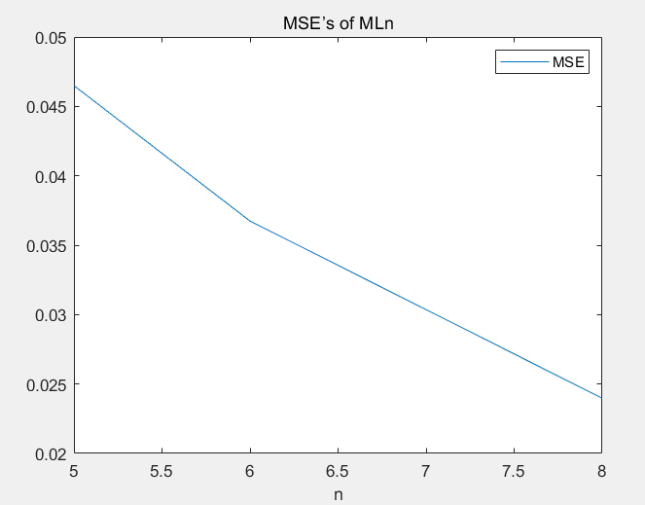

**#Problem4**

**a.**

**BR=，CR=**

**b.**

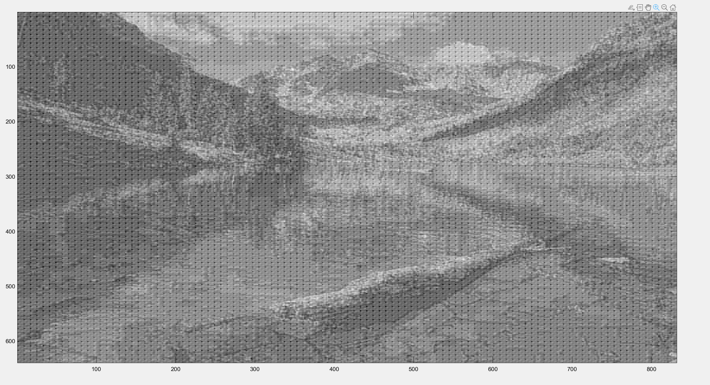



**C.**

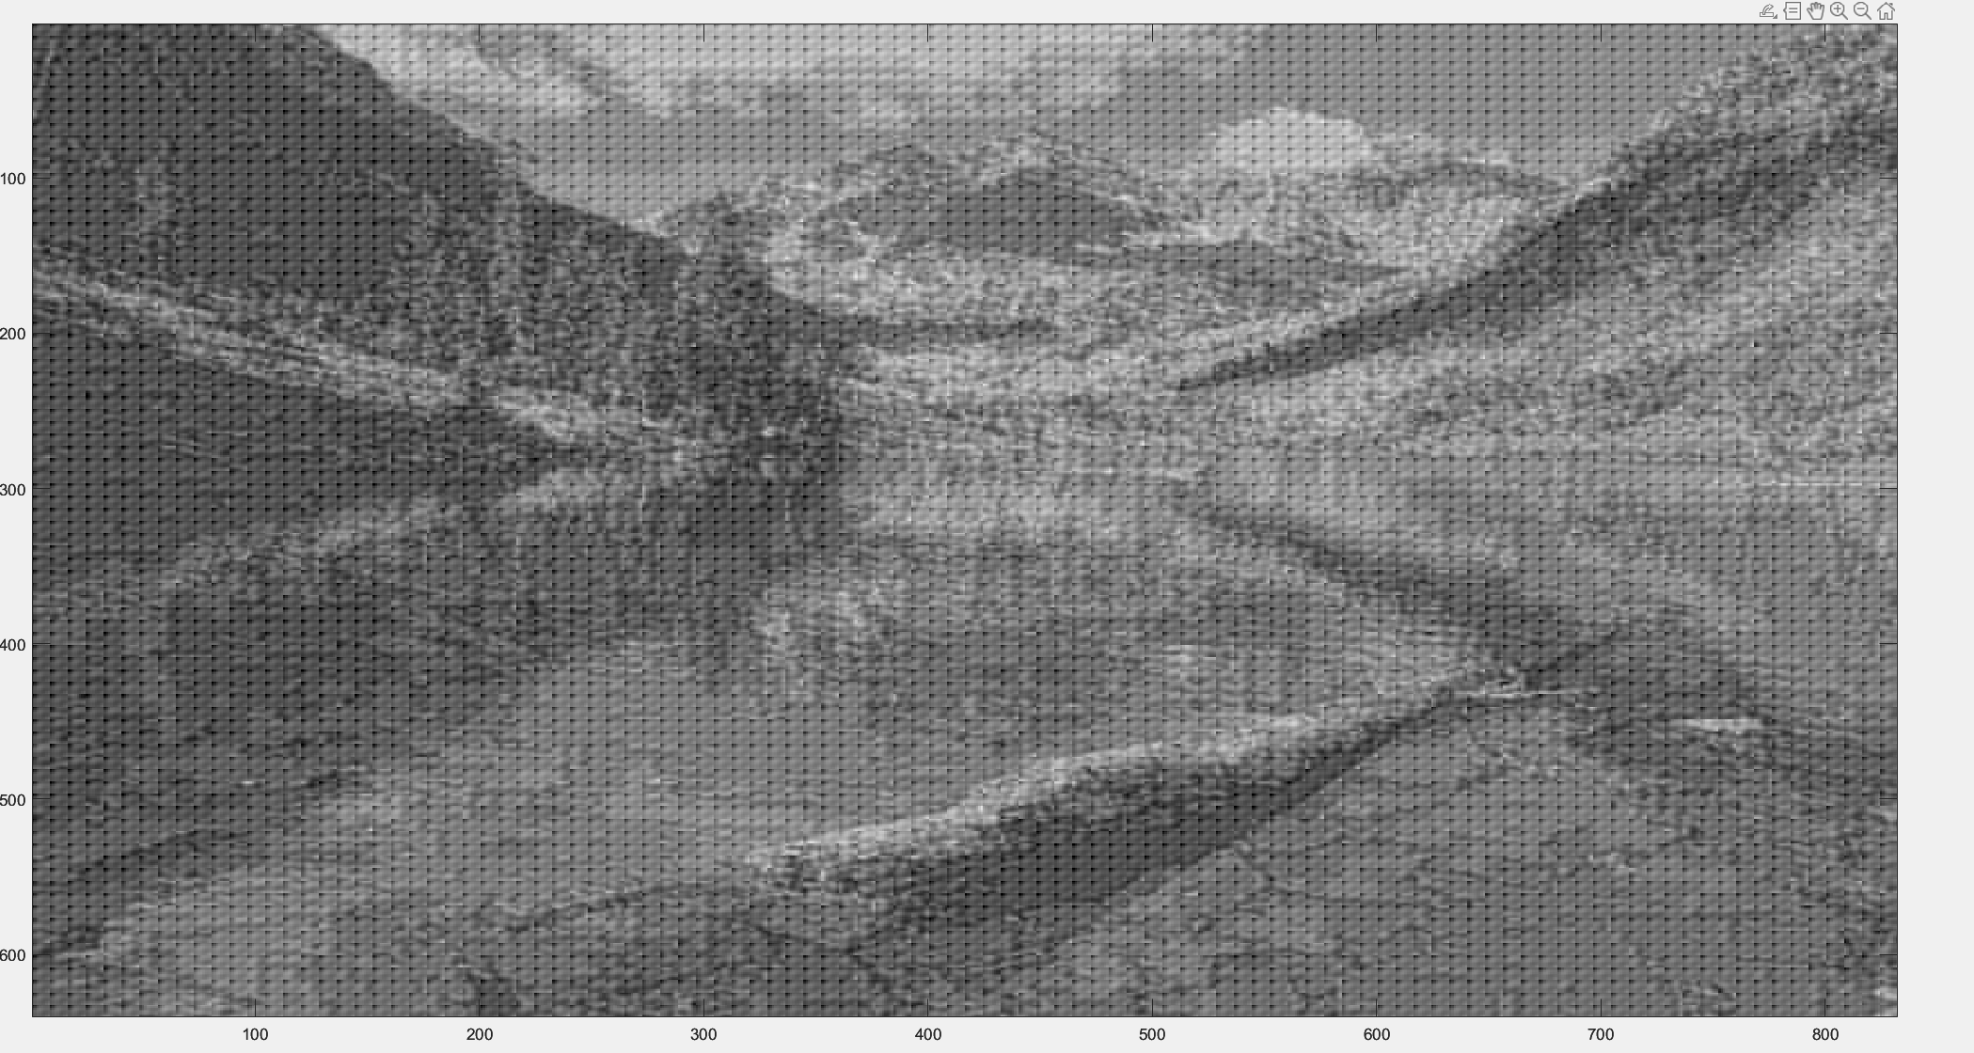

 **BR=，CR=**

**d.**

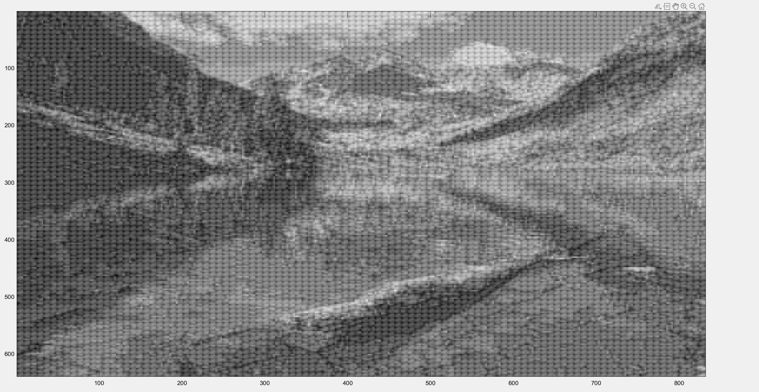

 **BR=，CR=**

**E.**

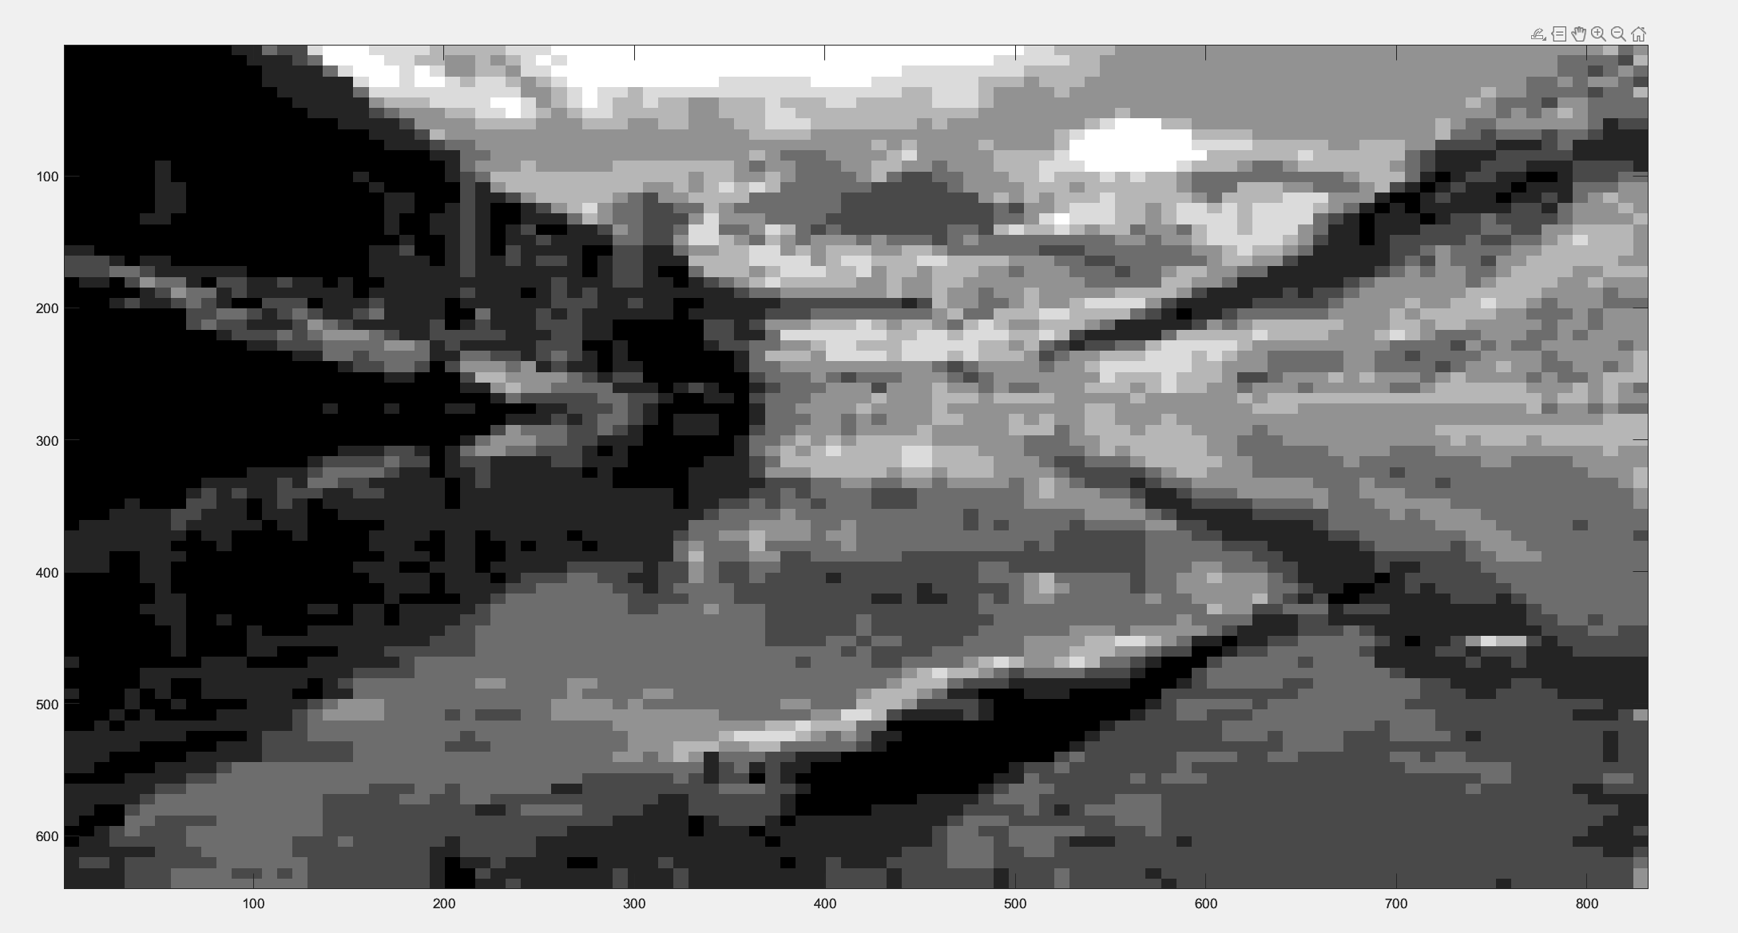

 **BR=，CR=**

**F.**

|  |  |  |  |  |
| --- | --- | --- | --- | --- |
|  | **Ghat15** | **Ghat10** | **Ghat6** | **Ghat1** |
| **BR** | **31/512** | **21/512** | **13/512** | **3/512** |
| **SNR** | **7.6859** | **9.4027** | **11.3568** | **14.3281** |
| **Image** |  |  |  |  |