WK7: In-class Exercise

Use jQuery to develop the Temperature program that you wrote for WK4-in-class.

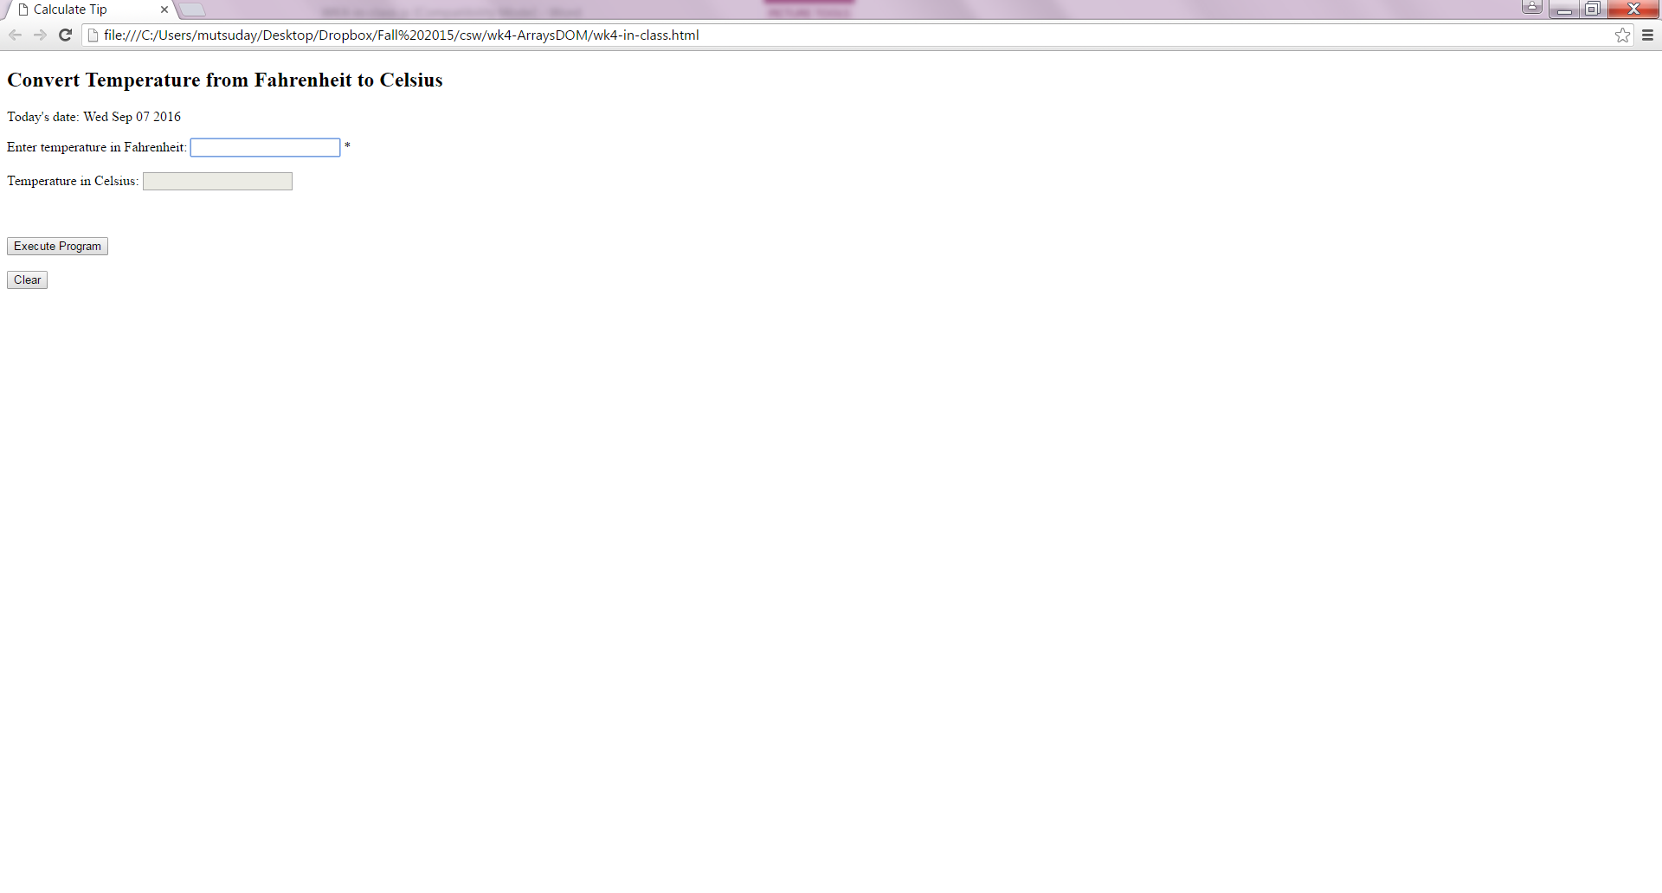

Print an error message in place of the \* (using a span tag) when letters or negative numbers are entered. Add a clear button which clears the textboxes and the span tag.

Answer the following questions on this document and show it to me in class when you demonstrate your program.

1. In your own words, explain what is jQuery?
2. How is the jQuery $ function similar to the $ function we wrote so far in the class?
3. What is one ability that the jQuery $ function has that our $ function doesn’t have?