**577 hw08 problem2**

**By Haoyi Lu & William Shu**

Problem a & b:

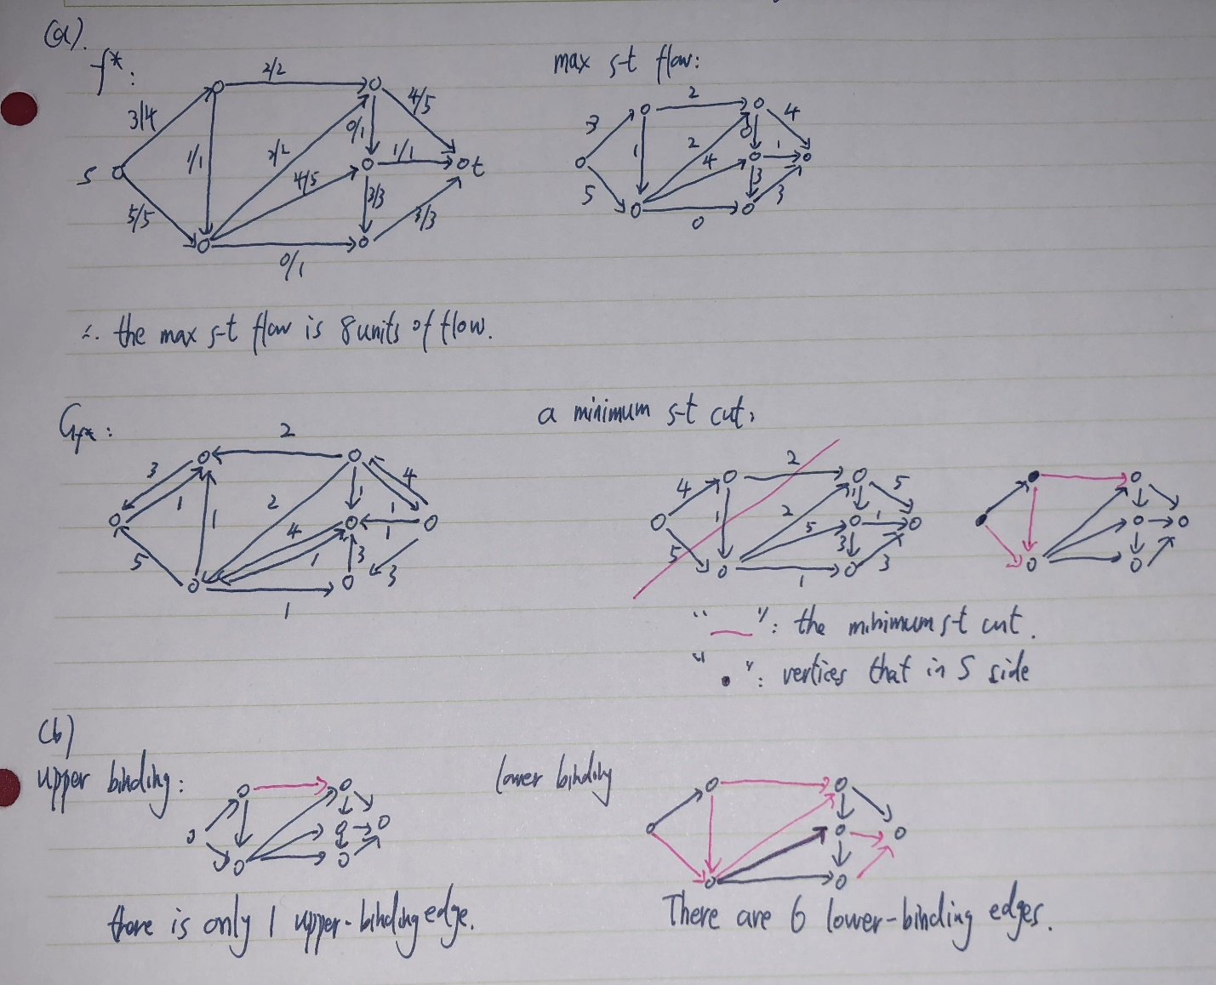

Problem c:

The algorithm is as follow:

1. Construct Gf*. Finding all vertices that are reachable from s in Gf* by BFS/DFS and denote the set by S.
2. Construct reversed Gf*. Finding all vertices that are reachable from t in reversed Gf* by BFS/DFS and denote the set by T.
3. Go through all edges (u, v) where u∈S and v ∈T. These are all the upper-binding edges in G.

Prove for correctness:

Only edges which are used to their capacity (fu,v = cu,v) can be upper-binding. Because only increasing the capacity of such an edge leads to a new edge in the residual graph Gf and hence potentially to a new augmenting path from s to t.

So the overall idea is finding the edge (u,v) with fully used, which means in Gf* there is only a directed path from v to u. And if u can be reached from s and t can be reached from v in Gf*, then the edge (u,v) is an upper-binding edge because adding a 1 capacity can lead to a new path from u to v in Gf* and then s can find a new path to t (we have said s has path to u and v has path to t, now there is a new path from u to v and hence s has a new path to t).

In our algorithm, step 1 is finding all vertices which are reachable from s; step 2 is finding all vertices which have paths to t; step 3 is finding all the edges (u,v) that satisfies u∈S and v ∈T. These are the edges which increased capacity would build a new path from s to t and then increasing the value of maximum flow by 1.

Running time:

Step1 and step 2 takes O(m+n)

Step 3 takes O(m).

So the total running time is linear and it is O(m+n).