**Reading Questions Week 2**

**Willem Bruin – 10209735**

1. 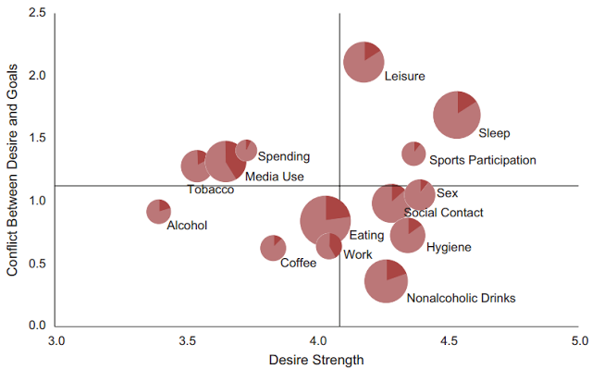

“degree to which participants’ desires conflicted with their goals as a function of the strength of the desire. The crossing horizontal and vertical lines indicate the grand means for conflict and strength in this sample. Results are shown for 14 different desire domains; the sizes of the pie charts represent the relative frequency of the desire. In each pie chart, the lighter portions indicate the probability of successfully controlling the desire (i.e., not enacting the desired behavior when attempting to resist it), whereas the darker portions indicate the probability of self-control failure”

Source: <http://pss.sagepub.com/content/early/2012/04/27/0956797612437426>

1. Position: this might be the most powerful visual variable in this graph. It has evident selective value since the location of pie charts are dependent on numeric values (desire strength and a quantification of conflict). Additionally, position has associative value since the figure shows different clusters grouped together. For example, media use, tobacco and spending money in the top left corner have relatively lower desire strength but higher conflict with participants’ goals, whereas the bottom right corner (sex, social contact & hygiene) have higher desire strength but lower conflicts with participants’ goals. Size: this visual variable is used to represent the relative frequency of the specified desire pie chart. Changes in size give rise to both order and association; it is shown in this figure that eating is the desire that participants feel the most often, in contrast to spending money which apparently affects participants the least.
2. This visualization was used for psychological research and in this case the domain problem characterization would be more or less identical to the goal of this study: the assessment and comparison of base rates with which various desires are experienced and resisted in people’s natural environments. In line with this, the data/operation abstraction is characterized by the data type output which is ultimately used for visual encoding; experience sampling was used to measure desires and desire regulation in everyday life to reveal differences in frequency and strength, the degree of conflict between desires and other goals, and the likelihood of resisting desire and the success of this resistance.
3. In my opinion this visualization does embody good practice. The goal of the designer was to assess and compare rates of experience and resistance of various desires. By using a pie-chart scatter plot the designer was able to represent this data while simultaneously enabling the comparison between different marks.
4. I believe visualization can be a form of functional art, it is not just the representation of pure information. Additionally a sense of creativity is needed to make a good visualization and what we regard as having good quality changes both with context and over time. Then again functional art does not always have to be in the form of visualization. One can use senses apart from sight as well as a medium to convey functional art.
5. This particular visualization was made for a Psychological Science journal and used to shed light on what people desire nowadays, what they feel conflicted about and what they try to resist in daily life. Therefor it is likely that the primary task of the designer was to present what these distinct desires actually are. This has been achieved since all desire data in this visualization have been represented by its own pie chart size and position. Additionally, this visualization allows comparisons; one is able to compare different desires with one another and see how a particular desire strength relates to its conflict between desire and goals, as well as its relative frequency and probability of self-control failure. There is also a trend of organization; the different desires have been grouped in different clusters along the x and y axis as well as an additional order in pie chart size to represent the relative frequency of the given desire. However, because so much different aspects of desire data are represented at once (pie chart size, position, color), it is hard for the reader to draw fast and evident conclusions regarding the correlations between different desires.