Welcome to the Steampunk Airship. As you are 50 KM up in the air you’ll be held company by automated turrets, rotation gears and a beautiful sunset.

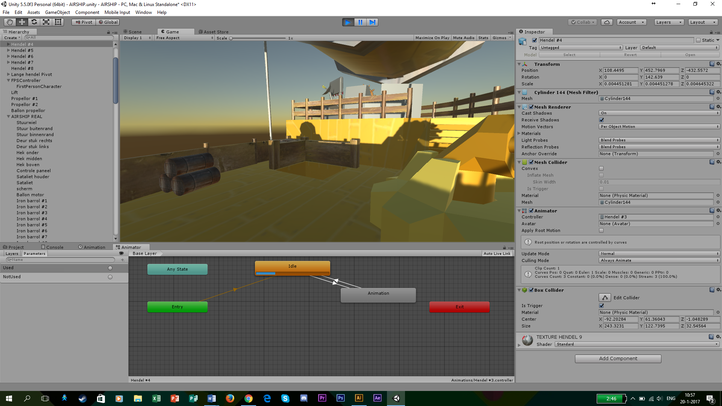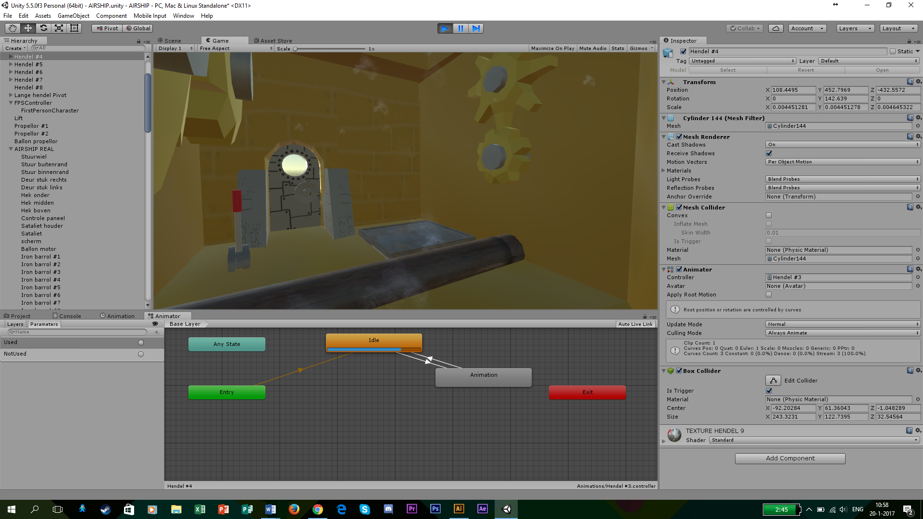

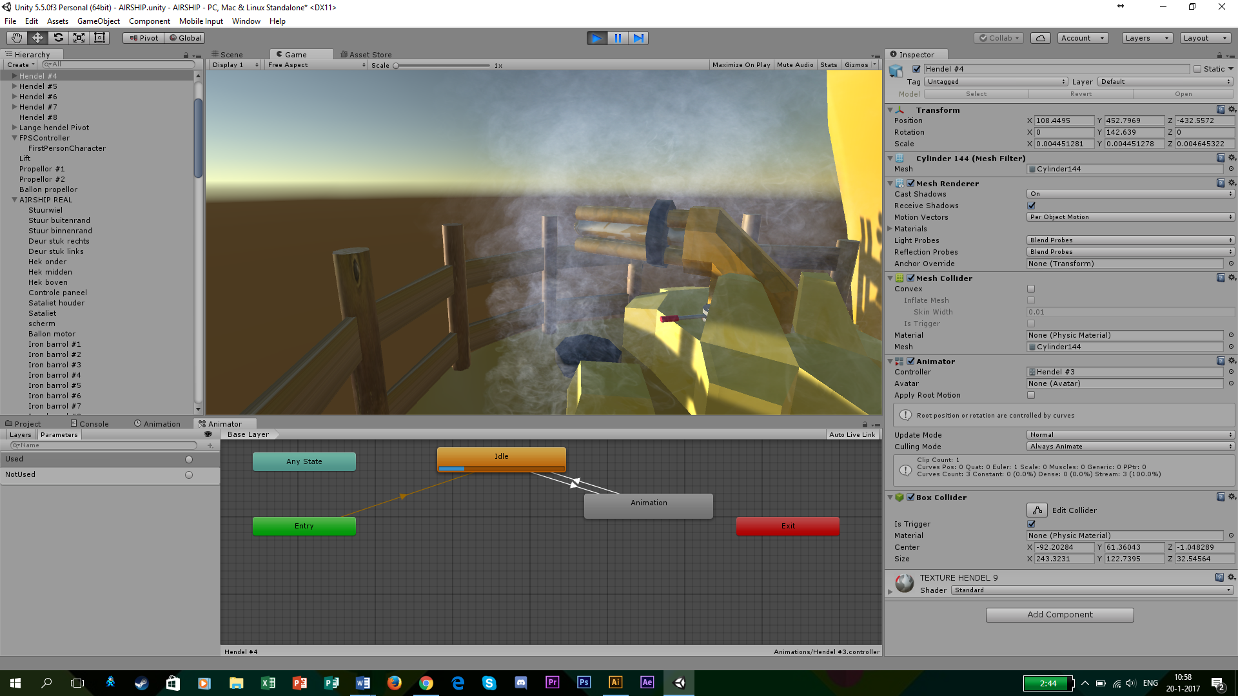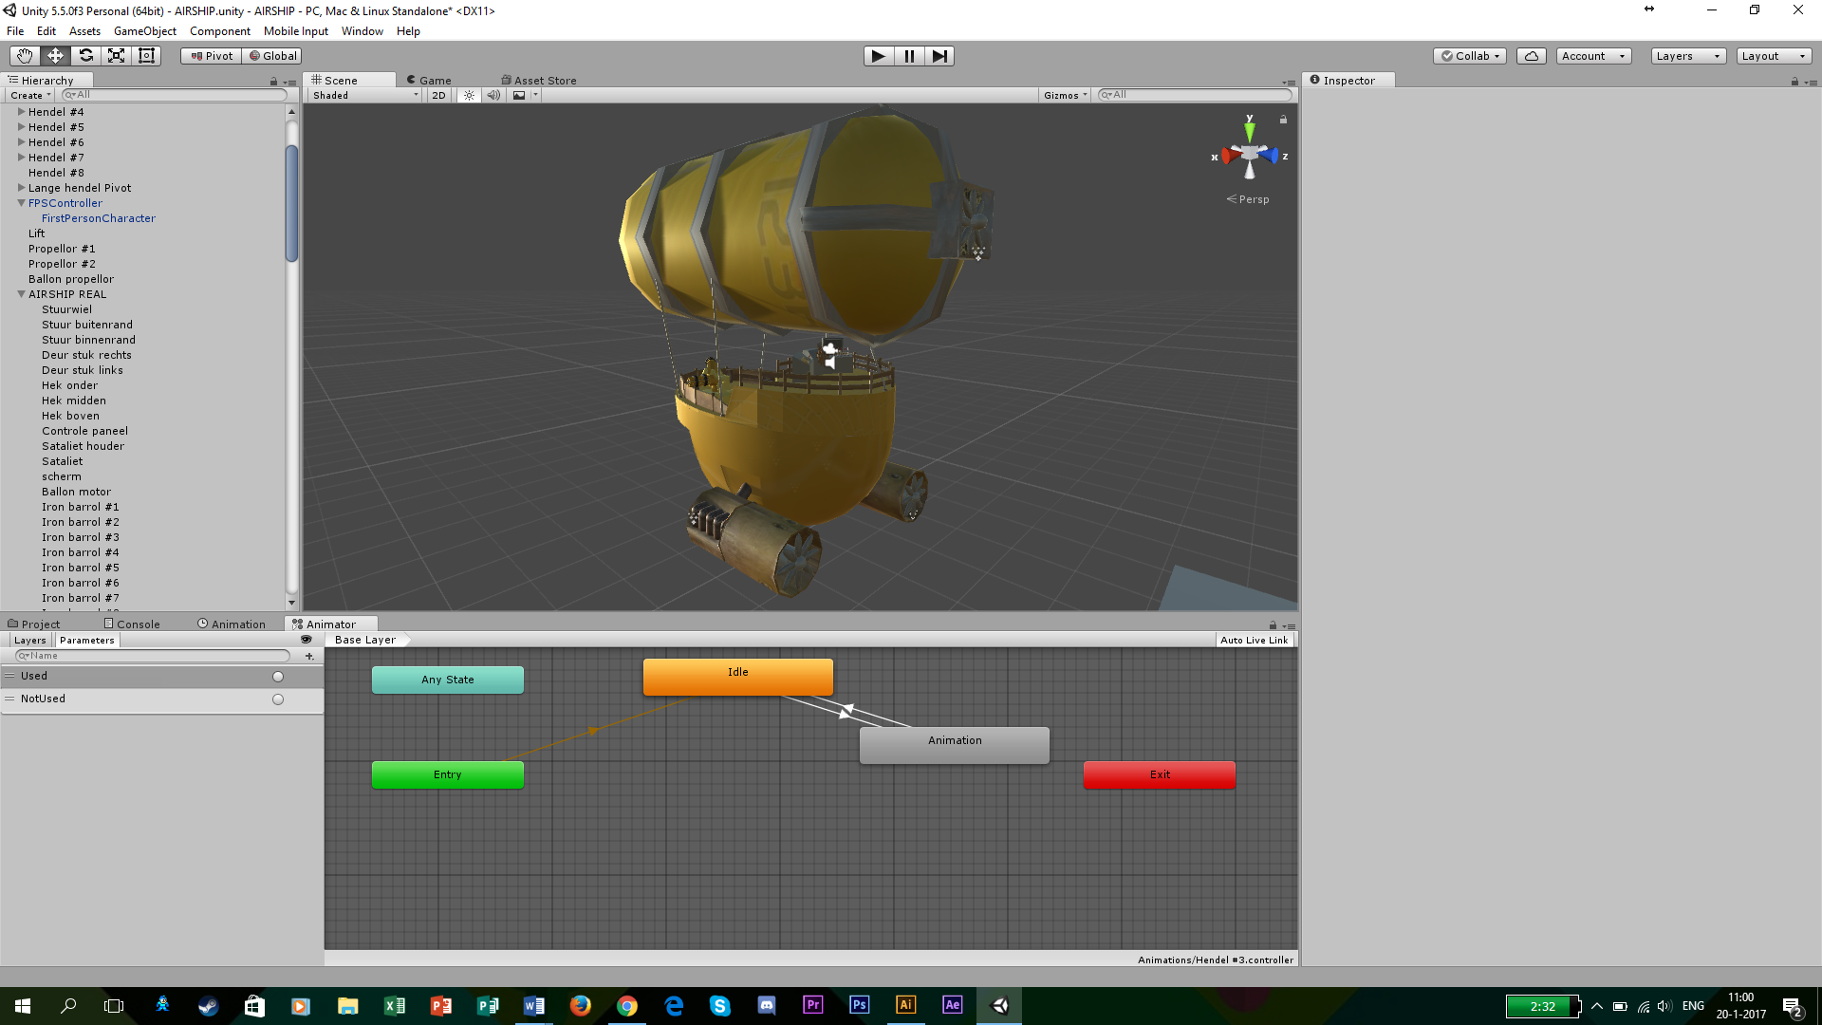

**Featuring**

* Fully automated rotation turrets
* Interactivity with the levers and elevator.
* Nice details that spice up the area.
* Beautiful steampunk atmosphere.
* And plesuring background music.