CoverCam

Purpose
Perform change detection on time series data (f.e. NDVI) using historical data, on per layer and per class basis.

Installation
Install the .sav files in the save_add folder (see also ENVI .sav files: Installation and configuration.
nrs_Utils.sav Library with utility routines
CoverCam.sav The actual software

Usage (gui)
covercam | Start the user interface of the change detection.
Alternatively start from the ENVI menu with ‘NRS | Probability of change (CoverCam)’. The following dialog will appear:
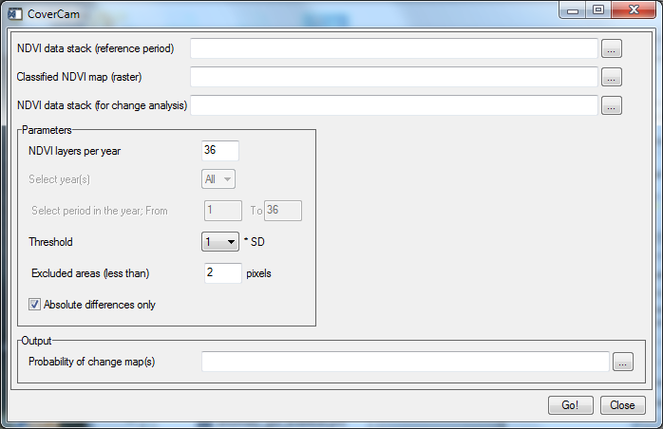
NDVI data stack (reference period) | The historical time series
Classified NDVI map (raster) | A classified image; unclassified values are recognized and used as a mask
NDVI data stack (for change analysis) | A (time series) input image, with byte per pixel / layer. This data is compared with the historical data for the change detection
NDVI layers per year | Number of layers per year in the time series
Select year | The change detection can be calculated for the entire period or only a single year
Select period | The change detection can be calculated for a specific period in the year
Threshold | The multiplication factor to calculate the probability of change; higher factors make the calculation less sensitive. Current selections are: 1.0, 1.5, 2.0, 2.5, 3.0, 3.5
Excluded areas (less than) | The calculation ignores areas that have less than a user specified number of pixels
Absolute differences only | If set will only calculate positive differences from the pooled standard deviation; if not set will calculate the actual difference from the pooled standard deviation
Probability of change image | The output of the change detection

Details
Area numbering:
The calculation is started by processing the classified image to determine all connected areas in the image. These areas are considered one by one later on. The areas are than checked on the size: if an area is smaller than the user specified (Mask area of at most N pixels) then this area is added to the mask. The areas with unclassified value are also added to the mask.
Historical data:
The historical data is used to create a lookup table per layer and per class (from the classified image). For each class/layer combination the standard deviation in the layer is calculated. This result in a 2D-table (#layers x #classes); the layers at the same period in the different years are then combined in a single so-called pooled standard deviation. This give the final lookup table (lut) with #layers_per_year x #classes.
Probability of change:
Now all areas that are not masked are processed. The average of the areas in the reference time series is calculated. For the same area the SD value is retrieved from the lut calculated above. This SD is multiplied by the user specified SD multiplier to adjust the sensitivity. Finally the magnitude is calculated (per layer) as the difference of the pixel value and the sum of the average and the final sensitivity number. By default (absolute differences only option is switched on) only the positive differences are summed to end up with a single value (the probability of change) for each location. If the option is switched off the actual differences are summed.

