Module ‘CopyShape’

Purpose
Extract spectra from a hyper spectral image and add the values of the spectra as attributes into a shapefile. The location of the spectra is determined by the point features in the shape file.

Installation
Installation is simple. Copy the ‘copyshape.sav’ file to the ENVI save_add extension folder. Restart ENVI, that’s it.

Usage
Restore the IDL if it is still minimized. On the ‘ENVI’ command line type:
copyshape

Output
The module will create a new shape file in the same folder as the original. The name of the new shape file is the original name extended with ‘_copy’. If you run the module several times, be aware that it will overwrite existing files without asking.

Explanation:
You will first be asked for the name of the input shape file (in an open file dialog)
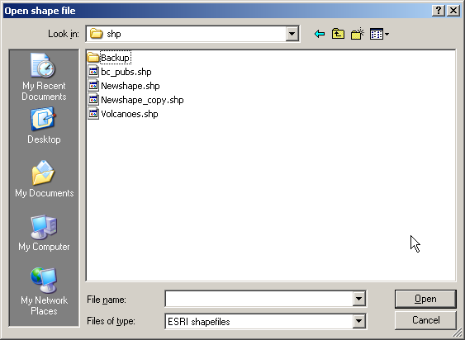
Next you can select the hyper spectral image in a regular ENVI image open dialog:
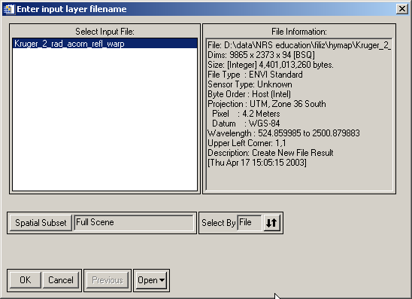
Clicking OK will start the process.
During the copy a progress indicator is displayed.

If the command line is not displayed, select ‘Window’ | ‘Command Input’ from the IDL main menu

