**CSI4142**

**Fundamentals of Data Science**

Course Professor**: Yazan Otoum**

Supervisor**: Lansu Dai**

**Phase 2: Physical Design and Data Staging**

Group 15

Team Members:

|  |  |
| --- | --- |
| First Name, Last Name: | Student ID: |
| Lixiong Wei | 300145970 |
| Zhiyuan Lin | 300126813 |

Due Date: March 22nd

**A one-page schematic with your high-level data staging plan.**

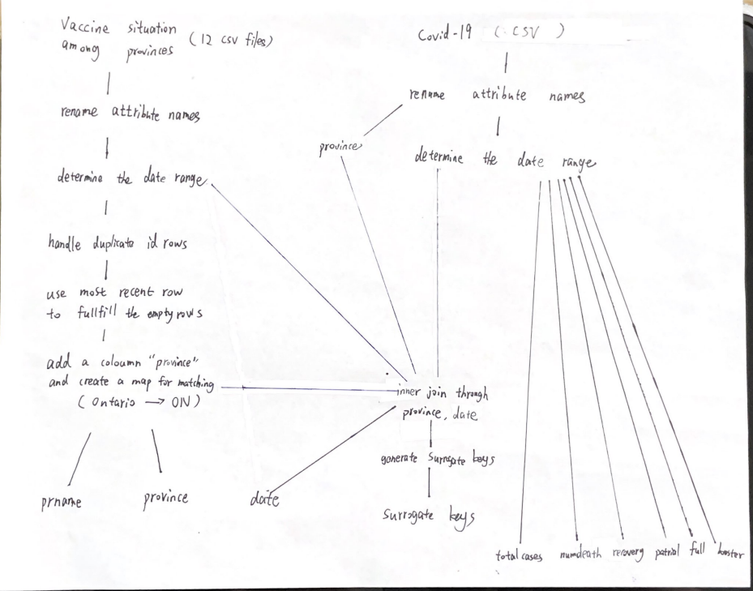

**Modification for original dimensional table design:**

During the data staging process, we notice that some of our original design are not needed; therefore, we remove some features:

* In the Vaccination dimension, there is a column called not, which represents the number of people that are not vaccinated. When doing OLAP, we will try to discover the relationship between vaccination and covid-19 cases, not vaccinated is not needed.
* Active from covidMetric dimension is removed (duplicated with positive)

**Issue and Solution**

**Issue 1:**

Data from different sources does not match, in our case, provinces in one table are shown as full names like “Ontario”, the other only with abbreviations like “ON”.

**Solution 1: Matching**

Create a dictionary for matching, add a new column in one of the table to match with the other

Code example:

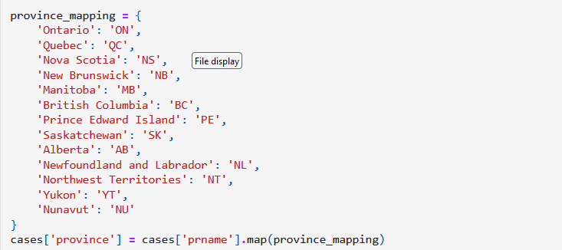

**Issue 2:**

Date is not match. In our case, we will analyze the data weekly, which means a specific date in a week will represent the change in the whole week (Sunday). However, each province updates the data irregularly (some provinces update on Wednesday, some on Friday).

**Solution 2: Binning Methods (Smoothing by bin boundaries)**

Fill in the table with the closest one. We use the covid-download.csv as standard because the table updates regularly, then for each date, if it can not be found on the other table, add the date with data from the closest date.

For example, if 2022-03-06 is needed but not occurred in table A, in the meantime, 2022-03-08 and 2022-03-01 are stored, use the data in 2022-03-08 to represent the data in 2022-03-06 and add it into table A.

**Issue 3:**

Data missing: Nunavut’s data has not been updated frequently since November 2022. There exists empty data “0” which harms the quality of data analysis.

**Solution 3:**

Fulfill the empty data by using the most recent row data to maintain the data validity.

**Team Planning and Work Distribution**

|  |  |  |  |  |  |  |
| --- | --- | --- | --- | --- | --- | --- |
| Deliverable checklist | Responsible | Expected completion date | Actual completion date | Estimated | Actual | Notes (if any) |
| team member(s) | time (hours) to complete | time (hours) to complete |
| Create database instance | Zhiyuan Lin | 15-Mar | 17-Mar | 3 hours | 6 hours |  |
| Create Date dimension | Zhiyuan Lin | 16-Mar | 19-Mar | 1 hour | 1 hour |  |
| Create Province dimension | Zhiyuan Lin | 16-Mar | 19-Mar | 1 hour | 1 hour |  |
| Create vaccination dimension | Zhiyuan Lin | 16-Mar | 19-Mar | 1 hour | 1 hour |  |
| create a connection between python and postgre | Zhiyuan Lin | 16-Mar | 19-Mar | 3 hours | 3 hour |  |
| Create COVID19Metric dimension | Zhiyuan Lin | 15-Mar | 17-Mar | 3 hours | 3 hours |  |
| Staging of dimension Date | Lixiong Wei | 17-Mar | 18-Mar | 0.5 day | 1 day |  |
| Staging of dimension Province | Lixiong Wei | 17-Mar | 18-Mar | 0.5 day | 1 day |  |
| Staging of dimension Vaccination | Lixiong Wei | 17-Mar | 18-Mar | 0.5 day | 1 day |  |
| Staging of dimension COVID19 Metric | Lixiong Wei | 17-Mar | 18-Mar | 0.5 day | 1 day |  |
| Surrogate key pipeline | Lixiong Wei | 19-Mar | 19-Mar | 1 hour | 1 hour |  |
| Staging of fact table – including FKs and measures | Lixiong Wei | 20-Mar | 20-Mar | 1 day | 1 day |  |
| Data quality handling and reporting | Lixiong Wei | 20-Mar | 19-Mar | 3 hours | 2 hour |  |
| SQL statement design | Zhiyuan Lin | 18-Mar | 19-Mar | 3 hour | 8 hour |  |
|  |