**CSI4106**

**Introduction to Artificial Intelligence**

Course Professor: **Caroline Barrière**

**Assignment 3: Reasoning in Humans and AI**

Group 67

Team Members:

|  |  |
| --- | --- |
| First Name, Last Name: | Student ID: |
| Lixiong Wei | 300145970 |

Due Date: Nov 12th

**Q1. Propositional logic and proofs**

Choose I, J, K, L

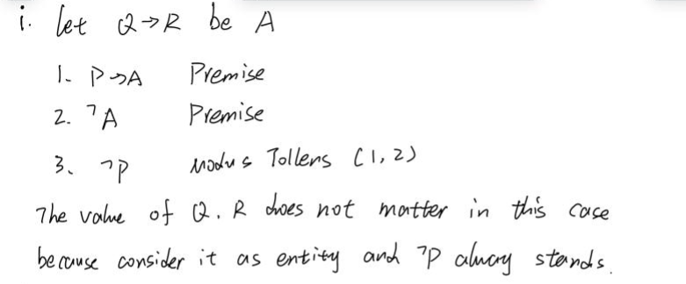

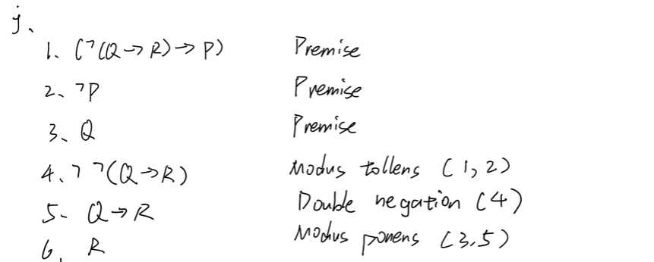

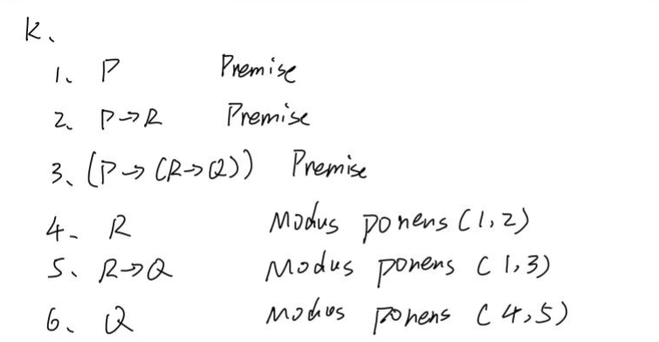

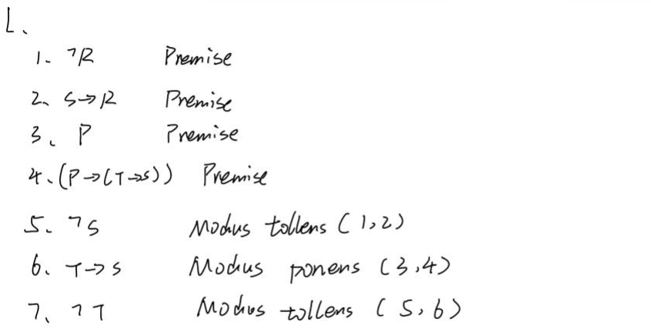

**Question 2. Predicate logic**

Express the statements in predicate logic: Ǝ **∀**

1. All graduate students have an undergraduate degree.

**∀x: GraduateStudent(x) 🡪 UndergraduateDegree(x)**

2. Anyone with an undergraduate degree studied in at least one university.

**∀x ∃y: UndergraduateDegree(x) 🡪 StudiedAt(x, y)**

3. A university, at any particular year, delivers courses to many students.

**∀x ∀y ∀z: (University(x) ∧ Year(y) ∧ StudentInUniversity(z) ∧ DeliversCoursesTo(x, y, z))**

4. For a professor to teach a course, there must be at least a student registered in it.

**∀x ∀y ∃z: (Teach(x,y) 🡪 Registered(x, y, z))**

5. A class is called a large class if at least 100 students are part of it.

**∀x: MoreThan100Student(x)🡪 LargeClass(x)**

6. Classmates are students taking the same course.

**∀x ∀y: Student(x) ∧ Student(y) ∧ SameCourse(x,y) 🡪 Classmate(x,y)**

7. A graduate student takes less courses than an undergraduate student

**∀x ∀y: GraduateStudent(x) ∧ UndergraduateStudent(y) 🡪 LessCourse(x,y)**

**Question 3. Fuzzy Logic**

1. define linguistic variable

Sleep: subset {light, deep, REM (rapid eye movement)}

* Range: 1 to 10
* Fuzzy Subsets:

Light: 1-4

Deep: 4-8

REM: 6-10

Leisure: subset {Low, Moderate, High, Abundant}

* Range: 0 to 10
* Fuzzy Subsets:

Low: 0-4

Moderate: 3-6

High: 5-8

Abundant: 7-10

Stress: subset {Low, Moderate, High, V}

* Range: 2 to 10
* Fuzzy Subsets:

Calm: 2-4

Moderate: 3-6

Intense: 5-8

Extreme: 7-10

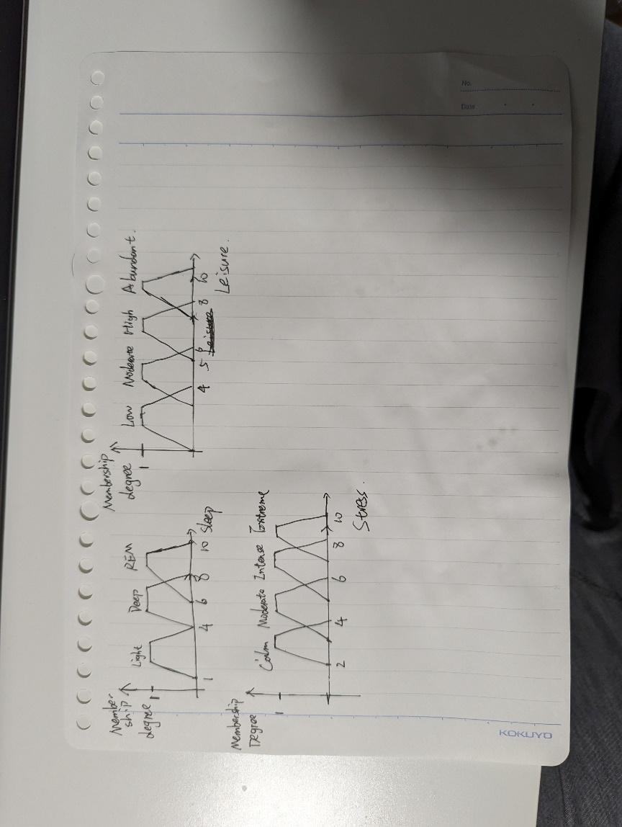

2. Fuzzy Rules

i. IF Stress is Calm AND Leisure is Abundant THEN Sleep quality is REM

ii. IF Stress is Intense OR Leisure is Low THEN Sleep quality is Light

iii. IF Stress is Moderate AND Leisure is Moderate THEN Sleep quality is Deep

3. Fuzzy Inference

Step 1.

Input: Stress = 5.5 and Leisure = 5

* Stress Level: Calm: 0, Moderate: 0.87, Intense: 0.32, Extreme: 0
* Leisure Time: Low: 0, Moderate: 0.8, High: 0, Abundant: 0

Step 2.

Rule 1. Min(0,0) = 0

Rule 2. Max(0.32,0) = 0.32

Rule 3. Min(0.87,0.8) = 0.8 (Deep)

Step 3. Transfer the resulting membership degree on the consequence

Rule 1 returns the result of 0, there will be no part for REM.

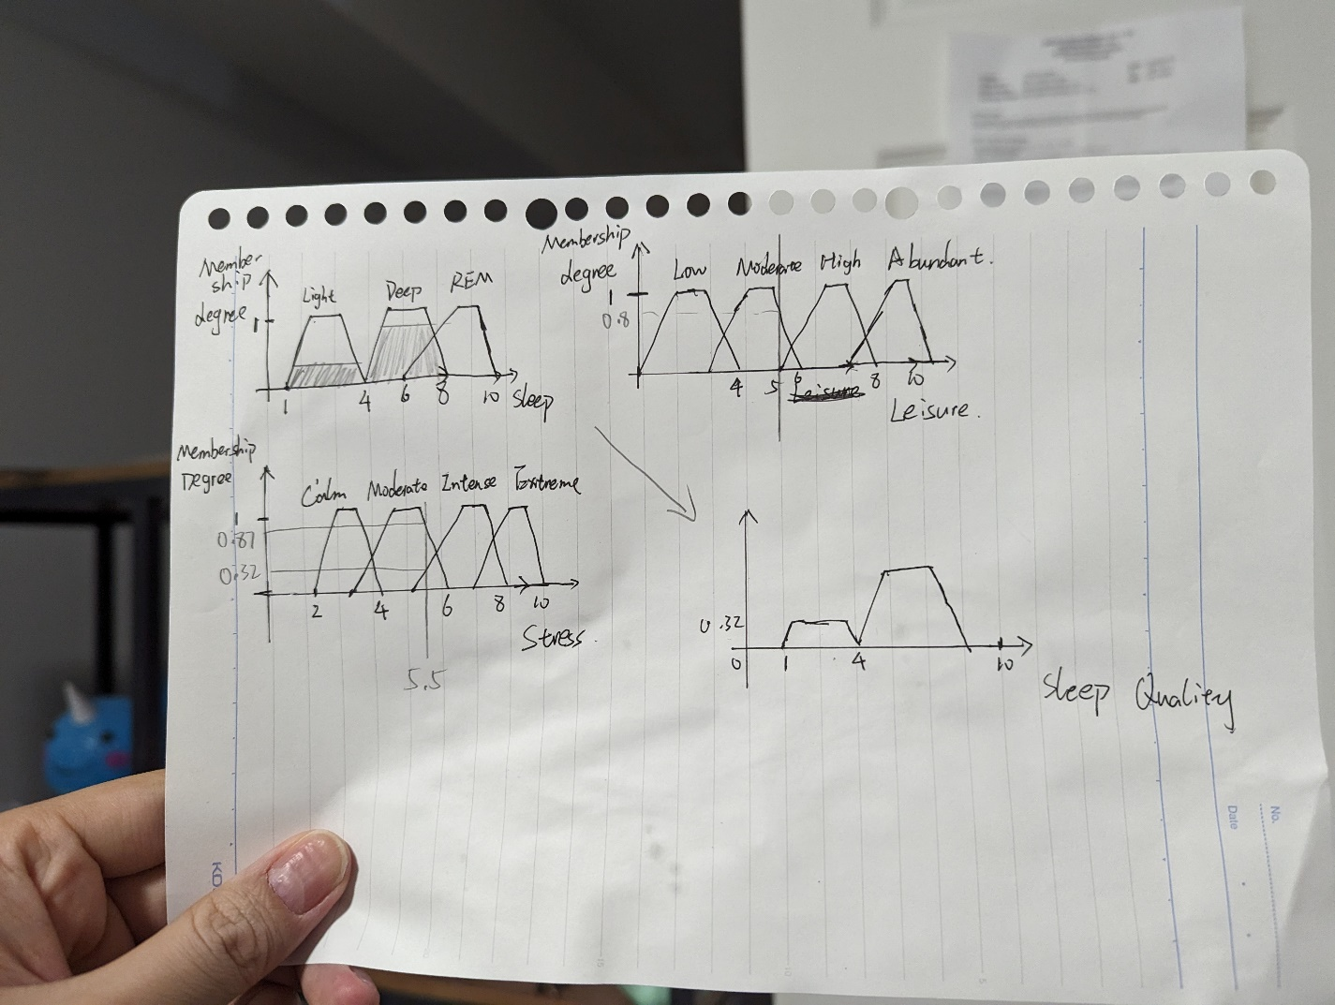

**Question 4. Reasoning**

**Constraint-based reasoning**

Reference: <https://www.examsbook.com/reasoning-ability-questions-and-answers/2>

**Q.13. In a certain code language,**

'134' means 'good and tasty';

'478' means 'see good pictures';

'729' means 'pictures are faint'.

**Which of the following digits stands for 'see'?**

(A) 9

(B) 2

(C) 1

(D) 8

This is a good example because it requires identifying the relationship between the digits and the corresponding words in the given constraints.

Other type of Reasoning intertwined: the problem involves deductive reasoning because the process is similar to deduction.

**Solution**:

From first and second sentence we know that only ‘4’ and ‘good’ occur, so we know that 4 is good, same reason for ‘7’ is “pictures”. Therefore, only left in second sentence is ‘see’ and 8 so ‘see’ is 8.

**Require knowledge:** Ability to decrypt the message base on the relationship between digit and alphabet and understanding of pattern recognition.

**Specific:** Recognizing that in this particular code, the digit '4' stands for 'see'.

**Generic:** Understanding the general concept of pattern recognition, which can be applied to similar problems involving coded messages.

**Inductive reasoning**

Reference: <https://www.examsbook.com/reasoning-ability-questions-and-answers/1>

**Q4. A, B, N, C, D, O, E, F, P, ?, ?, ?**

(A) G, H, I

(B) G, H, J

(C)  G, H, Q

(D)   J, K, L

This is a good example of inductive reasoning because it involves the process of finding the special cases 🡪 finding the pattern of the sequence 🡪 Apply to new case

Other type of reasoning involves Alphabet reasoning and deductive reasoning because it requires to find the pattern of alphabet.

**Solution**:

A, B are consecutive alphabets followed by N. Next three character are C, D, O, where C is followed by B in order and O is followed by N in order. The pattern is first two consecutive letters followed by another letter then start next sequence with same pattern.

Apply the rule to E, F, P also works, so the answer is G, H, Q.

**Required knowledge:** pattern recognition.

**Specific:** Recognizing the specific pattern in this sequence to determine the next elements.

**Generic:** Applying general knowledge of alphabetical order and pattern recognition that can be used in similar problems involving letter sequences.

**Analogical reasoning**

Reference: <https://www.examsbook.com/reasoning-ability-questions-and-answers/2>

**Q.15. Vaunt : Flaunt :: Disparate : ?**

(A) Similar

(B) Homogenous

(C) Contrast

(D) Alike

This is a good example of analogical reasoning as it requires recognizing the relationship between the first pair and applying the same relationship to identify the correct term for the second pair.

This problem may involve deductive reasoning, as the individual needs to deduce the relationship between "disparate" and the correct term based on the analogy presented.

**Solution:**

Understand the relationship between "vaunt" and "flaunt." Then apply the same relationship to determine the term that relates to "disparate" in a similar way, which is Contrast.

**Required Knowledge:**

Vocabulary knowledge: understanding the meanings of "vaunt," "flaunt," and "disparate." (lexical knowledge).

**Specific**: Recognizing the specific relationship between "vaunt" and "flaunt" and applying it to "disparate."

**Generic:** Applying general knowledge of word relationships and analogies to solve similar problems.

**Temporal reasoning**

Reference: <https://www.examsbook.com/critical-reasoning-questions-and-answers-for-competitive-exams/1>

**Q.4. If it was Friday on 3rd date of a month, then which day would come on the 4th day after 21st date of that month?**

(A) Tuesday

(B) Monday

(C) Thursday

(D) Sunday

This problem is a good example of temporal reasoning because it requires to navigate and reason about the temporal aspects of a calendar and temporal reasoning involves understanding the relationships between different points in time, such as days, and weeks.

This problem also involves mathematical reasoning, as it requires calculation of the right date.

**Solution:**

3rd 🡪 Friday, 7 days a week, 3rd + 7*3 = 24th , which is also Friday.

The forth date after 21st is 25th , which is Saturday.

**Required knowledge:**

Recognize the regular pattern of days in a week (7 days).

Calculate the number of days between the 21st and the desired date (25th).

**Specific**: Knowing that there are seven days in a week and understanding the pattern of days repeating.

**Generic**: The ability to apply the concept of a regular week cycle to any month or year, making it transferable to similar problems involving days of the week.

**Spatial reasoning**

**Reference:** <https://www.examsbook.com/reasoning-ability-questions-and-answers/4>

**Q.32. In an Exhibition seven cars of different companies - Cadillac, Ambassador, Fiat, Maruti, Mercedes, Bedford and Fargo are standing facing to east in the following order:**

1. Cadillac is next to right of Fargo.

2. Fargo is fourth to the right of Fiat.

3. Maruti car is between Ambassador and Bedford.

4. Fiat which is third to the left of Ambassador, is at one end.

**Which of the cars are on both the sides of Cadillac car?**

(A) Ambassador and Maruti (B) Maruti and Fiat (C) Fargo and Mercedes

(D) Ambassador and Fargo

This is a good example of spatial reasoning as it involves deducing the positions of the cars in the exhibition based on a set of conditions.

This problem also involves constrain-based reasoning, as the relationships are described with specific constraints that need to be considered while determining the positions of the cars.

**Solution:**

Draw a floor plan of each car position based on the conditions

1. C is on the right of FA

2. Fiat is on the left of FA, and forth location

3. Go to condition 4, A is just on the left of FA based on the

4. Go to condition 3 the two rest are B and M, B is on the left

5. Only Mercedes left, since Fiat is at the end of one side, the only position for Mercedes is at the other end.

Therefore, the position of all cars is:

Fiat, Bedford, Maruti, Ambassador, Fargo, Cadillac, Mercedes

The answer is C.

**Required Knowledge:**

Basic deductive reasoning skills.

Ability to visualize and reason about spatial arrangements.

**Specific:** Applying the given conditions to deduce the specific positions of the cars in the exhibition.

**Generic:** Applying general principles of spatial reasoning and problem-solving that can be used in similar problems.

**Question 5. Causal fallacies**

**Glittering generality**

Reference: <https://propagandafoodcomms9.weebly.com/glittering-generality.html>

“Things go better with Coke”

This advertisement is a good example of glittering generality because “better” can not be defined and has no specific meaning.

**Card Stacking**

Reference: <https://www.vanityfair.com/style/2013/09/burger-king-s-satisfries-are-the-best-thing-since-sliced-potatoes-deep-fried-in-vegetable-oil>

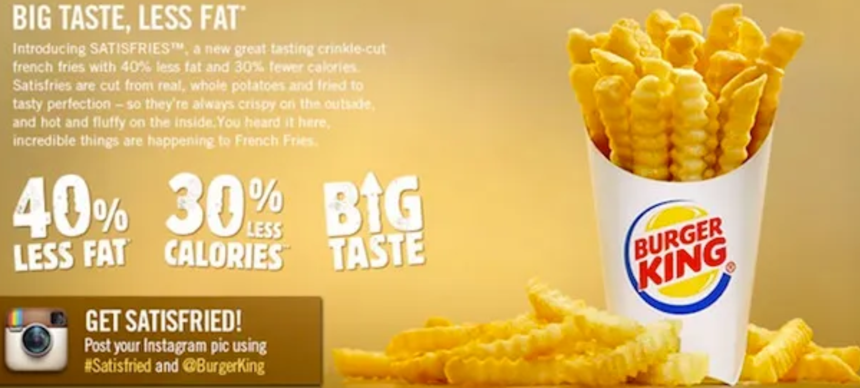

This propagation is good example of card stacking, it provides couple information like 40% fat and 30% calories less but not the fact that fries are still unhealthy due to high level of fat.

**Bandwagon**

Reference: <https://www.facebook.com/simsr.interface/posts/the-bandwagon-appeal-is-one-of-roughly-twenty-advertising-appeals-the-bandwagon-/2361136113920874/>

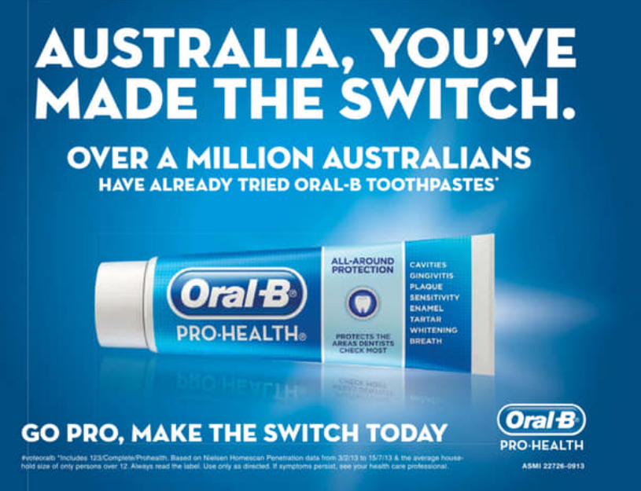

This advertisement is a good example of bandwagon as it said “over a million Australians have already tried ORAL-B toothpastes”. It attempts to encourage the target audience to use the product so that they don’t feel being left out.

2 examples from the lecture:

**Weak analogy**

Reference: <https://helpfulprofessor.com/false-analogy-examples/>

“Every year more people die in car crashes than in plane crashes. You will be much safer if a plane crashes.”

This is a good example of weak analogy because it draws an invalid comparison between two different situations. The overall risks and circumstances surrounding car crashes and plane crashes differ significantly (Number of use of car as transportation is way much than plane).

**Appeal to Ignorance**

Reference: <https://www.txst.edu/philosophy/resources/fallacy-definitions/appeal-to-ignorance.html>

“I guess I didn't get the job. They never called me back.”

In this example, the person is drawing a conclusion based on the absence of a specific event and lack of evidence of being rejected. This fits the fallacy of appeal to Ignorance.

**Question 6. Knowledge representation**

Link to the graph (PDF version):

<https://drive.google.com/file/d/1DzPFIeoKmYZa0RJYUi1k9fwcoMXOfuFz/view>

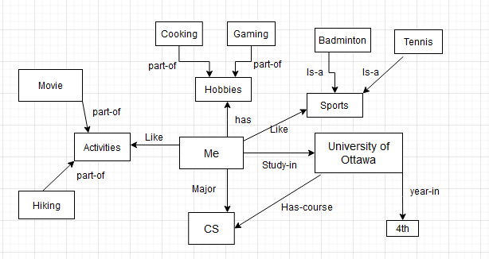

**Q7 – ChatGPT’s reasoning capabilities**

Reasoning Chosen and test case

**Causal Reasoning:**

Alice forgets her password; she won’t be able to login to her account.

**Mathematical reasoning:**

What is the number of ‘?’ in the following sequence: **1, 2, 3, 10, ?, 9802**

**Analogical reasoning:**

**Amnesia : Memory : : Paralysis : ?**

(A) Movement (B) Limbs (C) Handicapped (D) Legs

**Deductive reasoning:**

All noble gases are stable. Helium is a noble gas, so helium is stable.

**Temporal Reasoning:**

The bus is coming at 9:15am, and it takes 30 minutes for Alice to get to the station, when should Alice start to go to the station?

Test result:

**Causal Reasoning: almost success**

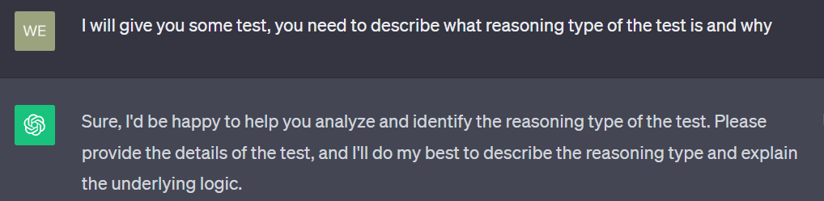

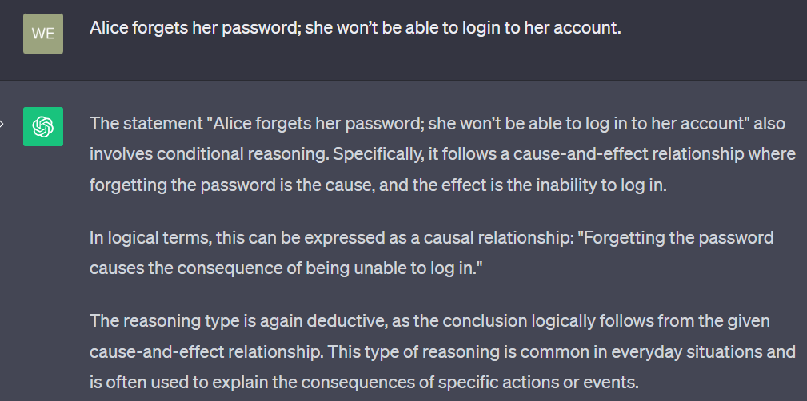

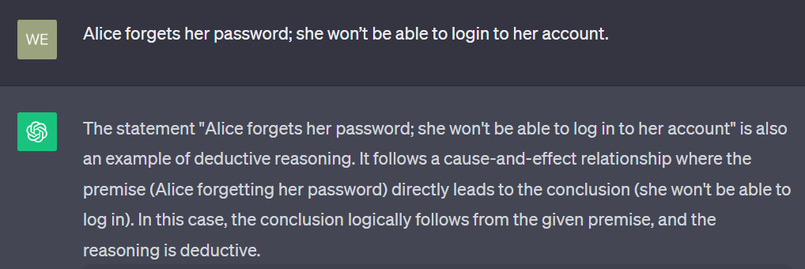

**Mathematical reasoning: Almost Success**

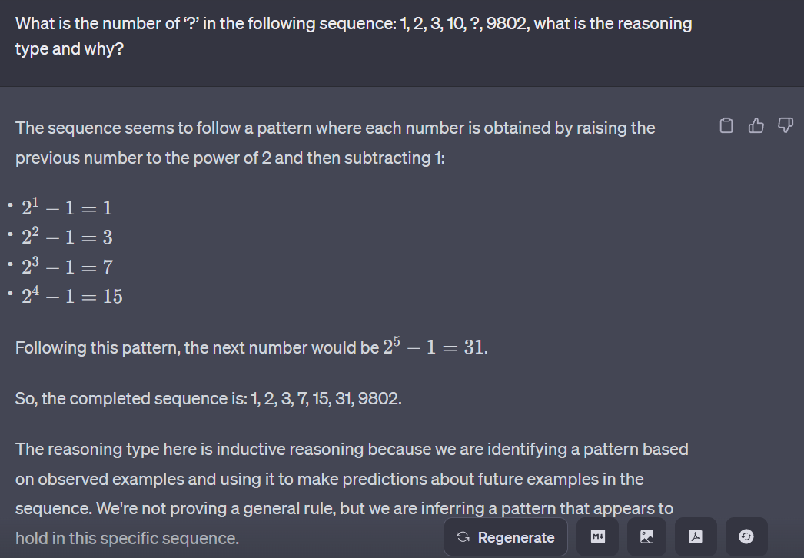

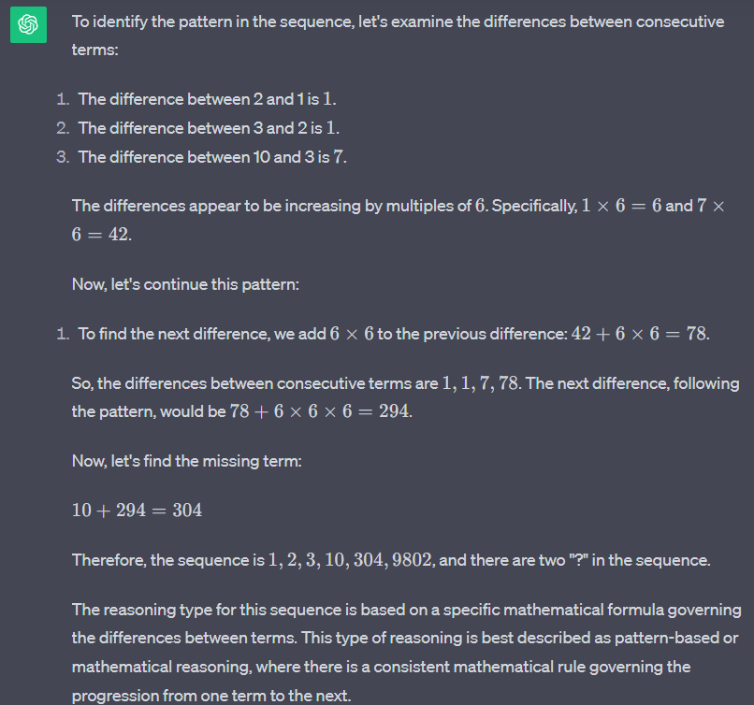

**Analogical reasoning: Success**

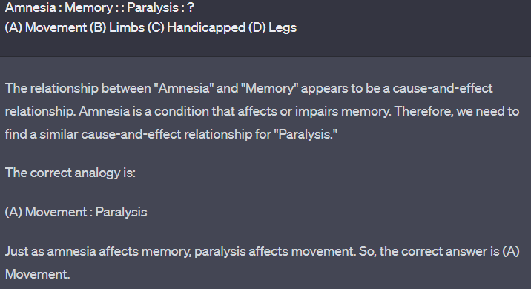

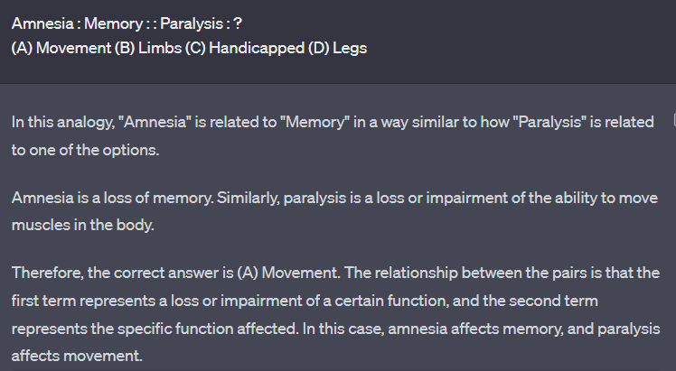

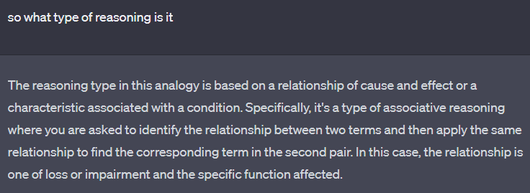

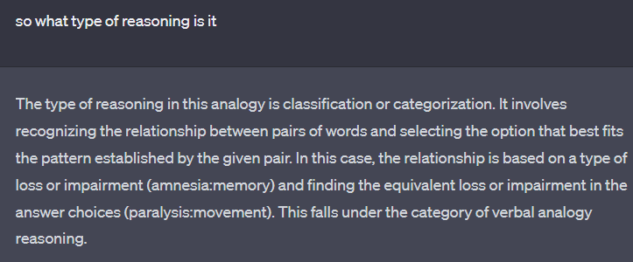

**Deductive reasoning: Success**

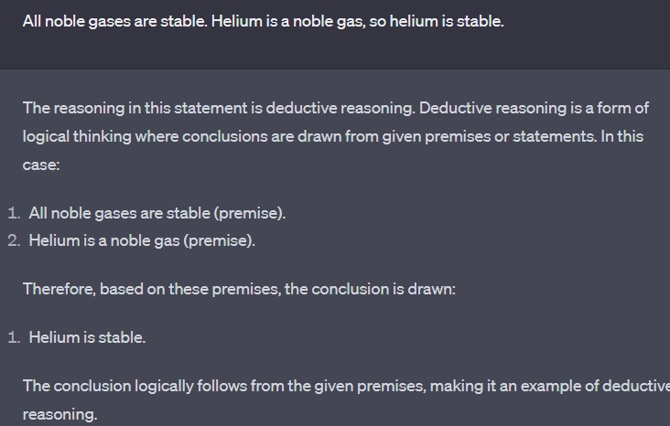

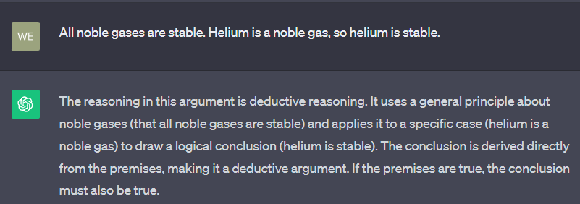

**Temporal Reasoning: not success not fail**

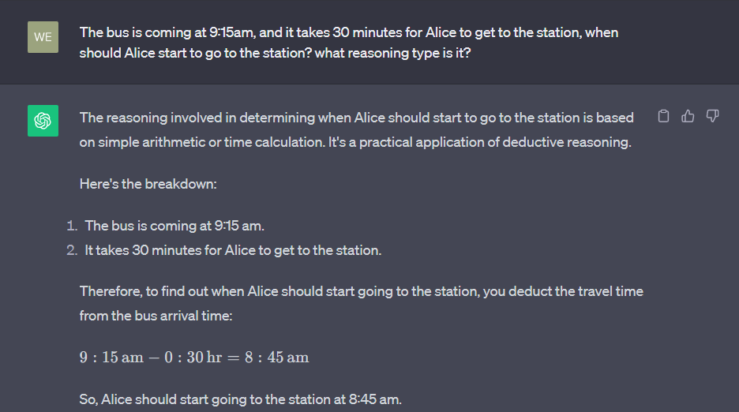

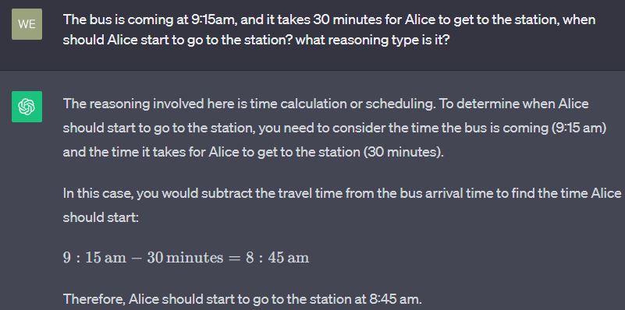

Result analysis:

There can be more than one type of reasoning interwined for a question, so GPT can return two different answers but both of them is reasonable. However, sometime it returns the wrong one like the mathematical reasoning question. It can not find the correct answer (the pattern is too complicated).

ChatGPT can perform most of the test. Whether the answer is true or false still need to be judged by human beings.