HomeSliderTest.doc 2019-1-03
Test of Selector 6 box with slider tape fixture and PCAN sniffer.

1 – Set the slider in the down (home) position and read the position (on the monitor) as 504826 or 504827. No errors indicated on camera LEDs.
Hm_504826_no_error
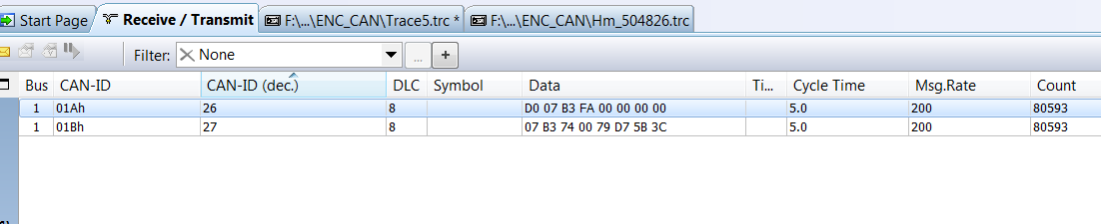
WITH THE SLIDER FIXED IN THE DOWN (home) POSITION -
For ID 26: Data byte 0 increments up and rolls over. Data bytes 1 – 7 do not change.
For ID 27: Data bytes 0 – 3 do not change. Data bytes 4 – 7 continually change (the CRC for both 26 & 27)

2 – Lift up the slider about 3/8” off the base. No errors indicated on camera LEDs. Monitor indicates 504802.
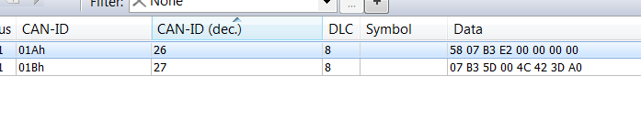
Therefore, the 3/8” (0.375”) is represented by a monitor difference of (504826 – 504802) 24, so each increment on the monitor is worth ( 0.375 / 24 ) = 0.01563” = 0.0397 cm = 0.397mm (CEDES doc says resolution is 0.5mm).

3 - Lift up the slider about 11/16” off the base. No errors indicated on camera LEDs. Monitor indicates 504792.
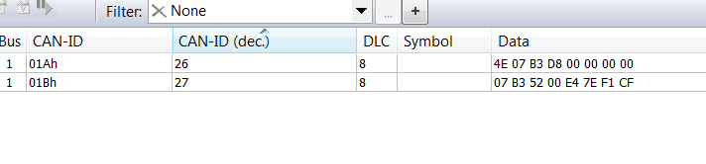
4 - Lift up the slider until camera shows errors on all four positions.
