Sel_6_GALX-1100_and_1133_ENCODER_CAN.doc
GALX-1100AN
The GALX-1133 ‘Encoder CAN’ goes to the GALX-1100AN, ‘ENC-H’ and ‘ENC-L’ (with baud rate of 250 kb).
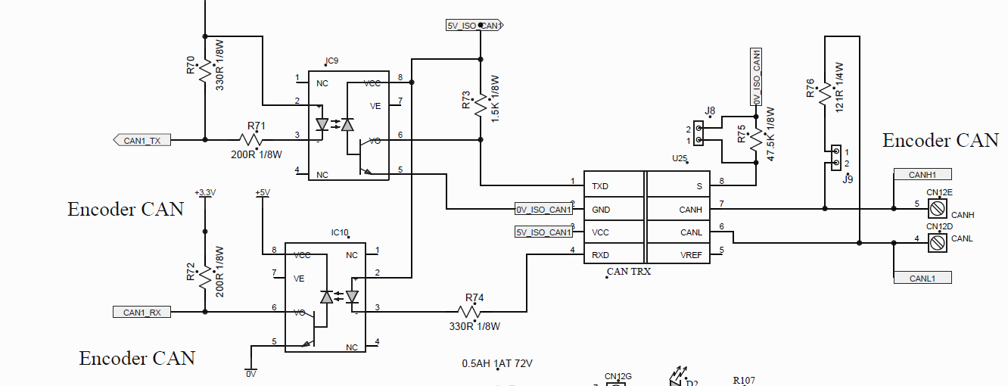

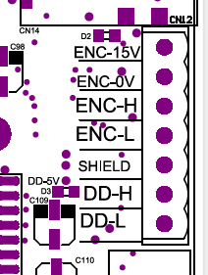

Which is labeled as CAN1_RX and CAN1_TX, and is connector CN12 (D and E). They are on IC-0221N (U17) at pins: C1-PD3/CANRX_B and BI-PD2/CANTX_B.
On the BOM, at line 34:
1 | U17 | IC-0221N | Dual Core Micro,208-BGA | Free Scale | MPC5668GF0AVMG | $26.950
This is a Free Scale MPC5668GF0AVMG, same as on the GALX-1132AN. However, on the 1133, CAN B is used, while on the 1132, the CAN B is accessed via the 1121 main I/O boar. But should be able to use the CAR CAN ( { CAN0_TX - A2 - PD0/CANTX-A} & { CAN0_RX - B2 - PD1/CANRX-A } ). Just change the baud rate to 250 kb and add the “void aps_receive_can_in (int16 BufIx)” from ZYM code in ‘F:\Galx_1133 Selector 6 box\7-11-2018 Johnny Ma APS Tester\7 GALX-1133AN REV B(APS Selector)\9-27-2017 v16.9 GALX1133 Tester MCU1 2 SPI(GGGGGG)(Done)\CAN\Read_cedes_can.c, line 799.

In the 1133 tester SW, the “void aps_receive_can_in (int16 BufIx)” is called from the ISR ( void APS_can_rcv_int (void), line 739 in Read_cedes_can.c ).
In the background SW; main(), the “void Aps_Unpack_Can (void)” gets called from “void Aps_Can_Control (void)”, line 882 in Read_cedes_can.c, and Aps_Can_Control() is called in the forever loop of main(), line 344.

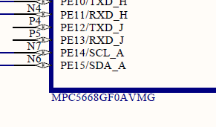 GALX-1132AN shown at left.

=========================================================
1133 BOARD TESTER SW
See ‘Read_cedes_can.c’ and void Aps_Unpack_Can (void) .
Aps_Unpack_Can() is called from Aps_Can_Control (void) { line 877 in Read_cedes_can.c }.
The CAN BUS is initialized at line 515. The call is made in main(0) with a param of 2 which sets baud to 250kb.

// **************************************************
// **** Initialize the ECAN 1000 CAN interface Board
// **************************************************

void aps_init_can_bus (int16 baud_change)
{
// baud_change = 0: use parameter
// baud_change = 1: set 125K
// baud_change = 2: set 250k
SEL_CAN.CTRL.B.PRESDIV = 9; // Prescale Devision Factor + 1 = Prescale Value for 250000

