**The Mountains & Seas Art Gallery**

The Mountains & Seas Art gallery is an independent art institution in Zhengzhou that serves the public. Extensively cooperate with well-known and emerging artists both locally and internationally, and organize rich activities such as academic exhibitions and public projects to bring out unlimited creativity, freedom, and personalized art consumption experience; with a global artistic perspective and The unique beauty of the artist presents the many possibilities of life and art.

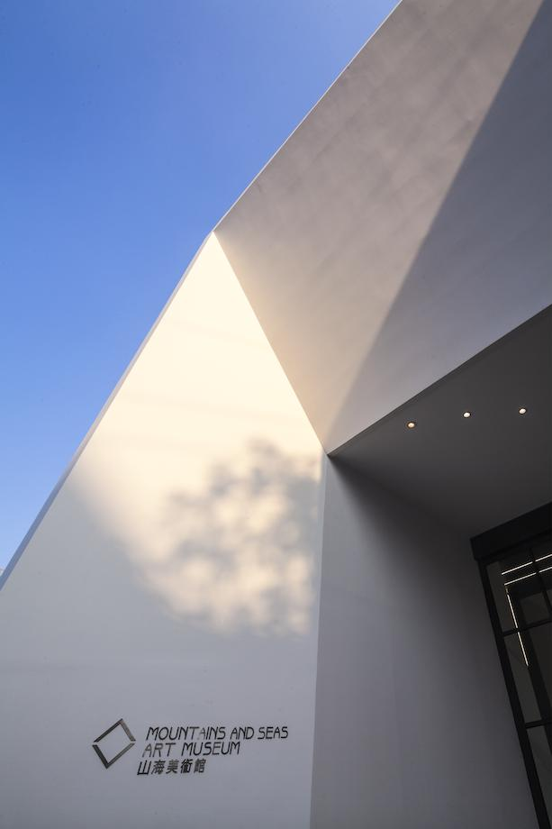

The Mountains & Seas Gallery has a total of more than 500 pieces, most of which are small-scale paintings of ancient and modern times, mainly including modern and contemporary Chinese calligraphers and painters, inscriptions, and relief rubbings of Longmen Grottoes, and traditional Henan prints.

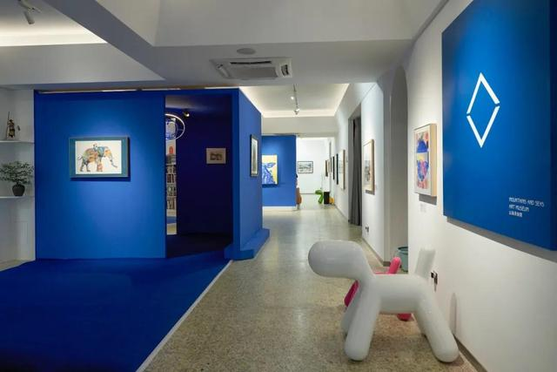

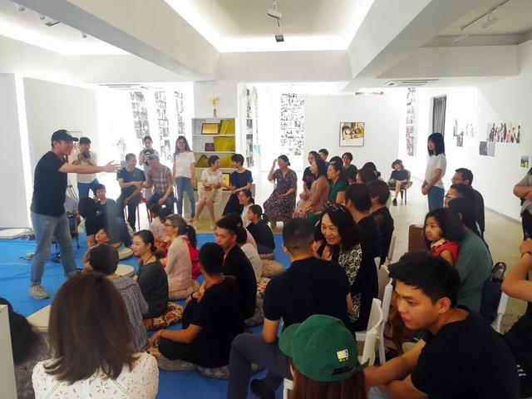

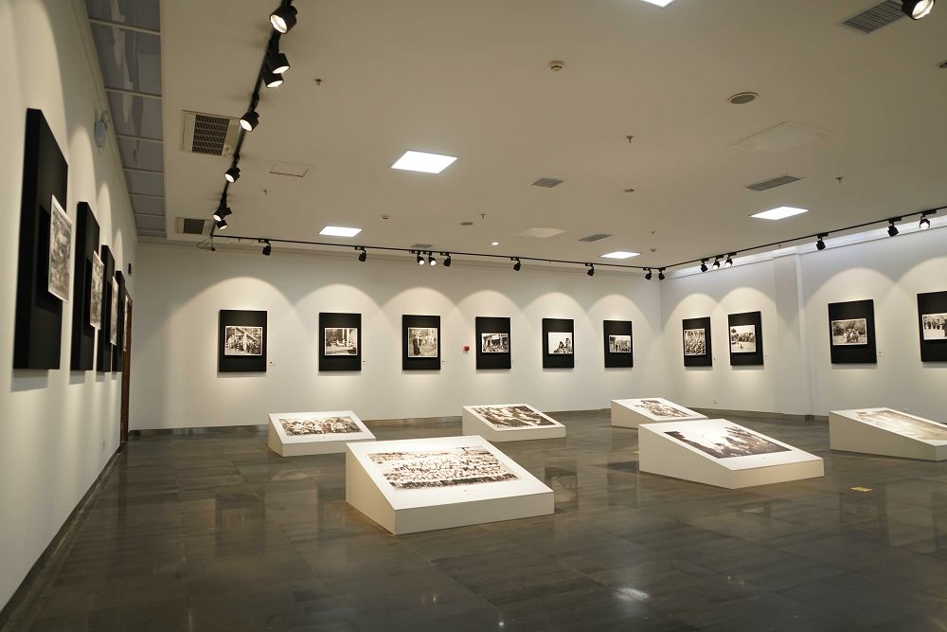

The Mountains & Seas gallery committed to the professional operation model of limited edition signed artworks in China. There are more than 100 contemporary artists and more than 80 emerging designers at home and abroad gathered here to dedicate original and forward-looking creative products to art and design lovers.

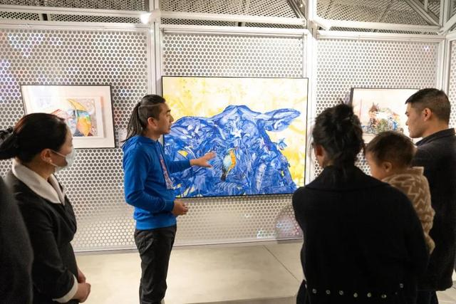

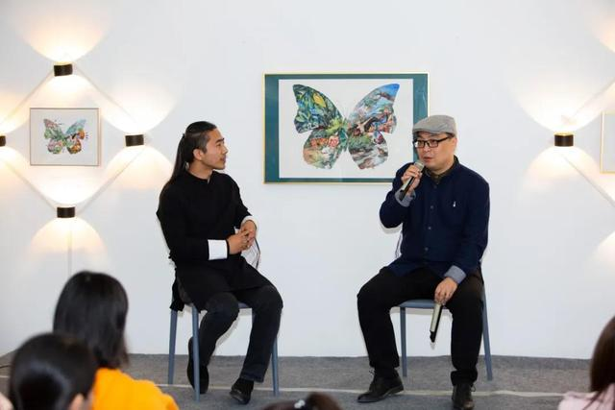

The Mountains & Seas art gallery provides a place for the public to gather, communicate, communicate, learn, and share each other’s interests and enthusiasm. The Mountains & Seas Art gallery’s Public Projects Department has expanded this platform. Through lectures and forums, art theaters, live performances, workshops, youth art classes, etc. The art gallery becomes an open classroom, an indispensable public space in the city. At the same time, galleries also actively and extensively participate in national and international art exhibitions to improve their professionalism and service quality.

* ART021

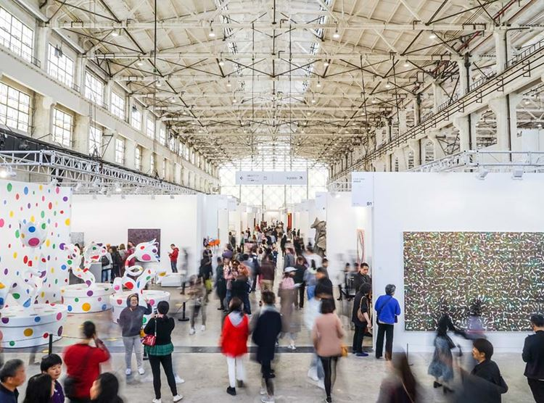

ART021 brings together the top galleries, institutions, artists and their works from around the world, aiming at building a platform for galleries, institutions, collectors and sponsors.

* Duration: Chinese Art in Change

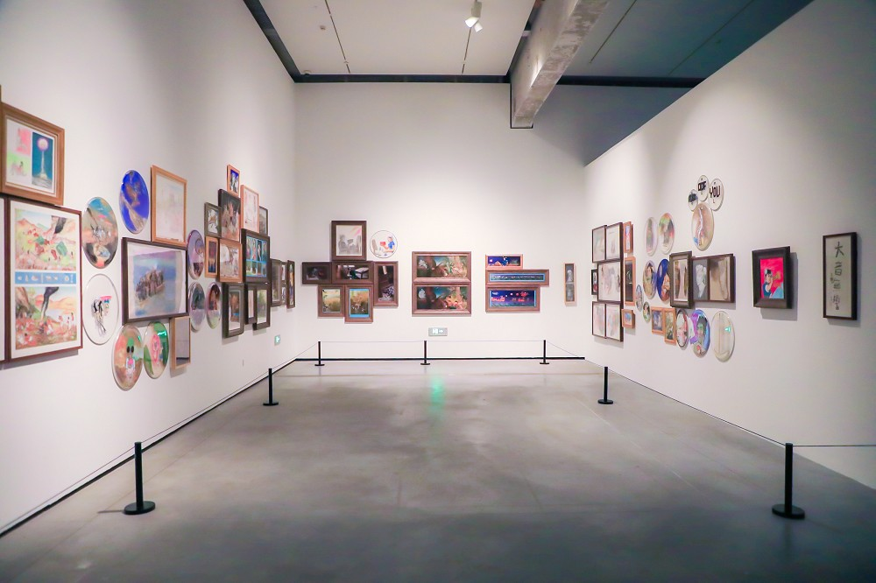

A total of 95 works (groups) of 91 Chinese artists are exhibited in this exhibition, covering various forms of media such as paintings, sculptures, installations, videos, and animations. The concept of the exhibition theme “Duration” comes from the French philosopher Bergson, who believes that duration means uninterrupted and eternal continuity, as well as eternal change. Every moment is an absorption of the past, and the endless possibilities of the future are based on the past and the present.