**The Mountains & Seas Art Gallery**

The Mountains & Seas Art gallery is an emerging gallery that serves the public in Zhengzhou which is located in a second-tier city. This city is where I lived in and it’s an ancient city full of historical art pieces. This is a contemporary art gallery which is very rare here. we have a large population as well as young collectors and emerging artists. And it integrates the three core elements of exhibition collection, art derivation, and public education, and extensively cooperates with emerging artists locally. Extensive activities such as exhibitions and public projects bring out unlimited creativity, freedom, and a personalized art consumption experience. yet, this gallery has an operation in Beijing in 798 art district. However, due to the fierce competition, only the Zhengzhou pavilion was retained.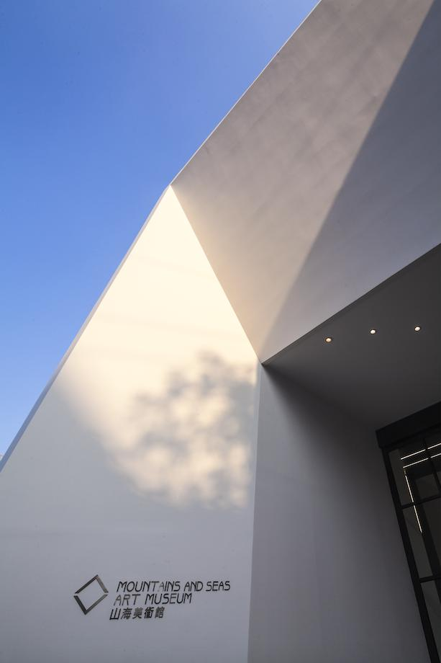

This gallery mainly sells photography, painting, and sculptures of local artists’ works. They have close relationships with about 20 local artists. The owner is still looking for potential, so they will hold private receptions and gatherings to make this a social center for contemporary art.

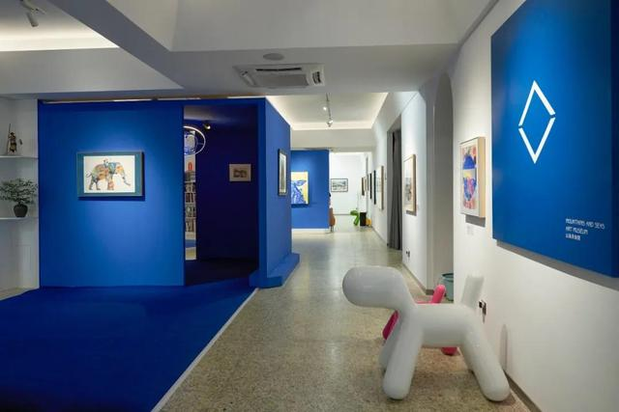

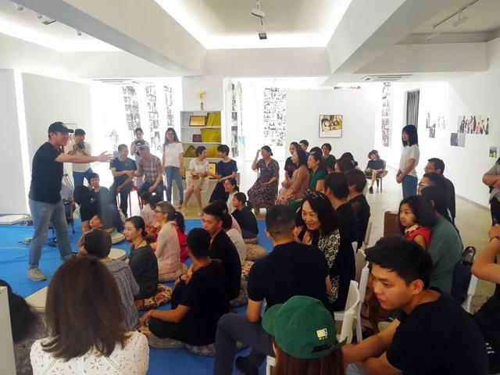

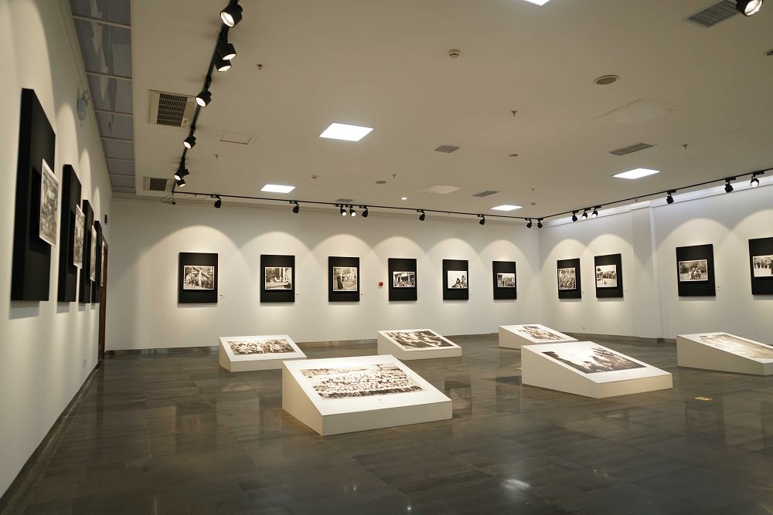

The Mountains & Seas art gallery provides a place for the public to gather, communicate, communicate, learn, and share each other’s interests and enthusiasm. It's Public Projects Department has expanded this platform. Through workshops, youth art classes the art gallery becomes an open classroom, an indispensable public space in the city. This is not only an exhibition but also a place for presentation and education. They are still doing some cultural and creative derivatives (souvenirs for sale). Because the owner has a very close relationship with collectors and artists, so they don’t have a website. It is through social media (Wechat) widely use in China to update news and promote, they believe this will bring them more privacy.

The owner of the gallery has an international perspective. He continues to pay attention to various art fairs at home and abroad. However, because participating in fairs at this stage can not bring advantages to the business, they choose to maintain a wait-and-see attitude. This gallery is very active and prosperous locally. It provides a local art market where they often have a small group of a wine parties. An active local market contributes to the construction of an artistic and cultural atmosphere, which is rare in cities of the same size in China. I believe that it will develop domestically and internationally in the future, or experience some new technologies and sales growth. Nowadays, Asian distributors have increased by 15%, imagine this big populous but small city will have great development in the future.