### 

### 

Property Management System Proposal

2nd June 2023

### **Tenants Data registration**

This is a crucial feature in property management systems that allows you to collect and organize information about the individuals or organizations renting your properties. It provides a centralized platform for managing tenant-related data and streamlines various aspects of the tenant-landlord relationship

**Benefits**

**Efficient Data Collection**:

The system enables you to gather all the necessary information about your tenants in one place. This includes their personal details, contact information, identification documents, emergency contacts, and any other relevant information required for the tenancy agreement. By having this information readily available, you can expedite the onboarding process for new tenants.

**Tenant Billing Account**

The Tenants Billing Account feature is a powerful tool within your property management system that facilitates accurate and efficient billing processes for your tenants. It provides a centralized platform to manage all financial transactions and billing-related activities associated with your rental properties.

**Simplified Rent Invoicing:**

The system automates the process of generating rent invoices for your tenants. It allows you to easily set up recurring billing cycles and automatically generates invoices based on the agreed-upon rental terms. This saves you time and effort in manually creating and distributing invoices, ensuring that your tenants receive accurate and timely rent bills.

Invoices **Notifications** sms & email:

The system can send automated notifications via sms and email to tenants regarding upcoming invoices, payment due dates, and any changes in invoices amounts. This ensures that tenants are well-informed and can plan their finances accordingly.

**Apartment Management Module**

The Apartment Management Module is a powerful component of your property management system that specifically focuses on managing apartments within your rental property portfolio. It offers comprehensive tools and functionalities to streamline the management of individual apartments and ensure efficient operations.

The platform provided the following abilities:

* Ability to register an apartment
* Ability to add the rentals under the various apartments
* Ability to set the various charges depending on the different apartments.

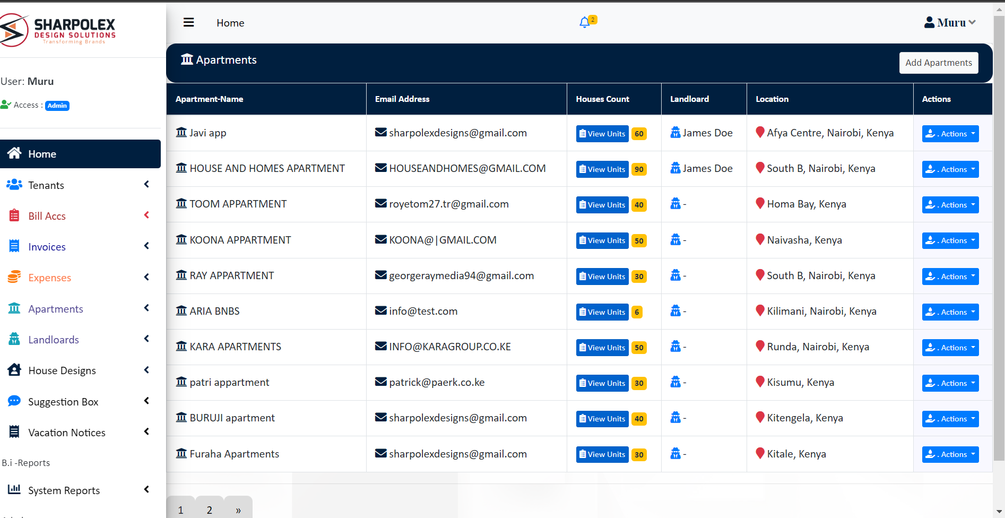

Figure .1 Apartments list

**Expenses Tracking**

The expenses tracking and management feature in our property management system offers a comprehensive solution for tracking and managing expenses both for the management and tenants of the properties. It allows you to efficiently monitor and control financial aspects related to property operations, ensuring transparency and accuracy in expense tracking.

##### **For the management**

**Expense Recording:** The system enables you to record various expenses incurred by the management, such as property maintenance, repairs, utilities, insurance, taxes, and other operational costs. You can enter details like the date, vendor, description, and amount for each expense.

**For the Tenants**

**Expense Tracking:**

Our system provides a transparent expense tracking mechanism for tenants. It allows them to view and track their individual expenses associated with their leased properties. This includes expenses like utilities, maintenance charges, and any other applicable fees.

**Expense Notifications sms & email:**

The system can send automated notifications via sms and email to tenants regarding upcoming expenses, payment due dates, and any changes in expense amounts. This ensures that tenants are well-informed and can plan their finances accordingly.

**Online Inbuilt Suggestion box**

The online suggestion box feature in our property management system serves as a digital platform for tenants to easily communicate with the management regarding any complaints, requests, or suggestions they may have.

It provides a convenient and efficient way for tenants to voice their concerns or provide feedback, enhancing communication and ensuring that their needs are addressed promptly.

**Online Vacation notices**

The online vacation notices feature in our property management system offers tenants a convenient way to post and indicate the dates they plan to vacate the premises. It serves as a digital platform where tenants can notify the management about their upcoming vacation plans from the property, ensuring efficient communication and coordination.

The platform comes with equipped sms and email notifications feature to allow communications to be

**Inbuilt system reports**

The inbuilt system reports feature in our property management system provides clients with a range of pre-built reports that offer valuable insights and analysis related to various aspects of property management. These reports help clients gain a comprehensive understanding of their property's financial performance, rent payments, and tenant information.

The reports can be fully customized to the property reports templates that is the logos and headers, as well we provide other custom reports to the system upon request.

**Automated Notifications**:

The property management system will has a robust notification engine that sends automated SMS and email notifications to clients based on specific triggers and events.

Event Triggers: The system will be designed to trigger notifications based on various events, such as:

Tenant Registration: Upon a tenant being registered to an apartment they will receive a sms and email notification welcoming them to there apartment

Invoicing notifications

Expenses notifications

Rent payments: upon accountant making a successfully payment reconciliation the tenant will receive a payment confirmation

**Tenants system Access**

The tenant system access feature in your property management system allows tenants to have secure online access to monitor their bills, expenses, and view payment receipts.

The platform provides the following functionalities.

Account Overview: Upon logging into the tenant portal, tenants will be presented with an account overview page that provides a snapshot of their current status. This may include details such as outstanding bills, upcoming payments, recent expenses, and important notifications.

Billing and Expense Tracking: Within the tenant portal, tenants will have access to a comprehensive breakdown of their bills and expenses. They will be able to view and track items such as rent, utility charges, maintenance fees, or any other relevant expenses associated with their tenancy.

Payment Receipts: The system will allow tenants to easily access and download payment receipts for their records. Each payment made towards rent or other charges will generate a receipt, which can be accessed and saved directly from the tenant portal. This provides tenants with a convenient way to keep track of their financial transactions.

Payment History: The tenant portal will include a payment history section that displays a chronological list of all payments made by the tenant. This overview will include details such as payment dates, amounts, payment methods, and the purpose of the payment (e.g., rent, utilities, fees). Tenants can refer to this section to review their payment activity over time.

Secure Communication: The tenant portal can offer a secure messaging system that allows tenants to communicate directly with the property management team. This ensures that any queries, concerns, or requests can be addressed promptly and securely.

Mobile Access: To provide convenience, the tenant portal can be accessible through mobile devices via a dedicated mobile app or a mobile-friendly website. This allows tenants to access their account information on the go and stay connected with their property management company.