Slides for Karl Berator

William Pincombe

## Gene Expression data for Wild Type (WT)

Table 1: Wild Type (WT)

|  | Placebo | AF42 |
| --- | --- | --- |
| Concentration | Trial 1 | Trial 2 | Trial 1 | Trial 2 |
| 0 | 5.51 | 4.47 | 9.10 | 9.69 |
| 1 | 6.41 | 5.12 | 11.88 | 12.82 |
| 2 | 5.71 | 4.79 | 15.21 | 14.78 |
| 3 | 7.94 | 5.86 | 18.41 | 18.27 |
| 4 | 6.87 | 4.30 | 23.81 | 21.24 |
| 5 | 7.29 | 5.82 | 25.10 | NA |
| 6 | 10.04 | 9.94 | 28.75 | 24.25 |
| 7 | 8.85 | 9.02 | 30.99 | 29.11 |
| 8 | 8.91 | 8.23 | 36.33 | 32.79 |
| 9 | 9.68 | 8.37 | 36.00 | 32.69 |
| 10 | 11.43 | 10.47 | 41.70 | 36.38 |

## Gene Expression data for gene type CT101

Table 1: CT101

|  | Placebo | AF42 |
| --- | --- | --- |
| Concentration | Trial 1 | Trial 2 | Trial 1 | Trial 2 |
| 0 | 5.35 | 5.81 | 8.97 | 11.49 |
| 1 | 4.01 | 6.58 | 11.62 | 15.01 |
| 2 | 8.53 | 9.28 | 14.87 | 17.88 |
| 3 | 9.90 | 10.71 | 15.47 | 20.17 |
| 4 | 11.66 | 13.67 | 17.29 | 26.22 |
| 5 | 10.70 | 13.48 | 20.78 | 31.77 |
| 6 | 13.65 | 15.20 | 22.30 | 34.43 |
| 7 | 15.98 | 17.65 | 24.37 | 36.66 |
| 8 | 16.74 | 19.01 | 27.44 | 39.26 |
| 9 | 18.44 | 19.93 | 30.74 | 44.18 |
| 10 | 20.21 | 24.47 | 33.96 | 48.96 |

## Plot for Wild Type

Warning: Removed 1 rows containing missing values (`geom_point()`).

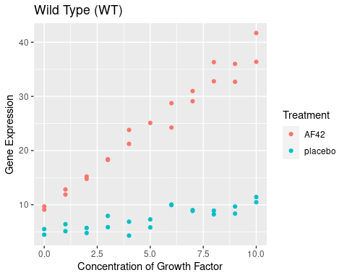

## Plot for CT101

