Secure Repository System for CERN: Design Document

Background
The European Organization for Nuclear Research, known as CERN, can offer advanced facilities for high-energy physics research. CERN also has a giant computer centre to help analyse experimental data and share it with other researchers worldwide.

System requirements
1. Server:
operation system (OS): Linux-based OS can provide security updates in the long term (at least five years). For this project, we choose Ubuntu 22.04 LTS.

2. Client:
For demonstration purpose, any OS can support python 3.10 or above.

3. Technologies:
Use microservices architecture to scale performance quickly and easily extend functionality in the future. Any library and solution used in this project should use open-source, auditable and have been proofed in high-security sections.

4. Network:
The server could be deployed microservices should have enough bandwidth (at least 1Gp fibre) to support potential substantial data download scenarios.

5. Storage:
Consider that the project could have tension concurrence IO operations, SSD, and appropriate RAID mode will support these scenarios. SSD can provide high-speed read/write; RAID can aid redundancy mechanism to prevent data loss.

6. Security Requirement:
All the data saved in the system should comply with GDPR.
Follow OWASP Application Security Verification Standard 4.0 (ASVS).

Proposed System
The system will be developed for the CERN, allowing users to create, upload, download, and delete files/data from a remote repository. When a user accesses the system, it will base on the user's permission to generate a view and allowed actions on files/data. It will have a rich permission configuration to prevent hindering staffs' daily work and gain high security to mitigate data leaks. The system will have two roles, user and administrator.

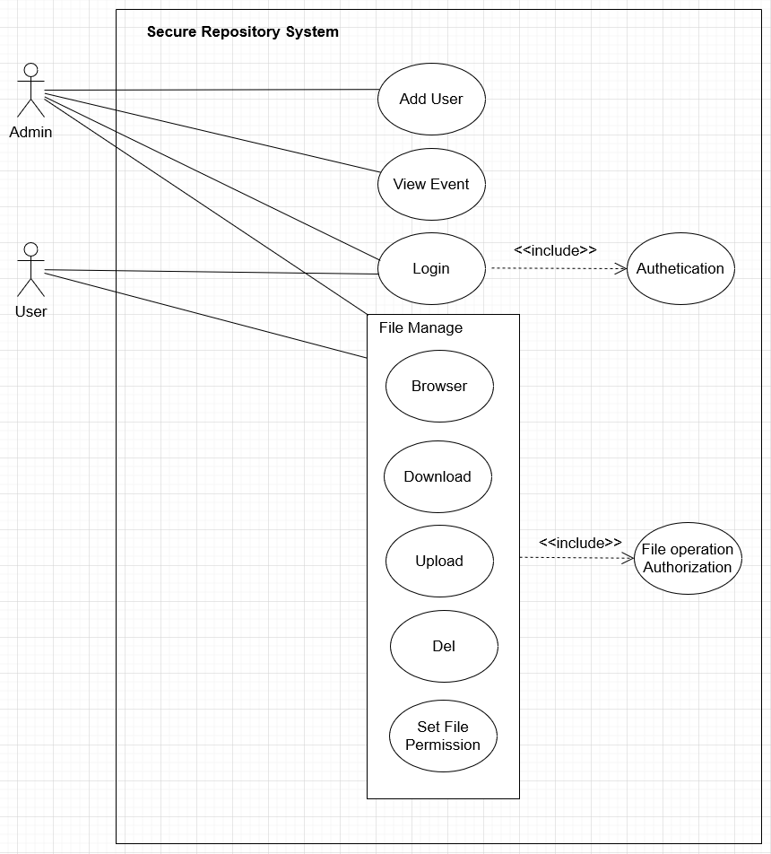
Use Case Diagram

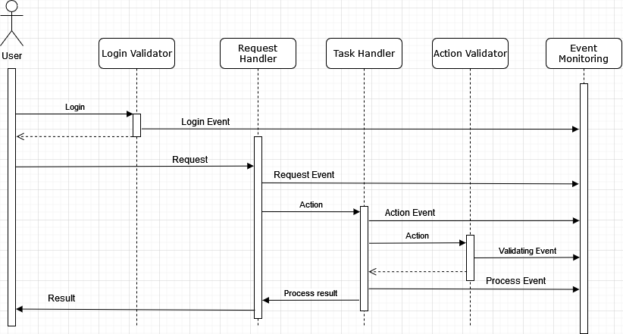
User Request Processing Sequence Diagram

Solutions
The whole system focuses on reducing data leaking and unauthorized access, but high security does not mean it will bring obstacles to regular users' daily use. The system will provide various configurations to each user request to satisfy different scenarios. Every file on the server will have a classification, and only users who meet the permission requirement can perform corresponding actions.
For example, the system can provide config to a user with a specific IP address or range to operate a file; or only a particular user can download one specification file.
There will be an appropriate component to record all the events in the system, and system maintainers can audit data to determine any suspect action.
For GDPR compliance, the system should keep minimal and necessary user data related to the functionality required, and only authorized staff can access the collected data.
For the purpose of building a high-quality, easy extension in the future and long-term maintainable software, all the components in the system will be written in single responsibility and interact with interface modern OOP style. The system also is designed to apply the microservice style, and each component can interact with the message or REST-API style. When processing user requests, any request should have its security policy for validation.
All the public functions should be covered by unit testing. And source code should be passed by static security analysis tools check, for example, Bandit. Pylint will use to guide code style.

Environment, Tools and Libraries
Python 3.10.4.
Flask with HTTPS enabled as a framework to build microservices.
SQLite is a relational database for demonstration purposes, and the database module can easily replace it with other open-source products.
Pylint to use for code quality/Error detection/Duplicate code detection.
Bandit will be used as a static analysis tool to detect security defects.
Mccabe to evaluate code complexity.

System Key Components
1. Authentication
1.1 Brief
1.1 UML (Option)
1.2 Security consideration

2. Authorization
2.1 Brief
2.1 UML(Option)
2.2 Security consideration

3. Event monitor
3.1 Brief
3.2 UML(Option)
3.3 Security consideration

4. DataBase Manager
4.1 Brief
4.2 UML(Option)
4.3 Security consideration

