Homework 1
Name: Wenliang Sun

Chapter 1
1.a Solution:
Confidentiality: In a banking example, Bob doesn’t want Alice to know how little money in his account.
Integrity: The bank and customers are concerned that their account balances don’t change in unauthorized manner.
Availability: is crucial for any online business.

3.Solution:
a) Because AOC shouldn’t let other people know some sensitive information of users. For example: credit card number, birthday and etc.
b) Because when users pay for their fees, the financial transactions should be integrity.
c) Because if the AOC is hard to use, it will lose many users.

Chapter 2
4. Solution: The key is shift 22, and the plaintext is “you are terminated”
5. Solution:
a) 2⁴⁸ seconds, about 8.923*10⁶ years.
b) 2⁷² seconds, about 1.497*10¹⁴ years.
c) 2²¹⁶ seconds, about 3.339*10⁵⁷ years.
14. Solution:
WEAR EALL LEAL
EALL -> THER -> ETHR
TOGE WEAR AWER
THER TOGE GTOE
So the ciphertext is “LEALETHRAWERGTOE”
15. Solution:
(1)
I | A | U | T | M | O | C | S | M | N
I | M | R | E | B | O | T | N | E | L
S | T | R | H | E | R | E | O | A | E
V | M | W | I | H | T | S | E | E | A
T | M | A | E | O | H | W | H | S | Y
C | E | E | L | T | T | E | O | H | M
U | O | U | F | E | H | T | R | F | T
(2)
Rules:
Column: (1 2 3 4 5 6 7 8 9 10) -> (2 4 67 6 5 9 3 10 1 8)
Row: (1 2 3 4 5 6 7) -> (3 5 1 4 7 6 2)
(3)
T | H | E | R | E | A | R | E | S | O
M | E | W | H | O | S | A | Y | T | H
A | T | C | O | M | M | U | N | I | S
M | I | S | T | H | E | W | A | V | E
O | F | T | H | E | F | U | T | U | R
E | L | E | T | T | H | E | M | C | O
M | E | T | O | B | E | R | L | I | N

The plaintext is “there are some who say that communism is the wave of the future let them come to berlin”

19. Solution:
a) Covert the plaintext and the ciphertext into binay.
Thrill: 111 001 101 010 100 100
KITLKE: 011 010 111 100 011 000
We could get the key by xor operation: 100 011 010 110 111 100 -> lkistl
b) Covert the plaintext and the ciphertext into binay.
Tiller: 111 010 100 100 000 101
KITLKE: 011 010 111 100 011 000
We could get the key by xor operation: 100 000 011 000 011 101 -> lekekr
24. Solution: the key is “key”, and the plaintext “spoon feeding in the long run teaches us nothing but the shape of the spoon”

Chapter 3
3. Solution:
a) Trudy could get the key by this formula: K = C ⊕ P
b) Since Trudy knows the key, she could get C’ to replace C: C’ = P’ ⊕ K
5. Solution:
For this question, we need do 8 times iteration. So I developed a java program to calculate it. The code is in the end of the homework. The result is:
Key= [0, 1, 0, 0, 0, 0, 0, 1]
X= [0, 0, 0, 0, 0, 0, 0, 1, 0, 1, 0, 1, 0, 1, 0, 1, 0, 1, 0]
Y= [1, 0, 1, 0, 1, 0, 1, 1, 0, 0, 1, 1, 0, 0, 1, 1, 0, 0, 1, 1, 0, 0]
Z= [1, 0, 1, 0, 1, 1, 1, 1, 0, 0, 0, 0, 1, 1, 1, 1, 0, 0, 0, 0, 1, 1, 1]
11. Solution:
a) The Feistel structure is particular example of the more general iterative structure used by all symmetric block ciphers, that consists of a sequence of rounds, with each round performing substitutions and permutations conditioned by a secret key value.
b) Yes.
c) No.
14.Solution:
a) 64 bits
b) 64 bits
c) 56 bits
d) 48 bits
e) 16 rounds
f) 8 S-boxes
g) 6 bits
h) 4 bits
23.Solution:
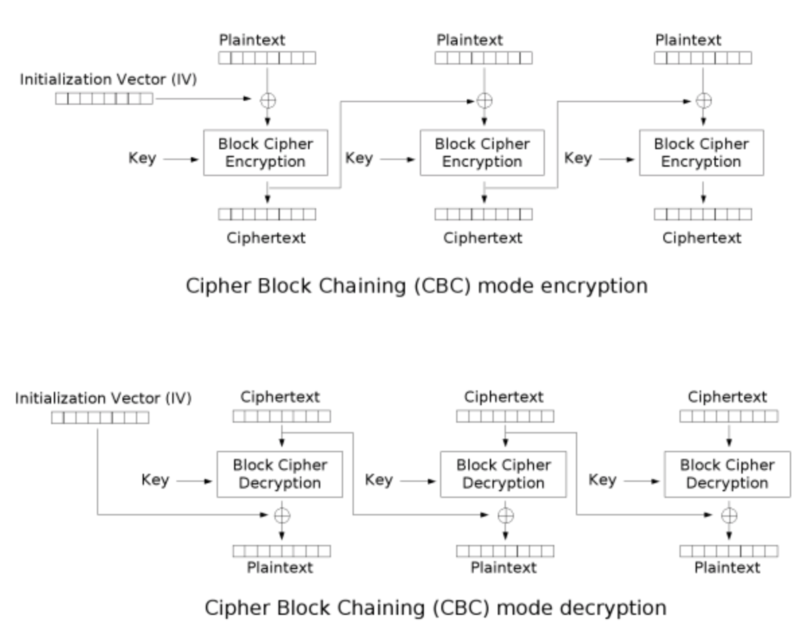

40. Solution:
No. Alice’s approach is not as secure as Bob’s. There is a straightforward meet-in-the-middle attack on double encryption using Cipher A, which has a work factor of about 2⁶⁴, assuming that we can store a lookup table of size 264. In comparison, the evaluation expected work to break Cipher B is 2¹²⁸. It is similar to the case that double DES and DES.

(A1) What is a security model? Describe the security model with the following application. Suppose you are developing a multi-play online gambling system.
Solution:
A security model is the combination of a threat and a trust model.
1. The gambling system concerns that operating a computer server to run a gaming application involves the same challenges and risks associated with operating a server for other applications. Intruders may break into or crash your server if its security profile, or level of protection is insufficient.
2. The gambling system threats include:
1) Risks from social interactions with strangers who may trick you into revealing personal or financial information
2) Risks from computer intruders exploiting security vulnerabilities
3) Risks from online and real-world predators
4) Risks from viruses, Trojan horses, computer worms, and spyware
3. The adversaries include: people who want to intrude the system and get sensitive information or other benefits.
4. We should trust the firewall in our computers, it is important to make sure the game vendor is reputable and download the game from a site we believe we can trust.

(A2) To design strong ciphers, what are the two security requirements and two design principles? Please explain them their meanings.
Solution:
Two fundamental cipher design principles: confusion and diffusion.
Confusion is defined as obscuring the relationship between the plaintext and ciphertext.
Diffusion is the idea of spreading the plaintext statistics through the ciphertext.
Two requirements are:
1) Long key space is used to exhaustive key search takes too long.
2) No shortcut attacks means as far as we know, there is no successful attack case.

(A3) Draw a table to show the block size, key length, number of rounds for each of the following block ciphers: DES, 3DES, AES.
 | Block size | Key length | Number of rounds
DES | 64 bits | 56 bits | 16 rounds
3DES | 64 bits | 168 bits | 48 DES-equivalent rounds
AES | 128 bits | 128, 192 or 256 bits | 10 to 14 rounds

Chapter 3 question 3 code:
/**
* Created by wenliang.sun on 1/26/18.
*/
public class IntroSecurity {

public static void main(String args[]) throws Exception {

String key = "";
String x = "1010101010101010101";
String y = "1100110011001100110011";
String z = "11100001111000011110000";
String registerNeedShift;
int[] xRegister = parseStringToIntArray(x);
int[] yRegister = parseStringToIntArray(y);
int[] zRegister = parseStringToIntArray(z);

for (int i = 0; i < 8; ++i){
// Calculate the key
key = key + getFirstBitOfKey(xRegister, yRegister, zRegister);
//Determine which register need to shift
registerNeedShift = getWhichRegisterShift(xRegister, yRegister, zRegister);
//If need, shift some registers
if(registerNeedShift.contains("x")){
xRegister = getX(xRegister);
}
if(registerNeedShift.contains("y")){
yRegister = getY(yRegister);
}
if(registerNeedShift.contains("z")){
zRegister = getZ(zRegister);
}
}
System.out.println("key = " + key);
System.out.println("x = " + Arrays.toString(xRegister));
System.out.println("y = " + Arrays.toString(yRegister));
System.out.println("z = " + Arrays.toString(zRegister));

}

private static String getWhichRegisterShift(int[] x, int[] y, int[] z) {
String registers = "";
int countZero = 0;
int countOne = 0;
if (x[8] == 0)
countZero++;
else if(x[8] == 1)
countOne++;

if (y[10] == 0)
countZero++;
else if(y[10] == 1)
countOne++;

if(z[10] == 0)
countZero++;
else if(z[10] == 1)
countOne++;

if (countOne > countZero){
if (x[8] == 1)
registers = registers + "x";
if (y[10] == 1)
registers = registers + "y";
if (z[10] == 1)
registers = registers + "z";
}
else{
if (x[8] == 0)
registers = registers + "x";
if (y[10] == 0)
registers = registers + "y";
if (z[10] == 0)
registers = registers + "z";
}
return registers;
}

public static String getFirstBitOfKey(int[] x, int[] y, int[] z){

return (x[18] ^ y[21] ^ z[22]) +"";
}

public static int[] getX(int[] x){

int[] temp = new int[x.length];
for (int j = 0; j < x.length;++j){
temp[j] = x[j];
}
x[0] = x[13] ^ x[16] ^ x[17] ^ x[18];
for (int i = 1;i <= 18; ++i ){
x[i] = temp [i-1];
}
return x;
}
public static int[] getY(int[] y){

int[] temp = new int[y.length];
for (int j = 0; j < y.length;++j){
temp[j] = y[j];
}
y[0] = y[20] ^ y[21];
for (int i = 1;i <= 21; ++i ){
y[i] = temp [i-1];
}
return y;
}
public static int[] getZ(int[] z){
int[] temp = new int[z.length];
for (int j = 0; j < z.length;++j){
temp[j] = z[j];
}
z[0] = z[7] ^ z[20] ^ z[21] ^ z[22];
for (int i = 1;i <= 22; ++i ){
z[i] = temp[i-1];
}
return z;
}

public static int[] parseStringToIntArray(String str) {
int length = str.length();
int[] result = new int[length];
for (int i = 0; i < length; i++) {
char c = str.charAt(i);
result[i] = Character.getNumericValue(c);
}
return result;
}
}

