Homework 2: Wenliang Sun

- (6) Consider a Diffie-Hellman scheme with a common prime p=11 and a primitive root g=2.
- If user A has a private key of 3, what is A’s public key?
- If user B has a private key of 5, what is its public key?
- What is their shared secret key K?

- 2³ mod 11 = 8
- 2⁵ mod 11 = 10
- K= 10³ mod 11=10

- (10 pts) Perform both encryption and decryption using the RSA algorithm for the following: (1) p=3, q=13, e=5, and M=3. (2) p=5, q=11, e=3, M=7; (you may guess d, you may use the repeated squaring based power reduction technique we introduced in the class)

Answer:
(1)n = p * q = 3 * 13 = 39
f(n) = (p-1) * (q-1) = 2 * 12 = 24
Now, we need to compute d = e-1 mod f(n) by using backward substitution of GCD algorithm:
According to GCD: gcd(f(n), e) = gcd (24, 5) = 1
Therefore, we have:
∵ d ≡ e⁻¹(mod ϕ(n))
d x e mod ϕ(n) = 1
5 d mod 24 = 1
∴ d = 5
So: Public Key: public = {e, n} = {5, 39}
Private Key: private= {d, n} = {5, 39}
Encryption:
C = Me mod n = 3⁵ mod 39 = 9
Description:
M = C^{d} mod n = 9⁵ mod 39 = 3

(2) n = p x q = 5 x 11 = 55
ϕ(n) = (p-1) x (q-1) = 4 x 10 = 40
gcd(ϕ(n), e) = gcd(40, 3) = 1
∵ d ≡ e⁻¹(mod ϕ(n))
d x e mod ϕ(n) = 1
3d mod 40 = 1
∴ d = 27
So Public Key: public = {e, n} = {3, 55}
Private Key: private = {d, n} = {27, 55}
Encryption:
C = Me mod n = 7³ mod 55 = 13
Decryption:
M = C^{d} mod n = 13²⁷ mod 55 = 7

- (5 pts) In a public-key system using RSA, you intercept the ciphertext C=10 sent to a user whose public key is e=5, n=35. What is the plaintext M?

Answer:
Since C = Me mod n
Therefore, 10 = M5 mod 35
The following table demonstrate value for M

M | 1 | 2 | 3 | 4 | 5
M5 mod 35 | 1 | 32 | 24 | 9 | 10
Therefore, M = 5
Since 55 mod 35 = 10
For further confirmation,
Cd mod n = M
10d mod 35 = 5, since 100000 mod 35 = 5
d = 5
2 primes p and q from 35 are 7 and 5
ϕ(n) = (p-1) * (q-1)

= (5-1) * (7-1) = 4 * 6 = 24 = z
Given that d * e mod z = 1 is always true
Therefore 5 * 5 mod 24 = 1 holds.

- (6pts) Let h1 and h2 be two hash functions. Show that if either h1 or h2 is collision resistant, then the hash function h(x) = h1(x) ||h2(x), is collision resistant.

Answer:
Let A be an adversary that with probability ε(n) outputs a pair x, x’ such that h(x) = h’(x). In such a case, by the definition of h, we have that h1(x) = h1(x’) and h2(x) = h2(x’). Thus, a finds a collision in both h1 and h2 with probability ε.

- (9 pts) Given that we have 46 students in our classroom, compute (1) what is the probability p1 that there is at least another people who have the same birthday as yours (2) what is the probability p2 that there are at least two people who have the same birthday? (3) based on the previous result, please explain why for SHA-1, its actual security strength is only about 80 bits.

Answer:
(1) p1 = 1 – (364 / 365)⁴⁵ ≈0.12
(2) p2 = 1 – 365! / (365^{n} *(365 - n)!) ≈0.95
(3) A secure hash that generates an N-bit output can be broken with a brute force work factor of about 2^{N/2}. In contrast, a secure symmetric key cipher with a key of length N can be broken with a work factor of 2^{N-1}. Consequently, the output of a hash function must be about twice the number of bits as a symmetric cipher key for an equivalent level of security—assuming both are secure, i.e., no shortcut attack exists for either.
For SHA-1 the output length is 160bits, according to the above formula, the actual security strength is only 80 bits.

- (8 pts) In this problem we will compare the security services that are provided by digital signatures (DS) and message authentication codes (MAC). We assume that Oscar is able to observe all messages sent from Alice to Bob and vice versa. Oscar has no knowledge of any keys but the public one in case of DS. State whether and how (i) DS and (ii) MAC protect against each attack. The value auth(x) is computed with a DS or a MAC algorithm, respectively.
- (Message integrity) Alice sends a message x = “Transfer $1000 to Mark” in the clear and also sends auth(x) to Bob. Oscar intercepts the message and replaces “Mark” with “Oscar”. Will Bob detect this?
- (Replay) Alice sends a message x = “Transfer $1000 to Oscar” in the clear and also sends auth(x) to Bob. Oscar observes the message and signature and sends them 100 times to Bob. Will Bob detect this?
- (Sender Authentication with cheating third party) Oscar claims that he sent some message x with a valid auth(x) to Bob but Alice claims the same. Can Bob clear the question in either case?
- (Authentication with Bob cheating) Bob claims that he received a message x with a valid signature auth(x) from Alice (e.g. “Transfer $1000 from Alice to Bob.”) but Alice claims she has never sent it. Can Alice clear this question in either case?
Answer:
- Message integrity attack
Alice sends a message to Bob. Oscar catches and replaces the message auth(x) and sends it to Bob.
DS protects this message integrity attack. To ensure this, the digital code is generated using the hash of the message and then it is encrypted using the sender’ s private key and it is added as signature. It assures that the message is from the authorized party who claims to be and it also assures that the message is not altered in between.
MAC protects this message integrity attack. To insure this, the MAC is generated based on the message and the secret key using the hash of the message and then it is encrypted using the sender’s private key and it is added as signature. Then, the MAC is appended to the message at sender’s side while transmitting. In the receiver side, the receiver receives the message along with the MAC. Then, the message alone along with the secret key is inputted to MAC algorithm which produces the MAC. The obtained MAC and the received MAC are compared to check for message authentication. If both MAC are same then the receiver can be assured, that the message is received for authenticated sender and it is received without any modification.
Therefore, the message integrity attack is detected with both DS and MAC.

- Replay attack:
Alice sends a message to Bob. In between, Oscar catches the message and signature and sends it to Bob 100 times.
In this case, there is no modification in the message. Thus, sending the same message again and again cannot be identified by the receiver Bob. Because, both the DS and MAC assures only the message is received from authenticated sender without any modifications.
Therefore, sending the same message again will not be identified by the receiver when using DS and MAC.

- Sender authentication
Bob receives a message. Oscar claims the message is sent by him and Alice claims that message is sent by her.
By using DS, Bob can verify the signature of the sender by decrypting the signature with both public key of the sender which results in hash message. If the generated hash message matches with the received hash message, then the message is received from the authenticated user. In this case, Bob tries with both Alice and Oscar public key to verify the authenticated user.
When using MAC, Bob can ask the secret key of both the users. Actually, he has the secret key already. Thus, the one who reveals the correct secret key is the authenticated user.
Therefore, Bob can identify whether the message is received from the authenticated sender with both DS and MAC.

- Message authentication cheating by the receiver
Bob tells that a message is received from Alice. Alice claims that she didn’t send that message.
By using DS, Alice can force Bob to forward the received message along with the signature. Hence, Alice can prove that she didn’t send that message if the signature doesn’t match.
By using MAC, Alice cannot prove that she didn’t send that message and hence, Bob can claim that Alice has generated and sent the message.
Therefore, if the receiver claims a message is sent by a sender only by using DS, the sender can prove that the message is not sent by him. This is not possible with MAC.

- (6 pts) What is a PKI? What are the three trust models for PKI (explain their meanings and example in some details)?

Answer: A public key infrastructure (PKI) supports the distribution and identification of public encryption keys, enabling users and computers to both securely exchange data over networks such as the Internet and verify the identity of the other party.
Monopoly: One CA universally trusted by everyone. Everyone must get certificates from the CA. The public key to this organization is the only PKI trust anchor and is embedded in all software and hardware. It is favored by VeriSign.
Oligarchy: A few trusted CAs and a certificate issued by any one of them is accepted. Competition with CA is good. This approach is used in modern browsers.
Anarchy: Fully distributed approach. No CA or list of CA provided to the users. Anyone can sign certificates for anyone else. Each user responsible for configuring some trust anchors. A database maintains these certificates. This model is used in PGP(web of trust).

4.2 Answer:
a) A name and a public key. To be of any value, it must also be signed by a CA.
b) Just about anything—phone number, office, department, etc.
c) If any of the information changes, a new certificate is needed.

4.6 Answer:
a) To encrypt: 19³=28 mod 33= 28. To decrypt: 28⁷=19 mod 33 =19.
b) The signed result is S=M^{d} mod N=25⁷mod 33 = 31. To verify the signature, Bob computes S3 mod N and the signature is verified if the result matches the received value M. For this case, 31³=25 mod 33. Suppose Bob receives the sent message M=25, the signature is verified.

4.12 Answer:
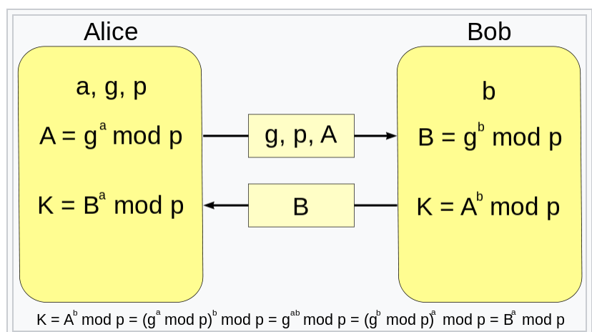

4.13 Answer:
No. Bob wants to solve for b in the equation (ga)b mod p = X, but this requires Bob to solve the discrete log problem, where the base is ga mod p.

5.4 Answer:
a) If I hash 2¹⁰ messages, then I have about 2²⁰ comparisons. For each 2¹² comparisons, I expect to find a collision, so the expected number 2⁸.
b) The collisions should be m² / 2^{n}.

5.17 Answer:
a) One way and collision resistance.
b) A forward search-hash all reasonable bids and look for ones that give the same hash as Alice’s and/or Bob’s bid.
c) Yes, most definitely.
d) Alice can should select a random value RA and submit h (A, RA), and similarly for the other bidders. When submitting her bid, Alice must submit her bid A and the random padding RA.
5.21 Answer:
Method (i) does not require anything to be stored. Method (ii) uses a stronger key to encrypt the data, making an attack directly on the ciphertext more different. Method (ii) could also be advantageous when Alice wants to change her password, since it is not necessary to decrypt/re-encrypt the data.

5.30 Answer:
a) Alice computers S=[h(M)] ^{Alice}.

b) Alice sends both M and S = [h(M)] ^{Alice} to Bob. Bob verifies that h(M) = {S} ^{Alice}.

