Homework 1: Your Name ______________________________

(please finish with typing and submit a hardcopy. You also need to show with some details how you solve a calculation or encryption/decryption problem)

Chapter 1:

(6 pts) 1.a:

Confidentiality: assets (or data or information) are accessed only by authorized parties, (or prevent unauthorized data access).

Integrity: Assets can be modified by authorized parties or only in authorized ways

Availability: Assets are accessible to authorized parties at appropriate times

(3 pts) 3: a. For example, payment of fees requires confidentiality of credit card information.
b. Integrity is required for financial transactions and when actually playing games.
c. If the service is not available on demand, it won't be too popular with users.

Chapter 2:

(6 pts) 4. The shift is 22 (or, equivalently, - 4) and the plaintext is “you are terminated."
(6 pts) 5:
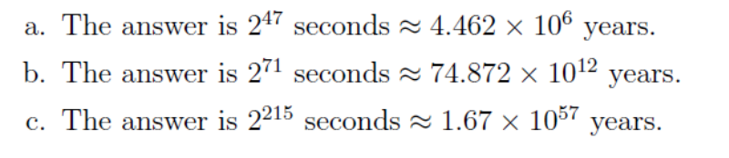
(5 pts) 14. The ciphertext is LEALETHRAWERGTOE.

(10 pts) 15: Put the ciphertext in a 7 x 10 array. Then the letters of “there" will all appear (in scrambled order) in one row. This gives a start on the column permutation. Once the
column perms are known, the row perms are easily determined. The answer is a quote
from President Kennedy: “There are some who say that communism is the wave of
the future. Let them come to Berlin."

(6 pts) 19: 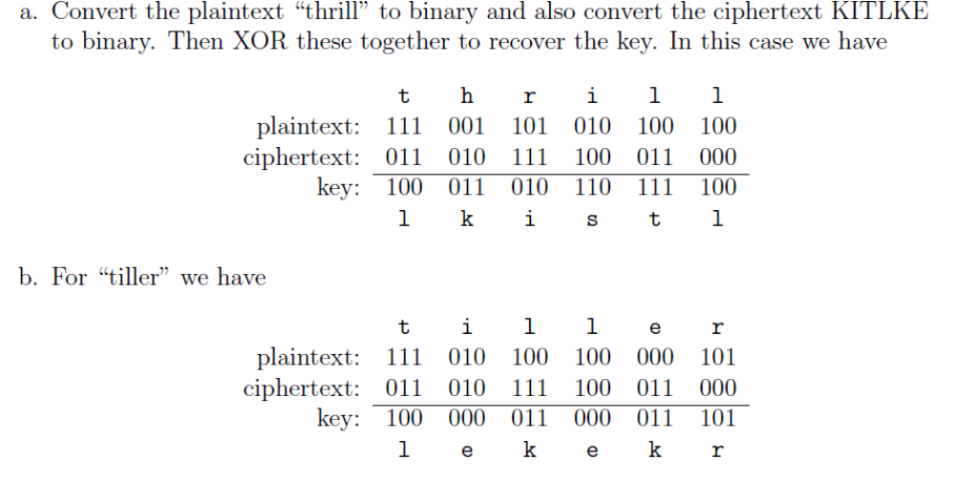
(10 pts) 24.
The plaintext is: Spoon feeding in the long run teaches us nothing but the shape of
the spoon. The key is KEY.

Chapter 3:

(10pts) 3. 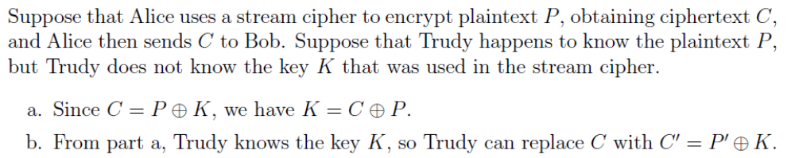

(9pts) 5. The key stream bits are 100000110…
this solution is for the original question which requires 32 bits output. So you can look at the first 8 bits only. Also depending on stepping first or generating key bit first, there could be one bit different from the standard solution , which are both fine. Please figure out the states of the three registers yourself.

(6pts) 11:
a. The formulas are given in the book.
b. Yes.
c. No.

(4pts) 14: a. 64 (DES plaintext block)
b. 64
c. 56
d. 48
e. 16
f. 8 （S-BOX）
g. 6(S-box input bits)
h. 4 S-box output bits)

23: (5pts) see slides.(CBC：加密：每一轮与上一轮结果做亦或运算；第一轮用IV亦或)

40: (extra credit, 10pts) No, this is not a good idea. There is a straightforward meet-in-the-middle attack on double encryption using Cipher A, which has a work factor of about 2⁶⁴, assuming that we can store a lookup table of size 2⁶⁴. In comparison, the expected work to break Cipher B is 2¹²⁷. See the discussion of the meet-in-the-middle attack on double DES. However, note that this attack requires known plaintext.

-----------------------------------------------------
(5pts) (A1) What is a security model? Describe the security model with the following application. Suppose you are developing a multi-play online gambling system.

- Security model is combination of trust model and threat model
- The answer may not be unique (as long as making sense).
Trust model: trust the server hosting the game to execute correctly.
Threat model: Game players may reverse engineer the software to change its logic, or further infer what other players, or deny their movements.

(5pts) (A2) To design strong ciphers, what are the two security requirements and two design principles? Please explain their meanings.

two security requirements
- Large key space
  - Exhaustive key search takes too long
- No shortcut attacks
  - No better than exhaustive key search

two design principles
- Confusion confusion refers to making the relationship between the ciphertext and the symmetric key as complex and involved as possible;(key and ciphertext)
- Diffusion diffusion refers to making the relationship between the plaintext and the ciphertext as complex and involved as possible (so that the plaintext statistics are spread over the ciphertext). (plaintext and ciphertext)

(5pts) (A3) Draw a table to show the block size, key length, number of rounds for each of the following block ciphers: DES, 3DES, AES.

 | Block Size | Key Length | #Rounds
DES | 64 | 56 | 16
3DES | 64 | 168 | 16 (or 48)
AES | 128, 192,256 | 128,192,256 | 10-14

