1.Solution:

Distances to two centroids are:

A: 0 and 1.414, B: 1 and 2.236, C: 1 and 0, D: 3.162 and 2.828, E: 4.472 and 1.414

So Cluster1: A, B; Cluster2: C, D, E

**Round 2:**

Set centroid 1 to be (1, 0.5) and centroid 2: (5/3, 11/3)

Distances to 2 centroids are:

A:0.5, 2.748, B: 0.5, 3.727, C: 1.802 and 2.357, D: 3.654 and 0.471, E: 4.924 and 1.886

So 2 clusters are still the same and centroids do not change.

2.Solution:

(a)MIN: P2 and P5 are in same cluster based on the table 2.

**Round 1:**

|  |  |  |  |  |
| --- | --- | --- | --- | --- |
|  | P1 | P2 U P5 | P3 | P4 |
| P1 | 1 | 0.1 | 0.41 | 0.55 |
| P2 U P5 | 0.1 | 1 | **0.64** | 0.47 |
| P3 | 0.41 | **0.64** | 1 | 0.44 |
| P4 | 0.55 | 0.47 | 0.44 | 1 |

So, P2UP5 and P3 are in same cluster after round 1.

**Round 2:**

|  |  |  |  |
| --- | --- | --- | --- |
|  | P1 | P2 U P5 U P3 | P4 |
| P1 | 1 | 0.1 | **0.55** |
| P2 U P5 U P3 | 0.1 | 1 | 0.44 |
| P4 | **0.55** | 0.44 | 1 |

So, P1 and P4 are in same cluster after round 2.

**Round 3:**

|  |  |  |
| --- | --- | --- |
|  | P1 U P4 | P2 U P5 U P3 |
| P1 U P4 | 1 | **0.1** |
| P2 U P5 U P3 | **0.1** | 1 |

Based on these tables, we can get the graph as below:

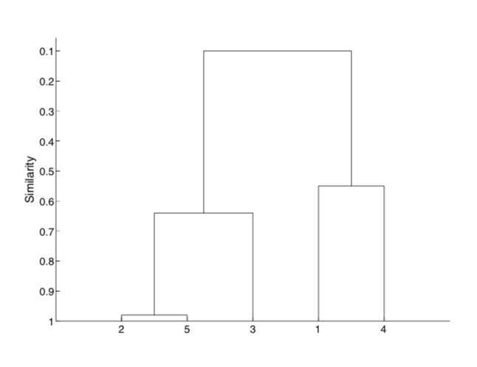

(b)MAX: P2 and P5 are in same cluster based on the table 2.

**Round 1:**

|  |  |  |  |  |
| --- | --- | --- | --- | --- |
|  | P1 | P2 U P5 | P3 | P4 |
| P1 | 1 | 0.1 | 0.41 | 0.55 |
| P2 U P5 | 0.35 | 1 | **0.85** | 0.76 |
| P3 | 0.41 | **0.85** | 1 | 0.44 |
| P4 | 0.55 | 0.76 | 0.44 | 1 |

So, P2UP5 and P3 are in same cluster after round 1.

**Round 2:**

|  |  |  |  |
| --- | --- | --- | --- |
|  | P1 | P2 U P5 U P3 | P4 |
| P1 | 1 | 0.41 | 0.55 |
| P2 U P5 U P3 | 0.41 | 1 | **0.76** |
| P4 | 0.55 | **0.76** | 1 |

So, P2 U P5 U P3 and P4 are in same cluster after round 2.

**Round 3:**

|  |  |  |
| --- | --- | --- |
|  | P1 | P2 U P5 U P3 U P4 |
| P1 | 1 | 0.55 |
| P2 U P5 U P3 U P4 | 0.55 | 1 |

Based on these tables, we can get the graph as below:

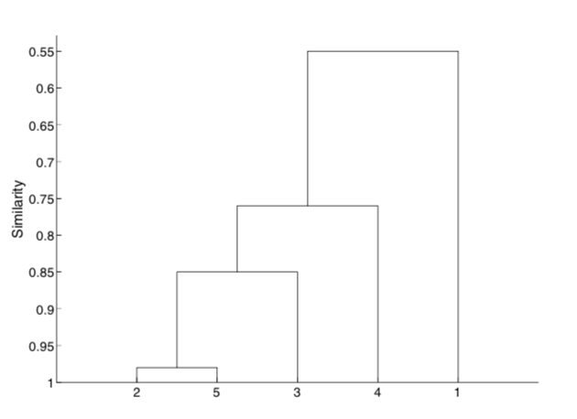

3.Solution:

1-D, 2-C, 3-B, 4-A

4.Solution:

(a)Suppose object b is an outlier and object a is normal. Object a has many nearest neighbors around it except b. But for b, its nearest neighbor can be object a.

(b)The first approach is that set the ijth entry to 0 if the jith is 0.

The second approach is that set the ijth entry to 1 if the jith is 1.