Name: Wenliang Sun

1.（a）s({a}) =7/10

s({a,b}) = 2/5

s({a,c,e})=1/5

(b) c({a,c} → {e})=2/3

c({e}→{a,c})=1/4

No, confidence is not a symmetric measure.

(c) s({a}) =4/5

s({a,b}) = 4/5

s({a,c,e})=2/5

2.(a) 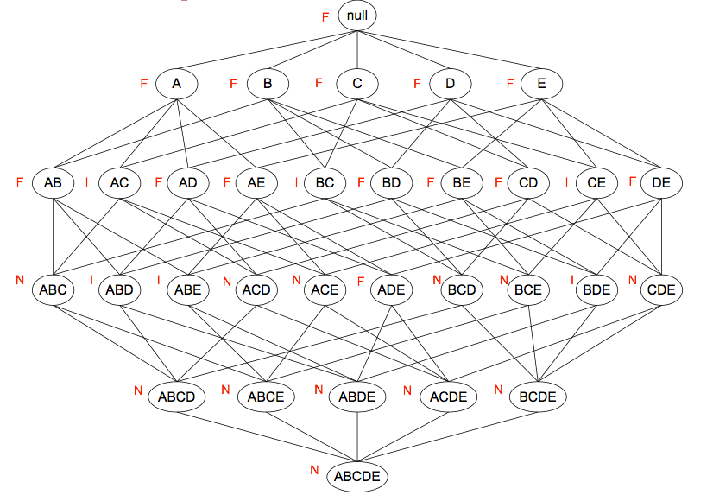

(b)15/32

(c)N=12, so 12/32=3/8

(d)I=5, so 5/32

3.(a)s(A)=10/200=0.05;s(B)=10/200=0.05;s(A,B)=9/200=0.045;

I(A,B)=P(A,B)/[P(A)\*P(B)]=18;

φ= [P (A, B) − P (A)P (B)] /[ P(A)P(B)(1−P(B))(1−P(A))]1/2=0.89

c(A→B)=9/10=0.9

c(B→A)=9/10=0.9

(b) s(A)=19/20=0.95;s(B)=19/20=0.95;s(A,B)=189/200=0.945;

I(A,B)=P(A,B)/[P(A)\*P(B)]=1.05;

φ= [P (A, B) − P (A)P (B) ] /[ P(A)P(B)(1−P(B))(1−P(A))]1/2=0.89

c(A→B)=189/190=0.99

c(B→A)=189/190=0.99

(c) Interest, support, and confidence are non-invariant while the φ-coefficient is invariant under the inversion operation. This is because φ-coefficient takes into account the absence as well as the presence of an item in a transaction.

4.(a)No, the ws>1;

(b)Yes.

5.(a)One

(b)Three