**Baseband Lab_2**

**4-QAM Transmitter**

7109064351何宗諭

7110064486 林鼎鈞

7110064504 蘭松耀

7110064501 何明志

1.實驗原理 :

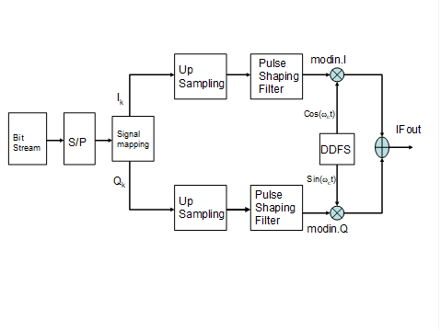

本實驗透過設計上圖中的submodule來完成一個4QAM的發射機，而其中的Pulse Shaping Filter將引用為Lab_1的結果。

2. Matlab code :

clear;

bit=fix(randn(1,500)); %Generate rand 0 or 1 signal sequence and the length of signal sequence is 5000 point

bit=abs(bit);

for (i=1:length(bit))

if(bit(i)>1)

bit(i)=1;

end

end

% -----------------------------------------------------------

if(rem(length(bit),2)==0) %Part_A S/P Converter

i1=1;

for(i=1:2:(length(bit)-1))

a1(i1,1:2)=bit(i:(i+1));

i1=i1+1;

end

else

i1=1;

for(i=1:2:length(bit)-2)

a1(i1,1:2)=bit(i:(i+1));

i1=i1+1;

end

end

for(i=1:length(a1)) %Part_B Signal Mapping

if(a1(i,1:2)==[0 0])

a2(i,1:2)=[1 1];

elseif(a1(i,1:2)==[0 1])

a2(i,1:2)=[1 -1];

elseif(a1(i,1:2)==[1 0])

a2(i,1:2)=[-1 1];

elseif(a1(i,1:2)==[1 1])

a2(i,1:2)=[-1 -1];

end

end

% ---------------------------------------------------------------------

for(i=1:length(a2)) % Part_C Up-sampling Interpolator

a3(i,:)=[a2(i,1) zeros(1,3) a2(i,2) zeros(1,3)];

end

intp_num=4; % Copy Lab1 Pulse Shaping Filter

symbol_interval=4;

r=0.5;

tap=2*symbol_interval*intp_num+1;

ti=-symbol_interval:1/intp_num:symbol_interval;

for i=1:tap

t=ti(i);

if t==0

srrcc(i)=1-r+4*r/pi;

elseif abs(t)==1/(4*r)

srrcc(i)=r/sqrt(2)*((1+2/pi)*sin(pi/4/r)+(1-2/pi)*cos(pi/4/r));

else

srrcc(i)=(sin(pi*t*(1-r))+4*r*t*cos(pi*t*(1+r)))/(pi*t*(1-(4*r*t)^2));

end

end

for(i=1:length(a3)) % combinate m_i1 and m_q1 from matrix to a one row matrix

m_i1(i,:)=[a3(i,1:4)];

m_q1(i,:)=[a3(i,5:8)];

end

m_i2=m_i1'; % temp variable

m_i=(m_i2(:))'; % final we want Ik

m_q2=m_q1'; % temp variable

m_q=(m_q2(:))'; % final we want Qk

% -----------------------------------------------------------------------

modi=conv(srrcc,m_i); % Part_D DDFS

modq=conv(srrcc,m_q);

txf_now=0;

txf_carrier_freq=pi/2;

for(i=1:length(modi))

ifout(i)=modi(i).*(cos(txf_now))-modq(i).*(sin(txf_now));

s(i)=sin(txf_now);

c(i)=cos(txf_now);

txf_now=txf_now+txf_carrier_freq;

end

figure

subplot(2,1,1)

plot(ifout)

title('time domain diagram');

subplot(2,1,2)

psd(ifout)

title('frequency domain diagram');

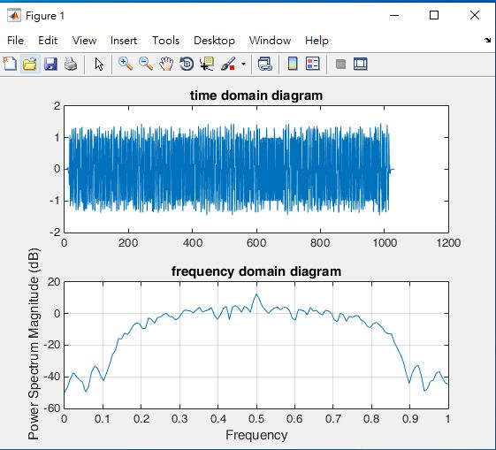

產生的波型如上圖所示，上圖為時域的波型圖，下圖為對應的頻譜

3. Veriolg :

我們這組分別設計系統方塊圖的各個子電路，最後再透過Top module將各個submodule呼叫進來，以實現4QAM發射機的硬體實做。

以下展示各個電路的程式:

**(1) S/P Converter :**

module sp(

clk,

rst,

sp_en,

sp_in,

sp_out

);

//

input clk, rst;

input sp_in;

input sp_en;

output reg [1:0] sp_out;

//

reg [1:0] out_temp;

reg flag; // asserted after first operation

reg ctrl;

// control signal

always@(posedge clk or posedge rst) begin

if(rst) begin

ctrl <= 0;

end

else if(sp_en) begin

ctrl <= ~ctrl;

end

else begin

ctrl <= ctrl;

end

end

// parallel

always@(posedge clk or posedge rst) begin

if(rst) begin

out_temp <= 0;

flag <= 0;

end

else if(sp_en && ctrl == 0) begin

out_temp <= sp_in;

flag <= flag;

end

else if(ctrl == 1) begin

out_temp <= out_temp << 1;

out_temp[0] <= sp_in;

flag <= 1;

end

end

// output

always@(posedge clk or posedge rst) begin

if(rst) begin

sp_out <= 0;

end

else if(ctrl == 0 && flag) begin

sp_out <= out_temp;

end

else begin

sp_out <= 2'bzz;

end

end

endmodule

**(2) Signal Mapping :**

module mapping(

clk,

rst,

map_en,

map_in,

i_out,

q_out

);

input clk, rst;

input map_en;

input [1:0] map_in;

output [1:0] i_out;

output [1:0] q_out;

reg signed [1:0] i_out;

reg signed [1:0] q_out;

// 4_QAM

always@(posedge clk or posedge rst) begin

if(rst) begin

i_out <= 2'b00;

q_out <= 2'b00;

end

else if(map_en) begin

case(map_in)

2'b00: begin

i_out <= 2'b01;

q_out <= 2'b01;

end

2'b01: begin

i_out <= 2'b01;

q_out <= 2'b11;

end

2'b10: begin

i_out <= 2'b11;

q_out <= 2'b01;

end

2'b11: begin

i_out <= 2'b11;

q_out <= 2'b11;

end

default: begin

i_out <= i_out;

q_out <= q_out;

end

endcase

end

else begin

i_out <= 2'bzz;

q_out <= 2'bzz;

end

end

endmodule

**(3) Up-sampling Interpolator :**

module up_sample(

clk,

rst,

up_en,

i_in,

q_in,

i_up_out,

q_up_out

);

input clk, rst;

input up_en;

input signed [1:0] i_in;

input signed [1:0] q_in;

output [1:0] i_up_out;

output [1:0] q_up_out;

reg signed [1:0] i_up_out;

reg signed [1:0] q_up_out;

//

reg [1:0] samp_cnt;

reg [1:0] buffer_i, buffer_q;

reg flag;

// sample counter

always@(posedge clk or posedge rst) begin

if(rst) begin

samp_cnt <= 0;

end

else if(up_en) begin

samp_cnt <= samp_cnt + 1;

end

else begin

samp_cnt <= samp_cnt;

end

end

// flag

always@(posedge clk or posedge rst) begin

if(rst) begin

flag <= 0;

end

else if(samp_cnt == 0) begin

flag <= 1;

end

else begin

flag <= flag;

end

end

always@(posedge clk or posedge rst) begin

if(rst) begin

buffer_i <= 0;

buffer_q <= 0;

end

else if(samp_cnt == 2'b10) begin

buffer_i <= i_in;

buffer_q <= q_in;

end

else begin

buffer_i <= buffer_i;

buffer_q <= buffer_q;

end

end

// output

always@(posedge clk or posedge rst) begin

if(rst) begin

i_up_out <= 2'b00;

q_up_out <= 2'b00;

end

else if(up_en) begin

case(samp_cnt)

2'b00: begin

if(flag == 0) begin

i_up_out <= i_in;

q_up_out <= q_in;

end

else begin

i_up_out <= buffer_i;

q_up_out <= buffer_q;

end

end

2'b01: begin

i_up_out <= 2'b00;

q_up_out <= 2'b00;

end

2'b10: begin

i_up_out <= 2'b00;

q_up_out <= 2'b00;

end

2'b11: begin

i_up_out <= 2'b00;

q_up_out <= 2'b00;

end

default: begin

i_up_out <= i_up_out;

q_up_out <= q_up_out;

end

endcase

end

else begin

i_up_out <= i_up_out;

q_up_out <= q_up_out;

end

end

endmodule

**(4) Top Module :**

module Four_QAM(

clk,

rst,

data_in,

data_en,

IFout

);

input clk, rst;

input data_en;

input data_in;

output reg [15:0] IFout;

//

wire [1:0] sp_out;

wire [1:0] i_map, q_map;

wire [1:0] i_up, q_up;

wire [13:0] i_srrc_in, q_srrc_in;

wire [15:0] I_out, Q_out;

// enable

reg map_en;

reg up_en;

reg ddfs_en;

// control flag

reg [1:0] ddfs_flag;

// process mode

reg [2:0] process;

// enable state

parameter MAP = 3'b011; // waiting three cycles for sp_out

parameter SAMPLE = 3'b100;

parameter DDFS = 3'b101;

// DDFS state

parameter COS = 2'b00;

parameter SIN = 2'b01;

parameter N_COS = 2'b10;

parameter N_SIN = 2'b11;

// serial_to_parallel converter

sp converter(.clk(clk), .rst(rst), .sp_in(data_in), .sp_en(data_en), .sp_out(sp_out));

// signal_mapping

mapping symbol(.clk(clk), .rst(rst), .map_en(map_en), .map_in(sp_out), .i_out(i_map), .q_out(q_map));

// up_sampling

up_sample sample(.clk(clk), .rst(rst), .up_en(up_en), .i_in(i_map), .q_in(q_map), .i_up_out(i_up), .q_up_out(q_up));

assign i_srrc_in = {i_up,12'd0};

assign q_srrc_in = {q_up,12'd0};

// pulse shaping filter

srrc_csd i_mod(.clk(clk), .rst(rst), .data_in(i_srrc_in), .data_out(I_out));

srrc_csd q_mod(.clk(clk), .rst(rst), .data_in(q_srrc_in), .data_out(Q_out));

//===========================================//

// CONTROL€UNIT //

//===========================================//

always@(posedge clk or posedge rst) begin

if(rst) begin

process <= 0;

end

else begin

process <= process + 1;

end

end

// enable signal

always@(posedge clk or posedge rst) begin

if(rst) begin

map_en <= 0;

up_en <= 0;

ddfs_en <= 0;

end

else if(data_en) begin

case(process)

MAP: begin

map_en <= 1;

up_en <= up_en;

ddfs_en <= ddfs_en;

end

SAMPLE: begin

up_en <= 1;

map_en <= map_en;

ddfs_en <= ddfs_en;

end

DDFS: begin

ddfs_en <= 1;

map_en <= map_en;

up_en <= up_en;

end

default: begin

map_en <= map_en;

up_en <= up_en;

ddfs_en <= ddfs_en;

end

endcase

end

else begin

map_en <= map_en;

up_en <= up_en;

ddfs_en <= ddfs_en;

end

end

// ddfs_flag

always@(posedge clk or posedge rst) begin

if(rst) begin

ddfs_flag <= 0;

end

else if(ddfs_en == 1) begin

ddfs_flag <= ddfs_flag;

end

end

always@(posedge clk or posedge rst) begin

if (rst) begin

IFout <= 0;

end

else begin

case(ddfs_flag)

COS: begin

IFout <= I_out;

end

SIN: begin

IFout <= Q_out;

end

N_COS: begin

IFout <= ~(I_out) + 1;

end

N_SIN: begin

IFout <= ~(Q_out) + 1;

end

default: begin

IFout <= IFout;

end

endcase

end

end

endmodule

4. 電路功能描述 :

(1) sp.v : 利用ctrl訊號來控制data_in移位以及輸出，ctrl訊號一個clock cycle會變一次。

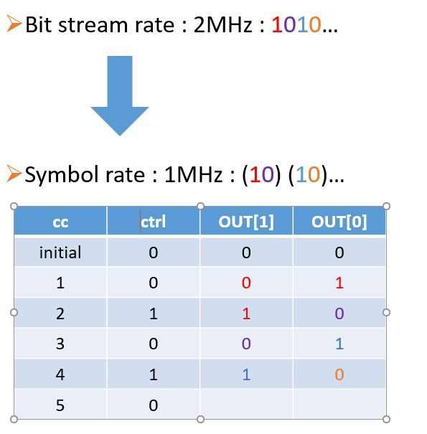

(2) mapping.v : 利用verilog中的case語法，製作多工器來決定星座圖上的對應輸出。

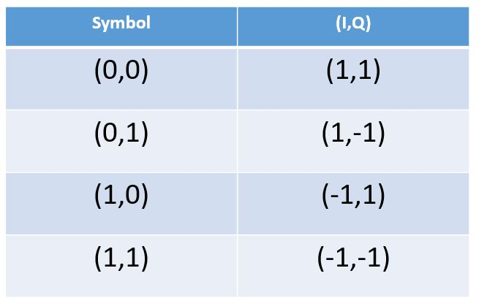

(3) up_sample.v : 設計一個計數器，並透過此計數器來控制upsample。此計數器為2 bits的計數器，故每四個clock cycle會循環一次，當計數器在第一個clock cycle時會輸出由(2)送進來的訊號，而在第2~4的clock cycle會輸出0，藉此來達到提升4倍sample rate的效果。

(4) Four_QAM.v :

此段程式會呼叫前面所設計子程式，並且執行DDFS block。

我們在主程式的後半部設計一個control unit，來控制其中的子程式的運作，例如第二段子程式會等待第一段子程式執行完才被觸發，以此類推，來確保輸出結果是正確的。

5. FPGA :

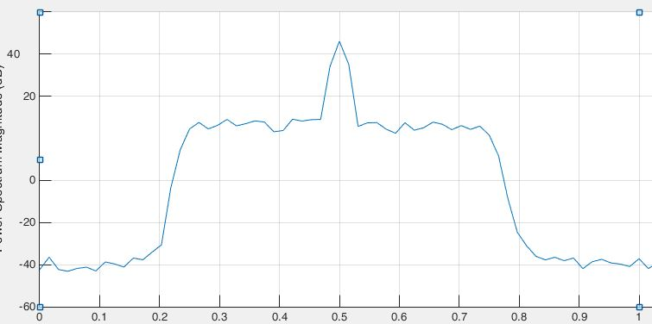

上圖為FPGA模擬的結果

可以看出在0.5的附近有一段突起。

**參考資料:**

1.范志鵬老師,“基頻通訊積體電路設計與實驗＂教材, 國立

中興大學 電機系。