Carrier Synchronization

Reference : John G. Proakis, M. Salehi, “Contemporary Communication Systems using MATLAB”, BookWare Companion Series, 2000.

Without loss of generality, we can assume that the input to the PLL is
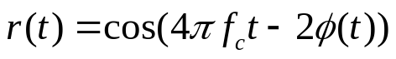
The PLL consists of a multiplier, a loop filter, and a voltage-controlled oscillator (VCO), as shown in Figure 1. If we assume that the output of the VCO is
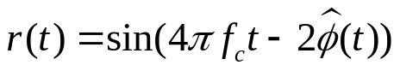.

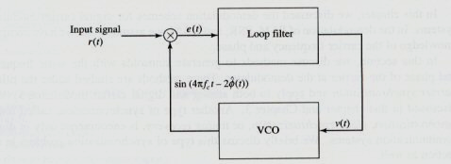

Figure 1 Phase Lock Loop

Then, at the input of the loop filter we have
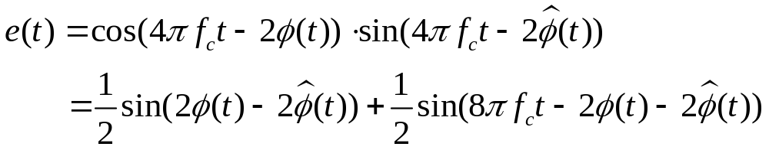

Note that e(t) has a high- and a low-frequency component. The role of the loop filter is to remove the high-frequency component and to make sure that 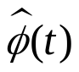 follows closely the variation in 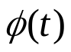.

A simple loop filter is a first-order lowpass filter with a transfer function of
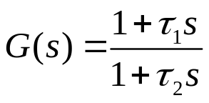
where 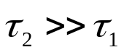 .
If we denote that the input of the VCO as v(t), then the output of the VCO will be a sinusoid whose instantaneous frequency deviation from 2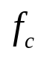 is proportional to v(t). Then the instantaneous frequency of the VCO output is
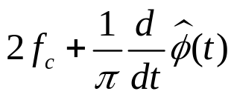,
therefore,
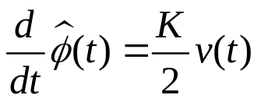,
or, equivalently,
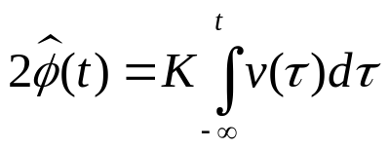,
where K is some proportional constant. After removal of the second and fourth harmonics, the PLL reduces to the one shown in Figure 2.

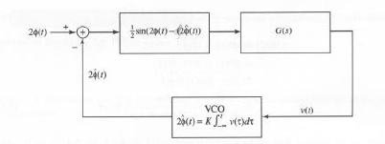
Figure 2 PLL after remove high-frequency component

Assuming that closely follows changes in , the difference 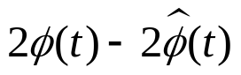 is very small, then
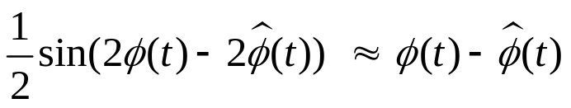,
With this approximation, the nonlinear component in Figure 2 is replaced by a linear component, resulting in the linearized PLL model shown in Figure 3.

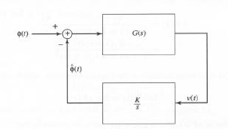
Figure 3 The linearized model for PLL

The model shown in Figure 3 is a linear control system with a forward gain of G(s) and a feedback gain of K/s ; therefore, the transfer function of the system is given by
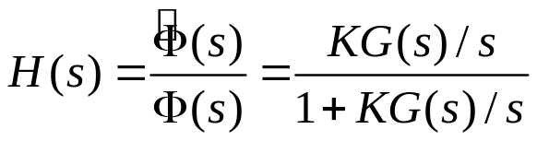.
Then, H(s) is given as
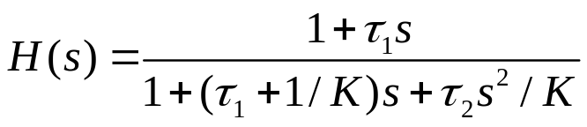.
With H(s) as the transfer function, if the input to the PLL is 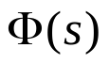, the error will be
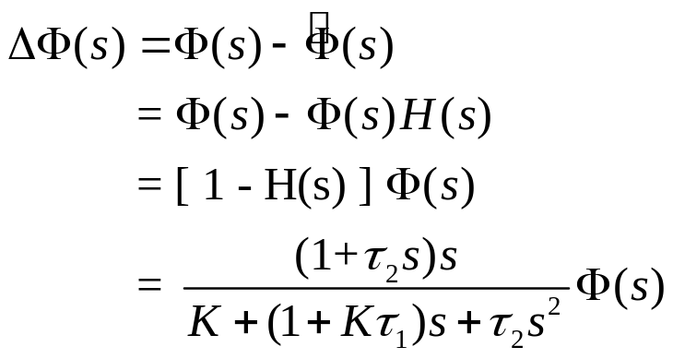,

At this time, some abrupt change causes a jump in that can be modeled as a step; that is 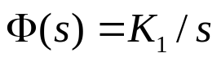. Then,

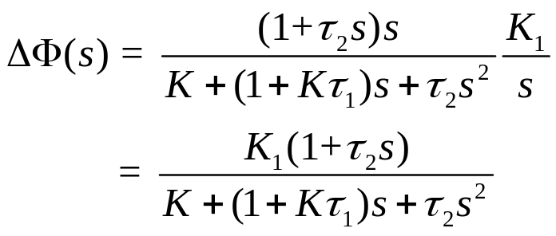.

Now, by using the final value theorem of the Laplace transform, which states that
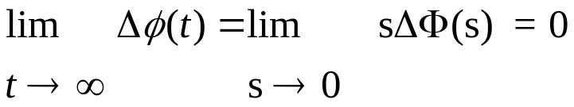

In other words, a simple first-order loop filter results in a PLL that can track jumps in the input phase.

The transfer function can be written in the standard form as
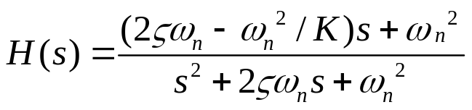,
where 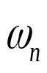 is the natural frequency, and 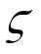 is the damping factor.
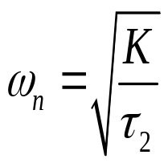 , 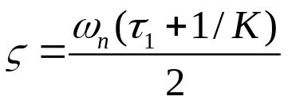

< Problems > Assuming that
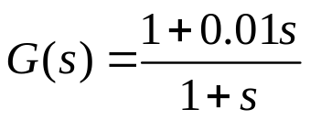,
and K=1, determine and plot the response of the PLL to an abrupt change of height 1 to the input phase.

<Solutions>
Here, 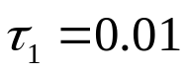 and 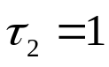 ; therefore ,
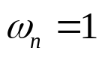
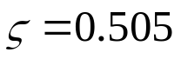,
which results in
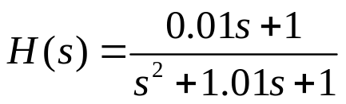.
We employ the MATLAB function tf2ss.m, which return the state-space model of a system described by its transfer function. After determining the state-space representation of the system, we obtain the step response numerically.
The function tf2ss.m takes the numerator and the denominator of the transfer function H(s) and return A, B, C, and D. Its state-space representation in the following form

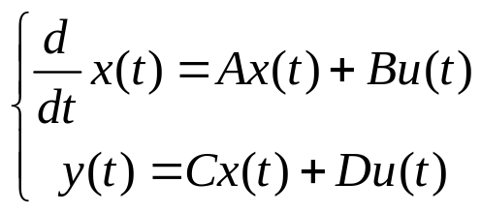,
This representation can be approximated by
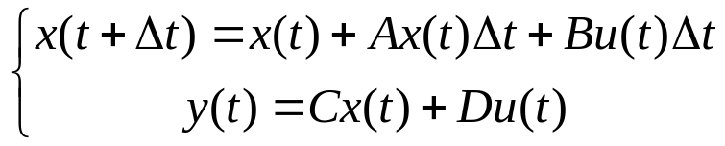
or equivalently,
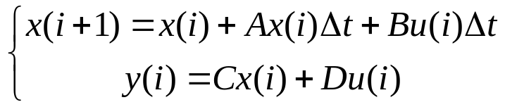.
For this problem, the numerator and the denominator vectors of H(s) to be [ 0.01 1] and [ 1 1.01 1], respectively. With the choice of numerator and denominator vectors, the state-space parameters of the system will be
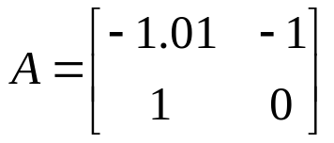, 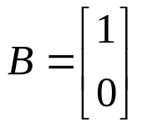,
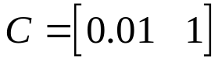, D=0 ,
The plot of the output of the PLL is given in Figure 4.

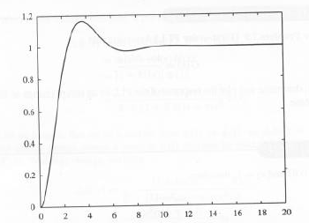
Figure 4
The MATLAB script for this problem is given as follows,
num=[ 0.01 1];
den=[ 1 1.01 1];
[a, b, c, d]=tf2ss(num, den);
dt=0.01;
u=ones(1,2000);
x=zeros(2,2001);
for i=1:2000
x(:,i+1)=x(:,i)+dt.*a*x(:,i)+dt.*b*u(i);
y(i)=c*x(:,i);
end
t=[0:dt:20];
plot(t(1:2000),y);

