William O. Holden PHIL 8400 Project I report
This part I of the project asked for many various things. I had to prepare data by creating a glossary and translation memory. Then I had to simulate a translating workflow for the first time. I chose Korean as my target language because of my familial connection to Korea, but I have no fluency in the language at all. While it was nice to see how the language was translated, but I feel it made creating my glossary and my full translated segment excel (holden_william_prg_2903-3178_en-ko) way harder to create.
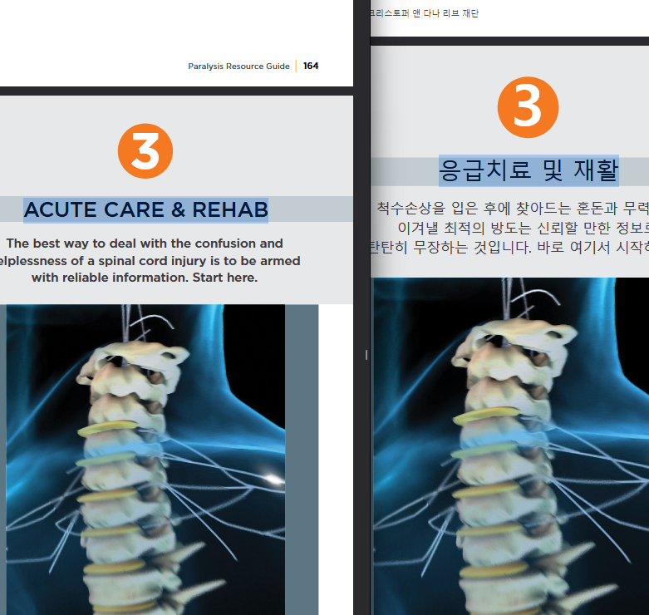
To create my holden_william_prg_2903-3178_en-ko file I went through and found the first sentence and then plugged it into the excel sentence by sentence. The matching pictures really helped to start the process. For sentences that weren’t the same length I needed to double check with google translate to make sure. The only problem I came across in the this process was website URLs. In the english version of the PRG urls began with “https://”, but the korean version only had the “www.” version of the website I took the liberty and added the prefix to the URLs to the hyperlinks.
After creating the excel, I created the TM and monolingual files. This part was relatively easy, but I had trouble exporting my monolingual files and TM in the proper UTF-8 encoding. I use LibreOffice for all my excel and csv files. LibreOffice is just an open source version of the Microsoft Office Suite, but the key difference was that it didn’t have the option to export in the proper text encoding. I utilized python instead to create my files, it was able to convert my excel files to the proper UTF-8 TXT Files.
After making sure my txt files were properly formatted I used memoQ for translation simulation. I created the project, created the translation memory, and ran my analysis’. For my translation memory I chose the only three wikipedia health TMs, this only left me with about 1,500 to 2,500 sentences. To bulk up I decided to add the WikiMatrix TM to my translation memory, ending with me having about 300,000 sentences in memory. Here is what I found at each step.
- Analysis-1: With only tm1_holden_william_prg_ko-en active, I ran a pre-translation analysis. The results, exported as 1_Analysis-holden_william_prg_2903-3178_en-ko-2025-09-28.19.03.csv, showed a very low match rate, with 94.45% No Match and 5.55% in the 50%-74% fuzzy match range. This indicated the external TM was not highly relevant to our specific PRG text. This TM was then exported as tmx1_holden_william_prg_ko-en.tmx and removed from the project
- Analysis-2: With this perfect project-specific TM active, I ran another analysis. The results, exported as 2_Analysis-holden_william_prg_2903-3178_en-ko-2025-09-28.19.28.csv, were dramatically different: 0% No Match, with 44.76% 100% Match and 55.24% 95%-99% Match. This demonstrates the immense value of a project-specific TM. This TM wasexported as tmx2_holden_william_prg_ko-en.tmx.
- Analysis-3: With the tweaked TM active, a third analysis was run. The results, exported as 3_Analysis-holden_william_prg_2903-3178_en-ko-2025-09-29.22.13.csv, showed the impact of the changes: 100% matches dropped to 41.86%, 95%-99% matches were at 48.16%, and lower fuzzy bands (85%-94%, 75%-84%) now appeared. One segment showed "No Match" (0.96%), likely due to a very significant alteration.

Below are my translations after tweaking my term base….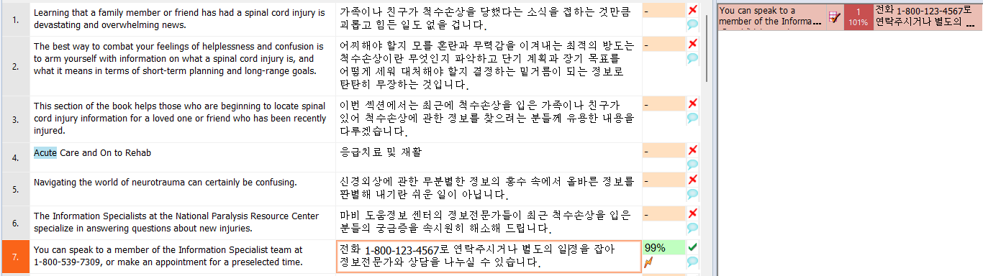After restarting memoQ after Analysis 3. I examined segments where only numbers were changed. The "Translation results" pane showed high fuzzy matches (e.g., 99%). When these matches are confirmed without manual adjustment, memoQ's "Match Patch" feature automatically applies the minor differences (like the changed numbers) from the TM to the target segment.
After the analysis’ with the three different translation memories., I ran my QA. The QA showed the most errors in repeating numbers, but after reviewing a few of the translations with google translate it seems that the translations are still correct.
This project so far has been super interesting! I’ve never delved too deeply into NLP besides speech transcription. I was happy to see another side to NLP. I also hold the personal belief that technology like this brings us closer together and allows for more communication/connections globally.

