1. 取得打卡紀錄

- **PATH:** `/record/`

- **METHOD:** `GET`

- **REQUEST:**

```json

{

"time_start": "(float)",

"time_end": "(float)",

}

**RESPONSE**

[

{

"user_id": "Jason",

"time": 1746089516.3946667

},

]

2. 打卡

- **PATH:** /record/ - **METHOD:** POST - **REQUEST:**

{

"user_id": "(string)",

"type": "(string)",

"time": "(float)"

}

**RESPONSE**

{

"status": "success"

}

打卡測試

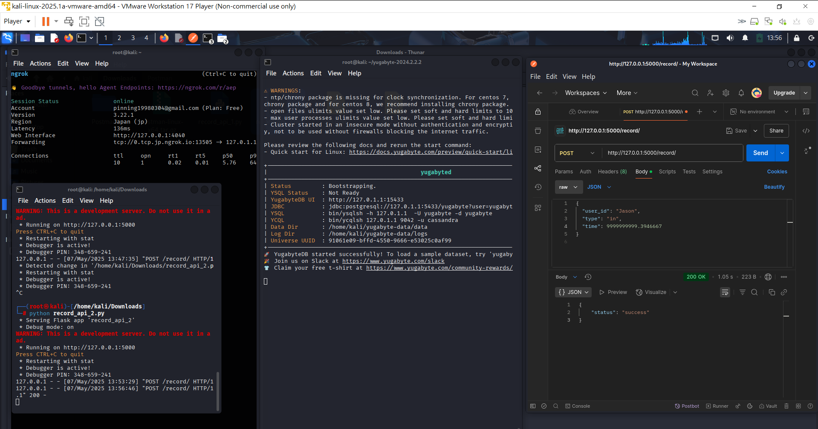

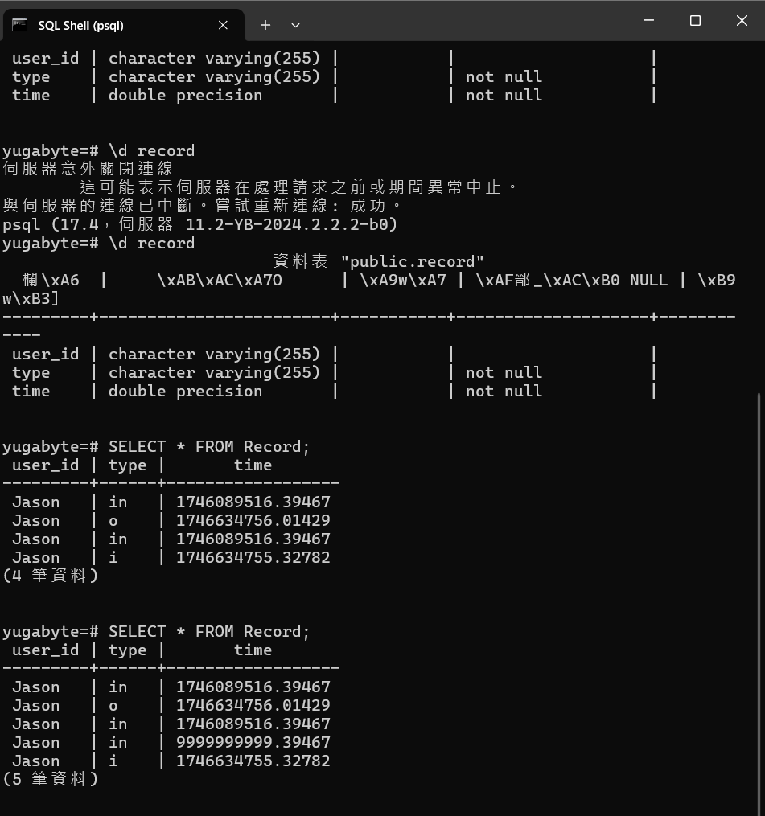

撈資料測試

