Design Document

Leonardo Barilani – leonardo.barilani@mail.polimi.it
William Bonvini – william.bonvini@mail.polimi.it
Matteo Frigerio – matteo6.frigerio@mail.polimi.it
Delivery Date: 16/5/2018

Abstract
This document contains the design parts for the Hypermedia Applications project. It contains the C-IDM, L-IDM, and P-IDM schemas, the scenarios, the design-in-the-small of the of our P-IDM schema and the DB design that consists of the ER diagram and the Relational Tables for the main pages.

C-IDM Schema

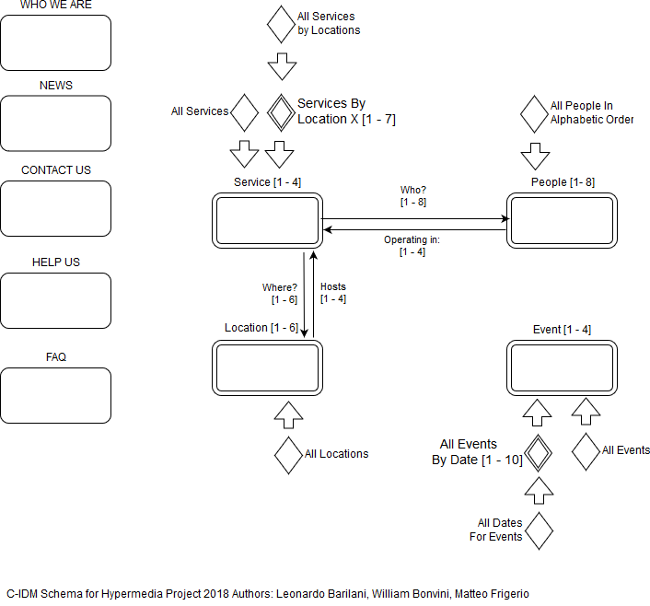

L-IDM Schema

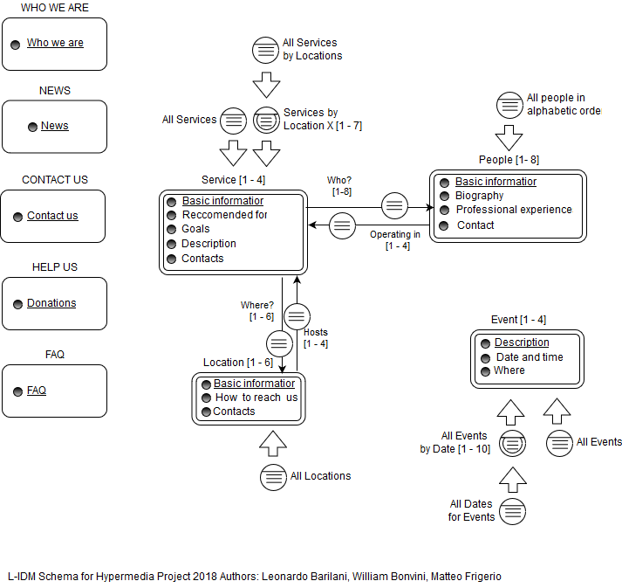

P-IDM Schema

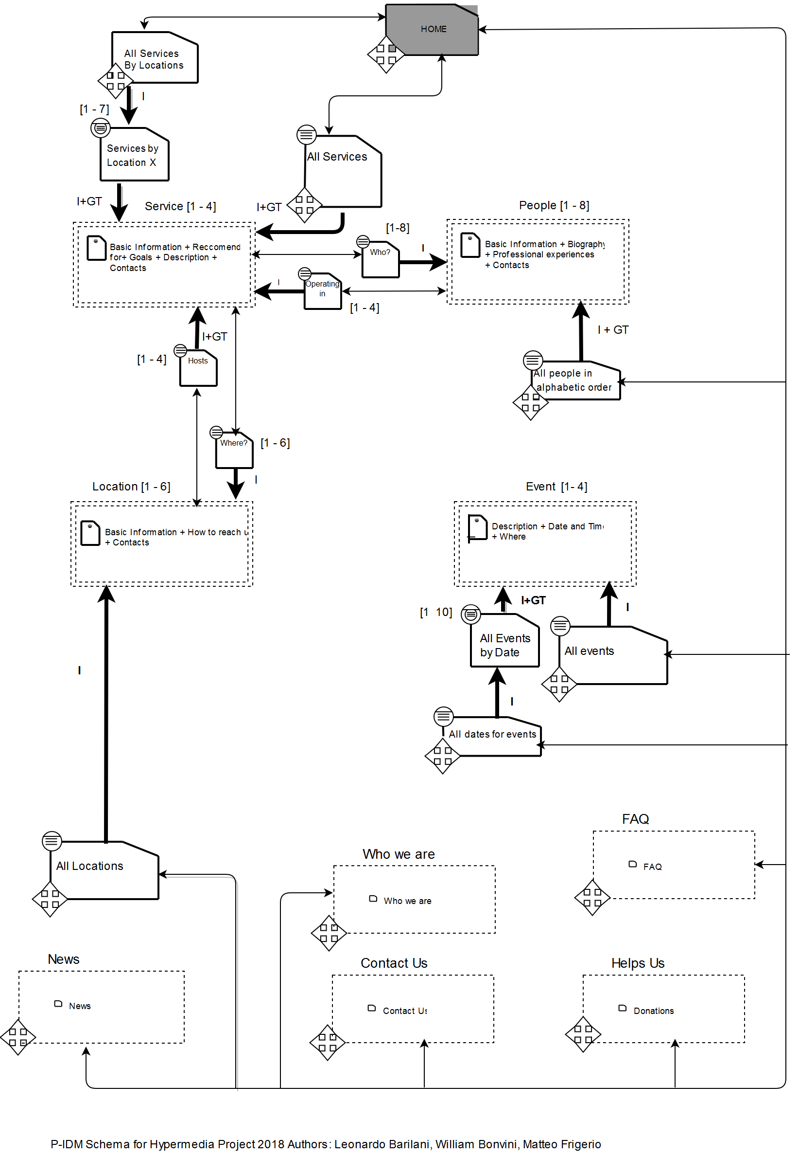

Scenarios

Scenario 1
A father of a child in need want to retrive informations about the association. He is searching information for a service that can help his child and also wanto to know if there are didactic activities for his education.
During his free time, the dad visit the association’s website: from the homepage, he click on the Services’ landmark and, because he is searching a location close to his house, he select “All Services By Location” from the “Services” menu. From the list, he choose the nearest location and, clicking on the location’s link, he sees on the location’s page all the available services. He find out that the location have the needed service.

Scenario 2
A benefactor is interested in helping the association. He want to know how to help the association, both economically and pratically, being, for example, a volounteer in usefull activities for the children of the association.
Visiting the association’s site he finds from the home that he can reach a “help us” page. He finds out that he can help the association by making donations, but he can’t see anywhere informations about helping practically the association, so he click on the FAQ page to gather further informations and he eventually find out that he can’t actually help the association the way he wanted.

Scenario 3
A doctor want to apply for a position. He’s trying to figure out what skills and requirements are needed.
From the homepage, he clicks on the “All People In Alphabetic Order” looking for skills of the association’s doctors. After clicking on the first doctor on the list, he scroll it by clicking “Next”. After gathering all the information he wanted, he click on the “Contact Us” landmark to send a mail to the association asking other information, such a show to apply and if he can have an appointment.

Design in the small
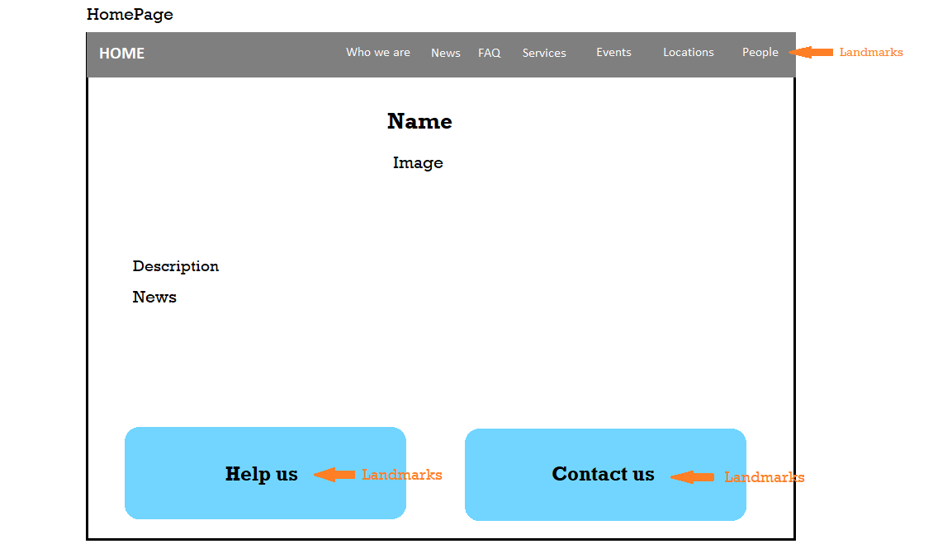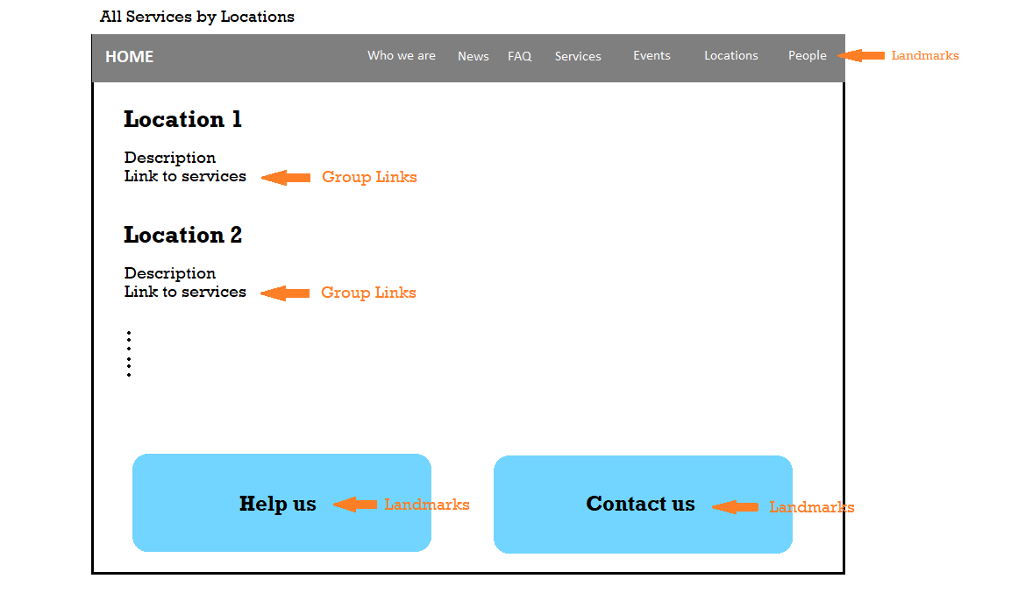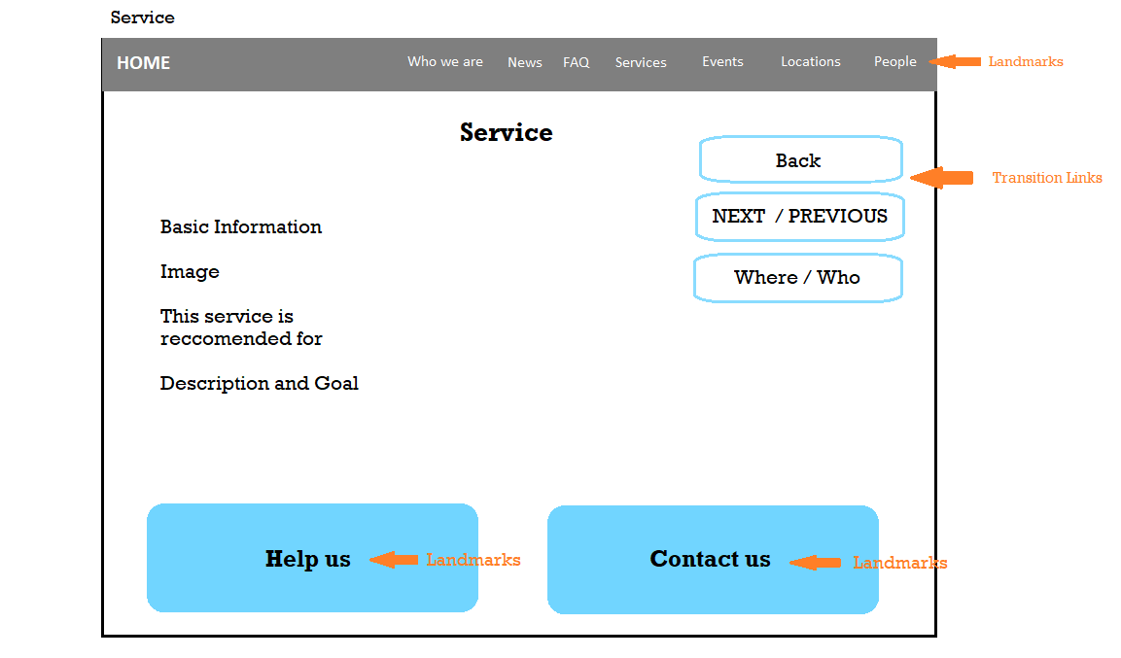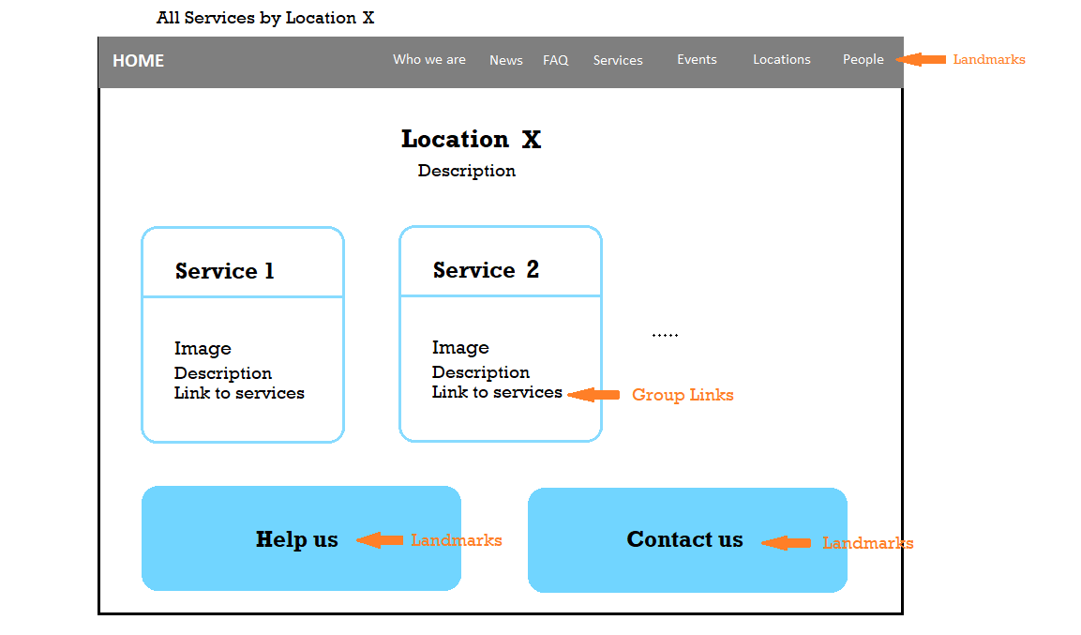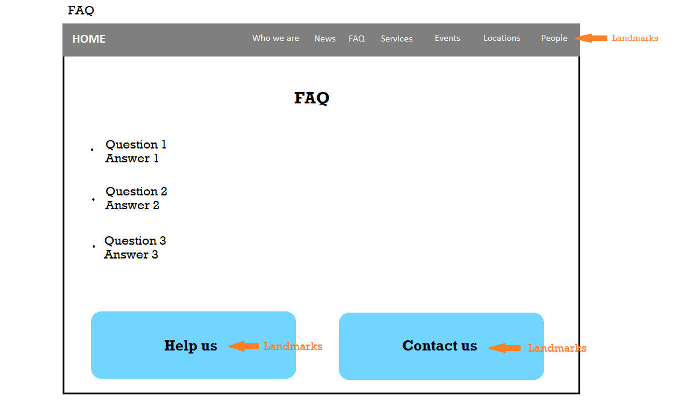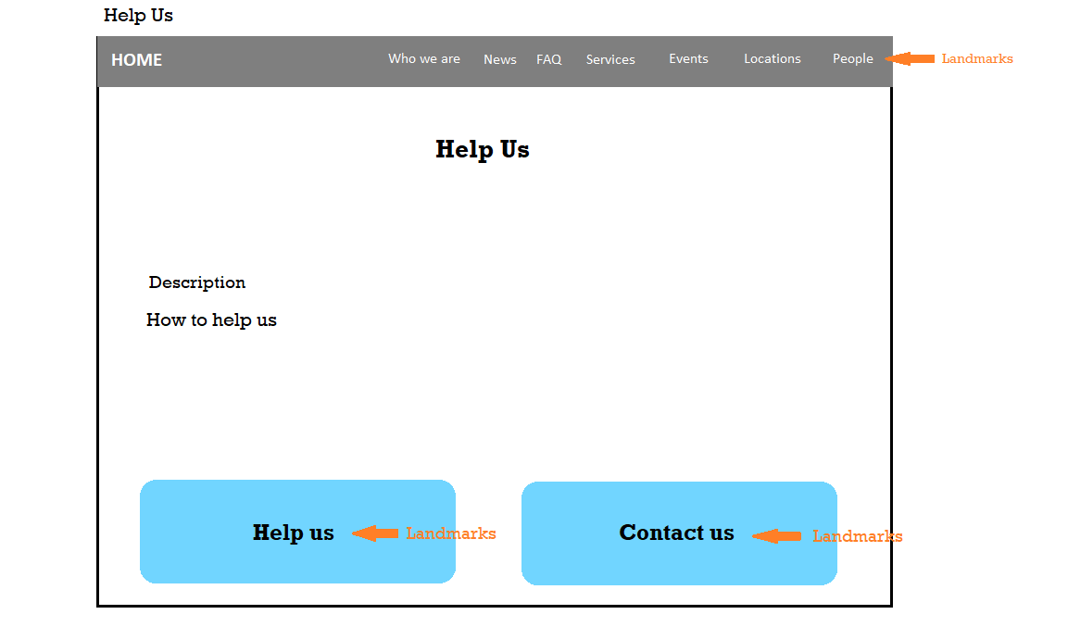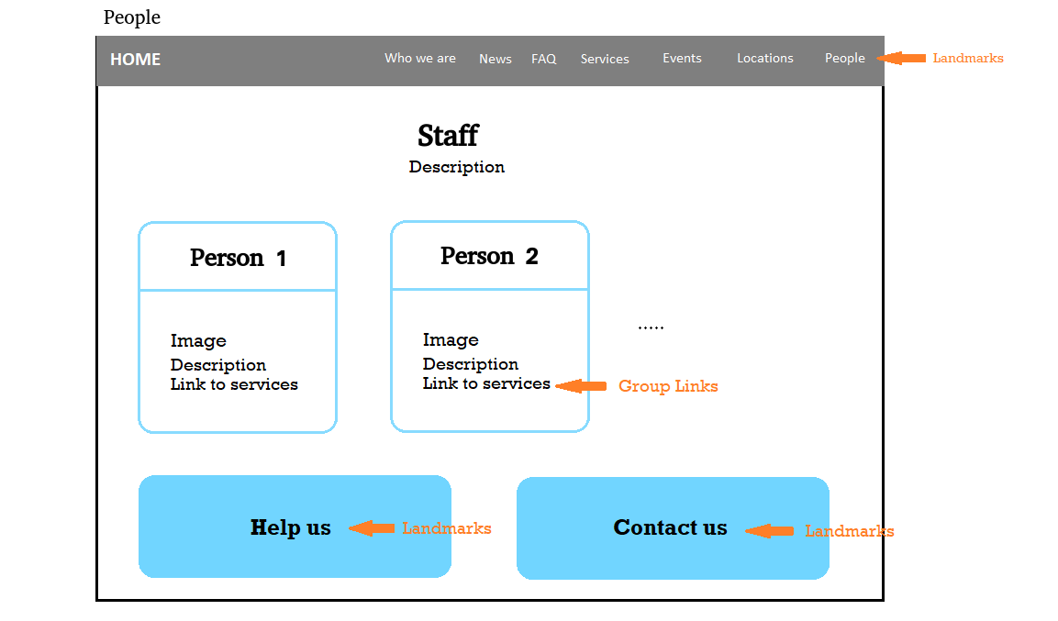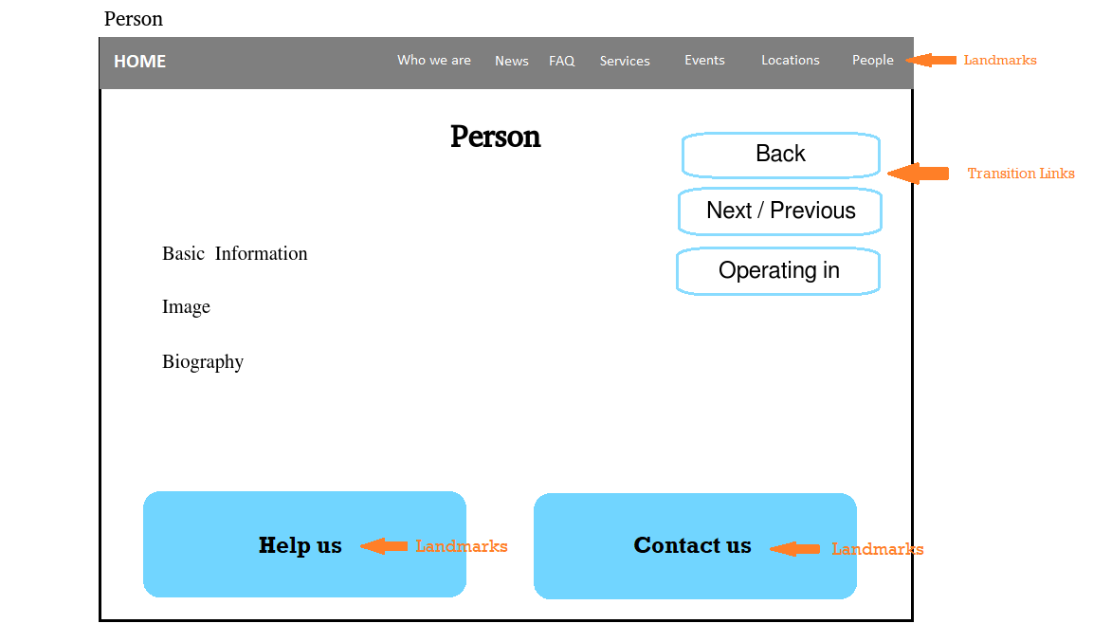

ER Diagram

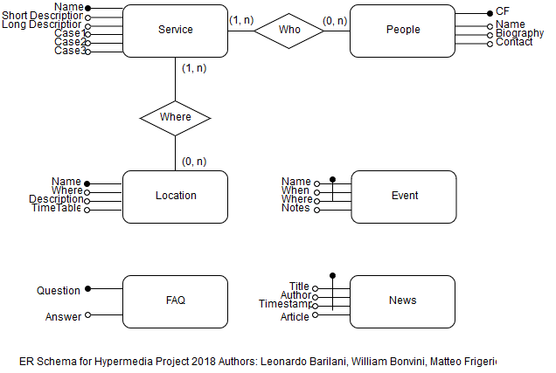

DataBase Tables

