Lab 1

# Problem 1 – Question on database modelling

I would store the list of toys in the database using three table tables. One called Toy, which would have the fields of age, name and toy_id as the primary key, and the other called Attributes, which would have a attribute_id as primary key and attributes as this tables field. The third table would be called ToyAttributes, which the primary key would be the mapping of one toy id as one Attributes id. I would then map it so it would constitute of a many to many relationship using the third table as the connection between the other two tables.

This is so the tables are easy to read and maintainable as they are decoupled through the main information. The performance would be quick as you would be able to get all the attributes from the toy_attribute table through the toy table (unless there is hundreds of records). The storage is quite efficient as the different attributes and toys are separated out, so they is the potential of sharing types of attributes between the toys, which minimise redundancy in the database. If new attributes are added, a new way of mapping would have to be created between the toy associated and the new attribute. Overall, this way is the most maintainable, performance efficient, storage efficient and dynamic for insertion of new tables.

# Problem 2 – From ER to relational model

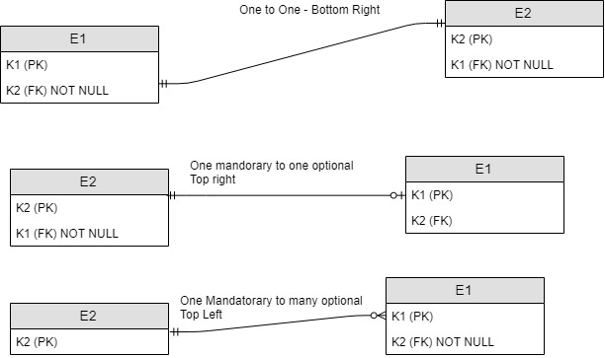

No because it is impossible to ensure the entity in the many part of the relationship to have at least one entity on the one part as an guaranteed feature without external application assistance.

# Problem 3 – Designing a relational model

