# 5. Evaluation

## 5.1. Introduction

This chapter will discuss the different methods of how NDMA was tested and evaluated. From the testing perspective, what was the technologies researched for testing NDMA. For evaluation, what were the metrics used for NDMA, regarding the UI design, performance and other key areas. When discussing both the testing and evaluation sections, the plans vs what was implemented would be included. This would include conceptual test plans, evaluation metrics, questionnaires designed and implemented tests. The errors and difficulties around both testing and evaluating the application would be discussed too. Finally, the decision making behind each decision will be also discussed.

## 5.2. Software Evaluation

The software evaluation stage of NDMA was evaluating the technical features of NDMA. This was through evaluating the tools that would be suitable to access NDMA. The type of tools that would assist in evaluating NDMA can be categorised as either testing or evaluation. Both have software and manual approaches. The plan was to use all the methods for the use of the application. This meant using Automated Testing, Manuel Testing, Automated Evaluation and Manual Evaluation.

There were numerous testing tools for NDMA. The ones which were initially perceived as being useful for NDMA application was NUnit framework, Selenium framework and dB Fit. Selenium application with NDMA was its capability to test front-views. This is by capturing the widgets and sections of the interfaces to interact with, in a similar way human would interact with the system. When combining with the NUnit framework, Selenium can create module tests and unit tests. This also means Selenium was capable of being used for black box, white box and grey box testing. As a result, it was planned to use Selenium framework for NDMA UI.

NUnit is a unit testing framework system. It designed to allow developers to test applications developed under .Net framework using unit test cases. By combining several unit tests, NUnit could be used as module test cases. Because of this, white box, black box and grey box testing can be created from the NUnit framework. As a result, it would be imported as the software testing framework for the middleware of NDMA. Overall, the test cases from the middleware and the front view can be combined. When this is done, test cases around acceptance testing can be derived. This is to ensure NDMA passes the technical, functional and user requirements.

Db Fit is a member of the FitNesse framework family. FitNesses is an implementation of the Framework for Integrated testing (FIT). This framework is used to run test cases on databases. The tests cases would work with the databases simple query statements and stored procedures. As a result of this, Db Fit is a framework which allows the use of integration testing, unit testing and acceptance testing. A disclaimer would be while Db Fit wasn’t designed for unit testing, for the purpose of NDMA it would be configured to create unit testing. DBFit is better served for black box or grey box testing rather then white box testing. Because of these reasons, DBFit was chosen to test the cloud database environment of NDMA.

In addition to the testing software frameworks, manual testing was also considered. This would be the user interacting with the user interface itself, such as enter data or clicking on widgets. Part of these tests can be designed in unit, intergration or acceptance testing of NDMA. This would also provide the opportunity to capture test cases in which the developer may have missed.

Evaluation tools that were consider for NDMA were mobile analytics tools and Azure analytics tools. Examples of mobile analytics tools can come from Google, Flurry or other mobile application focused organisations. These analytics tools would assist in several tasks regarding mobile applications. The first would be analysing the performance of the application in several different cases. The second would gather metric data to track the user details when using the mobile application. The third would be comparing the speed of the mobile application over time. These tools were considered for NDMA to ensure the user experience has been maximised, which is linked to the speed and performance of NDMA. Azure offers analytics tools for their services, which were considered for the cloud environment of NDMA.

Manuel evaluation of NDMA was also conducted. This was by designing a questionnaire that was centred around the 10 heuristics and the 7 modern mobile usability factors. Once that was completed, the same users whom have manually tested the system were asked the question.

The only software test cases written were ones against the advisor system. It was discovered Selenium only worked for web-based applications, not native ones. As a result, the selenium testing could not be implemented for NDMA. The testing of Azures services could not be conducted due to financial reasons. As a result of the inability to comply with the financial side of Azure subscriptions, the subscription was cancelled, and resources were deleted. Only the nutritional advisor was able to get tested using unit testing. Due to the lack of the diverse functionality of methods in the nutritional advisor, only a few parts of the nutritional advisor could be tested. The time scope meant not more tested could have been conducted. The manual testing was able to be completed in the given scope.

None of the considered analytics tools considered were implemented. Their actual implementation could not be completed in the given time scope of the application development. Only the manual evaluation was able to be completed.

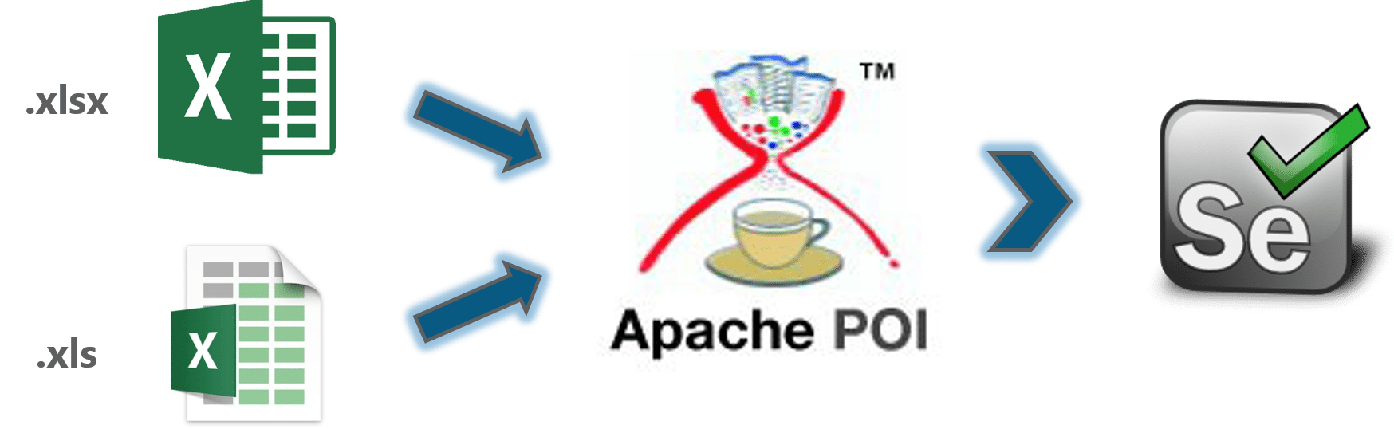

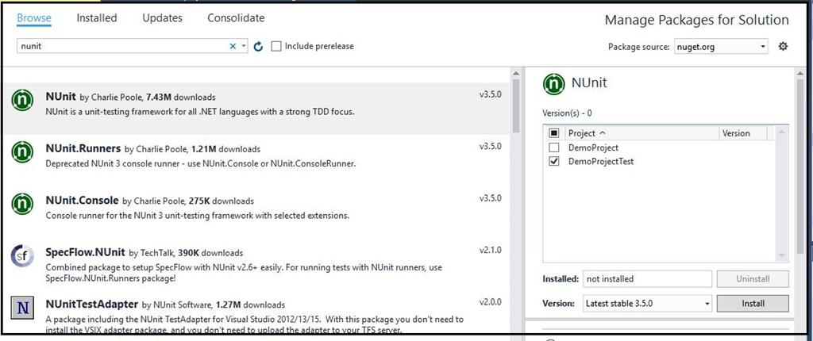

## 5.3. Specific Evaluation

The software plan was to test the nutritional advisor to see if they provided the correct information back in unit grey box test cases. The three test cases can be described as follows: ensuring there is data comping back from the recipe food api that is used to being queried. The advisor system can store the calories data. Lastly, the advisor can suggest advice through ensuring the recommended daily amount of nutrients is different from the stored calories. The choice to create grey box tests is the knowledge of how the system is supposed to behave when the test cases are running. However, the test cases do not really interact with the system. They only pass data into the advisor system, get data back from the advisor system and assert it against the desired outcome. While the tests do pass, they do not say a lot about NDMA except the advisor system is functional.

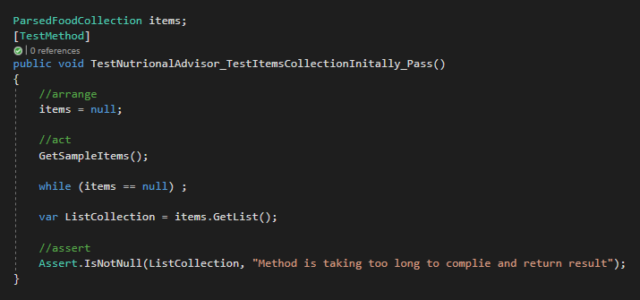

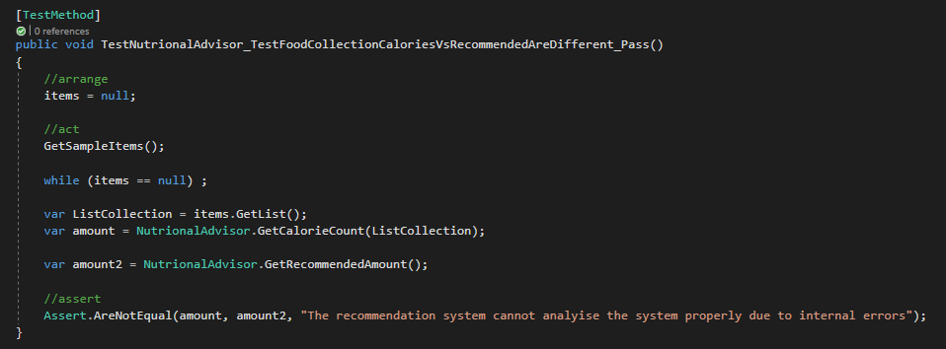

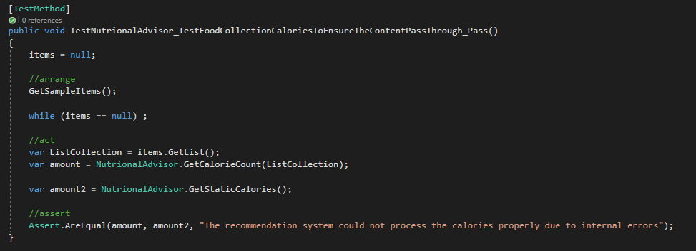

As a result, a word document of the test cases for manual testing was drafted up. This was used, alongside the questionnaire for the user, to get deeper insight the user experience. The provided feedback would allow the developer understanding of the technical issue through the description provided by the user when the manual testing was conducted. The test cases of the user input are found below:

**Manual Testing Requirements**

**Everything goes right**

* Once logged in, the person goes to the logging system and correct logs their diet, by adding their food using the + button and successfully logging the food
* Goes to the advisor system and understands both the graph of the application and the advice of the system when it is queried
* Goes to testing input food and is successfully able to get a sample dish for analysis

**The logging system**

* When the cancel button is pressed on the logging feature, it resonates with the persons understanding and the design decision
* When the discard button is pressed on the logging feature, it resonates with the persons understanding and the design decision
* When a food is about to be logged, to cancel by going back
* When a food item has being accidently clicked, the person can go back
* To change a person’s mind when logging the food by clicking the add button again
* The person’s opinion when the landscape of the phone changed
* Person’s overall opinion

**The Advisor System**

* Opinion on the graph view
* Understanding of the advice provided
* The testing food input functionality behaviour resonates with the user
* They cannot get the weekly advice unless all three inputs are completed
* If they make a mistake, to either backtrack or cancel it for the testing food input
* The advice and graph is what is expected from the users point of view

## 5.4. Questionnaires and Interviews Evaluation

The questionnaire for the evaluation was designed around the 10 heuristics and the 7 modern mobile usability factors. These were chosen due to creating the user interface around NDMA being the complexity. The other reasons were to allow the users to evaluate the application to the best of their ability that would allow the developers to understand the users’ evaluation. If the comprehension level between the user and the developers’ mismatch, two cases could occur. The first would be a worsen of the features offered by NDMA. The second is be nothing on NDMA would overall improve.

There are three examples of people whom were requested to evaluate NDMA. All three were provided the same questionnaire and to provide their answer. The topics are divided into the tables below. Where there is a rating system, after each table, the average of the rating is provided.

**Mobile Usability**

**Platform Usability – average = 8**

|  |  |  |  |
| --- | --- | --- | --- |
| **Question** | **User Answer 1** | **User Answer 2** | **User Answer 3** |
| How would you rate the usability of NDMA from 1 – 10, where 1 is terrible and 10 is brilliant? | 7 | 10 | 7 |
| Could you provide one reason why you rated the platform this way? | There are clear graphics and understandable features. Selections static rather than swipe able. | Easy accessible and understanding | While the application is easy and smooth to use, there is confusion as to the direction to take with the app in some areas |
| Is there any way you can think of to improve the usability of NDMA? | Place scrollable/tappable options | Bigger screens with more information | A tutorial on using the application itself |

**Provide Value Right Away (average = 8)**

|  |  |  |  |
| --- | --- | --- | --- |
| **Question** | **User Answer 1** | **User Answer 2** | **User Answer 3** |
| How would you rate the ability of NDMA to provide value right away from 1 – 10, where 1 is terrible and 10 is brilliant? | 6 | 10 | 8 |
| Could you provide one reason why you rated the platform this way? | The features seem to be limited to calorie count.  **(Note: This was before improvements were made to include the other macronutrients)** | Straight away I got information and advice | While the layout of the application and usage are really easy to complete, the advice part of the application does not provide the amount of details desired |
| Does NDMA provide value to you? | Yes | Yes | Yes |
| Do you believe it is provided right away? | Yes. Quick to give feedback. | Yes | Yes |
| In what way does the application provide, or not provide, value to you? | Provision: It is a great calorie counter with good display (bar chart)  Non-Provision: Other nutritional information would be good. | It provides value by being clear and to the point regarding logging and advisor system | Through the logging of the diet and analysing it vs the recommended in the application |

**Simple Navigation – average = 8**

|  |  |  |  |
| --- | --- | --- | --- |
| **Question** | **User Answer 1** | **User Answer 2** | **User Answer 3** |
| How would you rate the ability of NDMA to provide a simple navigation from 1 – 10, where 1 is terrible and 10 is brilliant? | 8 | 10 | 7 |
| Could you provide one reason why you rated the platform this way? | Navigation looks easy and natural. | “It sorta guides you what to do” | Mostly it is clear in the direction to go, but few different scenarios could to confusion |
| How simple was it to navigate to the different parts of the application? | Quite simple | It was really good and simple | Generally speaking, it was simple enough |
| How did you find the process of logging your diet? | I can see it would build up a good set of data | Easy | “Initially unclear but after the confusement passed, to was really simple” |
| How did you find the process of logging your diet? | Good | Easy – buttons tell you what to do | Simple enough itself |

**Clear & Concise Content – average = 8**

|  |  |  |  |
| --- | --- | --- | --- |
| **Question** | **User Answer 1** | **User Answer 2** | **User Answer 3** |
| How would you rate how clear and concise of the content of NDMA from 1 – 10, where 1 is terrible and 10 is brilliant? | 7 | 10 | 8 |
| Could you provide one reason why you rated the platform this way? | The data are well explained, but there could be more (calorie per food-type, comparable food types…) | It is applicable for non-tech savvy people | The layout is generic enough for understanding – it doesn’t go into anything too specific |
| Was the different contents and components of NDMA easily understood and concise in the information and layout? | Yes | Yes | Yes, it was clear and understood |
| Was there any part of the application that wasn’t clear and/or concise in the content? | The food options look as if it is what you see is what you get. Are there scrollable options? | no | No, everything was laid out clear enough |

**Minimize the Number of Steps – average = 8**

|  |  |  |  |
| --- | --- | --- | --- |
| **Question** | **User Answer 1** | **User Answer 2** | **User Answer 3** |
| How would you rate the ability of NDMA to minimise the number of steps for each functionality of the application from 1 – 10, where 1 is terrible and 10 is brilliant? | 8 | 10 | 7 |
| Could you provide one reason why you rated the platform this way? | The options are clearly described, and the app goes straight to information. | It gets straight to the point straight away | While some steps were clear, there were a few that were unclear and confusing |
| Is there any way to minimise more steps within the application itself, such as providing more easier layout for the logging feature, access to the advisor system or improve the login aspect etc? | You could put more options on one screen (5 – 7) as Miller’s chunking suggests. | Bigger window | Some of the pages to be placed together |

**Reduce Scrolling – average = 9**

|  |  |  |  |
| --- | --- | --- | --- |
| **Question** | **User Answer 1** | **User Answer 2** | **User Answer 3** |
| ) How would you rate the ability of NDMA to reduce the scrolling inside the application from 1 – 10, where 1 is terrible and 10 is brilliant? | 8 | 10 | 9 |
| Could you provide one reason why you rated the platform this way? | If scrolling is to be minimal, then this does minimise scrolling. | It was quick | Didn’t need to scroll for much |
| is there any part of the application where it could be improved to reduce the amount of scrolling inside the application? | Reduce graphics sizes (?) | no | no |

**Consider Landscape Orientation – average = 9 & 3**

|  |  |  |  |
| --- | --- | --- | --- |
| **Question** | **User Answer 1** | **User Answer 2** | **User Answer 3** |
| How would you rate the layout of NDMA in Portrait form from 1 – 10, where 1 is terrible and 10 is brilliant? | 9 | 10 | 8 |
| Could you provide one reason why you rated the platform this way? | Portrait suggests the app can be one-handed. | The information is displayed as desired | The pages were easy and clear to use for the application |
| How would you rate the layout of NDMA in Landscape form from 1 – 10, where 1 is terrible and 10 is brilliant? | 6 | 1 | 3 |
| Could you provide one reason why you rated the platform this way? | This might provide more linear information on display. | Can’t see anything | Items are more complicated, clustered and lack interactivity when held in this viewpoint |
| What would you like to see in the future for the application regarding the landscape mode of the application | Two or three comparable graphs / graphics or graphic with text box, left – right. | The application to be redesigned to be more landscape mode friendly | The application to be redesigned to be more landscape mode friendly |

**Ten Heuristics**

**#1: Visibility of system status – average = 8**

|  |  |  |  |
| --- | --- | --- | --- |
| **Question** | **User Answer 1** | **User Answer 2** | **User Answer 3** |
| How would you rate the ability of NDMA to ensure it made sure you knew what was going on with the application when navigating through it from 1 – 10, where 1 is terrible and 10 is brilliant? | 7 | 10 | 7 |
| Could you provide one reason why you rated the platform this way? | The names suggest navigation point, a nav guide might be useful, but only if there were more than 7 pages. | It was easy to use | Most of it is clear while a few steps were confusing |

**#2: Match between system and the real world – average = 9**

|  |  |  |  |
| --- | --- | --- | --- |
| **Question** | **User Answer 1** | **User Answer 2** | **User Answer 3** |
| How would you rate the ability of NDMA to match your expectations of the comprehensive language used by the application from 1 – 10, where 1 is terrible and 10 is brilliant? | 8 | 10 | 8 |
| Could you provide one reason why you rated the platform this way? | The language is clear and as expected | The language was easy to understand | You know where the items are, and the buttons behaved as expected |

**#3: User control and freedom = average = 8**

|  |  |  |  |
| --- | --- | --- | --- |
| **Question** | **User Answer 1** | **User Answer 2** | **User Answer 3** |
| How would you rate the ability of NDMA to provide control and freedom to you as a user from 1 – 10, where 1 is terrible and 10 is brilliant? | 6 | 10 | 9 |
| Could you provide one reason why you rated the platform this way? | There seems to be limited user control – ie one direction to use. | Can be used independently and quickly | The application is simple and easy to use |

**#4: Consistency and standards – average = 10**

|  |  |  |  |
| --- | --- | --- | --- |
| **Question** | **User Answer 1** | **User Answer 2** | **User Answer 3** |
| How would you rate the ability of NDMA to provide control and freedom to you as a user from 1 – 10, where 1 is terrible and 10 is brilliant? | **Unable to answer due to miscommunication error** | 10 | 10 |
| Could you provide one reason why you rated the platform this way? |  | Both are equal across the board | It sticks to what is expected |

**#5: Error prevention - average = 9**

|  |  |  |  |
| --- | --- | --- | --- |
| **Question** | **User Answer 1** | **User Answer 2** | **User Answer 3** |
| ) How would you rate the ability of NDMA to prevent error to you as a user from 1 – 10, where 1 is terrible and 10 is brilliant? | 7 | 10 | 10 |
| ) Could you provide one reason why you rated the platform this way? | I feel that the usability leaves no room for big mistakes. | It is easy to fix | It is easy to correct your mistakes |

**#6: Recognition rather than recall – avareage = 9**

|  |  |  |  |
| --- | --- | --- | --- |
| **Question** | **User Answer 1** | **User Answer 2** | **User Answer 3** |
| How would you rate the ability of NDMA to ensure you were able to recognise how to interact with the system rather then having to recall information for use of the application as a user from 1 – 10, where 1 is terrible and 10 is brilliant? | 8 | 10 | 8 |
| Could you provide one reason why you rated the platform this way? | The interface is readily recognisable and little recall required. | Have a bad memory but used it easily | Some areas can lead to uncertainty  ***\*\*Some areas are encapsulated with the logging feature, such as some of the buttons not being fully clear etc\*\**** |

**#7: Flexibility and efficiency of use – average = 8**

|  |  |  |  |
| --- | --- | --- | --- |
| **Question** | **User Answer 1** | **User Answer 2** | **User Answer 3** |
| How would you rate the flexibility and efficiency of NDMA from 1 – 10, where 1 is terrible and 10 is brilliant? | 5 | 10 | 8 |
| Could you provide one reason why you rated the platform this way? | I feel there is little flexibility in the app, but it does work efficiently. | The functions were easy to use, decipher and optimise | The app did what it was supposed to do |

**#8: Aesthetic and minimalist design – average = 8**

|  |  |  |  |
| --- | --- | --- | --- |
| **Question** | **User Answer 1** | **User Answer 2** | **User Answer 3** |
| How would you rate the design of NDMA in terms of being Aesthetic and minimalist, from 1 – 10, where 1 is terrible and 10 is brilliant? | 8 | 10 | 7 |
| Could you provide one reason why you rated the platform this way? | It does look good. Nice green. | There were no mixing colours to distract you | The application was simple and nice in its design |

**#9: Help users recognize, diagnose, and recover from errors – average = 9**

|  |  |  |  |
| --- | --- | --- | --- |
| **Question** | **User Answer 1** | **User Answer 2** | **User Answer 3** |
| How would you rate the ability of NDMA to help users recognize, diagnose, and recover from errors from 1 – 10, where 1 is terrible and 10 is brilliant? | 7 | 10 | 9 |
| Could you provide one reason why you rated the platform this way? | It looks capable of offering exits | There is plenty of guidance to know what to do | It allows the food to be changed if the wrong one was picked |

**#10: Help and documentation – average = 6**

|  |  |  |  |
| --- | --- | --- | --- |
| **Question** | **User Answer 1** | **User Answer 2** | **User Answer 3** |
| How would you rate the ability of NDMA to provide help and/or directions to documentation for use of the application, from 1 – 10, where 1 is terrible and 10 is brilliant? | 7 | 4 | 6 |
| Could you provide one reason why you rated the platform this way? | It gives enough instruction on-screen, though the options may be limited. | There was no direction to documentation, but it wasn’t needed | Lack of guidelines in certain areas of the application |

The conclusion of the report seems to have a general conscious of positive feedback. However, it must be noted the need to be careful with the sample data used for evaluation. There is potential for bias to come forward into the evaluation. This can happen even if the language has been created to minimise the difficulty for the person to answer. As such, evaluation from a bigger crowd would reduce the bias potential. This would have created a workload outside the scope of the application.

## 5.5. Conclusions

This chapter discussed the different ways of testing and evaluation of NDMA. It discussed the plans of the testing’s and evaluation of NDMA vs what happened. It discussed the tools and technologies available for NDMA to use for either testing or evaluation. The decisions and difficulties were also discussed regarding testing and evaluation of the system. Finally, the questionnaire was reviewed based on the manual testing from the users. While overall feedback seems positive, any indication of bias should be taken in consideration, especially when evaluating NDMA,