NDMA Overall Evaluation Sheet

**1. Platform Usability**

a) How would you rate the usability of NDMA from 1 – 10, where 1 is terrible and 10 is brilliant?

b) Could you provide one reason why you rated the platform this way?

c) Is there any way you can think of to improve the usability of NDMA?

**2. Provide Value Right Away**

a) How would you rate the ability of NDMA to provide value right away from 1 – 10, where 1 is terrible and 10 is brilliant?

b) Could you provide one reason why you rated the platform this way?

c) Dos NDMA provide value to you?

d) Do you believe it is provided right away?

e) In what way does the application provide, or not provide, value to you?

**3. Simple Navigation**

a) How would you rate the ability of NDMA to provide a simple navigation from 1 – 10, where 1 is terrible and 10 is brilliant?

b) Could you provide one reason why you rated the platform this way?

c) How simple was it to navigate to the different parts of the application?

d) How did you find the process of logging your diet?

e) How did you find the navigation process of the Advisor System?

**4. Clear & Concise Content**

a) How would you rate how clear and concise of the content of NDMA from 1 – 10, where 1 is terrible and 10 is brilliant?

b) Could you provide one reason why you rated the platform this way?

c) Was the different contents and components of NDMA easily understood and concise in the information and layout?

c) Was there any part of the application that was clear and/or concise in the content?

d) Was there any part of the application that wasn’t clear and/or concise in the content?

**5. Minimize the Number of Steps**

a) How would you rate the ability of NDMA to minimise the number of steps for each functionality of the application from 1 – 10, where 1 is terrible and 10 is brilliant?

b) Could you provide one reason why you rated the platform this way?

c) Is there any way to minimise more steps within the application itself, such as providing more easier layout for the logging feature, access to the advisor system or improve the login aspect etc?

**6. Reduce Scrolling**

a) How would you rate the ability of NDMA to reduce the scrolling inside the application from 1 – 10, where 1 is terrible and 10 is brilliant?

b) Could you provide one reason why you rated the platform this way?

c) is there any part of the application where it could be improved to reduce the amount of scrolling inside the application?

**7. Consider Landscape Orientation**

a) How would you rate the layout of NDMA in Portrait form from 1 – 10, where 1 is terrible and 10 is brilliant?

b) Could you provide one reason why you rated the platform this way?

c) How would you rate the layout of NDMA in Landscape form from 1 – 10, where 1 is terrible and 10 is brilliant?

d) Could you provide one reason why you rated the platform this way?

e) What would you like to see in the future for the application regarding the landscape mode of the application

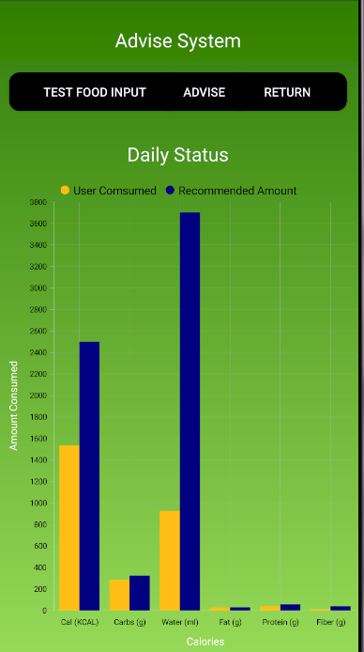

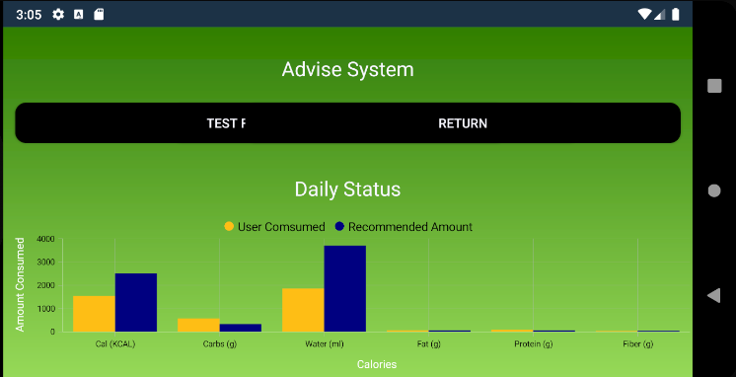

**#1: Visibility of system status**

a) How would you rate the ability of NDMA to ensure it made sure you knew what was going on with the application when navigating through it from 1 – 10, where 1 is terrible and 10 is brilliant?

b) Could you provide one reason why you rated the platform this way?

**#2: Match between system and the real world**

a) How would you rate the ability of NDMA to match your expectations of the comprehensive language used by the application from 1 – 10, where 1 is terrible and 10 is brilliant?

b) Could you provide one reason why you rated the platform this way?

**#3: User control and freedom**

a) How would you rate the ability of NDMA to provide control and freedom to you as a user from 1 – 10, where 1 is terrible and 10 is brilliant?

b) Could you provide one reason why you rated the platform this way?

**#4: Consistency and standards**

a) How would you rate the ability of NDMA to provide control and freedom to you as a user from 1 – 10, where 1 is terrible and 10 is brilliant?

b) Could you provide one reason why you rated the platform this way?

**#5: Error prevention**

a) How would you rate the ability of NDMA to prevent error to you as a user from 1 – 10, where 1 is terrible and 10 is brilliant?

b) Could you provide one reason why you rated the platform this way?

**#6: Recognition rather than recall**

a) How would you rate the ability of NDMA to ensure you were able to recognise how to interact with the system rather then having to recall information for use of the application as a user from 1 – 10, where 1 is terrible and 10 is brilliant?

b) Could you provide one reason why you rated the platform this way?

**#7: Flexibility and efficiency of use**

a) How would you rate the flexibility and efficiency of NDMA from 1 – 10, where 1 is terrible and 10 is brilliant?

b) Could you provide one reason why you rated the platform this way?

**#8: Aesthetic and minimalist design**

a) How would you rate the design of NDMA in terms of being Aesthetic and minimalist, from 1 – 10, where 1 is terrible and 10 is brilliant?

b) Could you provide one reason why you rated the platform this way?

**#9: Help users recognize, diagnose, and recover from errors**

a) How would you rate the ability of NDMA to help users recognize, diagnose, and recover from errors from 1 – 10, where 1 is terrible and 10 is brilliant?

b) Could you provide one reason why you rated the platform this way?

**#10: Help and documentation**

a) How would you rate the ability of NDMA to provide help and/or directions to documentation for use of the application, from 1 – 10, where 1 is terrible and 10 is brilliant?

b) Could you provide one reason why you rated the platform this way?