

Nutrient and Diet Manager Application Final Project Report

DT228

BSc in Computer Science

**William Carey**

**Dr Art Sloan**

School of Computer Science

Technological University, Dublin

**Date**

Abstract

A web application designed to assist people in making informed decisions about any suitable diet that incorporates all the nutritional values necessary to each individual need. It will also high key macronutrients and micronutrients essential to the person’s overall nourishment plan, catering to those whom have conditions, like lactose intolerance, that disables them from having certain products like milk.

Many people in the first world countries are employing diets that do not meet the WHO recommendations, which will have long lasting effects on both their generation and future generations that stem from them.

I will provide a solution that manages that for them through development iterations of the systems’ features that will be reviewed in intervals. Once these iterations are completed, I will run ongoing tests on both the front-end and back-end, incorporating both automated and manual.

After the testing’s, I will use peer review (mainly from those whom have manually tested the system), appropriate universal evaluation method on the application and comparison with similar technologies to ensure it is up to standard of minimum operation standards and other agreed protocols.

Declaration

I hereby declare that the work described in this dissertation is, except where otherwise stated, entirely my own work and has not been submitted as an exercise for a degree at this or any other university.

Signed:

_________________________

William Carey

Date

Acknowledgements

Body text

Table of Contents

1. Introduction 7

1.1. Project Background 7

1.2. Project Description 7

1.3. Project Aims and Objectives 7

1.4. Project Scope 7

1.5. Thesis Roadmap 7

2. Literature Review 8

2.1. Introduction 8

2.2. Research Topic 1 8

2.3. Research Topic 2 8

2.4. Existing Final Year Projects 8

2.5. Conclusions 8

3. Experiment Design 9

3.1 Introduction 9

3.2. Software Design 9

3.3. Software Test plan 9

3.4. Front-End 9

3.5. Middle-Tier 9

3.6. Back-End 9

3.7. Conclusions 9

4. Experiment Development 10

4.1. Introduction 10

4.2. Software Development 10

4.3. Front-End 10

4.4. Middle-Tier 10

4.5. Back-End 10

4.6. Conclusions 10

5. Evaluation 11

5.1. Introduction 11

5.2. Software Evaluation 11

5.3. Specific Evaluation 11

5.4. Questionnaires and Interviews Evaluation 11

5.5. Conclusions 11

6. Conclusions and Future Work 12

6.1. Introduction 12

6.2. Conclusions 12

6.3. Future Work 12

Bibliography 13

# 1. Introduction

## Project Background

I had the benefit of growing up with parents who knew the difference between healthy food and unhealthy food (healthy food would contain the necessary nutrition’s needed for the body). I know many people who did not get this knowledge which using technical resources to assist them in obtaining this knowledge.

According to Health Education Research, “There is ample evidence that printed, computer-tailored nutrition education is a more effective tool for motivating people to change to healthier diets than general nutrition education”.

In their results, which catered to a test group and control group, those whom were tested have been more likely to return to the computer medium then any other unless they were computer-illiterate and were more likely to change.

Because my application will be simplified and personalised to the users’ needs, they would get the necessary information more immediately which will impact their lives more quickly.

Through the work of Philip Lew, Luis Olsina and Li Zhang, User Experience and Web Quality are coming in “increasing interest”. This is due to “Web applications (WebApps), a combination of information content, functionality and services are fast becoming the most predominant form of software implementation and delivery today”.

As such, usability, UX, learnability and overall system quality would allow “evaluators to make sound design recommendations and ultimately better decision-making for improving the user experience as a whole”.

The users of my application should not have to learn too much from using this web application in terms of how to use it, combined with having interactive features as part of the web app to match min operation standards.

In the area of nutrition, the American Dietic Association supports “appropriately planned vegetarian diets, including total vegetarian or vegan diets”. This is as a result of being “shown to be healthful, nutritionally adequate, and may be beneficial in the prevention and treatment of certain diseases”. This ties to my application as one of many options for people whom want to employ a healthy diet as a proven method to undertake.

John, in his writings, explicit states that “Circadian and diurnal rhythms affect food intake, and earlier research has suggested that meal sizes increase, where the after-meals intervals and satiety ratios decrease over the day”. It was found that “when individual subjects ate a larger than the mean proportion of their total intake during the morning, they ate significantly less over the entire day. Conversely, when these same subjects ate a high proportion of their total intake during the evening, they ate significantly more over the entire day”. This would highlight the need to users of my application what part of their diet is a necessity, such as breakfast, as many people often go without, which impacts their diet for the remainder of the day.

## Project Description

I will development this using the C# programming, modern website architecture tools (HTML5, CSS3 etc), JavaScript libraries (jQuery, Bootstrap, Angular) in visual studios. The overall tasks will be completed on a windows environment.

Since I am using a Microsoft IDE from the development, the middleware I will be using is ASP .NET framework to separate the back-end logic from the front-end. Since this is a web application, any device that has internet access can access the site through the appropriate engines such as Firefox. I will also look into other APIs, such as RESTful, to optimise my application.

The feature driven development software methodology will be employed for this application designed using the client - server Architecture design pattern.

From scratch, I will outline the main business requirements using various reviewed iterations of prototypes. To complete each part of the business, which I set myself, I will research the various techniques and technologies that would best handle the different requests for the web application.

On regular intervals, I will document my works on a weekly basis to ensure I stay on track with my works combined with tests of the configuration of the application to ensure it follows the design pattern I have chosen.

To obtain the necessary layout and information requirements for the app, I will speak to various people whom are in the health/nutrient field for their input into the application development.

I will also hope to use similar professionals to manual test the system as well as potential users to ensure the application layout is minimal in learning curve. As part of this, I hope to have a feature that will allow the user to fix any minor errors the application may come across.

In my regular meetings with my supervisor, I plan to his guidance and knowledge to ensure my application stays in track in the documentation or the development phase. If he suggests any small features that I may find intriguing, I will look more depth into them for their viability for the application.

In the ongoing development of the application, I will use the git server control to assist me in managing the application.

Once each part is completed, I will use a combination of the Selenium (Front-end testing) Framework, Nuit (Business Logic Testing) and DbFit (Database Testing) to run the tests on the system features. I will also get peers to manually test the system to get feedback.

The evaluation phase would incorporate the feedback of the peers whom have tested the system, using the 10 heuristics and comparing with similar technologies to ensure it matches the minimum operation standards

## Project Aims and Objectives

Overall aim and some milestones along the way to achieve the aim

## Project Scope

Project scope, what the project isn’t about

## Thesis Roadmap

One sentence summary of the following chapters

# 2. Literature Review

## 2.1. Introduction

In this chapter …

## 2.2. Research Topic 1

## 2.3. Research Topic 2

## 2.4. Existing Final Year Projects

**Project 1**

**Title:** Proactive Order Management System

**Student:** Stephen Fox

**Description (brief):**

An application that allowed businesses to handle orders processes by analysing its data within the system. This system also provides businesses with information on how and when to process these orders. The order processes are placed into the system remotely through customers using a mobile application that can access and connect to the host web system.

**What was complex about this project?**

The task Scheduler manager was the most complex part of the system as many uncertain fields that could change that this system needed to calculate in order to be optimised for the overall system.

**What technical architecture was used?**

A Client – Server application with the tech tools iOS Application, Web Application and AngularJS acting as the client-side while Node.js, NuPIC, Proactive Module - Flask, Google Map Distance Matrix API and MongoDB as the server side

**Explain the key strengths and weakness as you see it**

To have an algorithm that dynamically creates task handlers based off the tasks requirements is a strength as it allows you to expand your resources and minimise data wastage at the same time.

The data involved does not seem to be protected through encryption or other methods, which could allow nearby people who could steal the data to view the data, is a major weakness of the application.

**Project 2**

**Title:** Glucose Coach

**Student:** Alex Kiernan

**Description (brief):**

An application designed to track people whom have type 1 diabetes to better manage their overall health by logging their blood sugar levels, their diet and their physical exertion into the coaching system. Once logged, the application will be able to provide the necessary suggestions catered to the individual user to enable them to better manage their glucose levels.

**What is complex about this project?**

The machine learning part of the overall system was the main complexity as research was needed to be conducted combined with the development of the sound process in order to properly process the user information into the system and export back accurate results to the user.

**What technical Architecture was used?**

A Client – Server architecture was used with the RESTful service links between the two, a remote relational database, a flask server and the machine learning system scikit-learn as server side while the use of a mobile application as the client.

**Explain the key strengths and weaknesses as you see it**

A key strength of the application was at the time of development, the constant monitoring of the users progress with the insulin intake was unique to the system design which provides it a competitive edge compared with similar applications

A weakness of the application would be the lack of knowledge provided back to the users whom used this application. If there were graphs that displayed over time the use of insulin intake over days and weeks, it would have made the user understand their blood sugars levels more in depth, which would have allowed them to make more informed decisions.

## 2.5. Conclusions

# 3. Experiment Design

## 3.1 Introduction

## 3.2. Software Design

## 3.3. Software Test plan

## 3.4. Front-End

## 3.5. Middle-Tier

## 3.6. Back-End

## 3.7. Conclusions

# 4. Experiment Development

## 4.1. Introduction

## 4.2. Software Development

## 4.3. Front-End

## 4.4. Middle-Tier

## 4.5. Back-End

## 4.6. Conclusions

# 5. Evaluation

## 5.1. Introduction

## 5.2. Software Evaluation

## 5.3. Specific Evaluation

## 5.4. Questionnaires and Interviews Evaluation

## 5.5. Conclusions

# 6. Conclusions and Future Work

## 6.1. Introduction

## 6.2. Conclusions

## 6.3. Future Work

# Bibliography

1. Oenema A, Brug J, Lechner L. Web-based tailored nutrition education: results of a randomized controlled trial. Health Education Research [Internet]. 2019 [cited 29 September 2019];16(6):647-660. Available from: <https://academic.oup.com/her/article-lookup/doi/10.1093/her/16.6.647>

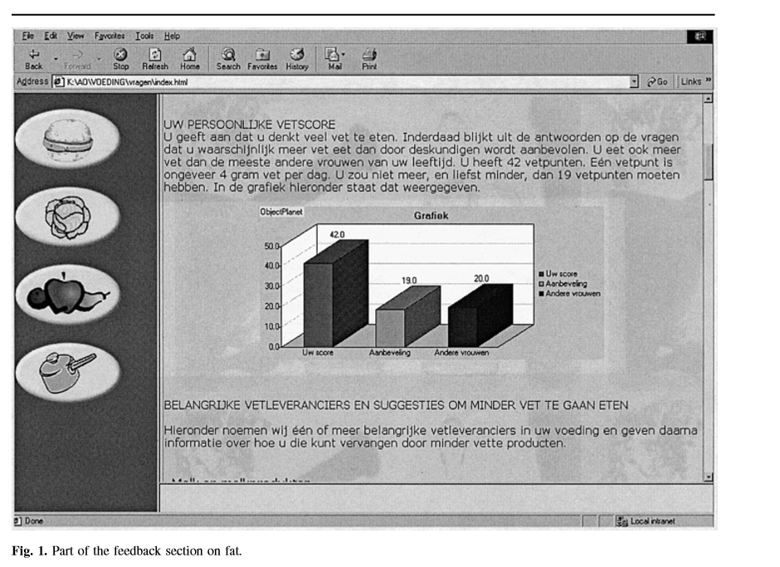

1. Lew P., Olsina L., Zhang L. (2010) Quality, Quality in Use, Actual Usability and User Experience as Key Drivers for Web Application Evaluation. In: Benatallah B., Casati F., Kappel G., Rossi G. (eds) Web Engineering. ICWE 2010. Lecture Notes in Computer Science, vol 6189. Springer, Berlin, Heidelberg

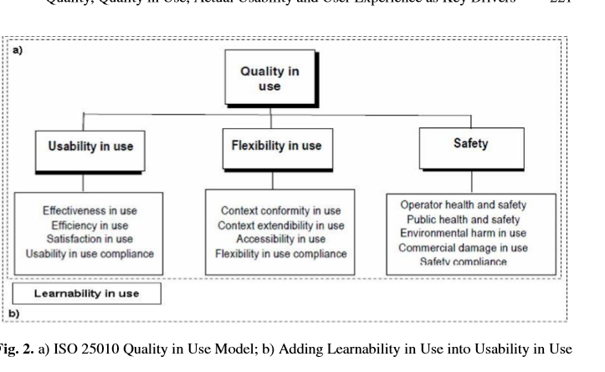

1. Crag W. Position of the American Dietetic Association: Vegetarian Diets. Journal of the Academy of Nutrition and Dietetics [Internet]. 2009 [cited 29 September 2019];109(7):1266-1282. Available from: <https://linkinghub.elsevier.com/retrieve/pii/S0002822309007007>
2. de Castro J. The Time of Day of Food Intake Influences Overall Intake in Humans. The Journal of Nutrition [Internet]. 2004 [cited 29 September 2019];134(1):Pages 104–111. Available from: https://academic.oup.com/jn/article/134/1/104/4688191