Part 3 Interim Report

# 3. Prototype Design

**As least 6 pages, but as many as you like (but lots of diagrams, which count towards the page total).**

## 3.1 Introduction

## 3.2. Software Methodology

## 3.3. Overview of System

Include a diagram

## 3.4. Front-End

Including screen prototypes and Use Cases

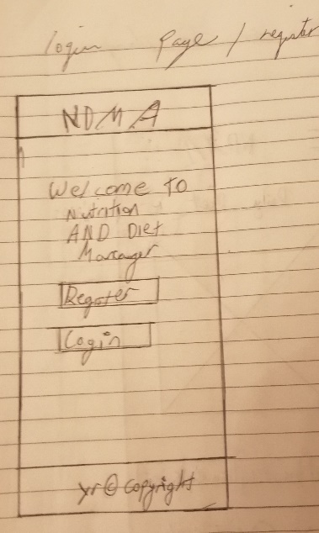 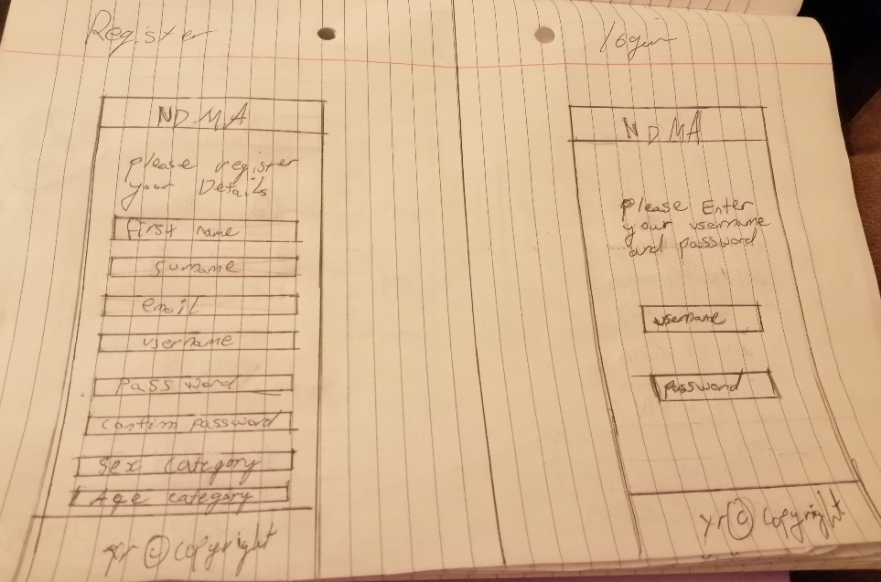

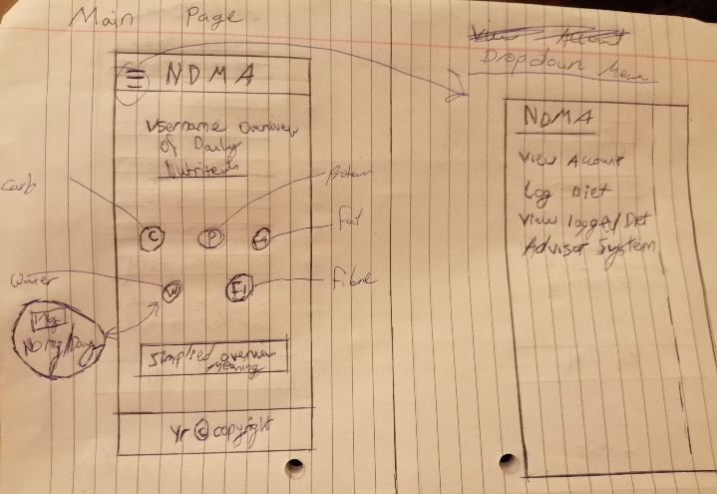 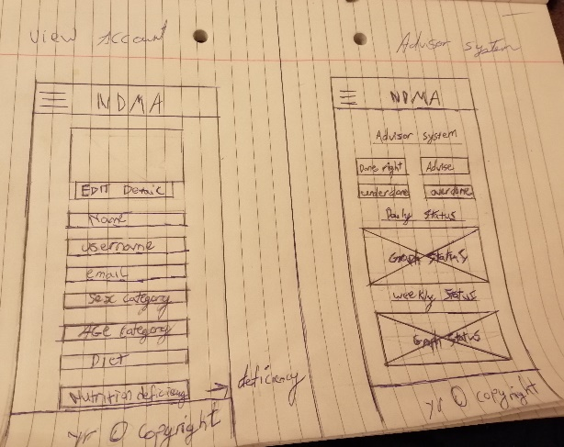

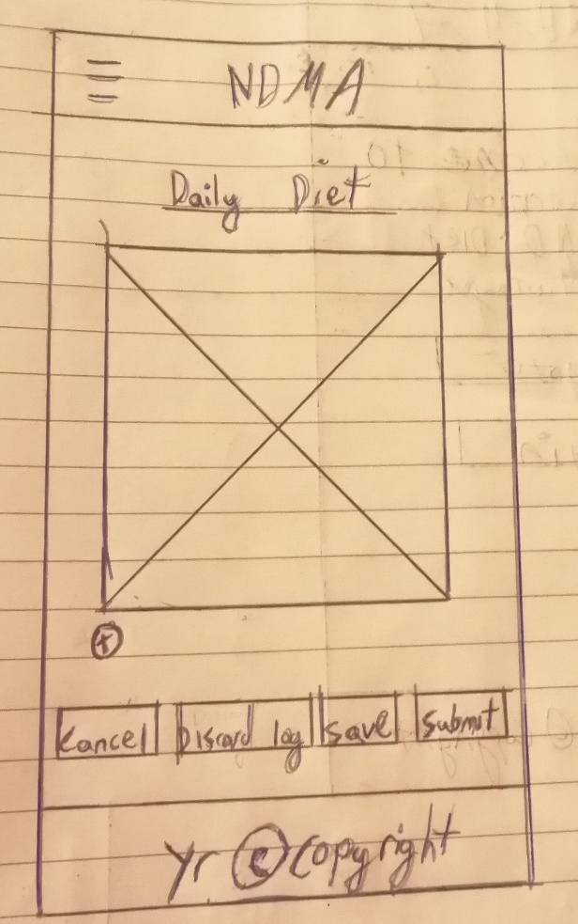

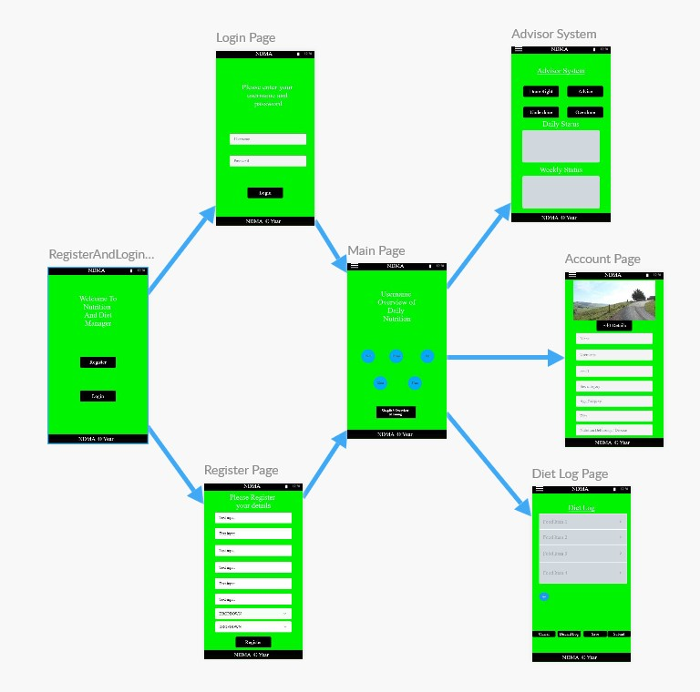

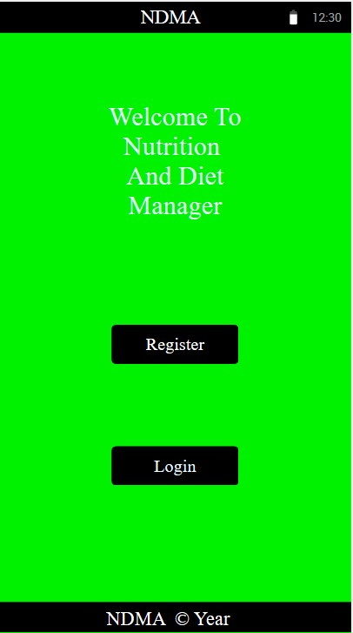 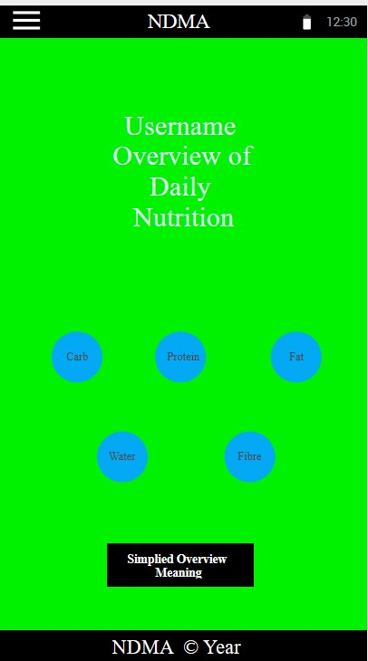 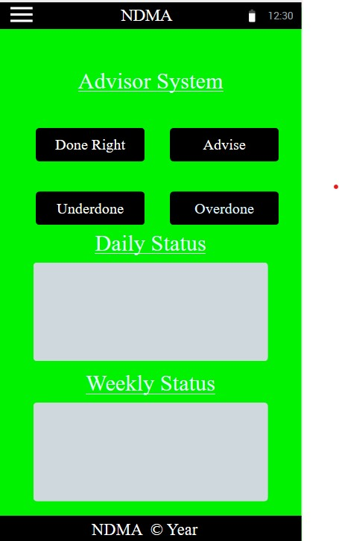

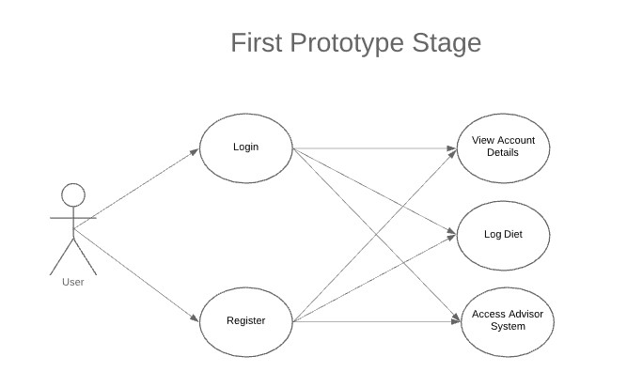

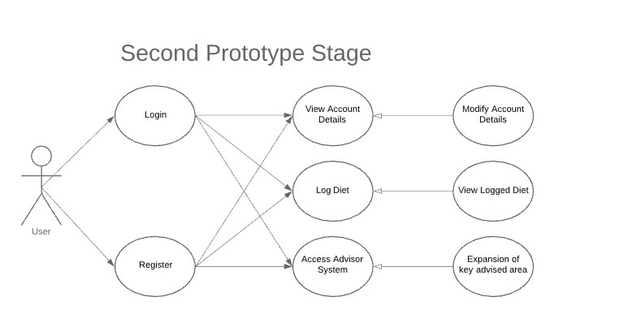

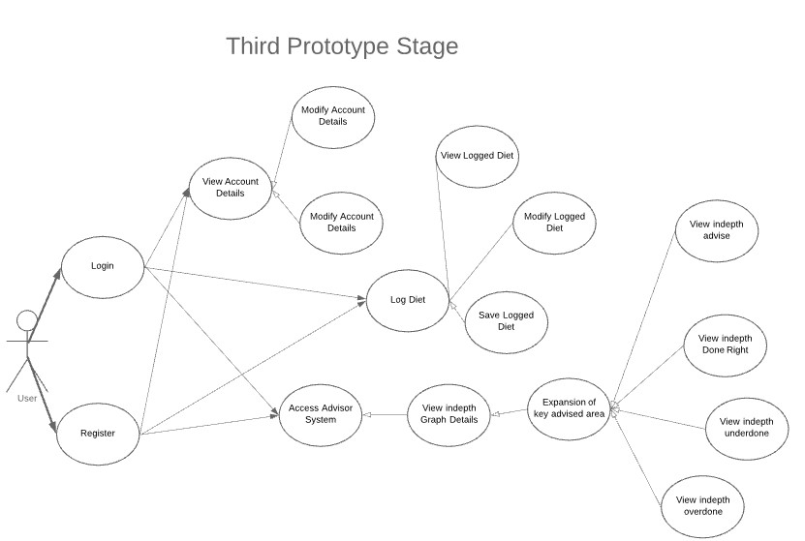

## 3.5. Middle-Tier

## 3.6. Back-End

Including ERDs, and maybe ISDs

## 3.7. Conclusions