**William Carey**

**C16315253**

**Operating Systems**

**Assignment**

**and Labs**

**Course Code**

**DT-228**

**Year 1**

**Computer Science**

Contents

Operating systems 1 Question 1 3

A) Batch Files 3

B ) Bash Files 5

c) Little Man Computer 6

OPERATING SYSTEMS 1 Question Three 7

Lab #1 7

7

Lab #2 9

Lab #3 12

Lab #4 14

Operating systems 1 Question 2 16

Group Assignmment 16

Group Reflections 16

References: 19

# 

# Operating systems 1 Question 1

## Batch Files

Before Test.bat

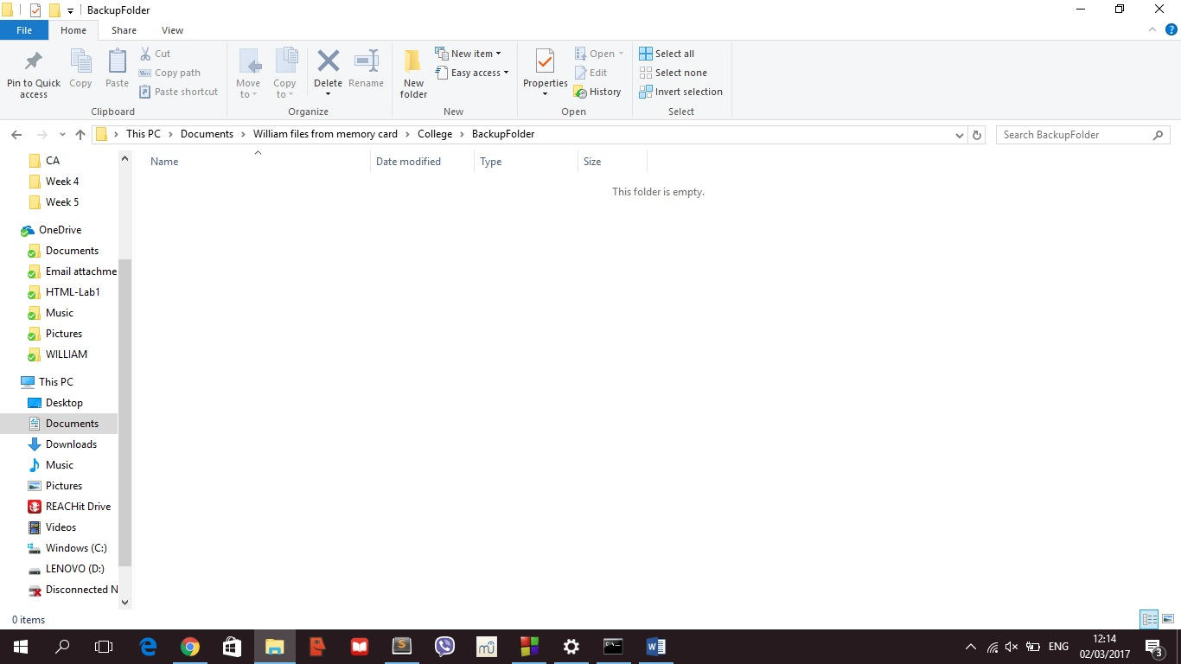

After Test.Bat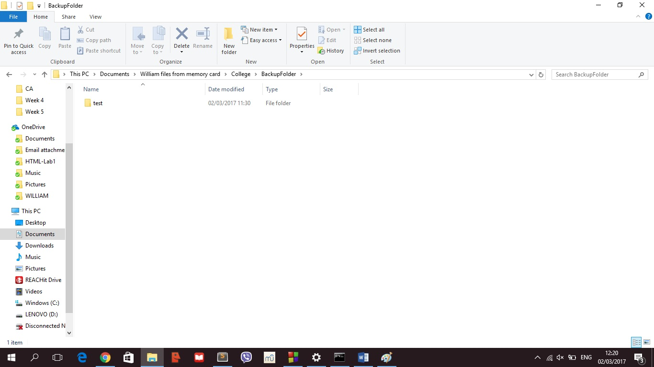

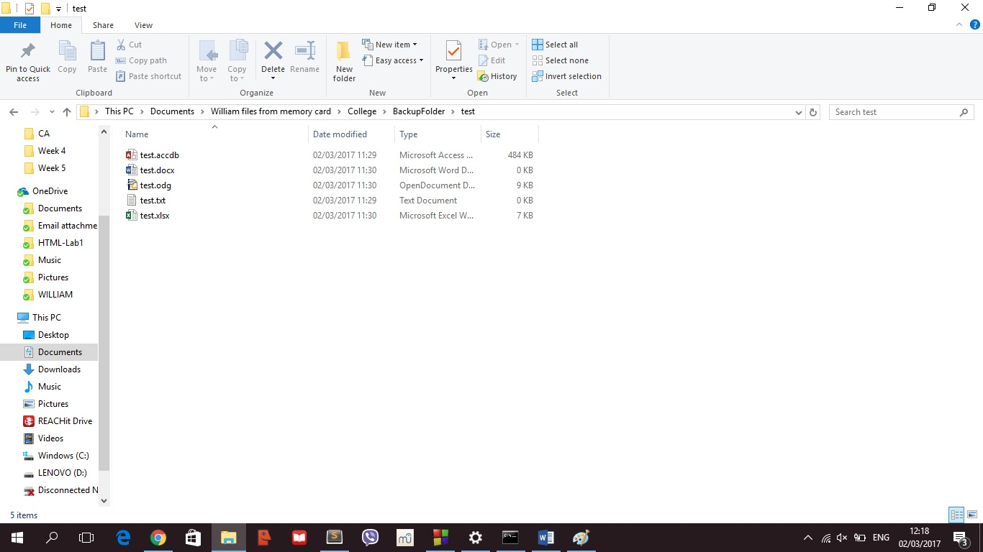

I had looked up a few websites on how to use a dos batch file, such as <http://www.computerhope.com/robocopy.htm> and <https://social.technet.microsoft.com/wiki/contents/articles/1073.robocopy-and-a-few-examples.aspx> to get an understanding of how to create a batch file. After looking up a few websites, I found three functions that could copy, which is normal copy, xcopy and Robocopy. By the descriptions, Robocopy seemed to be the most efficient but I didn’t understood it. So I googled dos batch files pdfs and I looked at a few of them. I then saved three of them, one of which was a short review of the commands, while the other two had more details in them. After spending a day reading these pdfs, I furthered understood the copying methods but didn’t know how to implement them. However, after talking to someone who know about the function, my biggest problem was the fact I had forgotten that one of the emails stated the recursive term in the assignment was only to show how I copied the file into another and not actually trying to copy one folder after another by recalling the batch file repeatedly. I should read the documents and emails more often.

**Commands**

I only used three commands

Echo (message) – This prints (message) to the screen

Robocopy/e – This copies all the directories and sub-directories from one file into another, including empty ones (as indicated by “/e” part of the function.

Cls – This clears the screen

Echo off – This removes the pathway/directory from the command line screen

## B ) Bash Files

Before Bash

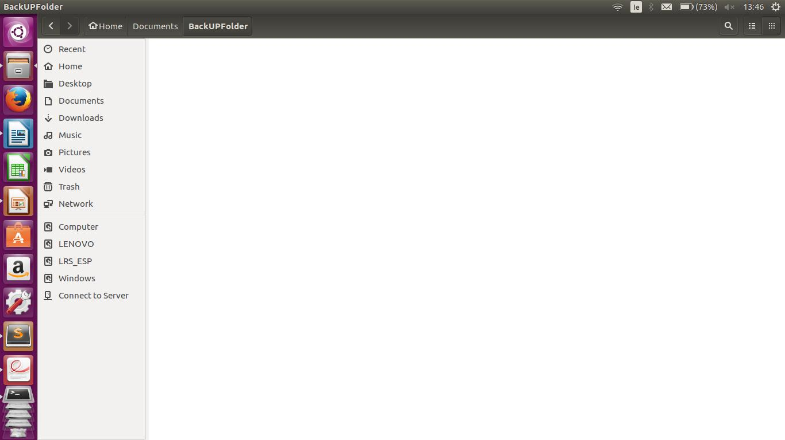

After Bash:

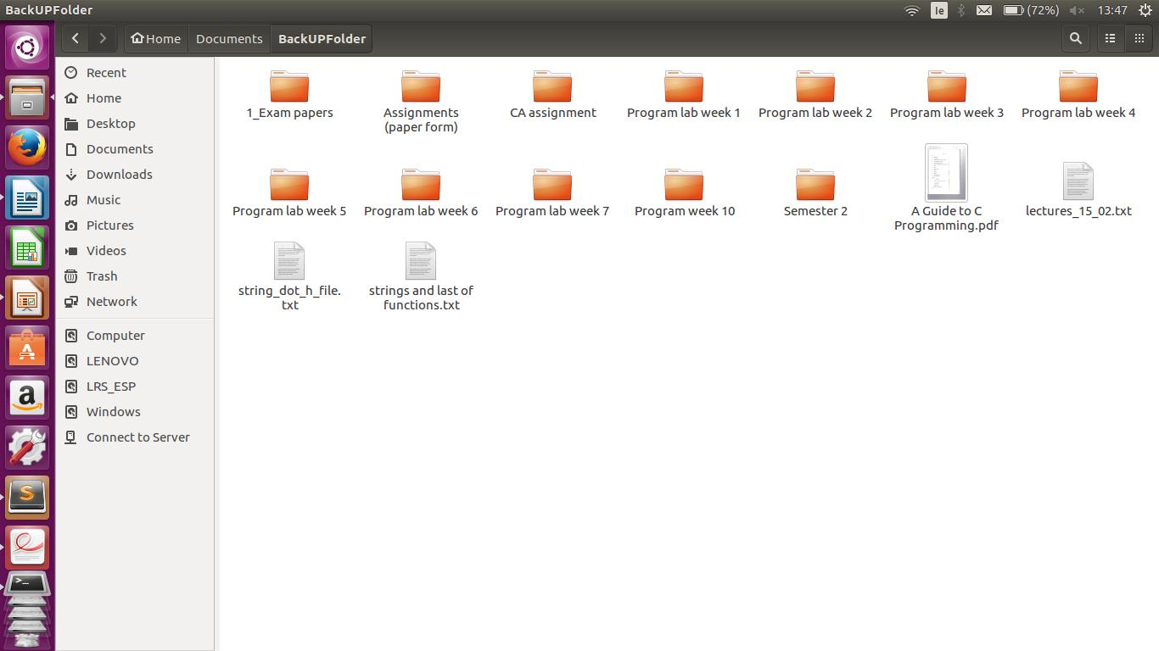

I had trouble thinking this up. However, I came across a person who uses Ubuntu Linux as his primary Operating system. So, he showed me how to create a file to copy a directory and place it into another file. After showing me this, I looked at the pdfs of bash files to understand the concepts of each little commands and what they actually do. After reading for about a hour, I understood what I actual did. Most of the language is the same as Windows Batch File, except with a few little differences.

For example, I used the echo feature in the bash file which prints the message I want it to print for me. I then used the mkdir funcrion to create a new directory called “BackUpFolder”. This allowed me to use the function cp which is the copy function. I copied the intial folder, “5_Programming” into the “BackUpFolder” by using the -r. -r allows me to append the copied data into the new directory.

I knew then the format was “cp -r source dest”, so I written cp -r 5_Programming/* as the source. The /* function after 5_Programming means everything in that directory. This means I copied every folder and file into “BackUpFolder” successfully.

## c) Little Man Computer

This program will take in two inputs from the user, add them and display the result back to the user

//this starts the program

Start

//This takes in an input from the user

901

//This stores the input into memory location ‘07’

307

//This reads in another number

901

//This adds the first number to the second

107

//This outputs the result to the user

902

//This tells the computer to take a break

000

END

# OPERATING SYSTEMS 1 Question Three

## Lab #1

## 

1. Two 100lb oxygen tank
2. Portable heating unit
3. 5 gallons of water
4. One case of dehydrated pet milk
5. Food concentrate
6. Solar-powered FM receiver transmitter
7. Parachute silk
8. First Aid Kit
9. Two .45 calibre pistols
10. Stellars map of the moons constellations
11. Magnetic compass
12. Life raft
13. Signal flares
14. 50’ of nylon rope
15. Box of matches

People I spoke to: Enda Rebbeca and Eilleen

**Your VARK Results**

Your scores were:

|  |  |
| --- | --- |
| • | Visual 6 |
| • | Aural 8 |
| • | Read/Write 9 |
| • | Kinesthetic 6 |
|  | **You have a multimodal learning preference. (VARK)** |

## Lab #2

Operating Systems 1 Lab 2 – DOS Commands

I typed DIR - This directs me to all the files located in that local file

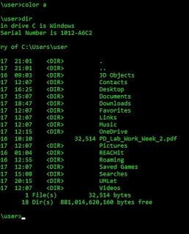

I typed HELP - This gives all the instructions to aid me in using the command line

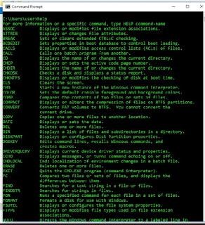

I typed CLS - This clears the screen, which is usefull if there is a lot of code and you want to narrow it down

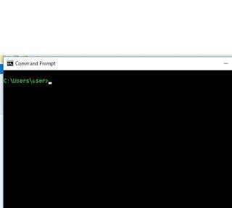

I typed HELLO WORLD - This prints out hello world to the screen for the user to see

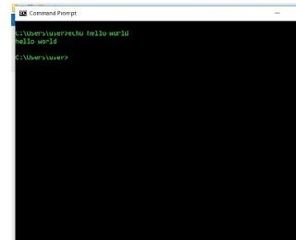

I typed CD .. - This brings the location of the command line back one place

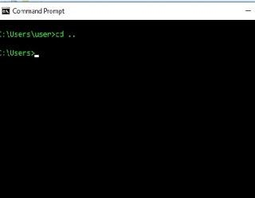

I typed PATH - This shows the pathway to all the local executable files as far as they go

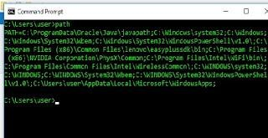

I typed TREE - This shows the pathway to all the text files within the same location

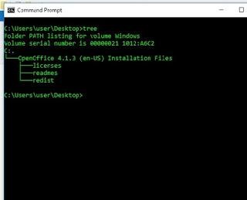

## Lab #3

Operating Systems 1 Lab 3 – Linux Commands

ls - This lets you see all the directories within the location the command line is

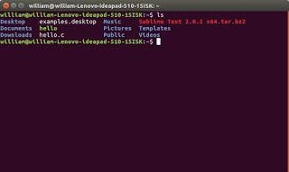

ls -la : This shows you the directory where you have last been and who has access and who does not to the flies in storage

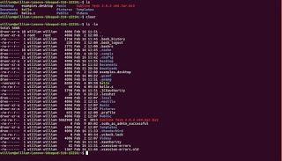

pwd - This shows the pathway to the directory where the command line is pointing at

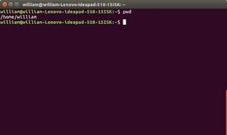

cd. - This changes the directory from where you are to where you are. If you ask me that is a pretty useless function

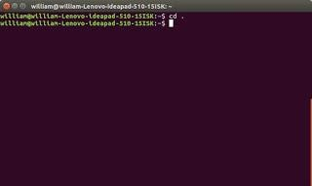

cd .. - This changes the pathway of the directory by one folder back, allowing you to get out of a folder

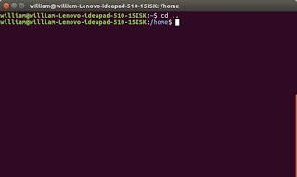

man man - this shows you the manual of the system and what you can actually do with the system itself

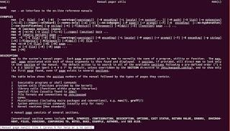

## Lab #4

Operating Systems 1 Lab 4 – DOS Batch File Creation

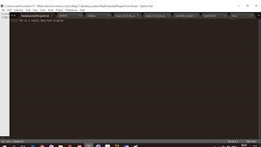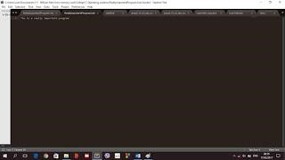

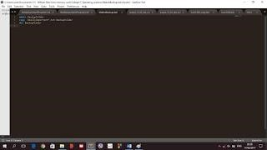

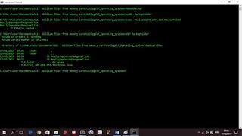

I had created two **text** files to make sure I understood the text files and to make sure they are correct.

Once I completed that, I created a **batch** file that will once executed will create a copy of the files I had created into a backup folder. This is executed by typing the files name into the **command line** which will execute the commands in the batch file.

## 

# Operating systems 1 Question 2

## Group Assignmment

### Group Reflections

**List of the Group Members**

* William Carey
* Rebecca Dillon
* Enda Keane
* Eilleen Rattigan
* Adam Ryan

**Groupname**

***The DIT crowd***

**Roles and Responsibilities of Group Members**

* Adam Ryan – Researcher of Biography of the creator of puppy linux and documenter, making sure the information is correct
* Eileen Rattigan – Researcher of Architecture for puppy linux and documenter, making sure the information is correct
* Rebecca Dillon – Researcher of the desktop applications and documenter, making sure the information is correct
* Enda Keane – Designer of the slides and presenter of 8 slides, making sure the slides are designed in the correct format while looking nice at the same time. Also learning the information to present it in a suitable way.
* William Carey – Organiser, presenter, documented the meetings and tasks. Making sure everyone knows what they are doing is valid to the tasks they are assigned. Making sure the information is documented so it can be used for later reference. Also organised the meetings and keeping track of the activities for the presentation.

**Frequency of Meetings**

A total of 4 meetings, on the following dates and times

11/02/2017 – 1pm to 3pm

23/02/2017 – 2pm to 4 pm

16/03/2017 – 2pm to 4 pm

04/04/2017 – 12pm to 1pm

**Decision Making**

Everyone put their ideas forward, then assigned a piece of work to each person based on their preferences and capabilities. It was democratically done and made sure everyone had a bit to do on the project.

**Timescales**

Started – 2/2/2017

Research on socerer linux – From 15/2/2017 to 20/2/2017

First team meeting on socerer linux – 16/02/2017

Research on puppy linux – From 23/2/2017

Second team meeting on puppy linux – 23/02/2017

Created Powerpoint – 03/03/2017

Designing and adding information to the Slides on powerpoint – 04/03/2017 – 04/04/2017

Third team meeting on speakers – 16/03/2017

Fourth team meeting on the presentation itself – 04/04/2017

Completed – 05/04/2017

**Resources Used**

howpuppyworks.html [Internet]. Barryk.org. 2017 [cited 3 April 2017]. Available from: <http://barryk.org/puppylinux/development/howpuppyworks.html>

. Kauler B. Barry Kauler [Internet]. Barryk.org. 2017 [cited 25 March 2017]. Available from: http://barryk.org/bkauler/

*Lighthouse PUP Architecture. http://www.lhpup.org/sfs/Architecture.htm (accessed 25 March 2017).*

Puppy Linux Community. *Puppy Linux. http://puppylinux.org/main/Download%20Latest%20Release.htm (accessed 25 March 2017).*

Puppy Linux Community. *Puppy Linux: Software Index. http://puppylinux.org/wikka/SoftwareIndex (accessed 25 March 2017).*

Puppy Linux Community. *Puppy Linux: Puppy School. http://puppylinux.org/wikka/PuppySchool (accessed 25 March 2017).*

## References:

1. Cooper M. Advanced bash scripting guide 5.3 volume 1. 1st ed. [Place of publication not identified]: Lulu Com; 2010.

2. folder B. Batch file to copy files from one folder to another folder [Internet]. Stackoverflow.com. 2017 [cited 9 March 2017]. Available from: http://stackoverflow.com/questions/986447/batch-file-to-copy-files-from-one-folder-to-another-folder