# Movie Review Database

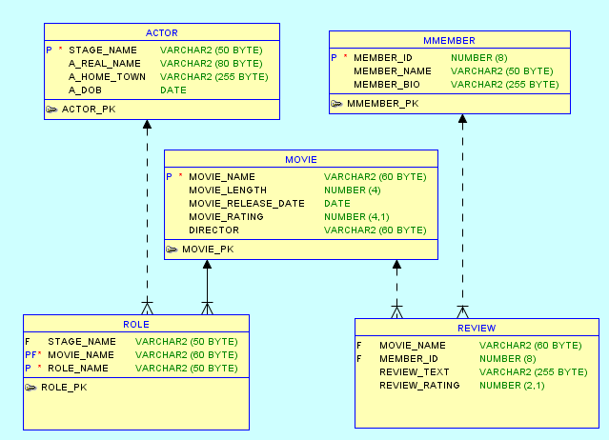

|  |  |  |
| --- | --- | --- |
| 1 | Write SQL to list the movie_name, movie_rating and review_rating of all movies that have a movie_rating higher than 5 and have a review_rating of 5. | 20 marks |
| 2 | Write SQL to list the names of movies (movie_name) that no-one has reviewed. | 20 marks |
| 3 | Write SQL to list the stage_name and role_name where an actor (stage_name) has played the same role (role_name) in more than one movie. | 20 marks |
| 4 | Write SQL to list the stage name of actors who have played the same roles as George Clooney (don't include George Clooney). | 20 marks |
| 5 | Write SQL to list the name (movie_name) and length (movie_length) of any movie that has a non-null movie length (movie_length is not null), that has been reviewed by every member. | 20 marks |